Supplemental Digital Content
1 Results of meta-analysis on clinical characteristics 2
2 Results of Trial Sequential Analysis 2
2.1 Supplementary figure 1 Trial Sequential Analysis and required information size for the effect of WUS for OSA 2
2.2 Supplementary figure 2 Trial Sequential Analysis and required information size for the effect of WUS on AHI 3
2.3 Supplementary figure 3 Trial Sequential Analysis and required information size for the effect of WUS on ODI 3

Results of meta-analysis on clinical characteristics
Clinical features | Number of study | OR/WMD (95%CI) | P | I2 | P for Q test
Age | 10 | 0.03 (-1.20-1.26) | 0.96 | 1.40% | 0.43
BMI | 9 | 0.39 (-0.12-0.90) | 0.13 | 10.40% | 0.35
Male | 10 | 1.27 (1.02-1.58) | 0.03 | 0 | 0.93
Diabetes | 10 | 1.39 (0.90-1.35) | 0.33 | 0 | 0.90
Smoking | 10 | 1.27 (1.01-1.56) | 0.04 | 0 | 0.84
Hypertension | 10 | 1.03 (0.84-1.26) | 0.77 | 0 | 0.60
Atrial fibrillation | 9 | 0.69 (0.52-0.92) | 0.01 | 0 | 0.64
ESS | 6 | 0.51 (-0.24-1.26) | 0.18 | 0 | 0.96
NIHSS | 10 | 0.12 (-0.19-0.44) | 0.43 | 26.8% | 0.20
OR odd ratio, WMD weight mean difference, BMI body mass index.

Results of Trial Sequential Analysis

Supplementary figure 1 Trial Sequential Analysis and required information size for the effect of WUS for OSA
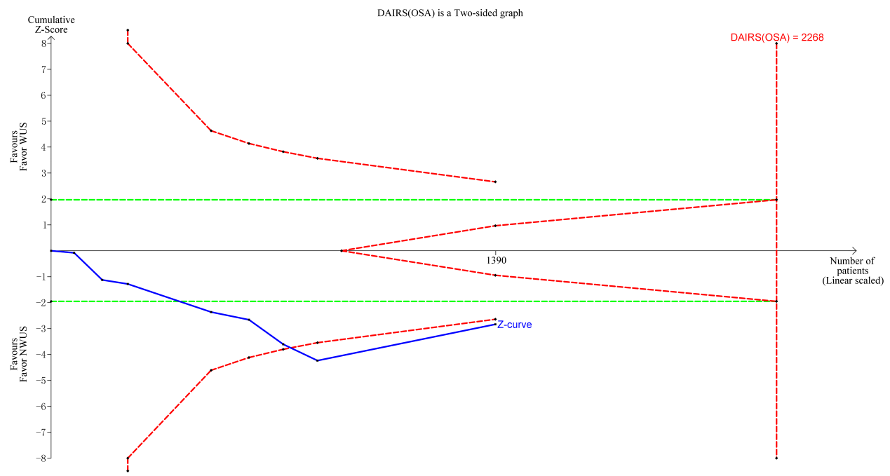

Supplementary figure 2 Trial Sequential Analysis and required information size for the effect of WUS on AHI
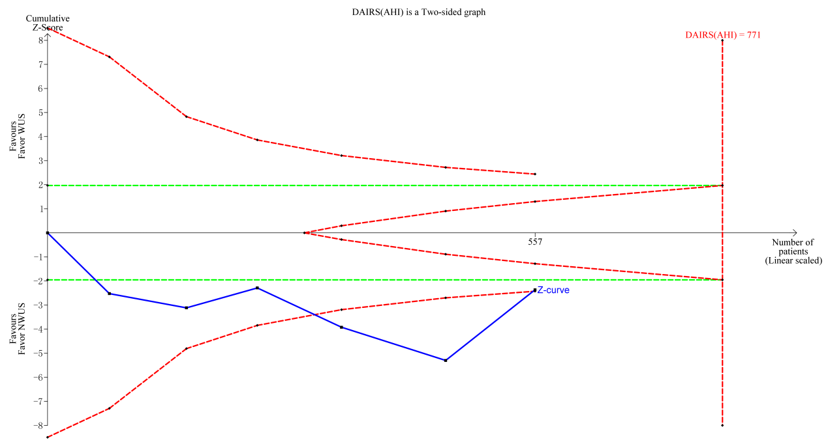

Supplementary figure 3 Trial Sequential Analysis and required information size for the effect of WUS on ODI
