Supplementary material
Supplementary Figure 1:
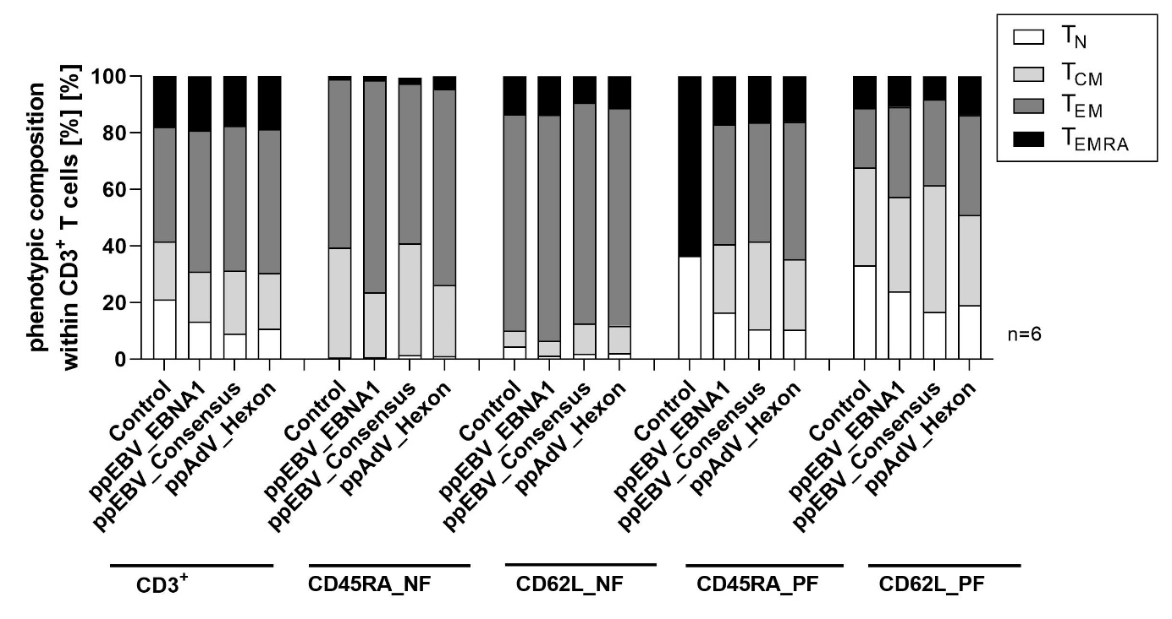
A
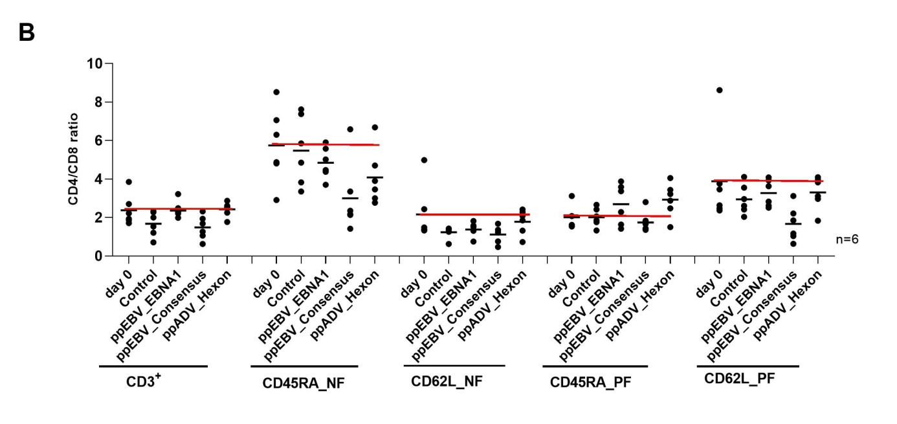

Supplementary Figure 1: Evaluation of T-cell frequencies and phenotypes after naïve T-cell depletion following in vitro stimulation.

CD3⁺ T-cells were isolated from PBMCs of six healthy blood donors followed by T_{N}-depletion using CD45RA and CD62L microbeads. The CD45RA_NF/PF and CD62L_NF/PF fractions were co-culutred at a density of 5 x 10⁵ with 5 x 10⁴ antigen- loaded target cells (loaded with 1 μg per peptide /ml ppEBV_EBNA1, ppEBV_Consensus, or ppAdV_Hexon) in the presence 50 U/ml IL-2, 10 ng/ml IL-7 and 10 ng/ml IL-15. Immunophenotypic analysis was performed by flow cytometry after 7 days of stimulation. (A) T-cell phenotypes among CD3⁺ T-cell fraction were described as: naïve (T_{N}: CD45RA⁺CD62L⁺), central memory (T_{CM}: CD45RA⁻CD62L⁺), effector memory (T_{EM}: CD45RA⁻CD62L⁻), and late effector memory T cells re-expressing CD45RA (T_{EMRA}: CD45RA⁺CD62L⁻). The isolated fractions consisted mainly of CD45RA_PF (T_{N} and T_{EMRA}) and CD45RA_NF (T_{CM} and T_{EM}) as well as CD62L_PF (T_{N} and T_{CM}) and CD62L_NF (T_{EMRA} and T_{EM}). Data represent the means of six donors. Memory/negative fractions: CD45RA_NF and CD62L_NF, naïve/positive fractions: CD45RA_PF and CD62L_PF. (B) CD4⁺/CD8⁺ T-cell ratio following stimulation with the different antigens within the different T-cell fractions. T-cell fractions cultured alone in the presence of IL-2, IL-7 and IL-15 served as control. Data are expressed as means of six donors and were calculated by subtracting the observed values from the effector cells co-cultured with unloaded target cells alone (negative control). Memory/negative fractions: CD45RA_NF and CD62L_NF, naïve/positive fractions: CD45RA_PF and CD62L_PF; pp – peptide pool.

Supplementary Figure 2:
Supplementary Figure 2: Evaluation of T-cell frequencies and phenotypes after naïve T-cell depletion following mixed lymphocyte reaction culture (MLR).
CD3⁺ T-cells were isolated from PBMCs of six healthy blood donors followed by T_{N}-depletion using CD45RA and CD62L microbeads. Effector cells (CD45RA_NF/PF and CD62L_NF/PF) were labelled with carboxyfluorescein succinimidyl ester (CFSE, 4 µM). 1 x 10⁵ CFSE-labelled T cells (responder) were co-cultured with irradiated (1x 30 Gy) autologous or pooled PBMCs (stimulator, from 3-5 donors) at an E:T ratio of 1:1 supplemented with IL-2, IL-7 and IL-15. As negative controls, target or effector cells were cultured in the presence of IL-2, IL-7 and IL-15 alone, while T-cell fractions co-cultured with anti-CD3/CD28 beads served as positive control. T-cell phenotypes were described as: naïve (T_{N}: CD45RA⁺CD62L⁺), central memory (T_{CM}: CD45RA⁻CD62L⁺), effector memory (T_{EM}: CD45RA⁻CD62L⁻), and late effector memory T cells re-expressing CD45RA (T_{EMRA}: CD45RA⁺CD62L⁻) among (A) CD3⁺, (B) CD4⁺, and (C) CD8⁺ T cells respectively. (D) CD4⁺/CD8⁺ T-cell ratio after T-cell-mediated alloreactivity in MLR assay within the different T-cell fractions. Data represent the means of six donors. Memory/negative fractions: CD45RA_NF and CD62L_NF, naïve/positive fractions: CD45RA_PF and CD62L_PF.

