Supplementary Materials
Global incidence, progression, and risk factors of age-related macular degeneration and projection of disease statistics in 30 years: Systematic Review, Meta-analysis, and Modelling

Supplementary MOOSE checklist
Supplementary Method. Quality assessment -Modified Newcastle-Ottawa risk of bias scoring guide.
Study heterogeneity and publication bias analysis.
Supplementary Table 1. Study characteristics: An overview of studies regarding AMD incidence or progression.
Supplementary Table 2. Included studies for pooled analysis on early- and late-AMD incidence and progression.
Supplementary Table 3. Newcastle-Ottawa risk of bias scores for the 28 studies included in this systematic review and meta-analysis.
Supplementary Table 4. Score summary.
Supplementary Table 5a. Odds ratios for incidence of early AMD by continent and country.
Supplementary Table 5b. Odds ratios for incidence of late AMD by continent and country.
Supplementary Figure 1a. Forest plot for annual incidence of early AMD by response rate.
Supplementary Figure 1b. Forest plot for annual incidence of late AMD by response rate.
Supplementary Figure 2a. Forest plot for annual incidence of early AMD by baseline year.
Supplementary Figure 2b. Forest plot for annual incidence of late AMD by baseline year.
Supplementary Figure 3a. Forest plot for annual incidence of early AMD by sample size.
Supplementary Figure 3b. Forest plot for annual incidence of late AMD by sample size.
Supplementary Figure 4a. Overall age trend of annual incidence of early AMD by country.
Supplementary Figure 4b. Male-specific age trend of annual incidence of early AMD by country.
Supplementary Figure 4c. Female-specific age trend of annual incidence of early AMD by country.
Supplementary Figure 4d. Overall age trend of annual incidence of late AMD by country.
Supplementary Figure 4e. Male-specific age trend of annual incidence of late AMD by country.
Supplementary Figure 4f. Female-specific age trend of annual incidence of late AMD by country.
Supplementary Figure 5a. Funnel plot for early AMD meta-analysis
Supplementary Figure 5b. Funnel plot for late AMD meta-analysis
Supplementary References.

Moose checklist
Criteria |  | Brief description of how the criteria were handled in the meta-analysis
Reporting of background should include
√ | Problem definition | Age-related macular degeneration (AMD) has become a major cause of visual impairment worldwide. However, the incidence, progression, and risk factors estimates of AMD vary between studies.
√ | Hypothesis statement | The estimated global pooled prevalence of AMD in 2013 was about 17%, and the number of individuals with AMD is 196 million and projected to increase to 288 million in 2040. Therefore, the burden of AMD is an emerging element of global vision loss with the increase in older persons.
√ | Description of study outcomes | Global incidence, progression, risk factors and projection of AMD.
√ | Type of exposure or intervention used | AMD (early and late)
√ | Type of study designs used | We included prospective cohort studies as comparisons of study populations. We excluded studies of reverse association.
√ | Study population | We placed no restrictions.
Reporting of search strategy should include
√ | Qualifications of searchers | The credentials of the two investigators LL and YYW are indicated in the author list.
√ | Search strategy, including time period included in the synthesis and keywords | PubMed, Web of Science, EMBASE, CNKI, Wanfang, and ViP up to September 1st, 2019.
√ | Databases and registries searched | This study is registered with PROSPERO, number CRD42019118832
√ | Search software used, name and version, including special features | We did not employ a search software. EndNote was used to merge retrieved citations and eliminate duplicates.
√ | Use of hand searching | We hand-searched bibliographies of retrieved papers for additional references.
√ | List of citations located and those excluded, including justifications | Details of the literature search process are outlined in the flow chart. The citation list is available upon request.
√ | Method of addressing articles published in languages other than English | Only articles published in English and Chinese were searched and included. The Chinese databases were also searched with Chinese terms.
√ | Method of handling abstracts and unpublished studies | We contacted a few authors of unpublished studies.
√ | Description of any contact with authors | We contacted authors who had conducted multivariate analysis with AMD incidence.
Reporting of methods should include
√ | Description of relevance or appropriateness of studies assembled for assessing the hypothesis to be tested | Detailed inclusion and exclusion criteria were described in methods section.
√ | Rationale for the selection and coding of data | Data extracted from each of the studies were relevant to the population characteristics, study design, exposure, outcome, and possible effect modifiers of the association.
√ | Assessment of study quality | Quality assessment by several indicators such as sample representatives, sample size, comparability between respondents and non-respondents, classification of AMD, and thoroughness of descriptive statistics reporting are shown in eMethod.
√ | Assessment of heterogeneity | Heterogeneity of the studies was explored using the chi-square test of heterogeneity and I² statistic that provided the relative amount of variance of the summary effect due to the between-study heterogeneity.
√ | Description of statistical methods in sufficient detail to be replicated | Description of methods of meta-analyses and assessment of publication bias are detailed in the methods.
√ | Provision of appropriate tables and graphics | PRISMA flow diagram. Figure 1.
Reporting of results should include
√ | Table giving characteristics of including studies | Supplementary Table 1
√ | Indication of statistical uncertainty of findings | 95% credible intervals were presented with all summary estimates; I² values
√ | Studies included for subgroup analysis | Supplementary Table 2
√ | Assessment of quality of included studies | Newcastle-Ottawa risk of bias scores of studies included are shown in Supplementary Table 3 and Supplementary Table 4
√ | Graph summarizing individual study estimates and overall estimate | Figures 2, 3, 4  Supplementary Figures 1, 2, 3
√ | Table giving odds ratio for incidence of AMD by continent and country | Supplementary Table 5
√ | Graph summarizing age trend of annual incidence of AMD by region and country | Supplementary Figures 4, 5
√ | Table giving projection estimates | Table 1
√ | Table giving risk factors analysis | Supplementary Table 5a and 5b
Reporting of discussion should include
√ | Consideration of alternative explanations for observed results | We discussed why some regions lacking research and how different risk factors performed differently in different studies.
√ | Quantitative assessment of bias | Egger test for funnel plot indicated publication bias in strengths of the association due to the most common biases in observational studies as shown in Supplementary Figure 6.
√ | Guidelines for future research | We recommend future studies to be conducted in regions lacking researches and to incorporate a standardized method.
√ | Disclosure of funding source | No separate funding was necessary for the undertaking of this systematic review.
√ | Generalization of the conclusions | We provided a global overview of the incidence, progression, and risk factors of AMD over the past few decades, and projected new cases of AMD for 2020 and up till 2050, by decade. The studies were across several regions, which indicated the substantial global burden of AMD, especially in an aging population.  We recommended focus on prevention and control of AMD in Asia and develop prevention programs for AMD on the basis of risk factors analysis.

Supplementary Method
Quality assessment-Modified Newcastle-Ottawa risk of bias scoring guide[1]
(1) Sample representativeness:
1 point: Described sampling process in detail.
0 points: Described sampling process in summary or without description.
(2) Sample size:
1 point: Sample size was greater than or equal to 2000 participants.
0 points: Sample size was less than 2000 participants.
(3) Non-respondents:
1 point: Comparability between respondent and non-respondent characteristics was established with a satisfactory response rate (>=80%).
0 points: The comparability between respondents and non-respondents was unsatisfactory, the response rate was unsatisfactory (<=80%), or there was no description of the response rate or the characteristics of the responders or non-responders.
(4) Classification of AMD:
1 point: The study estimated the incidence rate of early and late AMD separately.
0 points: The study estimated the overall incidence rate of AMD or did not provide an estimation.
(5) Quality of descriptive statistics reporting:
1 point: The study reported descriptive statistics to describe the population (e.g., age, sex) with proper measures of dispersion (e.g., mean, standard deviation).
0 points: The study did not report descriptive statistics, incompletely reported descriptive statistics, or did not report measures of dispersion.
Legend: The individual components listed above were summed to generate a total modified Newcastle-Ottawa risk of bias score for each study. Total scores ranged from 0 to 5. For grouping based on the total scores, studies were judged to be of low risk of bias (≥3 points) or high risk of bias (<3 points). The information above is depicted in eTable 3.

Study heterogeneity and publication bias analysis.
Standard chi-square test with I² statistics (the percentage of variability in incidence estimation due to heterogeneity rather than sampling error or chance) and p-values were used to assess between-study heterogeneity. Funnel plot (eFigure 6) and Egger test for funnel plot asymmetry were used to assess study publication bias.
Supplementary Table 1. Study characteristics: An overview of studies regarding AMD incidence or progression
Study no. | Region | Study name/ Location | Abbreviation | Baseline survey year | Follow-up year | Observed duration | Age range | Male | Female | Total sample size | Response rate for follow-up | AMD grading
1[2] | Europe | Antioxydants, Lipides Essentiels, Nutrition et Maladies Oculaires/France | ALIENOR | 2006-2008 | 2008-2012 | 3.8(1.1) | 73 + | 246 | 413 | 659 | 66.4 | IGS
2[3] | Asia | The Singapore Malay Eye Study/Singapore | SIMES | 2006-2008 | 2011-2013 | 6 | 40+ | 824 | 985 | 1809 | 72.1 | WAMDGS
3[4] | Africa | Nakuru Eye Disease Cohort Study/Kenya | NEDCS | 2007-2008 | 2013-2014 | 6 | 50+ | 635 | 647 | 1282 | 50.1 | IGS
4[5] | Australia | Blue Mountains Eye Study/Australia | BMES | 1992-1994 | 2007-2010 | 15.6 | 49+ | NA | NA | 1149 | NA | WAMDGS
5[6] | Asia | A Nationwide Population-Based Study/South Korea | NPBS | 2010 | 2012 | 3 | 40+ | 11955 | 8241 | 20196 | NA | AMD registration code (V201)
6[7] | Europe | the Rotterdam Study/Netherlands | RTES | 2000-2001 | 2011-2012 | 6.9 | 55+ | 3211 | 2362 | 5573 | NA | WAMDGS+  IGS
7[8] | Europe | The Age, Gene/Environment Susceptibility Study/Iceland | AGES | 2002-2006 | 2007-2011 | 5 | 67+ | NA | NA | 2864 | 58 | WAMDGS
8[9] | Asia | The Beijing Eye Study/China | BES | 2001 | 2006 | 5 | 40+ | 1327 | 1722 | 3049 | 73.2 | IGS
9[10] | North America | "THE LOS ANGELES | LALES | 2000-2003 | 2004-2008 | 4 | 40+ | NA | NA | 3908 | 76 | WAMDGS
10[11] | Asia | The Hisayama Study/Japan | HS | 1998 | 2007 | 9 | 40+ | 524 | 877 | 1401 | 79.1 | WAMDGS+  IGS
11[12] | North America | Beaver Dam Eye Study | BDES | 1988-1990 | 2003-2005 | 15 | 43+ | NA | NA | 2042 | 85.4 | WAMDGS
12[13] | Europe | Pathologies Oculaires Liées à l’Age/France | POLA | 1995-1997 | 1998-2000 | 3 | 60+ | NA | NA | 1424 | 79.9 | IGS
13[14] | North America | Barbados Eye Studies/USA | BISED II | 1987-1992 | 1997-2003 | 9 | 40-84 | 942 | 1414 | 2356 | 90.2 | Reading Center in Baltimore
14[15] | Europe | Copenhagen City Eye Study | CCES | 1986-1988 | 2000-2002 | 14 | 60-80 | NA | NA | 313 | 97.3 | WAMDGS
15[16] | Asia | The Hisayama Study/Japan | HS | 1998 | 2003 | 5 | 64±8 | 384 | 577 | 961 | 64.8 | WAMDGS+  IGS
Study no. | Region | Study name/ Location | Abbreviation | Baseline survey year | Follow-up year | Observed duration | Age range | Male | Female | Total sample size | Response rate for follow-up | AMD grading
16[17] | Europe | Copenhagen City Eye Study/Denmark | CCES | 1986-1988 | 2000-2002 | 14 | 60-80 | NA | NA | 313 | 97.3 | WAMDGS
17[18] | Europe | Reykjavik Eye Study/Iceland | RES | 1996 | 2001 | 5 | 50+ | 377 | 469 | 846 | 88.2 | WAMDGS+  IGS
18[19] | Australia | The Visual Impairment Project | VIP | 1992-1994 | 1997-1999 | 5 | 40-98 | NA | NA | 1618 | 62.3 | IGS
19[20] | Australia | Blue Mountains Eye Study/Australia | BMES I | 1992-1994 | 1997-1999 | 5 | 49+ | 992 | 1343 | 2335 | 75.1 | WAMDGS
20[21] | North America | Beaver Dam Eye Study | BDES | 1988-1990 | 1993-1995 | 5 | 43-86 | NA | NA | 3583 | 81.1 | WAMDGS
21[22] | Australia | Blue Mountains Eye Study/Australia | BMES II | 1992-1994 | 2002-2004 | 10 | 49+ | NA | NA | 1952 | 83,6 | WAMDGS
22[23] | North America | Beaver Dam Eye Study | BDES | 1988-1990 | 1998-2000 | 10 | 43-86 | NA | NA | 2663 | 75 | WAMDGS
23[24] | Europe | the Rotterdam Study/Netherlands | RTES | 1990-1993 | 1993-1994 | 2 | 55+ | 2055 | 2898 | 4953 | 90.9 | IGS
24[25] | North America | Waterman Study | WS | 1985 | 1990 | 5 | 30+ | 483 | NA | 483 | 91.7 | NA.
25[26] | North America | Salisbury Eye Evaluation Project | SEE | 1993 | 1995 | 2 | 65-84 | 794 | 1143 | 1937 | 86.5 | Salisbury Eye Evaluation Project
26[27] | North America | the Study of Osteoporotic Fractures | SOF | 1997-1998 | 2002-2004 | 5 | 74+ | NA | 1958 | 1958 | 86.9 | WAMDGS
27[28] | Asia | The Singapore Indian Eye Study/Singapore | SINDI | 2007-2009 | 2013-2015 | 6 | 40+ | 1047 | 1058 | 2105 | 75.5 | WAMDGS
28[29] | North America | Barbados Eye Studies/USA | BISED I | 1987-1992 | 1991-1996 | 4 | 40-84 | 1070 | 1507 | 2577 | 80.7 | Reading Center in Baltimore
29[30] | China | Handan Eye Study | - | 2006-2007 | 2012-2013 | 6 | 30+ | 2276 | 2772 | 5048 | 85.3 | WAMDGS
30[31] | Portugal | The Coimbra  Eye Study | - | 2009 | 2016 | 6.5 | 55+ | 697 | 919 | 1616 | 66.3 | IGS
WAMDGS: Wisconsin Age-Related Macular Degeneration Grading System;
IGS: International Grading System;
BISEDGP: BISED Grading Protocol;
NA, not applicable.

Supplementary Table 2. Included studies on early- and late-AMD incidence and progression.
 | Early-AMD incidence | Late-AMD incidence | AMD progression | Risk factors
Study No. | 1, 2, 4, 7, 9, 13, 15, 17, 18, 19, 20, 21, 22, 27, 28,29,30 | 1, 2, 4, 5, 7, 9, 12, 15, 17, 18, 19, 20, 21, 22, 27,29,30 | 7, 9, 13, 23 | 1, 2, 3, 4, 5, 7, 8, 10, 13, 15, 26, 27,29

Some studies did not participate in analysis because of the unavailability of data consolidation.

Supplementary Table 3. Newcastle-Ottawa risk of bias scores for the 28 studies included in this systematic review and meta-analysis.

Study no. | Study name/ Location | Abbreviation | Representativeness | Sample Size | Non-respondents | Classification of AMD | Descriptive Statistics | Total
1[2] | Antioxydants, Lipides Essentiels, Nutrition et Maladies Oculaires/France | ALIENOR | 1 | 0 | 0 | 1 | 1 | 3
2[3] | The Singapore Malay Eye Study/Singapore | SIMES | 1 | 0 | 0 | 1 | 1 | 3
3[4] | Nakuru Eye Disease Cohort Study/Kenya | NEDCS | 1 | 0 | 0 | 0 | 1 | 2
4[5] | Blue Mountains Eye Study/Austria | BMES Ⅲ | 1 | 0 | 0 | 1 | 1 | 3
5[6] | A Nationwide Population-Based Study/South Korea | NPBS | 1 | 1 | 0 | 0 | 1 | 3
6[7] | the Rotterdam Study/Netherlands | RTES | 1 | 1 | 0 | 0 | 1 | 3
7[8] | The Age, Gene/Environment Susceptibility Study/Iceland | AGES | 1 | 1 | 0 | 1 | 1 | 4
8[9] | The Beijing Eye Study/China | BES | 1 | 1 | 0 | 0 | 1 | 3
9[10] | The Los Angeles Latino Eye Study/USA | LALES | 1 | 1 | 0 | 1 | 1 | 4
10[11] | The Hisayama Study/Japan | HS | 1 | 0 | 0 | 1 | 1 | 3
11[12] | Beaver Dam Eye Study | BDES | 1 | 1 | 1 | 1 | 0 | 4
12[13] | Pathologies Oculaires Liées à l’Age/France | POLA | 0 | 0 | 0 | 0 | 0 | 0
13[14] | Barbados Eye Studies/USA | BISED II | 1 | 1 | 1 | 1 | 1 | 5
14[15] | Copenhagen City Eye Study | CCES | 1 | 0 | 1 | 0 | 1 | 3
15[16] | The Hisayama Study/Japan | HS | 1 | 0 | 0 | 1 | 1 | 3
16[17] | Copenhagen City Eye Study/Denmark | CCES | 1 | 0 | 1 | 0 | 1 | 3
17[18] | Reykjavik Eye Study/Iceland | RES | 1 | 0 | 1 | 1 | 1 | 4
18[19] | The Visual Impairment Project | VIP | 1 | 0 | 0 | 1 | 1 | 3
19[20] | Blue Mountains Eye Study/Austria | BMES I | 1 | 1 | 0 | 1 | 1 | 4
20[21] | Beaver Dam Eye Study | BDES Ⅰ | 1 | 1 | 1 | 1 | 0 | 4
21[22] | Blue Mountains Eye Study/Austria | BMES II | 1 | 0 | 1 | 1 | 1 | 4
22[23] | Beaver Dam Eye Study | BDES Ⅱ | 1 | 1 | 0 | 1 | 0 | 3
23[24] | the Rotterdam Study/Netherlands | RTES | 1 | 1 | 1 | 0 | 1 | 4
24[25] | Waterman Study | WS | 1 | 0 | 1 | 0 | 0 | 2
25[26] | Salisbury Eye Evaluation Project | SEE | 1 | 0 | 1 | 1 | 1 | 4
26[27] | the Study of Osteoporotic Fractures | SOF | 1 | 0 | 1 | 1 | 1 | 4
27[28] | The Singapore Indian Eye Study/Singapore | SINDI | 1 | 1 | 0 | 1 | 1 | 4
28[29] | Barbados Eye Studies/USA | BISED I | 1 | 1 | 1 | 1 | 1 | 5
29[30] | China | - | 1 | 1 | 1 | 1 | 1 | 5
30[31] | Portugal | - | 1 | 0 | 0 | 1 | 1 | 3
Studies are ordered according to study number. Full details regarding Newcastle-Ottawa risk of bias scoring are provided in eMethod.

Supplementary Table 4. Score summary
Total Newcastle-Ottawa Score | N(%)
0 | 1(3.3%)
1 | 0(0)
2 | 2(6.7%)
3 | 13(43.3%)
4 | 11(36.7%)
5 | 3(10.0%)

Supplementary Table 5a. Odds ratios for incidence of early AMD by continent and country
 | Model 1 OR
Age per decade | 1.74 (1.52, 1.99)
Female | 1 Ref
Male | 0.99 (0.78, 1.22)
Europe | 1 Ref
Asia | 0.25 (0.09, 0.77)
Oceania | 0.51 (0.18, 1.60)
North America | 0.36 (0.14, 1.01)
Singapore | 1 Ref
Australia | 1.93 (0.47, 8.91)
Iceland | 3.78 (0.67, 22.85)
USA | 1.37 (0.36, 5.20)
Japan | 1.06 (0.21, 5.72)
China | 0.83 (0.17, 4.54)
Response rate | 1.00 (0.96, 1.04)
Baseline year | 0.98 (0.94, 1.03)

When adjusted by age and gender, taking Singapore as reference, Iceland ranked the highest in incidence of early AMD (OR: 3.78; 95% CrI: 0.67-22.85). *: adjusted for age and sex.

Supplementary Table 5b: Odds ratios for incidence of late AMD by continent and country
 | Model 1 OR
Age per decade | 1.86 (1.63, 2.16)
Female | 1 Ref
Male | 0.50 (0.28, 0.94)
Europe | 1 Ref
Asia | 1.02 (0.07, 10.93)
Oceania | 0.63 (0.04, 9.01)
North America | 0.67 (0.04, 10.08)
Singapore | 1 Ref
Australia | 0.79 (0.19, 4.06)
Iceland | 1.34 (0.18, 11.24)
USA | 0.83 (0.21, 3.92)
Japan | 0.99 (0.15, 7.00)
South Korea | 4.72 (0.82, 25.08)
China | 0.39 (0.06, 2.47)
Response rate | 0.99 (0.95, 1.04)
Baseline year | 1.03 (0.97, 1.08)

When adjusted by age and gender, taking Singapore as reference, South Korea ranked the highest in incidence of late AMD (OR: 4.72; 95% CrI: 0.82-25.08). *: adjusted for age and sex.

Supplementary Figure 1a. Forest plot for annual incidence of early AMD by response rate
When concerning response rate, the data shows that 17 studies had low response rates[2-11, 13, 16, 19, 20, 23, 28, 31] (<80%), while 13 studies had high response rates.[12, 14, 15, 17, 18, 21, 22, 24-27, 29, 30] When stratified by response rate, the overall global annual incidence of early AMD was 1.60 (95% CrI: 1.21-2.12) per 100 person-years. The annual incidence was 1.93 (95% CrI: 1.04-3.52) per 100 person-years in studies with high response rates[14, 18, 21, 22, 29, 30] and 1.44 (95% CrI: 0.89-2.31) per 100 person-years in studies with low response rates.[2, 3, 8, 10, 16, 19, 20, 23, 28, 31]
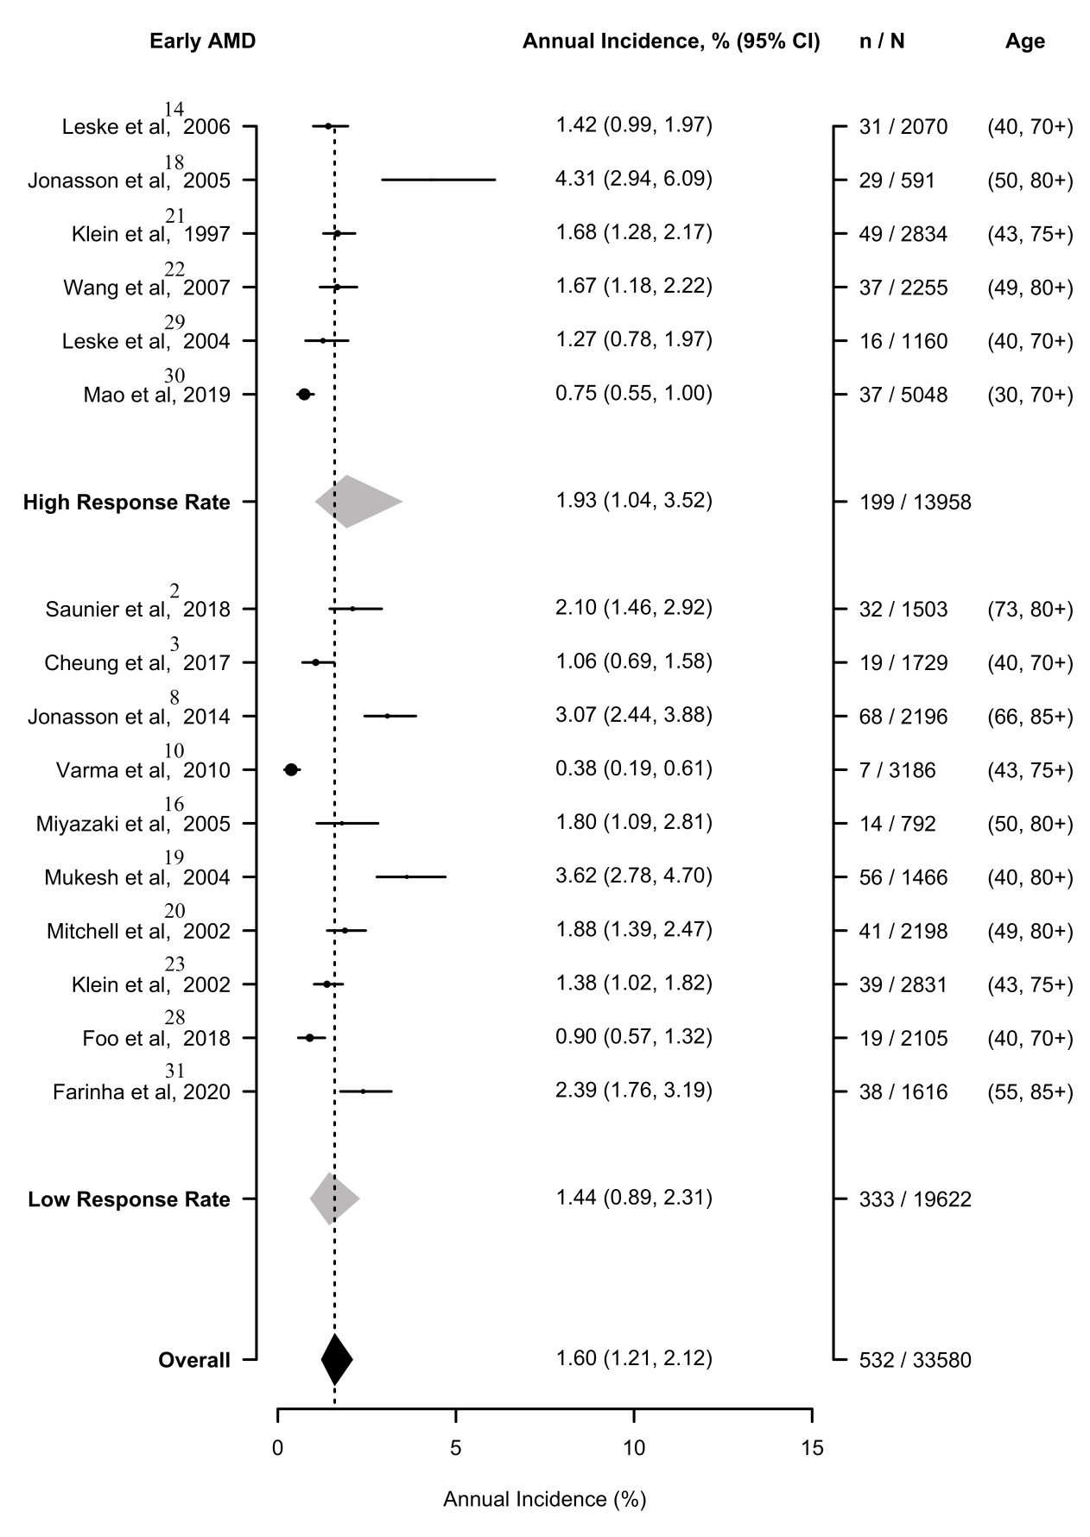
* High Response Rate: >= 80%; Low Response Rate: < 80%
Supplementary Figure 1b. Forest plot for annual incidence of late AMD by response rate
When stratified by response rate, the overall global annual incidence of late AMD was 0.18% (95% CrI: 0.12-0.25) per 100 person-years. The annual incidence was 0.22 (95% CrI: 0.12-0.40) per 100 person-years in studies with high response rates[18, 21, 22, 30] and 0.17 (95% CrI: 0.10-0.24) per 100 person-years in studies with low response rates.[2, 3, 8, 10, 13, 16, 19, 20, 23, 28, 31]
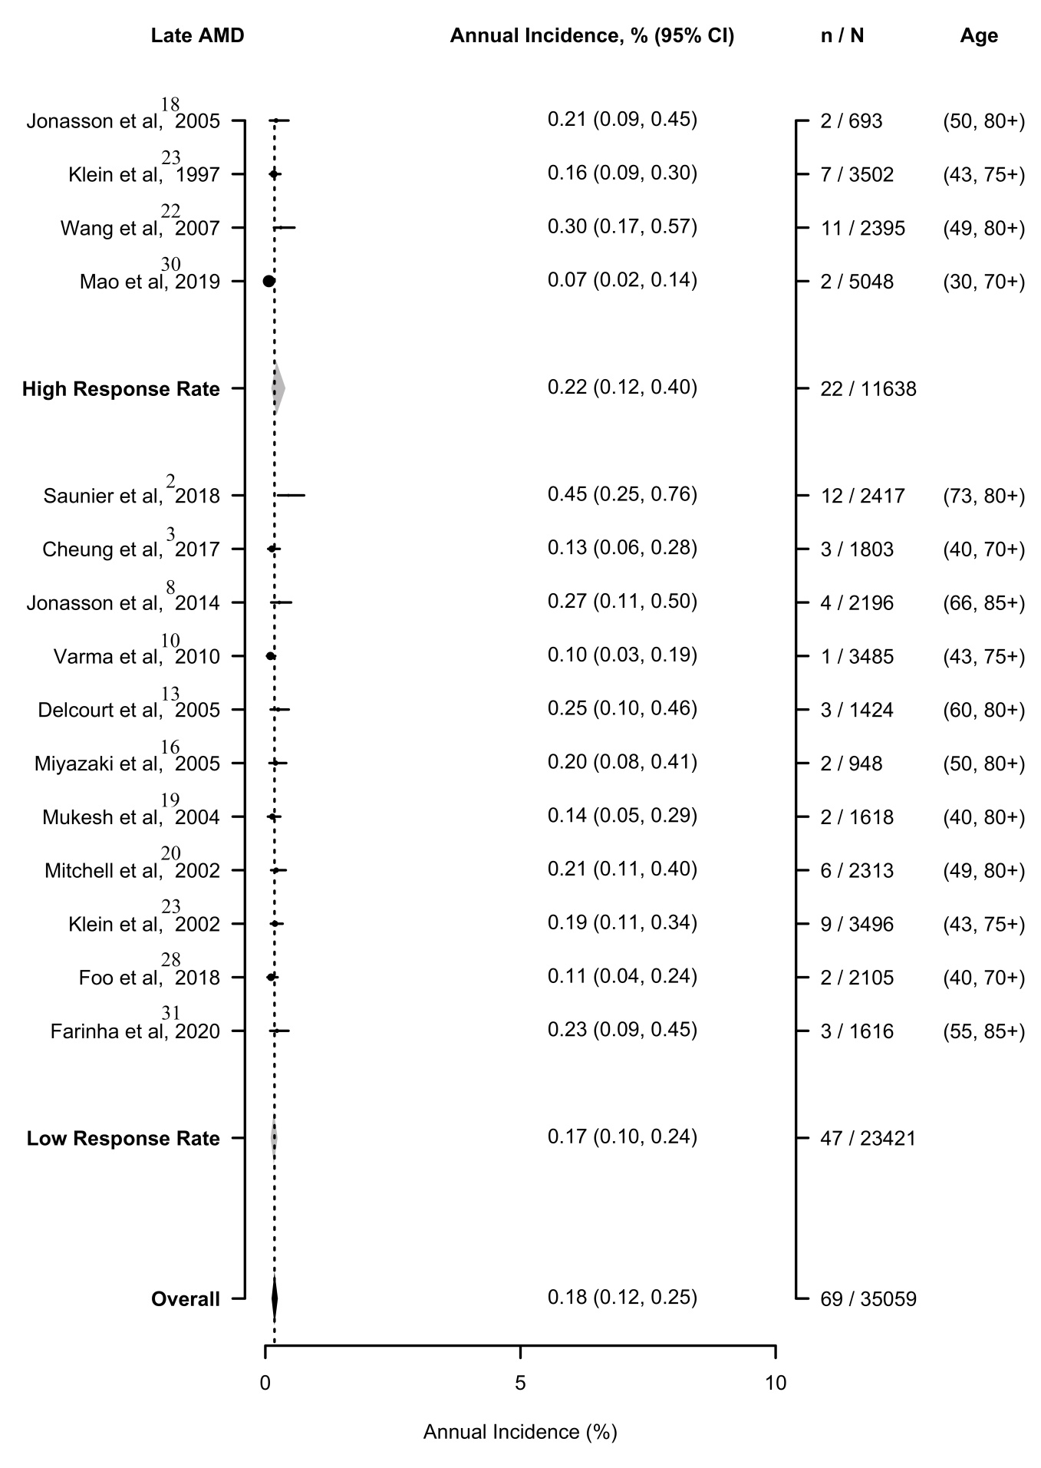
* High Response Rate: >= 80%; Low Response Rate: < 80%
Supplementary Figure 2a. Forest plot for annual incidence of early AMD by baseline year
Among all included longitudinal population-based observational studies, 19 were conducted before 2000[5, 11-27, 29] and 11 were conducted after 2000.[2-4, 6-10, 28, 30, 31] For early AMD, the annual incidence was 2.10 (95% CrI: 1.21-3.35) per 100 person-years in studies conducted before 2000[5, 14, 16, 18-23, 29] and 1.10 (95% CrI: 0.57-2.04) per 100 person-years in studies conducted after 2000.[2, 3, 8, 10, 28, 30, 31]
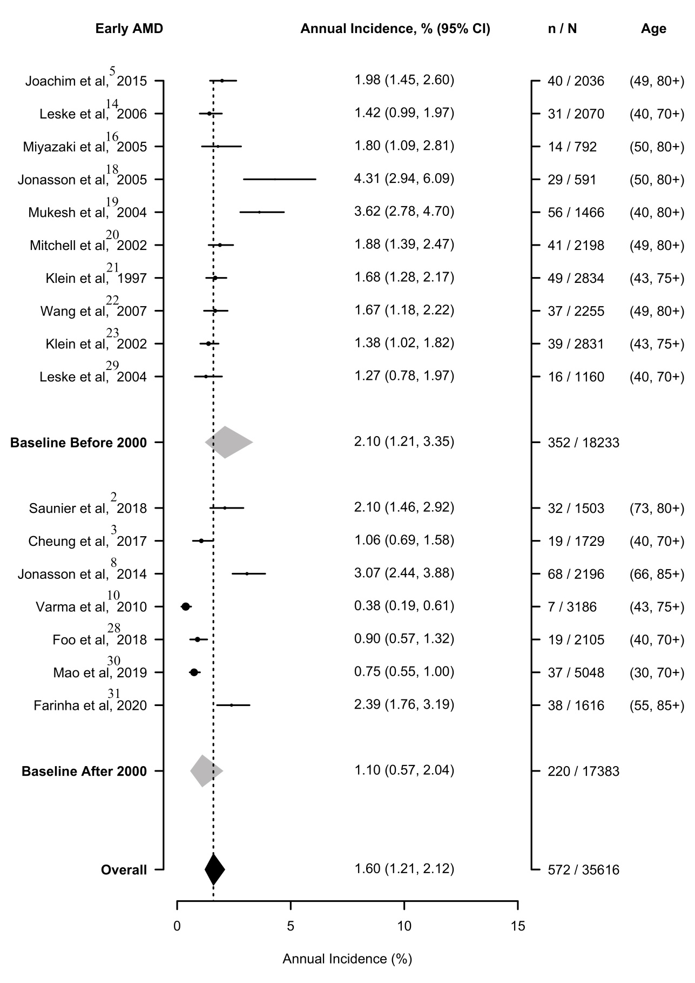
Supplementary Figure 2b. Forest plot for annual incidence of late AMD by baseline year
For late AMD, the annual incidence was 0.26 (95% CrI: 0.15-0.41) per 100 person-years in studies conducted before 2000[5, 13, 16, 18-23] and 0.20 (95% CrI: 0.11-0.34) per 100 person-years in studies conducted after 2000.[2, 3, 6, 8, 10, 28, 30, 31]
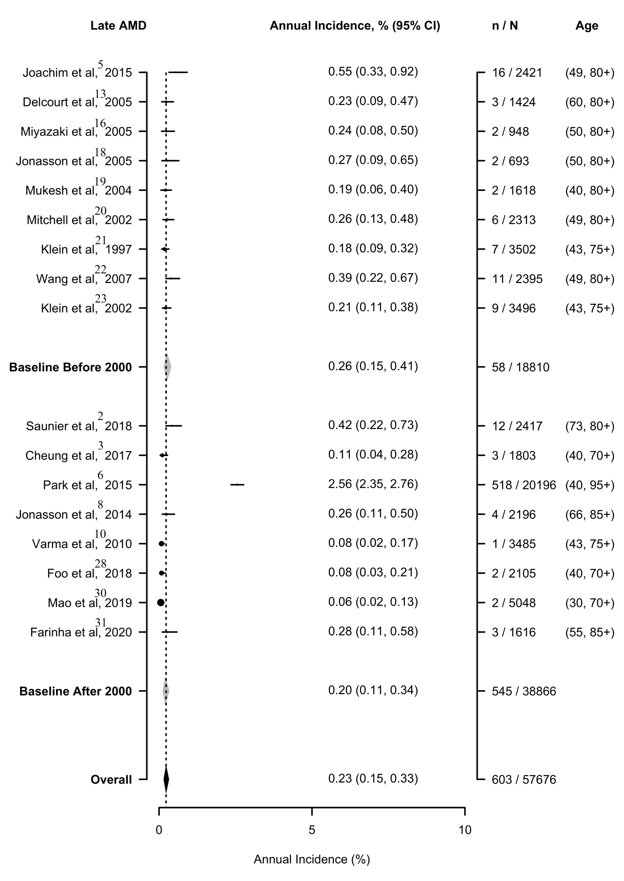
Supplementary Figure 3a. Forest plot for annual incidence of early AMD by sample size
For early AMD, the annual incidence was 1.34 (95% CrI: 0.78-2.32) per 100 person-years in studies with large sample sizes[8, 10, 14, 20, 21, 23, 28-30] and 1.91 (95% CrI: 1.11-3.36) per 100 person-years in studies with small sample sizes.[2, 3, 5, 16, 18, 19, 22, 31] The higher incidence of studies with small sample sizes may have been due to poor sample representation.
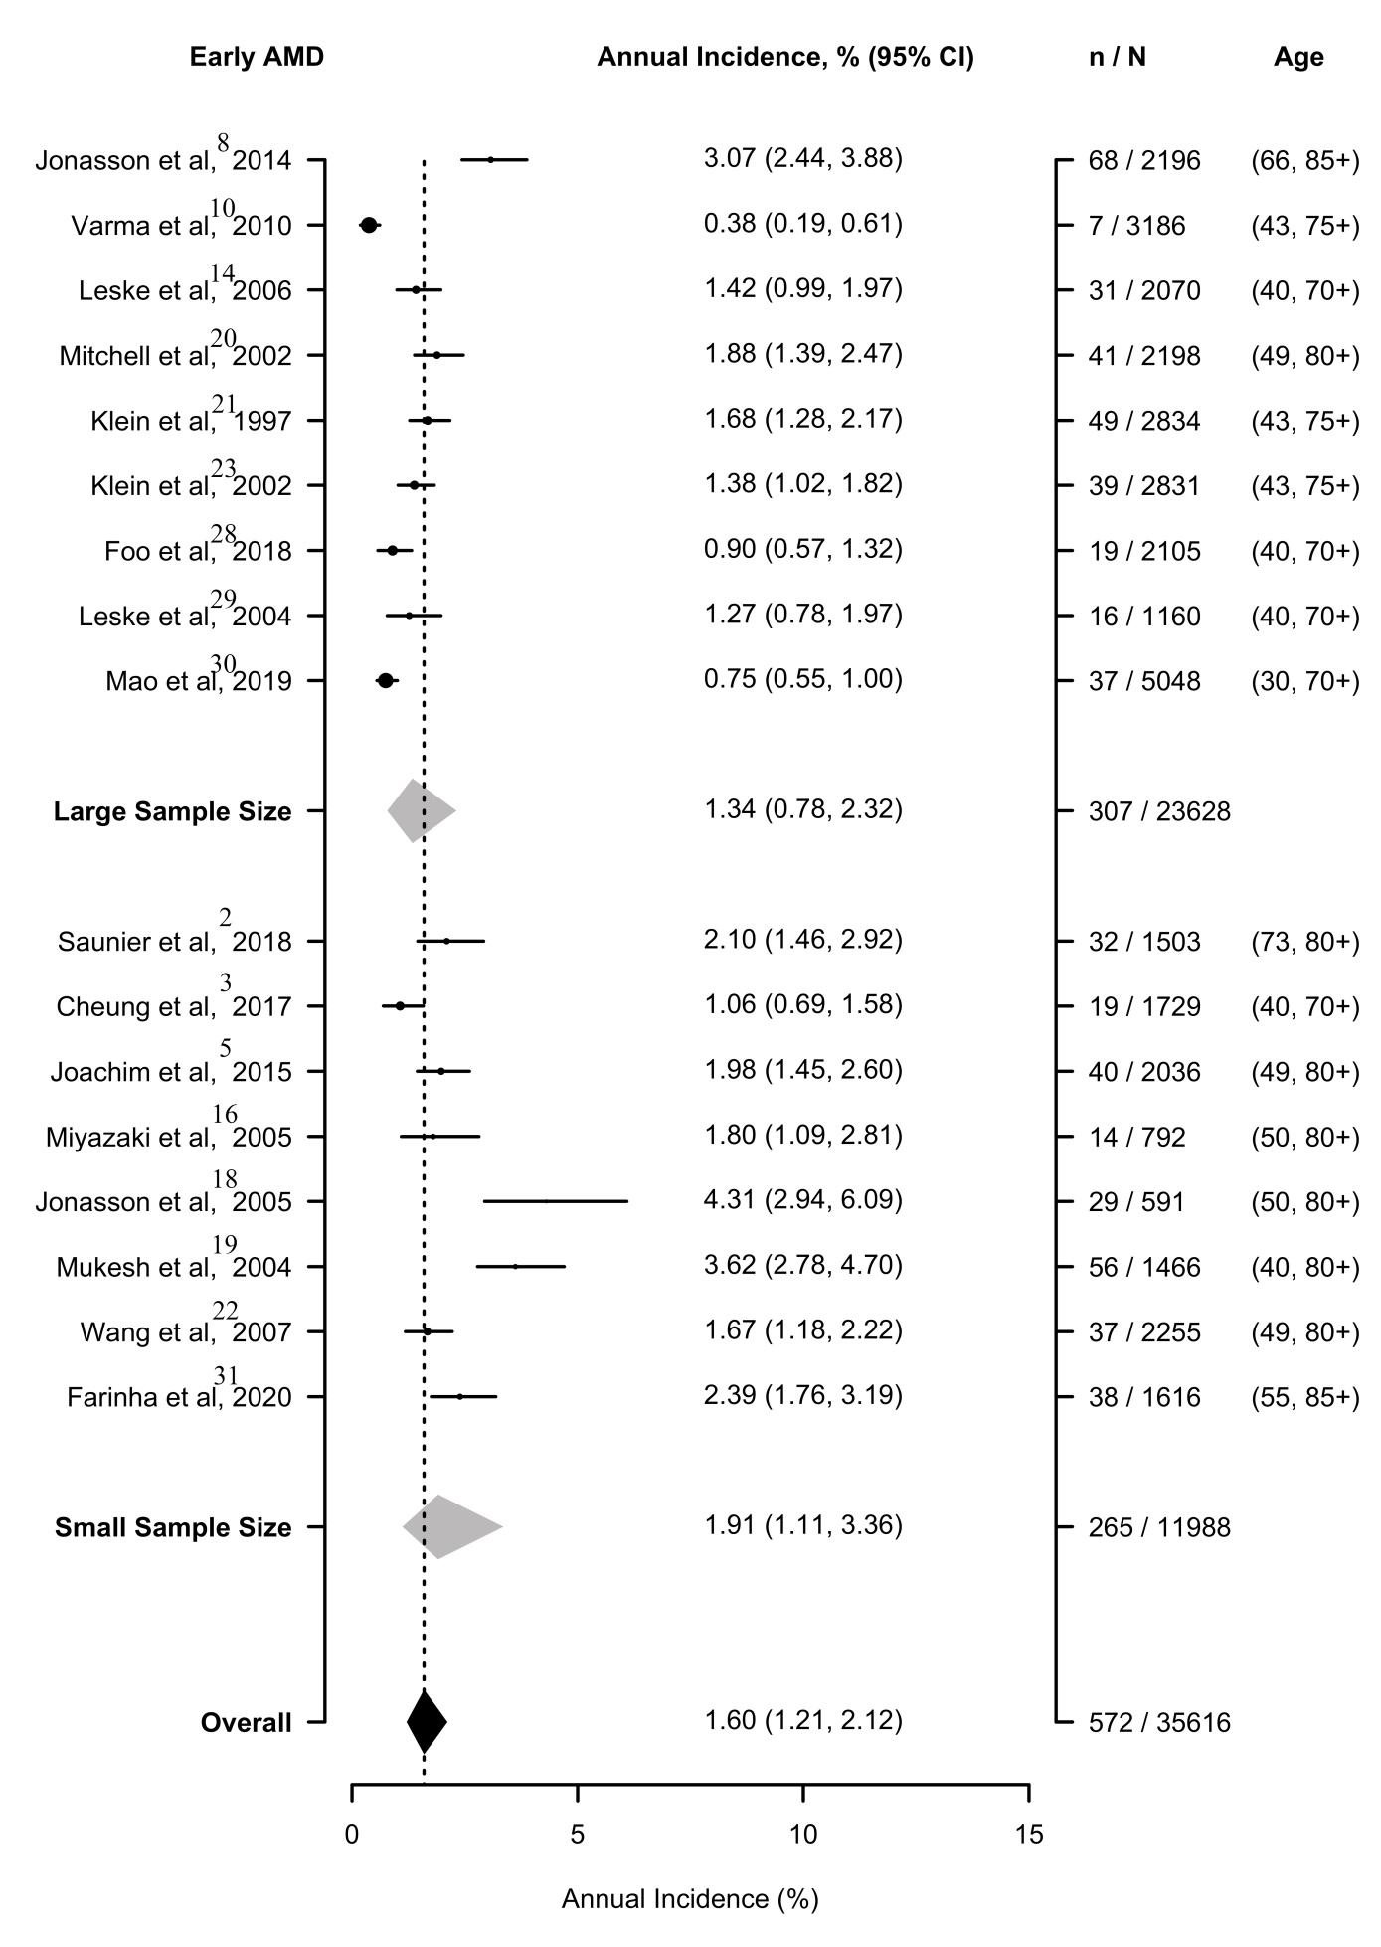
Large sample size≥2000, small sample size ＜2000
Supplementary Figure 3b. Forest plot for annual incidence of late AMD by sample size
For late AMD, the annual incidence was 0.17 (95% CrI: 0.04-0.51) per 100 person-years in studies with large sample sizes[6, 8, 10, 20, 21, 23, 28, 30] and 0.25 (95% CrI: 0.08-0.83) per 100 person-years in studies with small sample sizes.[2, 3, 5, 13, 16, 18, 19, 22, 31] The incidence of studies with small sample size was higher, which may have been due to poor sample representation.
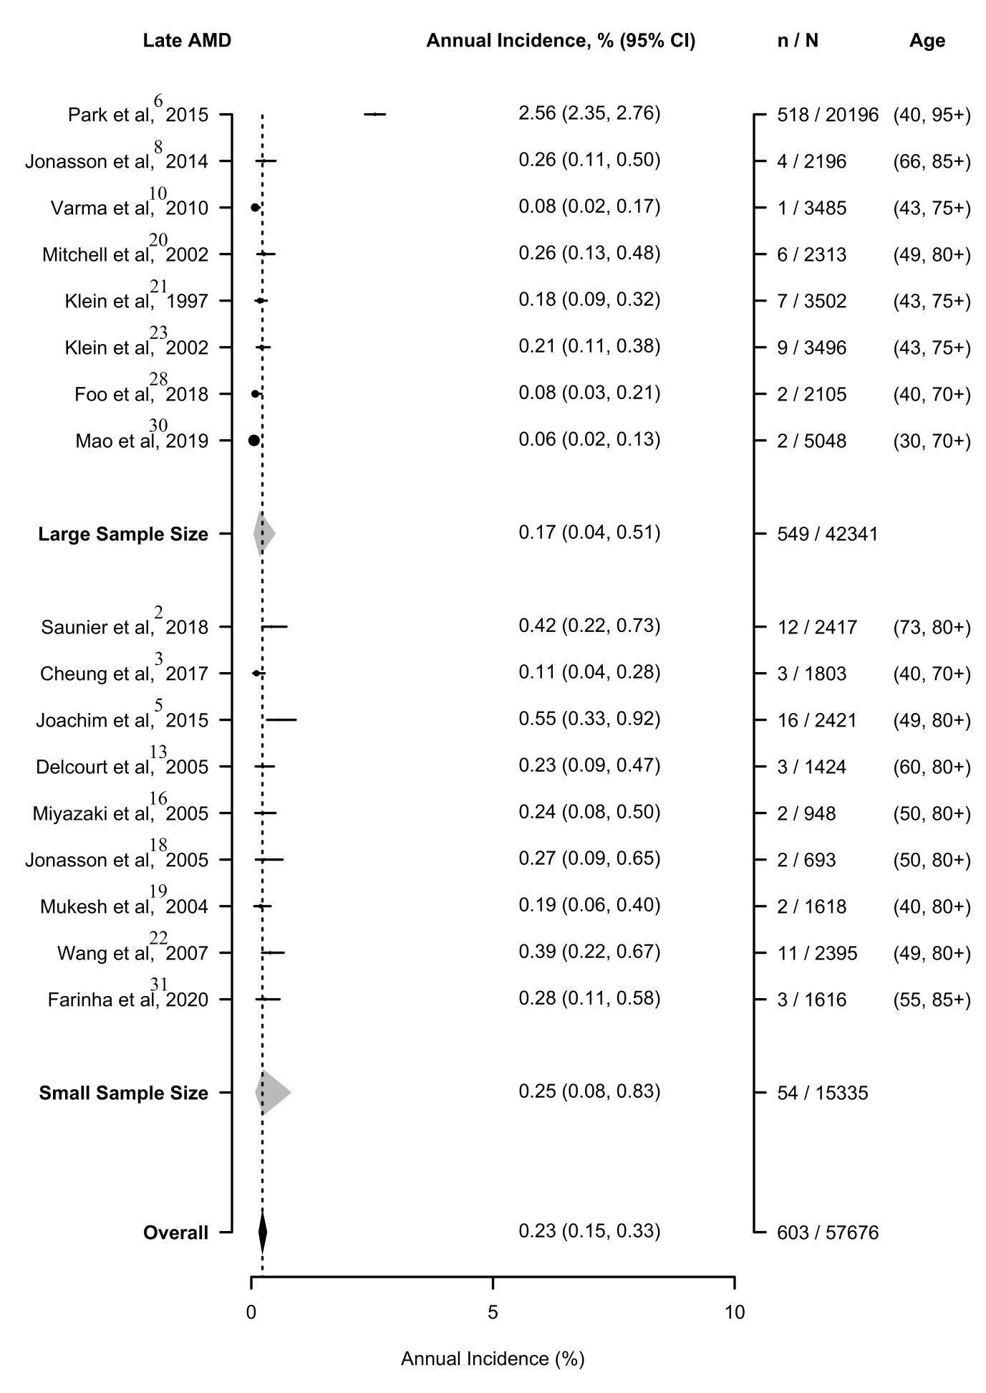
Large sample size≥2000, small sample size ＜2000
Supplementary Figure 4a. Overall age trend of annual incidence of early AMD by country.
Similar to age trend stratified by region, incidence increased with age. Compared to the total trend, the incidence of early AMD in Iceland was the highest when age was over 65 years old.

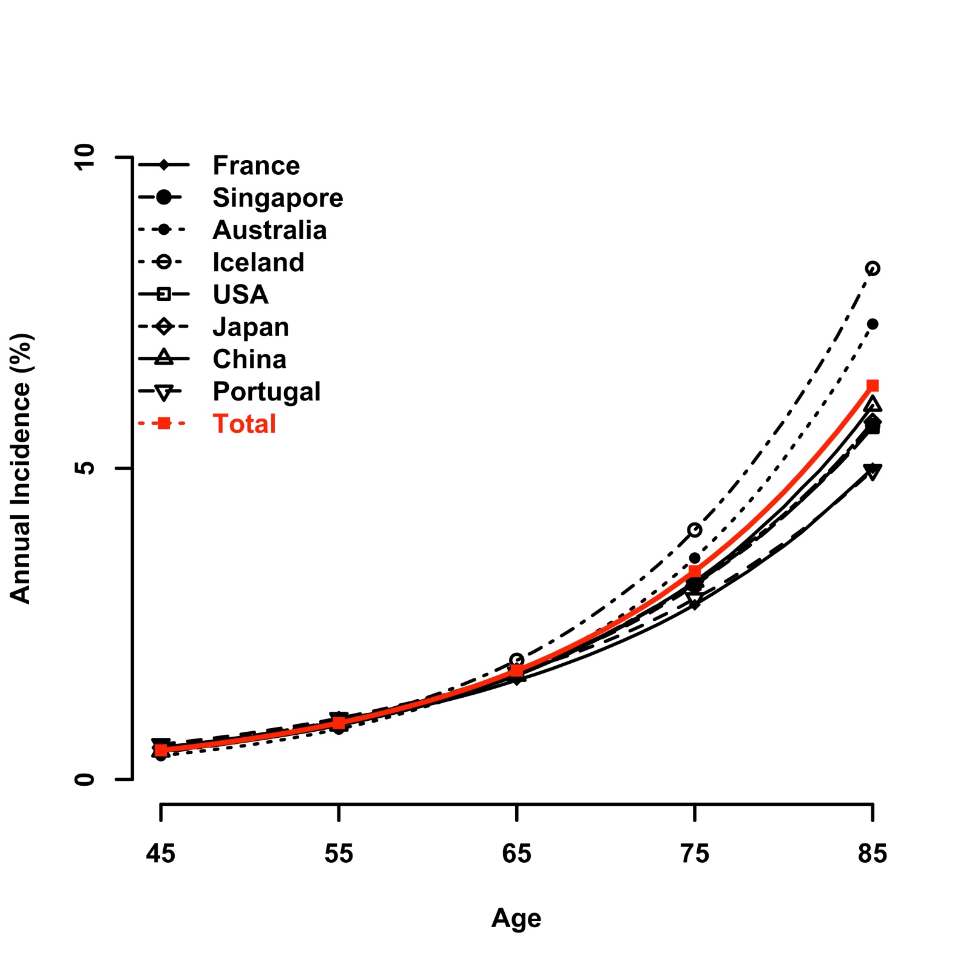
Supplementary Figure 4b. Male-specific age trend of annual incidence of early AMD by country.
For males, Singapore, Australia, the USA, and Japan had similar incidence rates and trends. Iceland had the highest incidence, which increased most rapidly.

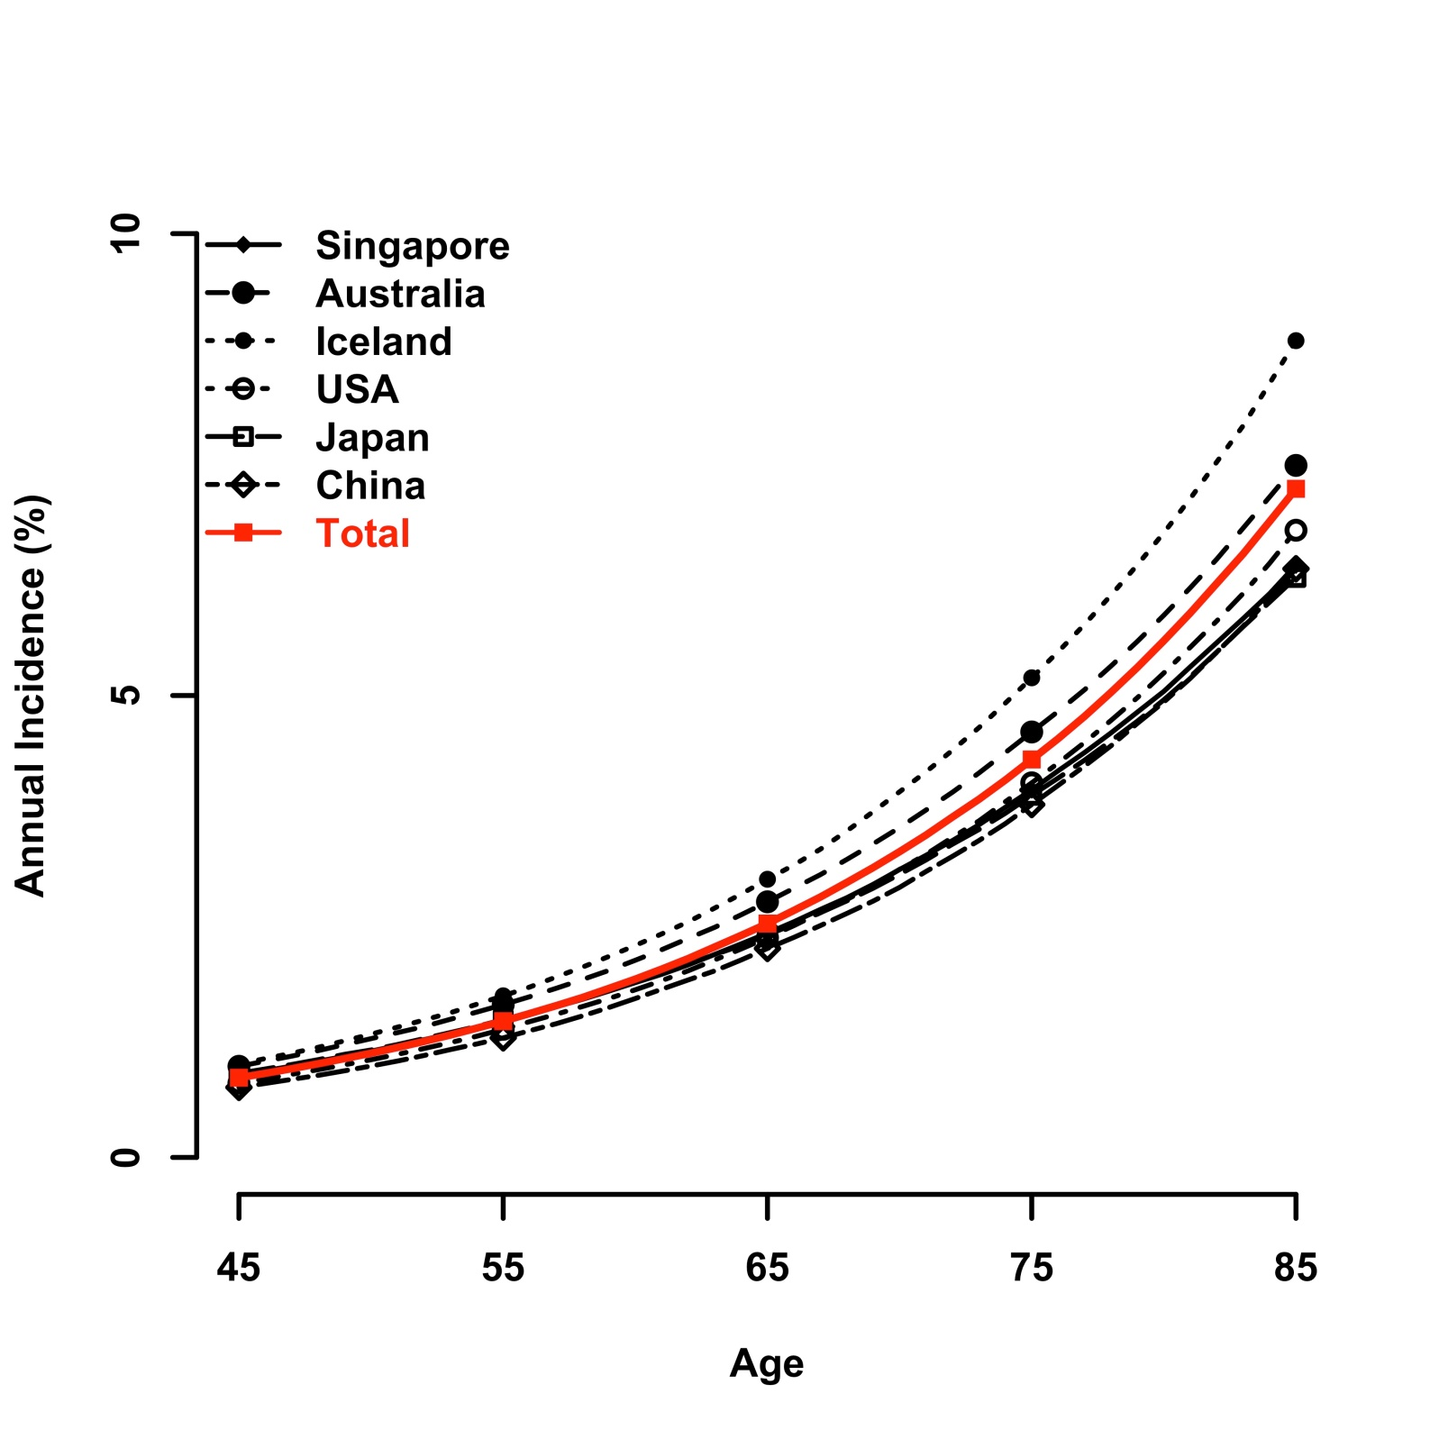
Supplementary Figure 4c. Female-specific age trend of annual incidence of early AMD by country.
For females, the notable increase in Iceland was much higher than in other countries.

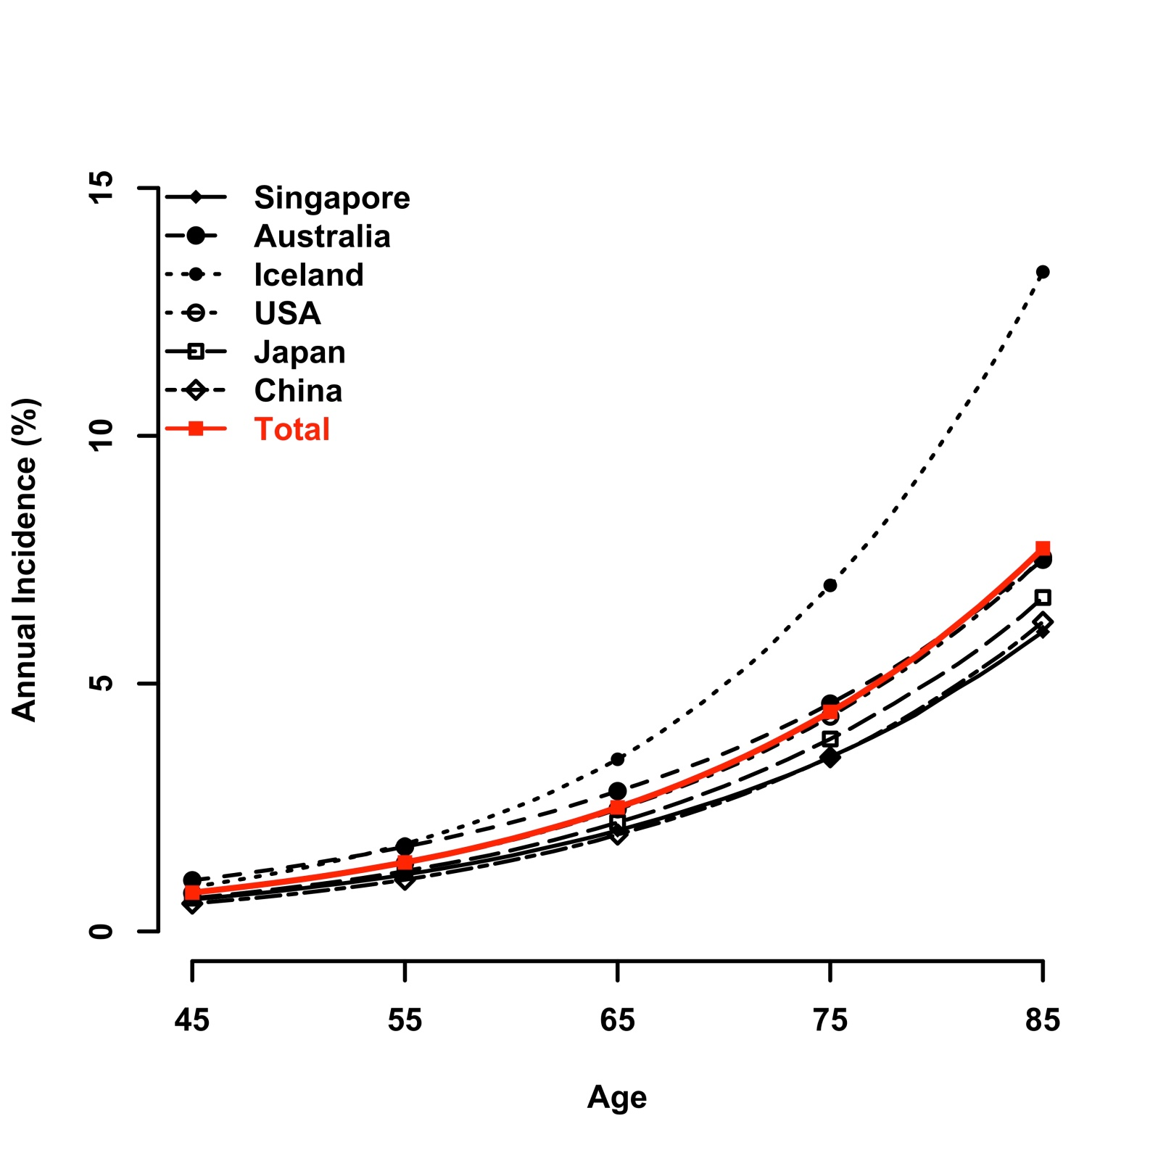
Supplementary Figure 4d. Overall age trend of annual incidence of late AMD by country.
In age trend of annual incidence of late AMD, South Korea had the highest incidence, and incidence increased most rapidly in Australia after age 75 years of age.

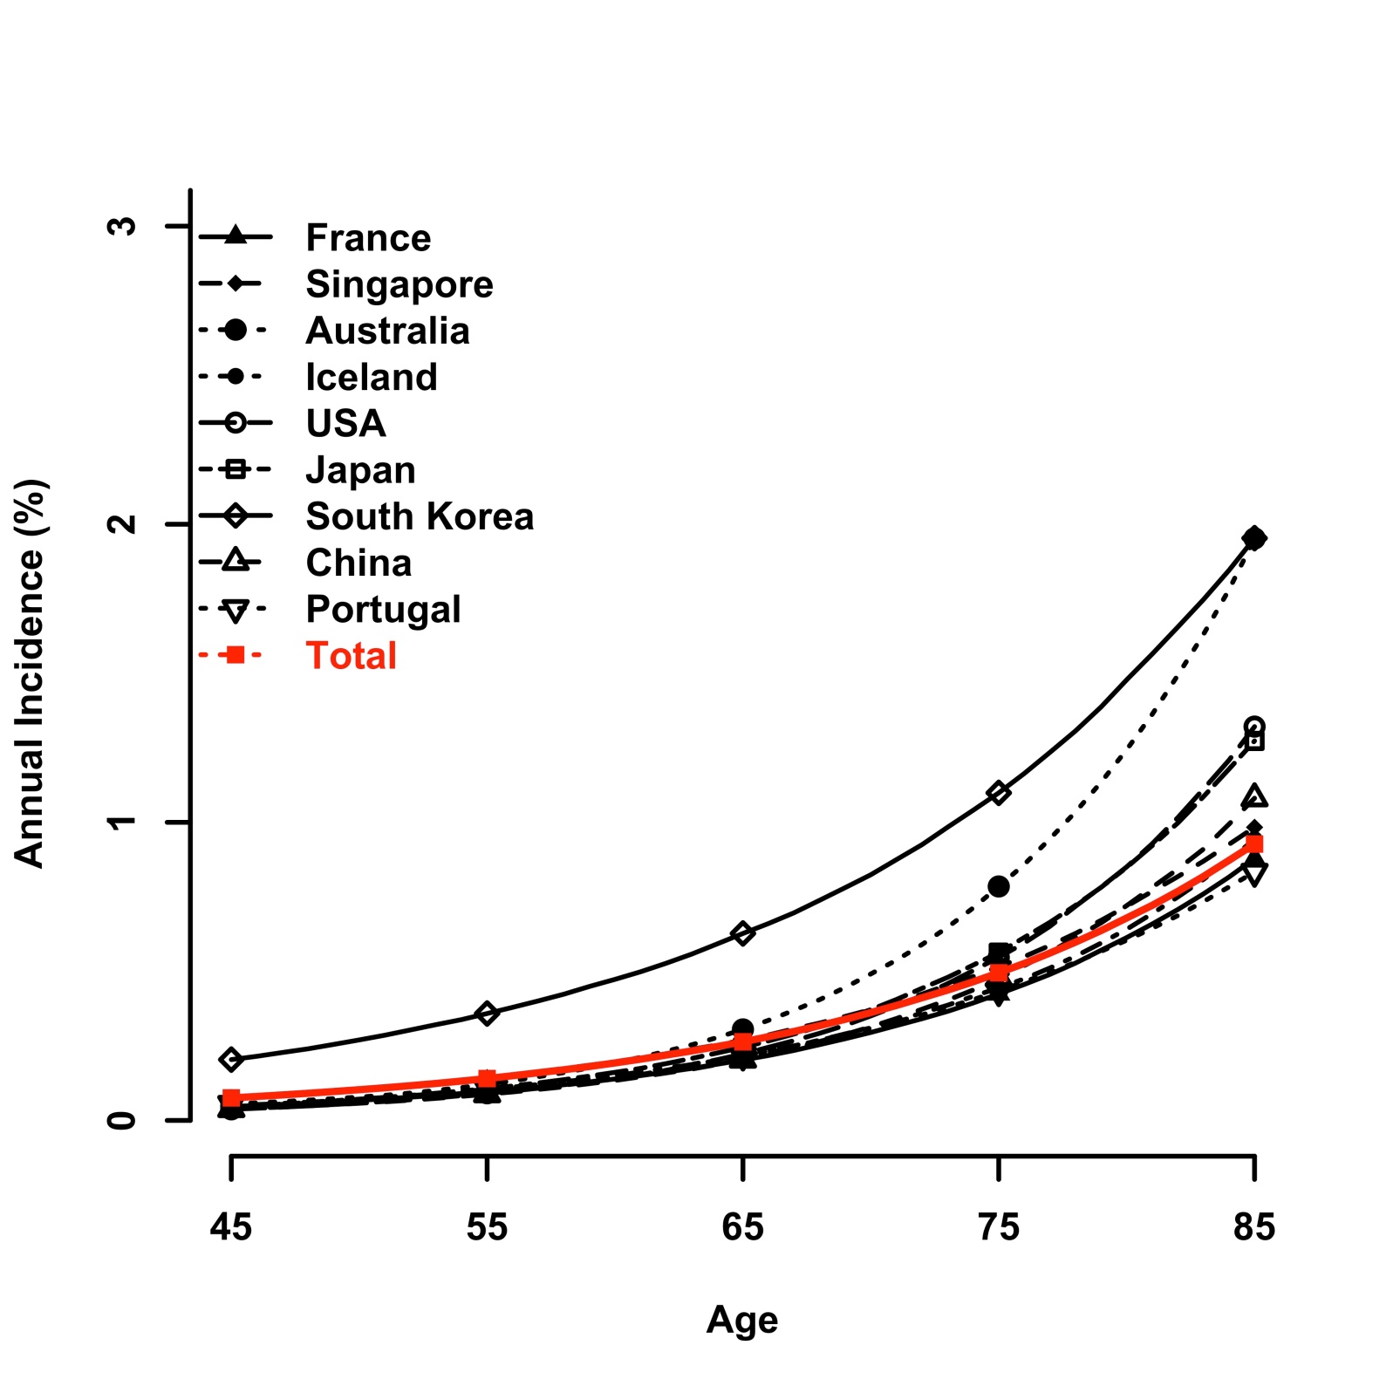
Supplementary Figure 4e. Male-specific age trend of annual incidence of late AMD by country.
For the annual incidence of late AMD in males, South Korea had the highest incidence, and incidence increased most rapidly in Japan after 75 years of age.
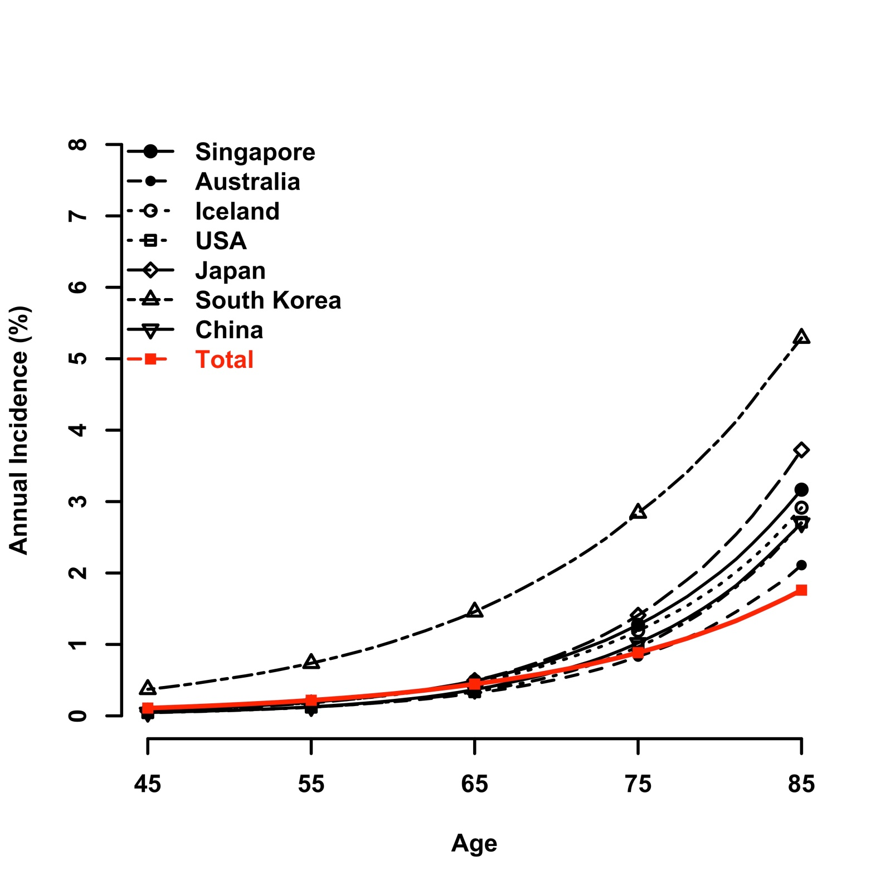

Supplementary Figure 4f. Female-specific age trend of annual incidence of late AMD by country.
For the annual incidence of late AMD in females, incidence in Iceland increased most rapidly after 75 years of age and peaked at 85 years of age. Before the point of intersection, South Korea had higher incidence.

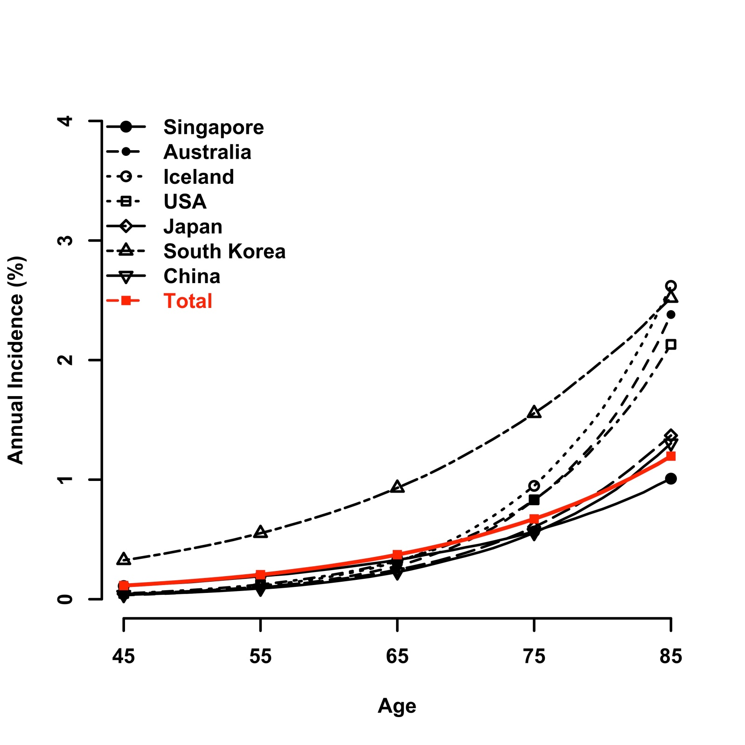
Supplementary Figure 5a. Funnel plot for early AMD meta-analysis
For early AMD meta-analysis, visual inspection of the funnel plot revealed minimal asymmetry. P-value was 0.017, which indicated evidence of minimal publication bias.
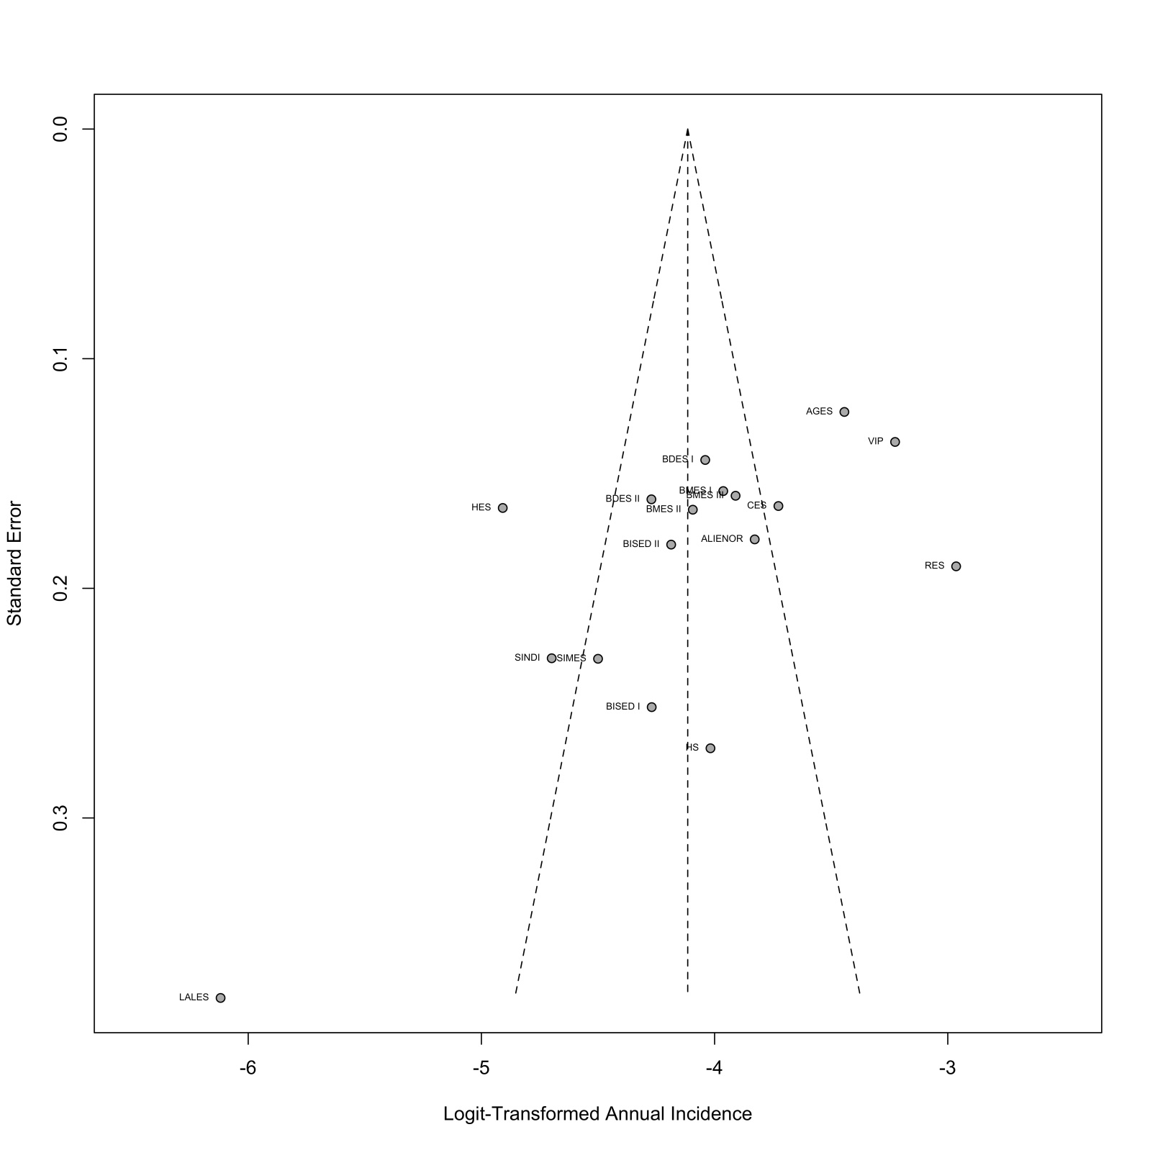
Supplementary Figure 5b: Funnel plot for late AMD meta-analysis
For late AMD meta-analysis, visual inspection of the funnel plot revealed significant asymmetry. P-value was less than 0.0001, which indicated evidence of significant publication bias.
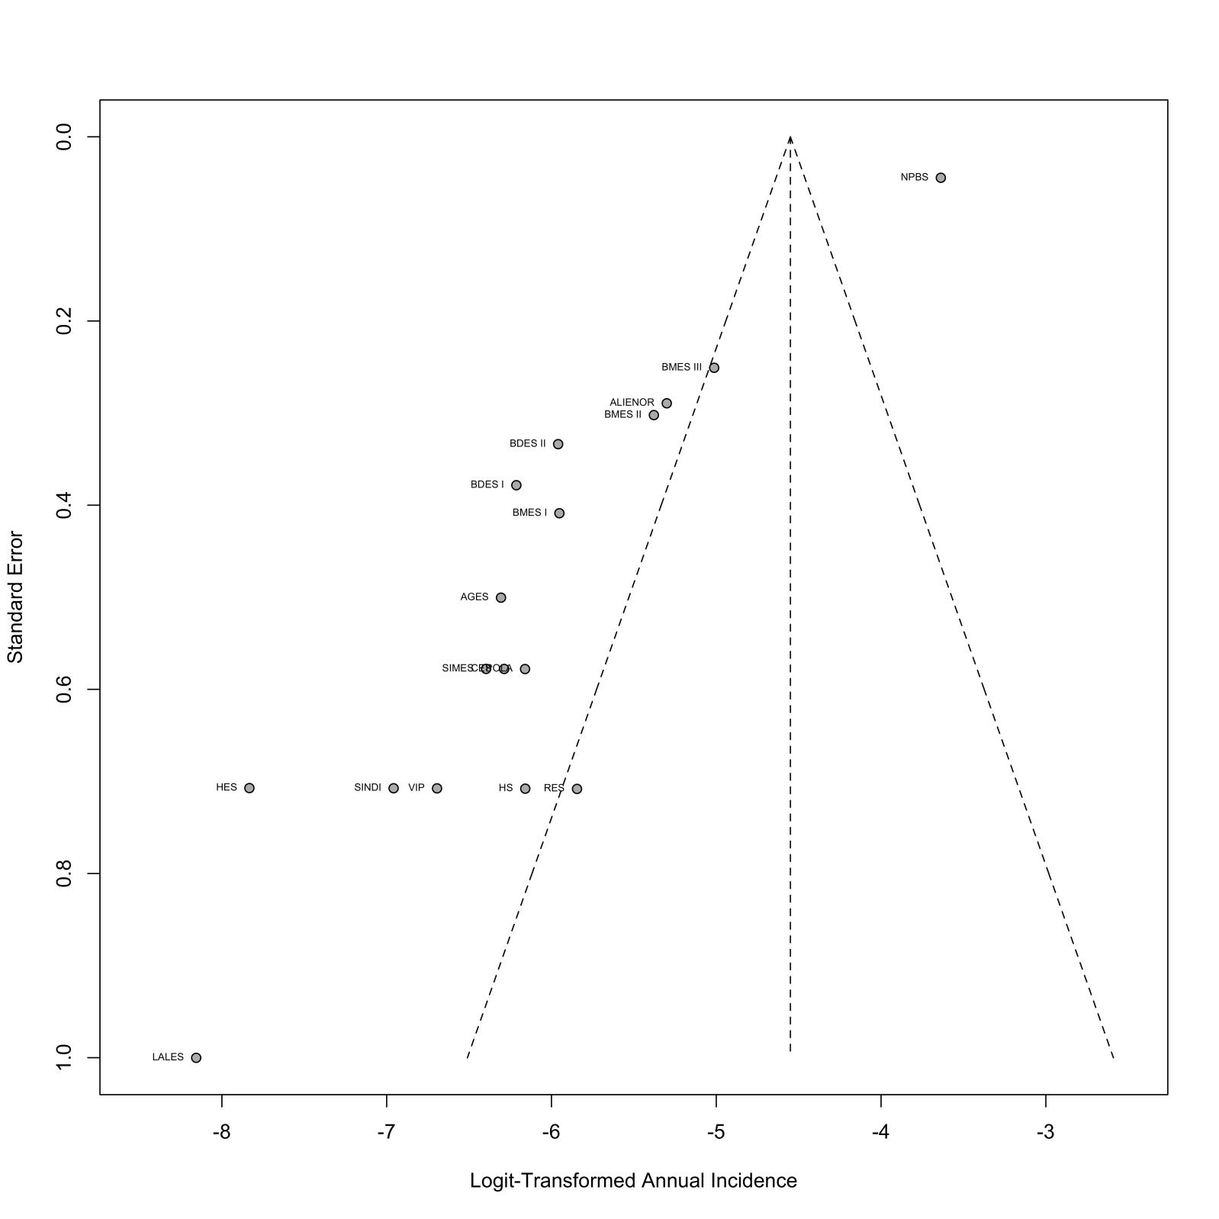

Supplementary References
1. Rotenstein LS, Ramos MA, Torre M, Segal JB, Peluso MJ, Guille C, et al. Prevalence of Depression, Depressive Symptoms, and Suicidal Ideation Among Medical Students: A Systematic Review and Meta-Analysis. JAMA. 2016 Dec 6;316(21):2214-36.
2. Saunier V, Merle BMJ, Delyfer MN, Cougnard-Gregoire A, Rougier MB, Amouyel P, et al. Incidence of and Risk Factors Associated With Age-Related Macular Degeneration: Four-Year Follow-up From the ALIENOR Study. JAMA Ophthalmol. 2018 May 1;136(5):473-81.
3. Cheung CMG, Ong PG, Neelam K, Tan PC, Shi Y, Mitchell P, et al. Six-Year Incidence of Age-Related Macular Degeneration in Asian Malays: The Singapore Malay Eye Study. Ophthalmology. 2017 Sep;124(9):1305-13.
4. Bastawrous A, Mathenge W, Peto T, Shah N, Wing K, Rono H, et al. Six-Year Incidence and Progression of Age-Related Macular Degeneration in Kenya: Nakuru Eye Disease Cohort Study. JAMA Ophthalmol. 2017 Jun 1;135(6):631-8.
5. Joachim N, Mitchell P, Burlutsky G, Kifley A, Wang JJ. The Incidence and Progression of Age-Related Macular Degeneration over 15 Years: The Blue Mountains Eye Study. Ophthalmology. 2015 Dec;122(12):2482-9.
6. Park SJ, Kwon KE, Choi NK, Park KH, Woo SJ. Prevalence and Incidence of Exudative Age-Related Macular Degeneration in South Korea: A Nationwide Population-Based Study. Ophthalmology. 2015 Oct;122(10):2063-70 e1.
7. Chaker L, Buitendijk GH, Dehghan A, Medici M, Hofman A, Vingerling JR, et al. Thyroid function and age-related macular degeneration: a prospective population-based cohort study--the Rotterdam Study. BMC Med. 2015 Apr 23;13:94.
8. Jonasson F, Fisher DE, Eiriksdottir G, Sigurdsson S, Klein R, Launer LJ, et al. Five-year incidence, progression, and risk factors for age-related macular degeneration: the age, gene/environment susceptibility study. Ophthalmology. 2014 Sep;121(9):1766-72.
9. You QS, Xu L, Yang H, Li YB, Wang S, Wang JD, et al. Five-year incidence of age-related macular degeneration: the Beijing Eye Study. Ophthalmology. 2012 Dec;119(12):2519-25.
10. Varma R, Foong AW, Lai MY, Choudhury F, Klein R, Azen SP, et al. Four-year incidence and progression of age-related macular degeneration: the Los Angeles Latino Eye Study. Am J Ophthalmol. 2010 May;149(5):741-51.
11. Yasuda M, Kiyohara Y, Hata Y, Arakawa S, Yonemoto K, Doi Y, et al. Nine-year incidence and risk factors for age-related macular degeneration in a defined Japanese population the Hisayama study. Ophthalmology. 2009 Nov;116(11):2135-40.
12. Klein R, Klein BE, Knudtson MD, Meuer SM, Swift M, Gangnon RE. Fifteen-year cumulative incidence of age-related macular degeneration: the Beaver Dam Eye Study. Ophthalmology. 2007 Feb;114(2):253-62.
13. Delcourt C, Lacroux A, Carriere I, Group PS. The three-year incidence of age-related macular degeneration: the "Pathologies Oculaires Liees a l'Age" (POLA) prospective study. Am J Ophthalmol. 2005 Nov;140(5):924-6.
14. Leske MC, Wu SY, Hennis A, Nemesure B, Yang L, Hyman L, et al. Nine-year incidence of age-related macular degeneration in the Barbados Eye Studies. Ophthalmology. 2006 Jan;113(1):29-35.
15. Buch H, Vinding T, la Cour M, Jensen GB, Prause JU, Nielsen NV. Risk factors for age-related maculopathy in a 14-year follow-up study: the Copenhagen City Eye Study. Acta Ophthalmol Scand. 2005 Aug;83(4):409-18.
16. Miyazaki M, Kiyohara Y, Yoshida A, Iida M, Nose Y, Ishibashi T. The 5-year incidence and risk factors for age-related maculopathy in a general Japanese population: the Hisayama study. Invest Ophthalmol Vis Sci. 2005 Jun;46(6):1907-10.
17. Buch H, Nielsen NV, Vinding T, Jensen GB, Prause JU, la Cour M. 14-year incidence, progression, and visual morbidity of age-related maculopathy: the Copenhagen City Eye Study. Ophthalmology. 2005 May;112(5):787-98.
18. Jonasson F, Arnarsson A, Peto T, Sasaki H, Sasaki K, Bird AC. 5-year incidence of age-related maculopathy in the Reykjavik Eye Study. Ophthalmology. 2005 Jan;112(1):132-8.
19. Mukesh BN, Dimitrov PN, Leikin S, Wang JJ, Mitchell P, McCarty CA, et al. Five-year incidence of age-related maculopathy: the Visual Impairment Project. Ophthalmology. 2004 Jun;111(6):1176-82.
20. Mitchell P, Wang JJ, Foran S, Smith W. Five-year incidence of age-related maculopathy lesions: the Blue Mountains Eye Study. Ophthalmology. 2002 Jun;109(6):1092-7.
21. Klein R, Klein BEK, Jensen SC, Meuer SM. The Five-year Incidence and Progression of Age-related Maculopathy. Ophthalmology. 1997;104(1):7-21.
22. Wang JJ, Rochtchina E, Lee AJ, Chia EM, Smith W, Cumming RG, et al. Ten-year incidence and progression of age-related maculopathy: the blue Mountains Eye Study. Ophthalmology. 2007 Jan;114(1):92-8.
23. Klein R, Klein BE, Tomany SC, Meuer SM, Huang GH. Ten-year incidence and progression of age-related maculopathy: The Beaver Dam eye study. Ophthalmology. 2002 Oct;109(10):1767-79.
24. Klaver CC, Assink JJ, van Leeuwen R, Wolfs RC, Vingerling JR, Stijnen T, et al. Incidence and progression rates of age-related maculopathy: the Rotterdam Study. Invest Ophthalmol Vis Sci. 2001 Sep;42(10):2237-41.
25. Bressler NM, Munoz B, Maguire MG, Vitale SE, Schein OD, Taylor HR, et al. Five-year incidence and disappearance of drusen and retinal pigment epithelial abnormalities. Waterman study. Archives of ophthalmology (Chicago, Ill : 1960). 1995 Mar;113(3):301-8.
26. Chang MA, Bressler SB, Munoz B, West SK. Racial differences and other risk factors for incidence and progression of age-related macular degeneration: Salisbury Eye Evaluation (SEE) Project. Invest Ophthalmol Vis Sci. 2008 Jun;49(6):2395-402.
27. Coleman AL, Seitzman RL, Cummings SR, Yu F, Cauley JA, Ensrud KE, et al. The association of smoking and alcohol use with age-related macular degeneration in the oldest old: the Study of Osteoporotic Fractures. Am J Ophthalmol. 2010 Jan;149(1):160-9.
28. Foo VHX, Yanagi Y, Nguyen QD, Sabanayagam C, Lim SH, Neelam K, et al. Six-Year Incidence and Risk Factors of Age-Related Macular Degeneration in Singaporean Indians: The Singapore Indian Eye Study. Sci Rep. 2018 Jun 11;8(1):8869.
29. Leske MC, Wu SY, Hyman L, Hennis A, Nemesure B, Schachat AP, et al. Four-year incidence of macular changes in the Barbados Eye Studies. Ophthalmology. 2004 Apr;111(4):706-11.
30. Mao F, Yang X, Yang K, Cao X, Cao K, Hao J, et al. Six-Year Incidence and Risk Factors for Age-Related Macular Degeneration in a Rural Chinese Population: The Handan Eye Study. Invest Ophthalmol Vis Sci. 2019 Dec 2;60(15):4966-71.
31. Farinha CVL, Cachulo ML, Alves D, Pires I, Marques JP, Barreto P, et al. Incidence of Age-Related Macular Degeneration in the Central Region of Portugal: The Coimbra Eye Study - Report 5. Ophthalmic Res. 2019;61(4):226-35.

