SUPPLEMENTAL MATERIAL

Tharani Thirugnanachandran¹, MBChB, FRACP, Henry Ma¹,FRACP, PhD, Melissa Mitchell¹, MBBS, Chloe Wong¹, MBBS, Jason Vuong¹, MBBS, Shaloo Singhal¹, MBBS, FRACP, Lee- Anne Slater², FRANZCR, Richard Beare³, PhD, Velandai Srikanth⁴, FRACP, PhD, Thanh Phan¹, FRACP, PhD
¹Stroke & Ageing Research (STAR), Department of Medicine, School of Clinical Sciences at Monash Health, Monash University, Clayton, VIC, ²Monash Health, Diagnostic Imaging, Monash Health, Clayton, Australia, ³Murdoch Children’s Research Institute, Developmental Imaging Group - Neurosciences Research Unit - Southern Clinical School - Monash University, Melbourne, Australia, ⁴Peninsula Clinical School, Central Clinical School, Monash University, Melbourne, Australia.

Supplementary: I) PRISMA flow diagram; II) Histogram of hierarchical partitioning of corticofugal fiber tracts at stroke onset (A) and seven days (B) post stroke (M1 - Blue, PMdv – Green, SMA – Red); III) The M1 fiber tracts (blue) from the SMATT template are mapped to infarct topography of ACA stroke. The 3D figure demonstrates the posterior location of the M1 fiber tracts.

Prof Thanh G Phan
Department of Neurology, Monash Health, 246 Clayton Road, Clayton
Clinical Trials, Imaging and Infomatics (CTI) Division,
Stroke and Aging Research Group, Department of Medicine, Monash University
Victoria, Australia, 3168, Phone: +613 9594 2240, Fax: +613 9594 6241 Email:Thanh.Phan@monash.edu

72 patients with ACA stroke assessed for eligibility

38 patients had MRI scans
47 patients with confirmed ACA stroke

25 excluded:
16 – concomitant infarcts in other arterial territories
9 – no visible vessel occlusion on CTA/MRA

32 patients had suitable CTP scans

Supplementary Figure I – PRISMA flow diagram

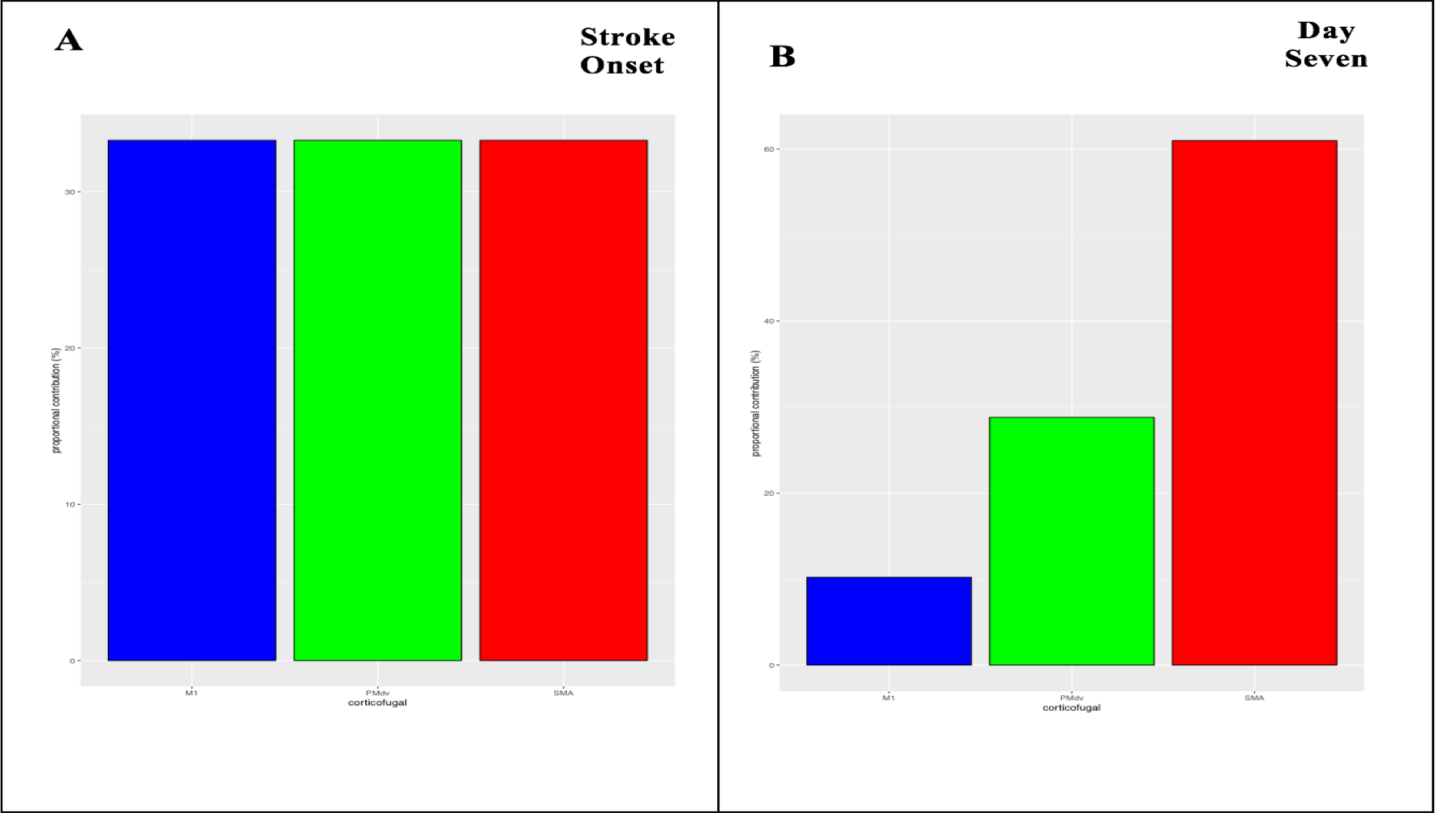
Supplementary Figure II – Hierarchical partitioning of corticofugal fibre tracts at stroke onset (A) and seven days (B) post stroke (M1 - Blue, PMdv – Green, SMA – Red).

M1
PMdv
SMA
M1
PMdv
SMA

Supplementary Figure III) The M1 fiber tracts (blue) from the SMATT template are mapped to infarct topography of ACA stroke. The 3D figure demonstrates the posterior location of the M1 fiber tracts.

