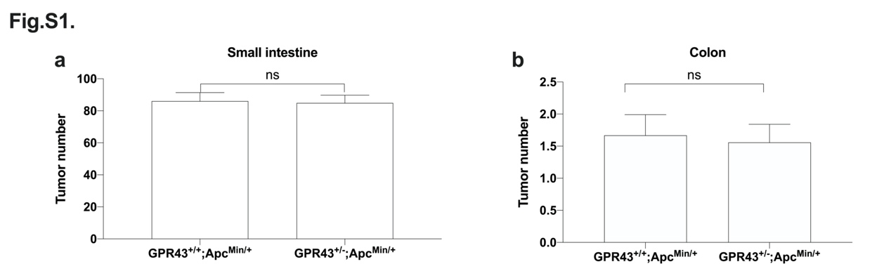Fig. S1. One allele of GPR43 deficiency does not alter the tumor burden in Apc^{Min/+} mice. Total tumor burden in the small intestine (a) and colon (b) at 15 weeks of age. GPR43^{+/+}; Apc^{Min/+}, n=18, GPR43^{+/-}; Apc^{Min/+}, n=16. Statistical analysis was performed using Student’s t-test, ns: no significance.

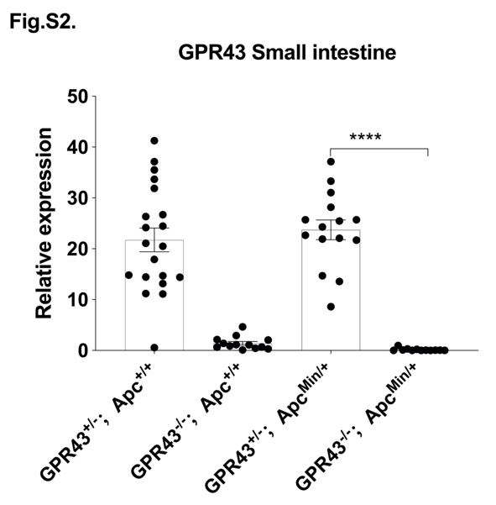
Fig. S2. GPR43 deficiency confirmed in GPR43^{-/-} mice. Intestinal tissues were harvested from GPR43^{+/-}; Apc^{+/+} (n=20), GPR43^{-/-}; Apc^{+/+} (n=13), GPR43^{+/-}; Apc^{Min/+} (n=15) and GPR43^{-/-}; Apc^{Min/+} (n=12). GPR43 expression was analyzed by real-time PCR. Statistical analysis was performed using Student’s t-test, ****p < 0.0001.

