Supplement 1
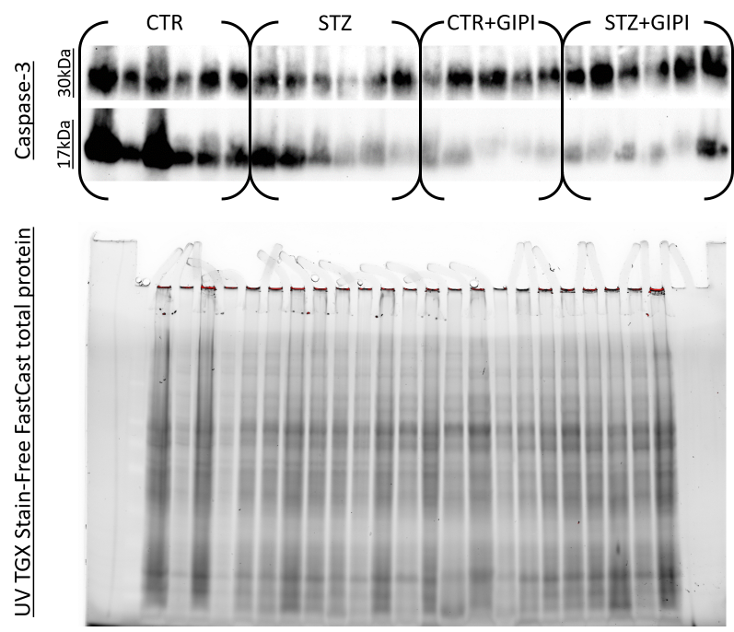
Fig S1-1. Caspase-3 PAGE and Western blot raw data.
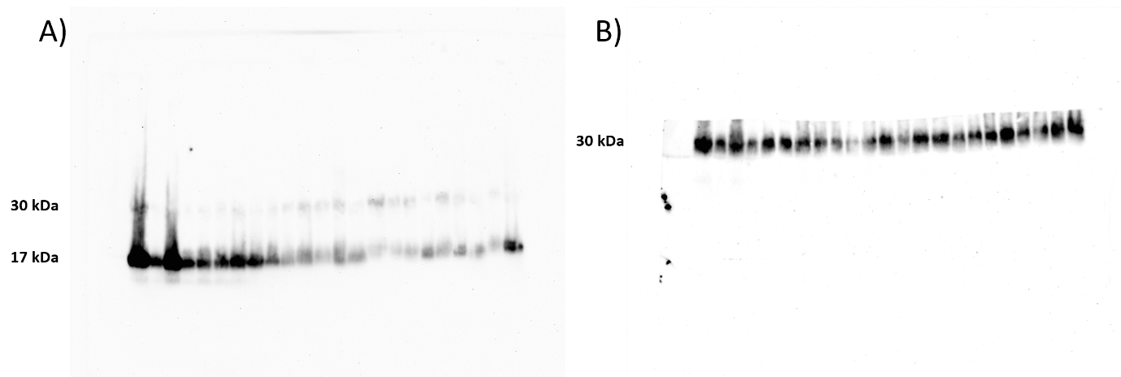
Fig S1-2. Uncropped images of 17 and 30 kDa caspase-3. (A) A strong 17 kDa and weak caspase-3 signal on the same membrane. (B) The lower part of the membrane was covered by a non-transparent PVC membrane. The upper part of the membrane was cut away.

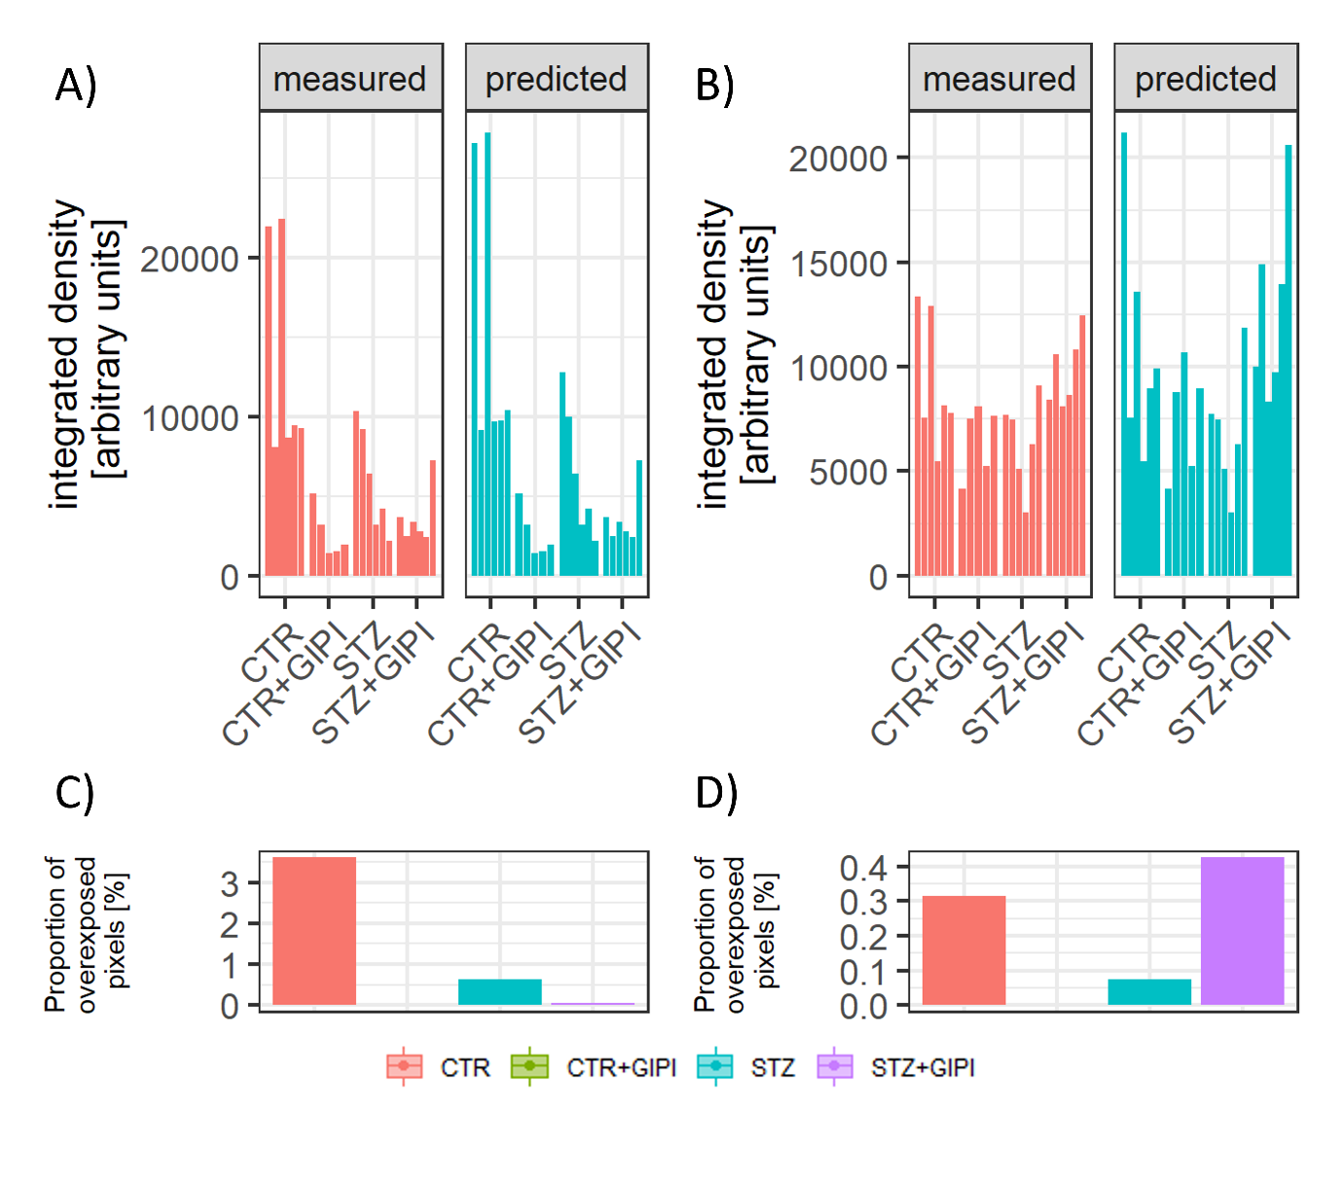
Fig S1-3. Contribution of overexposed pixels to 17 kDa and 30 kDa caspase-3 (CAS-3) estimates. (A) Measured (left) and predicted (right) values based on plot profile-informed estimates of masked integrated density areas for 17 kDa CAS-3 western blots. (B) Measured (left) and predicted (right) values based on plot profile-informed estimates of masked integrated density areas for 30 kDa CAS-3 western blots. (C) The proportion of overexposed pixels by group for 17 kDa CAS-3 western blots. (D) The proportion of overexposed pixels by group for 30 kDa CAS-3 western blots.

As some bands i) demonstrated smearing patterns, ii) overexposure and iii) demonstrated technical artifacts that, based on the proportion and distribution of overexposed pixels could have theoretically affected the results (although subsequent analyses (Fig. S1-3) indicated a dramatic effect was not very likely), we decided to repeat the western blots. Original homogenates were consumed so adjacent pieces of the duodenum were homogenized and analyzed by western blot using the same procedure. Three additional pieces of the duodenum were homogenized per animal so a total of 4 bands were obtained for each animal (including the overexposed membrane shown in Fig S1-1. and Fig S1-2.). Considering homogenates represented hierarchical biological data due to dependence of data obtained from the analyses of neighboring cells hierarchical models were used for the analyses in a similar way as described for the hierarchical data obtained by immunofluorescence. Group comparisons were based on all data points (4 independent western blot runs (i.e. 4 independent western blot membranes) with 4 (dependent due to isolation from neighboring tissue) sets of 23 homogenates (n_{CTR}: 6; n_{STZ}: 6; n_{CTRGIPI}: 5; n_{STZGIPI}: 6). The membrane from which the signal was obtained was included in the model to control for the potential effect of the membrane that contained several potential sources of systemic variation that could have affected overall accuracy to maintain analytical precision. Raw signal from additional gels and membranes is shown in Fig. S1-4.
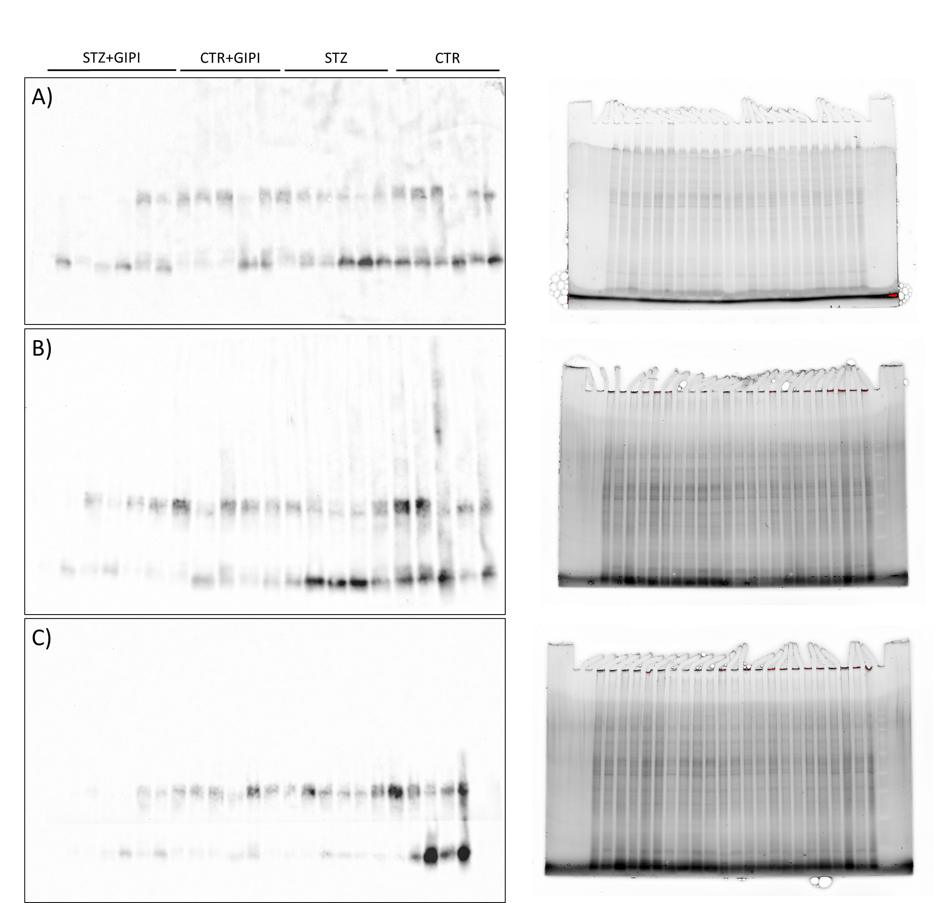
Fig S1-4. Additional replicates of western blots from homogenates of adjacent duodenal tissue. (A) Additional membrane and gel 1. (B) Additional membrane and gel 2. (C) Additional membrane and gel 3. A horizontal line artifact is a PVC membrane that was used to spread chemiluminescent reagent evenly across the membrane.

