Supplement 2
Table 1. The main effects linear-mixed model for nuclear CAS-3 signal intensity
contrast | ratio | SE | df | lower.CL | upper.CL | null | t.ratio | p.value
CTR / STZ | 2.3690 | 0.6900 | 10.9873 | 1.2477 | 4.4977 | 1 | 2.9612 | 0.0130
GIPI / SAL | 1.1466 | 0.3306 | 10.9951 | 0.6079 | 2.1628 | 1 | 0.4745 | 0.6444

Table 2. Interaction linear-mixed model for nuclear CAS-3 signal intensity
contrast | ratio | SE | df | lower.CL | upper.CL | null | t.ratio | p.value
CTR GIPI / STZ GIPI | 3.2142 | 1.3200 | 10.0559 | 0.9162 | 11.2763 | 1 | 2.8432 | 0.0701
CTR GIPI / CTR SAL | 1.6226 | 0.7108 | 9.9672 | 0.4245 | 6.2024 | 1 | 1.1049 | 0.6948
CTR GIPI / STZ SAL | 2.8388 | 1.1667 | 10.0857 | 0.8089 | 9.9624 | 1 | 2.5388 | 0.1127
STZ GIPI / CTR SAL | 0.5048 | 0.2065 | 9.8893 | 0.1441 | 1.7686 | 1 | -1.6714 | 0.3865
STZ GIPI / STZ SAL | 0.8832 | 0.3355 | 10.0141 | 0.2764 | 2.8226 | 1 | -0.3269 | 0.9872
CTR SAL / STZ SAL | 1.7496 | 0.7161 | 9.9188 | 0.4992 | 6.1317 | 1 | 1.3667 | 0.5456

Table 3. CAS-3 17 kDa main effects model
contrast | ratio | SE | df | lower.CL | upper.CL | null | t.ratio | p.value | p_pretty
CTR / STZ | 1.6385 | 0.3316 | 20 | 1.0743 | 2.4992 | 1 | 2.4399 | 0.0241 | 0.0241
GIPI / SAL | 0.3024 | 0.0612 | 20 | 0.1982 | 0.4612 | 1 | -5.9103 | 0.0000 | 0.0000

Table 4. CAS-3 17 kDa interaction model
contrast | ratio | SE | df | lower.CL | upper.CL | null | t.ratio | p.value | p_pretty
CTR GIPI / STZ GIPI | 1.0965 | 0.2990 | 19 | 0.5094 | 2.3602 | 1 | 0.3379 | 0.9863 | 0.9863
CTR GIPI / CTR SAL | 0.2023 | 0.0552 | 19 | 0.0940 | 0.4355 | 1 | -5.8606 | 0.0001 | 0.0001
CTR GIPI / STZ SAL | 0.4777 | 0.1302 | 19 | 0.2219 | 1.0281 | 1 | -2.7101 | 0.0613 | 0.0613
STZ GIPI / CTR SAL | 0.1845 | 0.0480 | 19 | 0.0888 | 0.3833 | 1 | -6.5011 | 0.0000 | 0.0000
STZ GIPI / STZ SAL | 0.4356 | 0.1132 | 19 | 0.2097 | 0.9048 | 1 | -3.1968 | 0.0225 | 0.0225
CTR SAL / STZ SAL | 2.3607 | 0.6137 | 19 | 1.1366 | 4.9032 | 1 | 3.3043 | 0.0179 | 0.0179

Table 5. CAS-3 30 kDa main effects model
contrast | ratio | SE | df | lower.CL | upper.CL | null | t.ratio | p.value
CTR / STZ | 1.4810 | 0.2827 | 20 | 0.9946 | 2.2053 | 1 | 2.0577 | 0.0529
GIPI / SAL | 1.0644 | 0.2032 | 20 | 0.7148 | 1.5849 | 1 | 0.3268 | 0.7472

Table 6. CAS-3 30 kDa interaction model
contrast | ratio | SE | df | lower.CL | upper.CL | null | t.ratio | p.value
CTR GIPI / STZ GIPI | 1.0679 | 0.2821 | 19 | 0.5081 | 2.2446 | 1 | 0.2488 | 0.9944
CTR GIPI / CTR SAL | 0.7675 | 0.2027 | 19 | 0.3652 | 1.6131 | 1 | -1.0018 | 0.7502
CTR GIPI / STZ SAL | 1.5302 | 0.4042 | 19 | 0.7280 | 3.2162 | 1 | 1.6103 | 0.3967
STZ GIPI / CTR SAL | 0.7187 | 0.1810 | 19 | 0.3539 | 1.4592 | 1 | -1.3116 | 0.5670
STZ GIPI / STZ SAL | 1.4328 | 0.3609 | 19 | 0.7057 | 2.9092 | 1 | 1.4279 | 0.4982
CTR SAL / STZ SAL | 1.9938 | 0.5022 | 19 | 0.9819 | 4.0482 | 1 | 2.7395 | 0.0578

Table 7. CAS-3 17/30 kDa main effects model
contrast | ratio | SE | df | lower.CL | upper.CL | null | t.ratio | p.value
CTR / STZ | 1.1063 | 0.2397 | 20 | 0.7040 | 1.7385 | 1 | 0.4664 | 0.646
GIPI / SAL | 0.2841 | 0.0616 | 20 | 0.1808 | 0.4464 | 1 | -5.8084 | 0.000

Table 8. CAS-3 17/30 kDa interaction model
contrast | ratio | SE | df | lower.CL | upper.CL | null | t.ratio | p.value
CTR GIPI / STZ GIPI | 1.0268 | 0.3299 | 19 | 0.4160 | 2.5340 | 1 | 0.0822 | 0.9998
CTR GIPI / CTR SAL | 0.2636 | 0.0847 | 19 | 0.1068 | 0.6506 | 1 | -4.1496 | 0.0028
CTR GIPI / STZ SAL | 0.3122 | 0.1003 | 19 | 0.1265 | 0.7704 | 1 | -3.6238 | 0.0090
STZ GIPI / CTR SAL | 0.2568 | 0.0787 | 19 | 0.1085 | 0.6076 | 1 | -4.4384 | 0.0015
STZ GIPI / STZ SAL | 0.3040 | 0.0931 | 19 | 0.1285 | 0.7194 | 1 | -3.8869 | 0.0050
CTR SAL / STZ SAL | 1.1840 | 0.3627 | 19 | 0.5004 | 2.8018 | 1 | 0.5514 | 0.9450

Table 9. VL/CD main effects linear-mixed model
contrast | ratio | SE | df | lower.CL | upper.CL | null | t.ratio | p.value
CTR / STZ | 2.8260 | 0.8564 | 11.0118 | 1.4507 | 5.5054 | 1 | 3.4284 | 0.0056
GIPI / SAL | 0.5261 | 0.1577 | 11.0002 | 0.2720 | 1.0179 | 1 | -2.1420 | 0.0554

Table 10. VL/CD interaction linear-mixed model
contrast | ratio | SE | df | lower.CL | upper.CL | null | t.ratio | p.value
CTR GIPI / STZ GIPI | 4.8272 | 1.8308 | 9.7579 | 1.5049 | 15.4839 | 1 | 4.1508 | 0.0094
CTR GIPI / CTR SAL | 0.9793 | 0.4003 | 10.0781 | 0.2809 | 3.4139 | 1 | -0.0512 | 0.9999
CTR GIPI / STZ SAL | 1.6015 | 0.6124 | 10.0701 | 0.4979 | 5.1514 | 1 | 1.2316 | 0.6223
STZ GIPI / CTR SAL | 0.2029 | 0.0774 | 9.9712 | 0.0631 | 0.6519 | 1 | -4.1830 | 0.0086
STZ GIPI / STZ SAL | 0.3318 | 0.1171 | 9.9442 | 0.1126 | 0.9777 | 1 | -3.1262 | 0.0452
CTR SAL / STZ SAL | 1.6353 | 0.6287 | 10.2863 | 0.5074 | 5.2703 | 1 | 1.2794 | 0.5945

Table 11. VL main effects linear-mixed model
contrast | ratio | SE | df | lower.CL | upper.CL | null | t.ratio | p.value
CTR / STZ | 1.9311 | 0.3218 | 11.0142 | 1.3383 | 2.7864 | 1 | 3.9495 | 0.0023
GIPI / SAL | 0.6682 | 0.1101 | 10.9997 | 0.4649 | 0.9604 | 1 | -2.4460 | 0.0325

Table 12. VL interaction linear-mixed model
contrast | ratio | SE | df | lower.CL | upper.CL | null | t.ratio | p.value
CTR GIPI / STZ GIPI | 2.4781 | 0.5440 | 9.7047 | 1.2613 | 4.8688 | 1 | 4.1337 | 0.0097
CTR GIPI / CTR SAL | 0.8936 | 0.2118 | 10.0988 | 0.4332 | 1.8431 | 1 | -0.4745 | 0.9630
CTR GIPI / STZ SAL | 1.3349 | 0.2960 | 10.0851 | 0.6781 | 2.6280 | 1 | 1.3026 | 0.5815
STZ GIPI / CTR SAL | 0.3606 | 0.0797 | 9.9664 | 0.1833 | 0.7094 | 1 | -4.6148 | 0.0045
STZ GIPI / STZ SAL | 0.5387 | 0.1102 | 9.9285 | 0.2879 | 1.0079 | 1 | -3.0247 | 0.0532
CTR SAL / STZ SAL | 1.4938 | 0.3335 | 10.3511 | 0.7578 | 2.9450 | 1 | 1.7980 | 0.3272

Table 13. CD main effects linear-mixed model
contrast | ratio | SE | df | lower.CL | upper.CL | null | t.ratio | p.value
CTR / STZ | 0.6816 | 0.1061 | 11.0152 | 0.4838 | 0.9601 | 1 | -2.4620 | 0.0315
GIPI / SAL | 1.2676 | 0.1953 | 10.9994 | 0.9031 | 1.7793 | 1 | 1.5394 | 0.1520

Table 14. CD interaction linear-mixed model
contrast | ratio | SE | df | lower.CL | upper.CL | null | t.ratio | p.value
CTR GIPI / STZ GIPI | 0.5149 | 0.0993 | 9.6277 | 0.2842 | 0.9328 | 1 | -3.4415 | 0.0285
CTR GIPI / CTR SAL | 0.9130 | 0.1907 | 10.1314 | 0.4826 | 1.7272 | 1 | -0.4358 | 0.9709
CTR GIPI / STZ SAL | 0.8319 | 0.1625 | 10.1065 | 0.4581 | 1.5106 | 1 | -0.9422 | 0.7836
STZ GIPI / CTR SAL | 1.7733 | 0.3450 | 9.9605 | 0.9774 | 3.2172 | 1 | 2.9440 | 0.0602
STZ GIPI / STZ SAL | 1.6157 | 0.2908 | 9.9034 | 0.9306 | 2.8051 | 1 | 2.6652 | 0.0936
CTR SAL / STZ SAL | 0.9111 | 0.1795 | 10.4462 | 0.5010 | 1.6572 | 1 | -0.4723 | 0.9636

Table 15. ECH/ECW main effects linear-mixed model
contrast | ratio | SE | df | lower.CL | upper.CL | null | t.ratio | p.value
CTR / STZ | 1.4711 | 0.2041 | 11.0076 | 1.0841 | 1.9963 | 1 | 2.7828 | 0.0178
GIPI / SAL | 0.6467 | 0.0888 | 10.9962 | 0.4781 | 0.8748 | 1 | -3.1755 | 0.0088

Table 16. ECH/ECW interaction linear-mixed model
contrast | ratio | SE | df | lower.CL | upper.CL | null | t.ratio | p.value
CTR GIPI / STZ GIPI | 1.0176 | 0.1180 | 9.4844 | 0.7111 | 1.4562 | 1 | 0.1506 | 0.9987
CTR GIPI / CTR SAL | 0.4198 | 0.0529 | 10.1412 | 0.2858 | 0.6166 | 1 | -6.8891 | 0.0002
CTR GIPI / STZ SAL | 0.9069 | 0.1058 | 9.7575 | 0.6336 | 1.2981 | 1 | -0.8373 | 0.8357
STZ GIPI / CTR SAL | 0.4125 | 0.0488 | 10.2636 | 0.2877 | 0.5915 | 1 | -7.4811 | 0.0001
STZ GIPI / STZ SAL | 0.8912 | 0.0966 | 9.8352 | 0.6390 | 1.2429 | 1 | -1.0625 | 0.7187
CTR SAL / STZ SAL | 2.1604 | 0.2572 | 10.5473 | 1.5060 | 3.0991 | 1 | 6.4700 | 0.0003

Table 17. ECH main effects linar-mixed model
contrast | ratio | SE | df | lower.CL | upper.CL | null | t.ratio | p.value
CTR / STZ | 1.2983 | 0.1436 | 11.0051 | 1.0178 | 1.6561 | 1 | 2.3604 | 0.0378
GIPI / SAL | 0.7729 | 0.0846 | 10.9996 | 0.6074 | 0.9834 | 1 | -2.3541 | 0.0382

Table 18. ECH interaction linear-mixed model
contrast | ratio | SE | df | lower.CL | upper.CL | null | t.ratio | p.value
CTR GIPI / STZ GIPI | 0.9714 | 0.0959 | 9.8089 | 0.7174 | 1.3154 | 1 | -0.2937 | 0.9906
CTR GIPI / CTR SAL | 0.5536 | 0.0588 | 10.0561 | 0.4001 | 0.7658 | 1 | -5.5688 | 0.0011
CTR GIPI / STZ SAL | 0.9634 | 0.0953 | 9.9032 | 0.7114 | 1.3048 | 1 | -0.3763 | 0.9808
STZ GIPI / CTR SAL | 0.5698 | 0.0567 | 10.1199 | 0.4206 | 0.7721 | 1 | -5.6514 | 0.0010
STZ GIPI / STZ SAL | 0.9918 | 0.0910 | 9.9518 | 0.7489 | 1.3135 | 1 | -0.0898 | 0.9997
CTR SAL / STZ SAL | 1.7405 | 0.1736 | 10.2157 | 1.2843 | 2.3587 | 1 | 5.5563 | 0.0011

Table 19. ECW main effects linear-mixed model
contrast | ratio | SE | df | lower.CL | upper.CL | null | t.ratio | p.value
CTR / STZ | 0.8791 | 0.0507 | 10.9588 | 0.7742 | 0.9981 | 1 | -2.2355 | 0.0472
GIPI / SAL | 1.1954 | 0.0682 | 10.9407 | 1.0543 | 1.3553 | 1 | 3.1300 | 0.0096

Table 20. ECW interaction linear-mixed model
contrast | ratio | SE | df | lower.CL | upper.CL | null | t.ratio | p.value
CTR GIPI / STZ GIPI | 0.9549 | 0.0713 | 9.2179 | 0.7572 | 1.2041 | 1 | -0.6188 | 0.9235
CTR GIPI / CTR SAL | 1.3210 | 0.1080 | 10.2036 | 1.0296 | 1.6948 | 1 | 3.4057 | 0.0281
CTR GIPI / STZ SAL | 1.0607 | 0.0799 | 9.6528 | 0.8411 | 1.3378 | 1 | 0.7824 | 0.8607
STZ GIPI / CTR SAL | 1.3834 | 0.1064 | 10.3352 | 1.0949 | 1.7480 | 1 | 4.2202 | 0.0075
STZ GIPI / STZ SAL | 1.1109 | 0.0779 | 9.7144 | 0.8955 | 1.3781 | 1 | 1.5004 | 0.4732
CTR SAL / STZ SAL | 0.8030 | 0.0623 | 10.7952 | 0.6353 | 1.0149 | 1 | -2.8281 | 0.0684

Table 21. Duodenum TBARS main effects linear model
contrast | estimate | SE | df | lower.CL | upper.CL | t.ratio | p.value
CTR - STZ | 0.9092 | 0.6611 | 20 | -0.4699 | 2.2883 | 1.3752 | 0.1843
GIPI - SAL | 2.0368 | 0.6611 | 20 | 0.6577 | 3.4160 | 3.0808 | 0.0059

Table 22. Duodenum TBARS interaction model
contrast | estimate | SE | df | lower.CL | upper.CL | t.ratio | p.value
CTR GIPI - STZ GIPI | 2.8766 | 0.7598 | 19 | 0.7400 | 5.0131 | 3.7858 | 0.0063
CTR GIPI - CTR SAL | 4.0042 | 0.7598 | 19 | 1.8677 | 6.1408 | 5.2698 | 0.0002
CTR GIPI - STZ SAL | 3.1249 | 0.7598 | 19 | 0.9884 | 5.2614 | 4.1126 | 0.0030
STZ GIPI - CTR SAL | 1.1276 | 0.7245 | 19 | -0.9095 | 3.1648 | 1.5565 | 0.4256
STZ GIPI - STZ SAL | 0.2483 | 0.7245 | 19 | -1.7888 | 2.2855 | 0.3428 | 0.9857
CTR SAL - STZ SAL | -0.8793 | 0.7245 | 19 | -2.9164 | 1.1578 | -1.2137 | 0.6260

Table 23. Plasma TBARS main effects model
contrast | estimate | SE | df | lower.CL | upper.CL | t.ratio | p.value
CTR - STZ | 6.4993 | 1.261 | 35 | 3.9393 | 9.0593 | 5.1540 | 0
GIPI - SAL | -12.8592 | 1.261 | 35 | -15.4192 | -10.2992 | -10.1975 | 0

Table 24. Plasma TBARS interaction model
contrast | estimate | SE | df | lower.CL | upper.CL | t.ratio | p.value
CTR GIPI - STZ GIPI | 5.4609 | 1.8489 | 34 | 0.4673 | 10.4546 | 2.9536 | 0.0276
CTR GIPI - CTR SAL | -13.8975 | 1.8489 | 34 | -18.8911 | -8.9039 | -7.5165 | 0.0000
CTR GIPI - STZ SAL | -6.4753 | 1.8489 | 34 | -11.4689 | -1.4816 | -3.5022 | 0.0069
STZ GIPI - CTR SAL | -19.3584 | 1.7432 | 34 | -24.0665 | -14.6504 | -11.1051 | 0.0000
STZ GIPI - STZ SAL | -11.9362 | 1.7432 | 34 | -16.6442 | -7.2282 | -6.8473 | 0.0000
CTR SAL - STZ SAL | 7.4222 | 1.7432 | 34 | 2.7142 | 12.1303 | 4.2578 | 0.0008

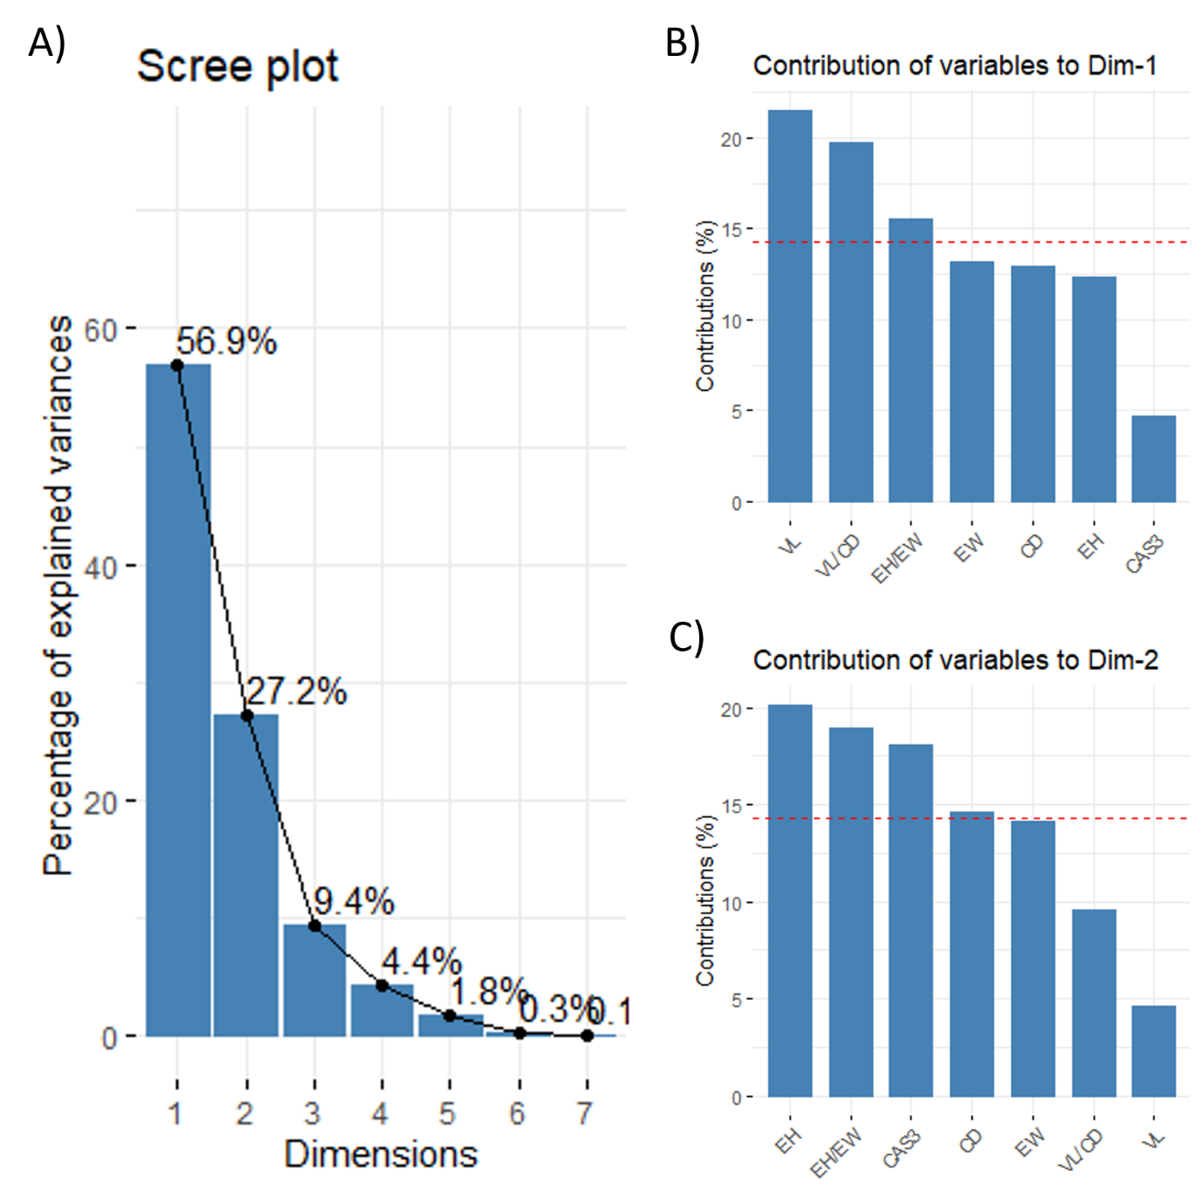
Fig S2-1. Principal component analysis (A) scree plot, and the contribution of individual variables to the (B) first and (C) second principal component. Dim 1 –1st dimension; Dim 2 – 2nd dimension; CTR – control animals; STZ – animals treated intracerebroventricularly with streptozotocin; CTR + GIPI – the control animals treated acutely with intracerebroventricular [Pro³]-GIP; STZ + GIPI – STZ animals treated acutely with intracerebroventricular [Pro³]-GIP. EH – epithelial cell height; EW – epithelial cell width; CD – crypt depth; VL – villus length; VL/CD – the ratio of villus length and adjacent crypt depth; CAS3 – intesnity of nuclear caspase-3 signal corresponding to activated caspase.

Table 25. Western blot replication CAS-3 17 kDa.
contrast | estimate | SE | df | lower.CL | upper.CL | t.ratio | p.value | p.pretty
CTR - (CTR+GIPI) | 0.6445 | 0.0988 | 23.4297 | 0.4403 | 0.8487 | 6.5224 | 0.0000 | 0.000
CTR - STZ | 0.4409 | 0.0932 | 79.0857 | 0.2554 | 0.6265 | 4.7303 | 0.0000 | 0.000
CTR - (STZ+GIPI) | 0.6876 | 0.0962 | 4.1850 | 0.4250 | 0.9502 | 7.1454 | 0.0017 | 0.002
(CTR+GIPI) - STZ | -0.2035 | 0.0978 | 78.5059 | -0.3982 | -0.0089 | -2.0817 | 0.0406 | 0.041
(CTR+GIPI) - (STZ+GIPI) | 0.0431 | 0.0978 | 78.5059 | -0.1515 | 0.2378 | 0.4410 | 0.6604 | 0.660
STZ - (STZ+GIPI) | 0.2467 | 0.0944 | 17.9966 | 0.0483 | 0.4451 | 2.6119 | 0.0177 | 0.018

Table 26. Western blot replication CAS-3 30 kDa.
contrast | estimate | SE | df | lower.CL | upper.CL | t.ratio | p.value | p.pretty
CTR - (CTR+GIPI) | 0.1948 | 0.1731 | 12.2910 | -0.1814 | 0.5709 | 1.1254 | 0.2819 | 0.282
CTR - STZ | 0.3198 | 0.1159 | 40.8941 | 0.0857 | 0.5538 | 2.7591 | 0.0086 | 0.009
CTR - (STZ+GIPI) | 0.5957 | 0.2359 | 7.3831 | 0.0437 | 1.1477 | 2.5254 | 0.0378 | 0.038
(CTR+GIPI) - STZ | 0.1250 | 0.1222 | 39.8239 | -0.1221 | 0.3720 | 1.0226 | 0.3127 | 0.313
(CTR+GIPI) - (STZ+GIPI) | 0.4009 | 0.1222 | 39.8239 | 0.1539 | 0.6480 | 3.2808 | 0.0022 | 0.002
STZ - (STZ+GIPI) | 0.2760 | 0.1743 | 11.0269 | -0.1077 | 0.6596 | 1.5828 | 0.1417 | 0.142

Table 27. Western blot replication CAS-3 17 kDa corrected for CAS-3 30 kDa.
contrast | estimate | SE | df | lower.CL | upper.CL | t.ratio | p.value | p.pretty
CTR - (CTR+GIPI) | 0.6728 | 0.0970 | 20.6122 | 0.4709 | 0.8748 | 6.9362 | 0.0000 | 0.000
CTR - STZ | 0.5071 | 0.0955 | 72.7493 | 0.3168 | 0.6975 | 5.3113 | 0.0000 | 0.000
CTR - (STZ+GIPI) | 0.8005 | 0.1070 | 4.7714 | 0.5215 | 1.0795 | 7.4840 | 0.0008 | 0.001
(CTR+GIPI) - STZ | -0.1657 | 0.0966 | 75.9910 | -0.3581 | 0.0268 | -1.7144 | 0.0905 | 0.091
(CTR+GIPI) - (STZ+GIPI) | 0.1277 | 0.1026 | 70.4480 | -0.0768 | 0.3322 | 1.2451 | 0.2172 | 0.217
STZ - (STZ+GIPI) | 0.2934 | 0.0943 | 15.9164 | 0.0933 | 0.4934 | 3.1101 | 0.0068 | 0.007

