Supplement 3
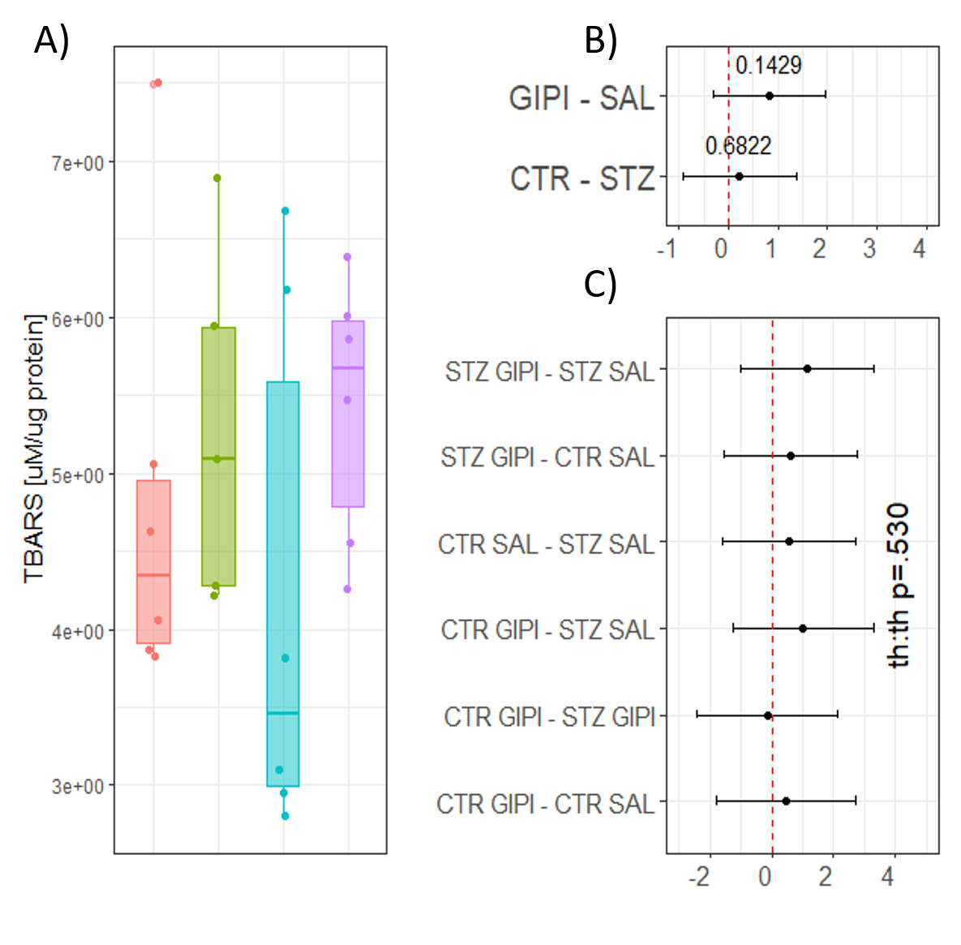
Fig S3-1. The effect of intracerebroventricular glucose-dependent insulinotropic polypeptide receptor inhibitor [Pro³]-GIP (GIPI) on oxidative stress in ileum in control rats and the rat model of sporadic Alzheimer’s disease induced by intracerebroventricular streptozotocin (STZ). (A) Raw data of plasma thiobarbituric reactive substances (TBARS) reflecting systemic oxidative stress. The effects of STZ and GIPI on plasma TBARS are reported as differences of estimated marginal means extracted from (B) the main effects model or (C) taking into account treatment interaction. CTR – control animals; STZ – animals treated intracerebroventricularly with streptozotocin; CTRGIPI – control animals treated intracerebroventricularly with GIPI; STZGIPI – STZ animals treated intracerebroventricularly with GIPI.

