eTable 1. Search strategies
PubMed
1. nasal polyps[MeSH Terms]
2. ((((nasal polyp*[Title/Abstract]) OR (nose polyp*[Title/Abstract])) OR (nasi papilloma[Title/Abstract])) OR (nasal papilloma[Title/Abstract])) OR (nasi polyposis[Title/Abstract])
3. #1 OR #2
4. sinusitis[MeSH Terms]
5. ((((((CRSwNP[Title/Abstract]) OR (chronic rhinosinusitis[Title/Abstract])) OR (rhinopolyp*[Title/Abstract])) OR (sinus Infection*[Title/Abstract])) OR (sphenoid* sinusitis[Title/Abstract])) OR (pansinusitis[Title/Abstract])) OR (rhinitis[Title/Abstract])
6. #4 OR #5
7. #3 OR #6
8. dupilumab[Supplementary Concept]
9. (((dupilumab[Title/Abstract]) OR (Dupixent[Title/Abstract])) OR (Anti-IL-4Rα mAb[Title/Abstract])) OR (Anti-IL-4Rα monoclonal antibody[Title/Abstract])
10. #8 OR #9
11. mepolizumab[Supplementary Concept]
12. ((((mepolizumab[Title/Abstract]) OR (Bosatria[Title/Abstract])) OR (Nucala[Title/Abstract])) OR (Anti-IL-5 mAb[Title/Abstract])) OR (Anti-IL-5 monoclonal antibody[Title/Abstract])
13. #11 OR #12
14. omalizumab[MeSH Terms]
15. (((Xolair[Title/Abstract]) OR (anti-IgE monoclonal antibody[Title/Abstract])) OR (anti-IgE mAb[Title/Abstract])) OR (anti-IgE antibody[Title/Abstract])
16. #14 OR #15
17. antibodies, monoclonal[MeSH Terms]
18. (((((lebrikizumab[Title/Abstract]) OR (tralokinumab[Title/Abstract])) OR (anti-IL-13 monoclonal antibodies[Title/Abstract])) OR (anti-IL-13 mAb[Title/Abstract])) OR (reslizumab[Title/Abstract])) OR (benralizumab[Title/Abstract])
19. #17 OR #18
20. #10 OR #13 OR #16 OR #19
21. #7 AND #20
Cochrane Library
1. MeSH descriptor: [Nasal Polyps] explode all trees
2. (nasal polyp*):ti,ab,kw OR (nose polyp*):ti,ab,kw OR (nasi papilloma):ti,ab,kw OR (nasal papilloma):ti,ab,kw OR (nasi polyposis):ti,ab,kw (Word variations have been searched)
3. #1 OR #2
4. MeSH descriptor: [Sinusitis] explode all trees
5. (CRSwNP):ti,ab,kw OR (chronic rhinosinusitis):ti,ab,kw OR (rhinopolyp*):ti,ab,kw OR (sinus Infection*):ti,ab,kw OR (rhinitis):ti,ab,kw (Word variations have been searched)
6. #4 OR #5
7. #3 OR #6
8. (dupilumab):ti,ab,kw OR (Dupixent):ti,ab,kw OR (Anti-IL-4Rα mAb):ti,ab,kw OR (Anti-IL-4Rα monoclonal antibody):ti,ab,kw (Word variations have been searched)
9. (mepolizumab):ti,ab,kw OR (Bosatria):ti,ab,kw OR (Nucala):ti,ab,kw OR (Anti-IL-5 mAb):ti,ab,kw OR (Anti-IL-5 monoclonal antibody):ti,ab,kw (Word variations have been searched)
10. MeSH descriptor: [Omalizumab] explode all trees
11. (Xolair):ti,ab,kw OR (anti-IgE monoclonal antibody):ti,ab,kw OR (anti-IgE mAb):ti,ab,kw OR (anti-IgE antibody):ti,ab,kw (Word variations have been searched)
12. MeSH descriptor: [Antibodies, Monoclonal] explode all trees
13. (lebrikizumab):ti,ab,kw OR (tralokinumab):ti,ab,kw OR (anti-IL-13 mAb):ti,ab,kw OR (reslizumab):ti,ab,kw OR (benralizumab):ti,ab,kw (Word variations have been searched)
14. #8 OR #9 OR #10 OR #11 OR #12 OR #13
15. #7 AND #14
Embase
1. 'nose polyp'/exp
2. 'nasal polyp*':ab,ti OR 'nose polyp*':ab,ti OR 'nasi papilloma':ab,ti OR 'nasal papilloma':ab,ti OR 'nasi polyposis':ab,ti
3. #1 OR #2
4. 'sinusitis'/exp
5. crswnp:ab,ti OR 'chronic rhinosinusitis':ab,ti OR rhinopolyp*:ab,ti OR 'sinus infection*':ab,ti OR rhinitis:ab,ti OR 'sphenoid* sinusitis':ab,ti
6. #4 OR #5
7. 'dupilumab'/exp
8. dupilumab:ab,ti OR dupixent:ab,ti OR 'anti-il-4rα mab':ab,ti OR 'anti-il-4rα monoclonal antibody':ab,ti
9. #7 OR #8
10. 'mepolizumab'/exp
11. mepolizumab:ab,ti OR bosatria:ab,ti OR nucala:ab,ti OR 'anti-il-5 mab':ab,ti OR 'anti-il-5 monoclonal antibody':ab,ti
12. #10 OR #11
13. 'omalizumab'/exp
14. xolair:ab,ti OR 'anti-ige monoclonal antibody':ab,ti OR 'anti-ige mab':ab,ti OR 'anti-ige antibody':ab,ti
15. #13 OR #14
16. 'monoclonal antibody'/exp
17. lebrikizumab:ab,ti OR tralokinumab:ab,ti OR 'anti-il-13 mab':ab,ti OR reslizumab:ab,ti OR 'benralizumab'/exp OR benralizumab
18. #9 OR #12 OR #15 OR #16 OR #17
19. #3 OR #6
20. #18 AND #19
21. #20 AND [medline]/lim
22. #20 NOT #21
Web of Science
1. TOPIC: (nasal polyp*) OR TOPIC: (nose polyp*) OR TOPIC: (nasi papilloma) OR TOPIC: (nasal papilloma) OR TOPIC: (nasi polyposis)
2. TOPIC: (sinusitis) OR TOPIC: (CRSwNP) OR TOPIC: (chronic rhinosinusitis) OR TOPIC: (rhinopolyp*) OR TOPIC: (sinus Infection*) OR TOPIC: (rhinitis) OR TOPIC: (sphenoid* sinusitis)
3. #1 OR #2
4. TOPIC: (dupilumab) OR TOPIC: (Dupixent) OR TOPIC: (Anti-IL-4Rα mAb) OR TOPIC: (Anti-IL-4Rα monoclonal antibody)
5. TOPIC: (mepolizumab) OR TOPIC: (Bosatria) OR TOPIC: (Nucala) OR TOPIC: (Anti-IL-5 mAb) OR TOPIC: (Anti-IL-5 monoclonal antibody)
6. TOPIC: (omalizumab) OR TOPIC: (Xolair) OR TOPIC: (anti-IgE monoclonal antibody) OR TOPIC: (anti-IgE mAb) OR TOPIC: (anti-IgE antibody)
7. TOPIC: (monoclonal antibody) OR TOPIC: (lebrikizumab) OR TOPIC: (tralokinumab) OR TOPIC: (anti-IL-13 mAb) OR TOPIC: (reslizumab) OR TOPIC: (benralizumab)
8. #4 OR #5 OR #6 OR #7
9. #8 AND #3

eTable 2. Summary of certainty of the evidence (GRADE)

Comparison | Nature of the evidence | Certainty of the evidence | Downgrading due to
Omalizumab vs Placebo | Direct | High | -*
Dupilumab vs Placebo | Direct | High | -
Mepolizumab vs Placebo | Direct | High | -
Omalizumab vs Dupilumab | Indirect | Moderate | Imprecision
Omalizumab vs Mepolizumab | Indirect | Moderate | Imprecision
Dupilumab vs Mepolizumab | Indirect | Moderate | Imprecision

GRADE, Grading of Recommendations Assessment, Development and Evaluation; *, not available.

eTable 3. Surface values under the cumulative ranking curve, PrBest and mean rank of all outcomes
 |  | Placebo | Intervention
 |  |  | Omalizumab | Dupilumab | Mepolizumab
NPS | SUCRA | 0.006 | 0.532 | 0.900 | 0.563
 | PrBest | 0.000 | 0.087 | 0.750 | 0.164
 | Mean rank | 4 | 2.4 | 1.3 | 2.3
SNOT-22 | SUCRA | 0.019 | 0.606 | 0.916 | 0.460
 | PrBest | 0.000 | 0.083 | 0.768 | 0.149
 | Mean rank | 3.9 | 2.2 | 1.3 | 2.6
UPSIT | SUCRA | 0.000 | 0.500 | 1.000 | -*
 | PrBest | 0.000 | 0.000 | 1.000 | -
 | Mean rank | 3 | 2 | 1.000 | -
NCS | SUCRA | 0.000 | 0.693 | 0.807 | -
 | PrBest | 0.000 | 0.386 | 0.614 | -
 | Mean rank | 3 | 1.6 | 1.4 | -
Adverse events | SUCRA | 0.731 | 0.263 | 0.259 | 0.747
 | PrBest | 0.314 | 0.530 | 0.340 | 0.599
 | Mean rank | 1.8 | 3.2 | 3.2 | 1.8

SUCRA, Surface values under the cumulative ranking curve; *, not compared.

Figure legends
eFigure 1. A, ‘Risk of bias’ graph: review authors’ judgements about each risk of bias item presented as percentages across all included studies. B, ‘Risk of bias’ summary: review authors’ judgements about each risk of bias item for each included study.
eFigure 2. Pair-wise meta-analysis comparing (A) NPS (nasal polyp score), (B) SNOT-22 (sino-nasal outcome test-22), (C) UPSIT (University of Pennsylvania smell identification test), (D) NCS (nasal congestion score), and (E) Adverse events.

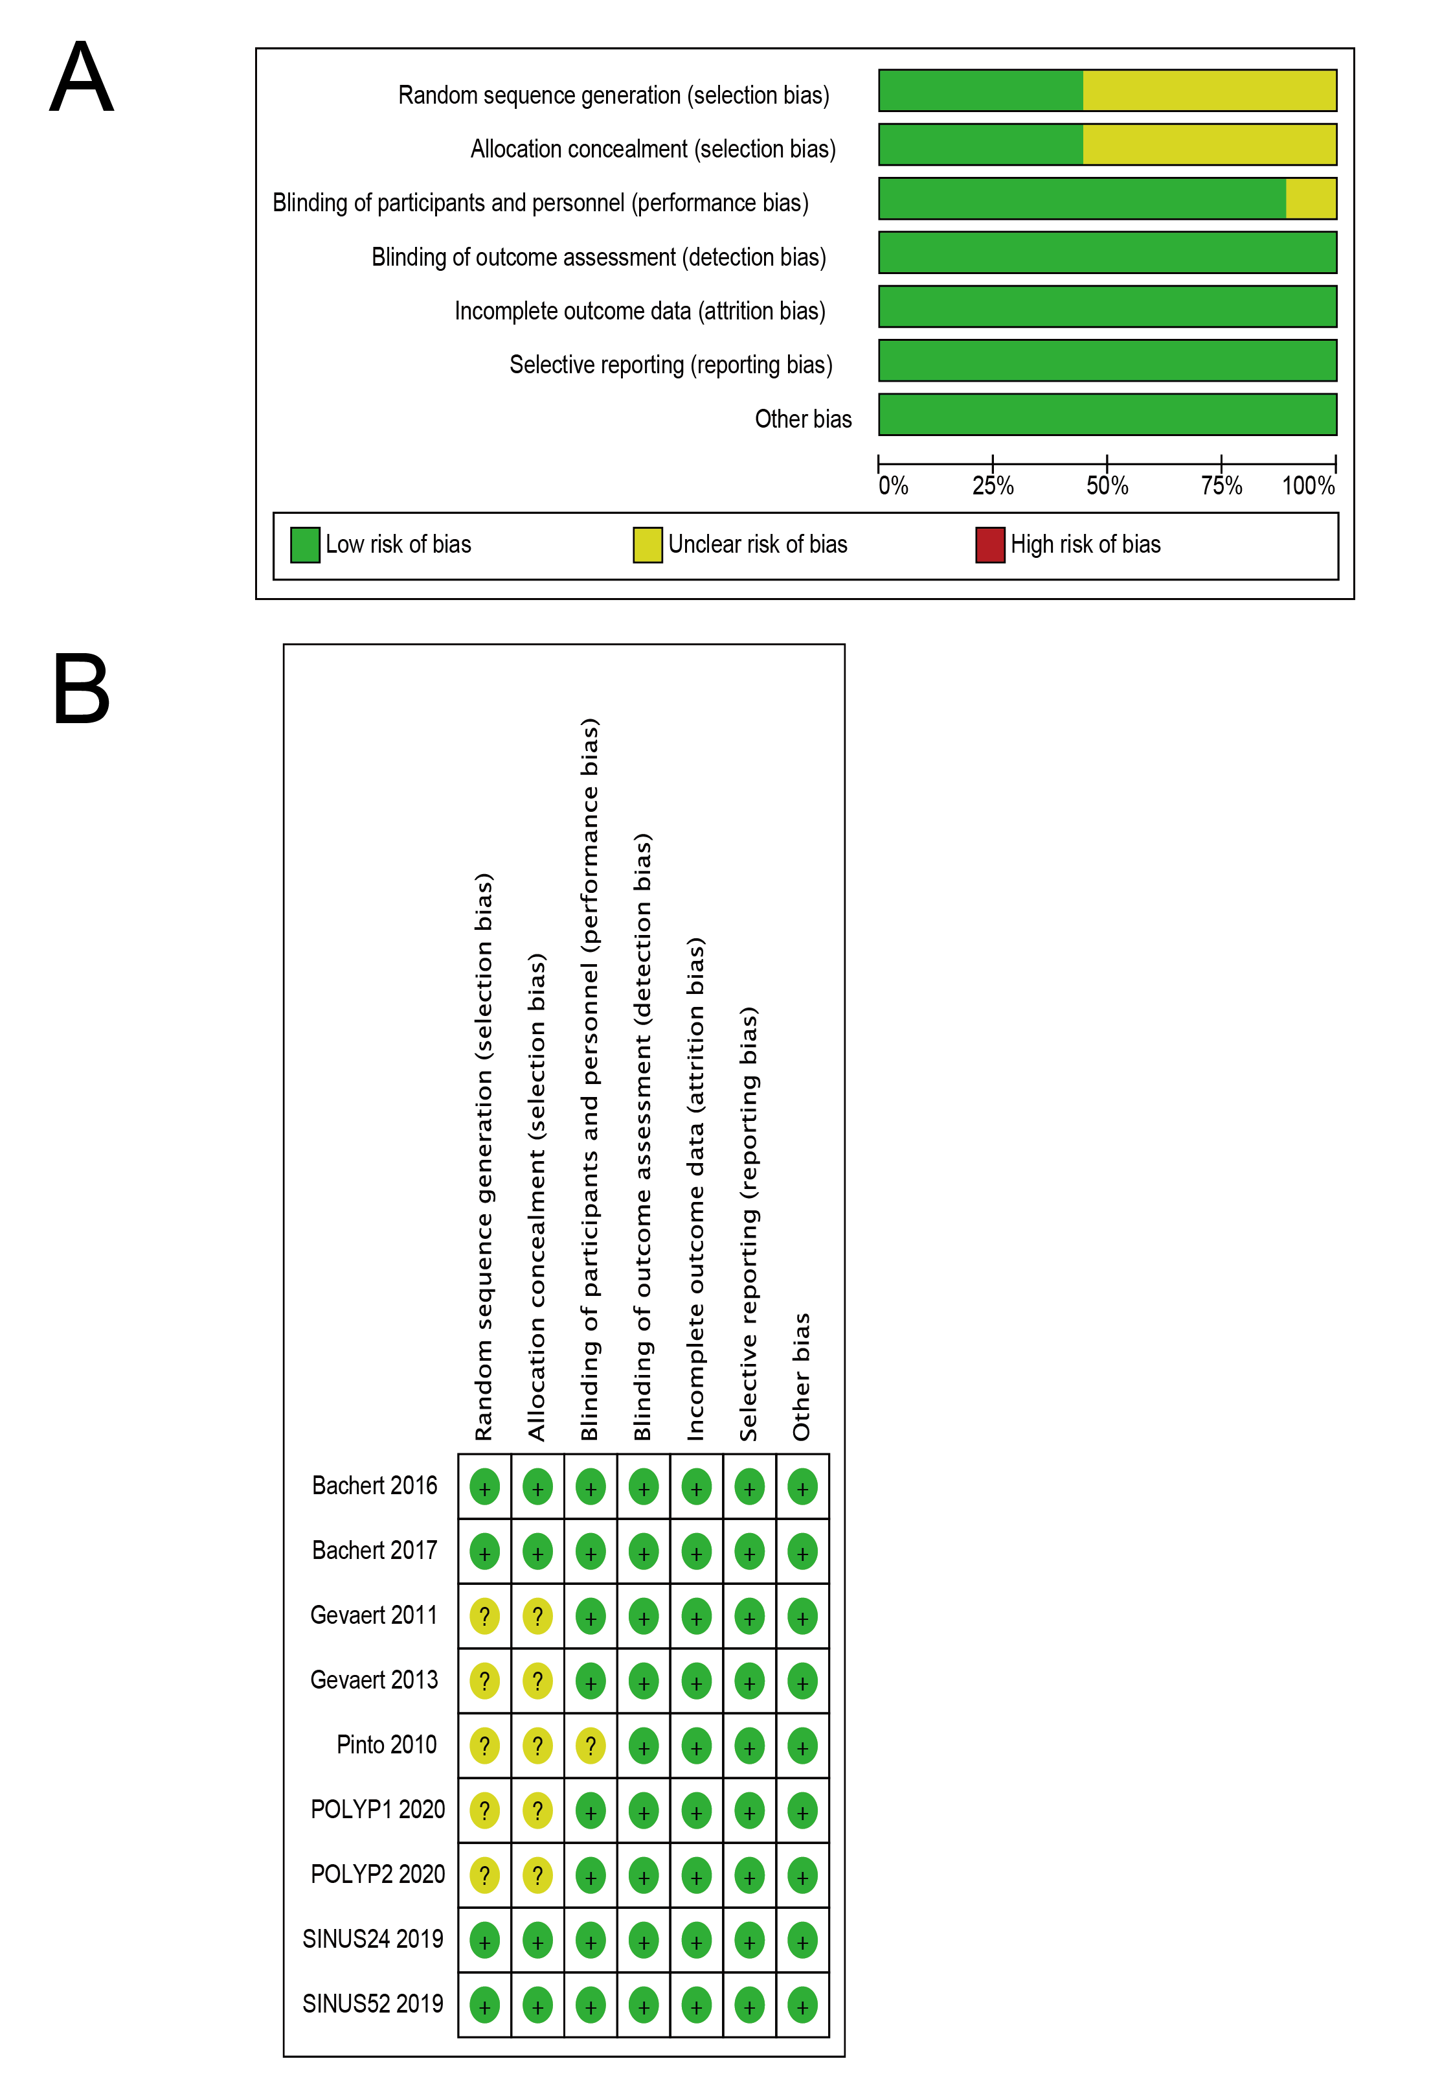
eFigure 1. A, ‘Risk of bias’ graph: review authors’ judgements about each risk of bias item presented as percentages across all included studies. B, ‘Risk of bias’ summary: review authors’ judgements about each risk of bias item for each included study.
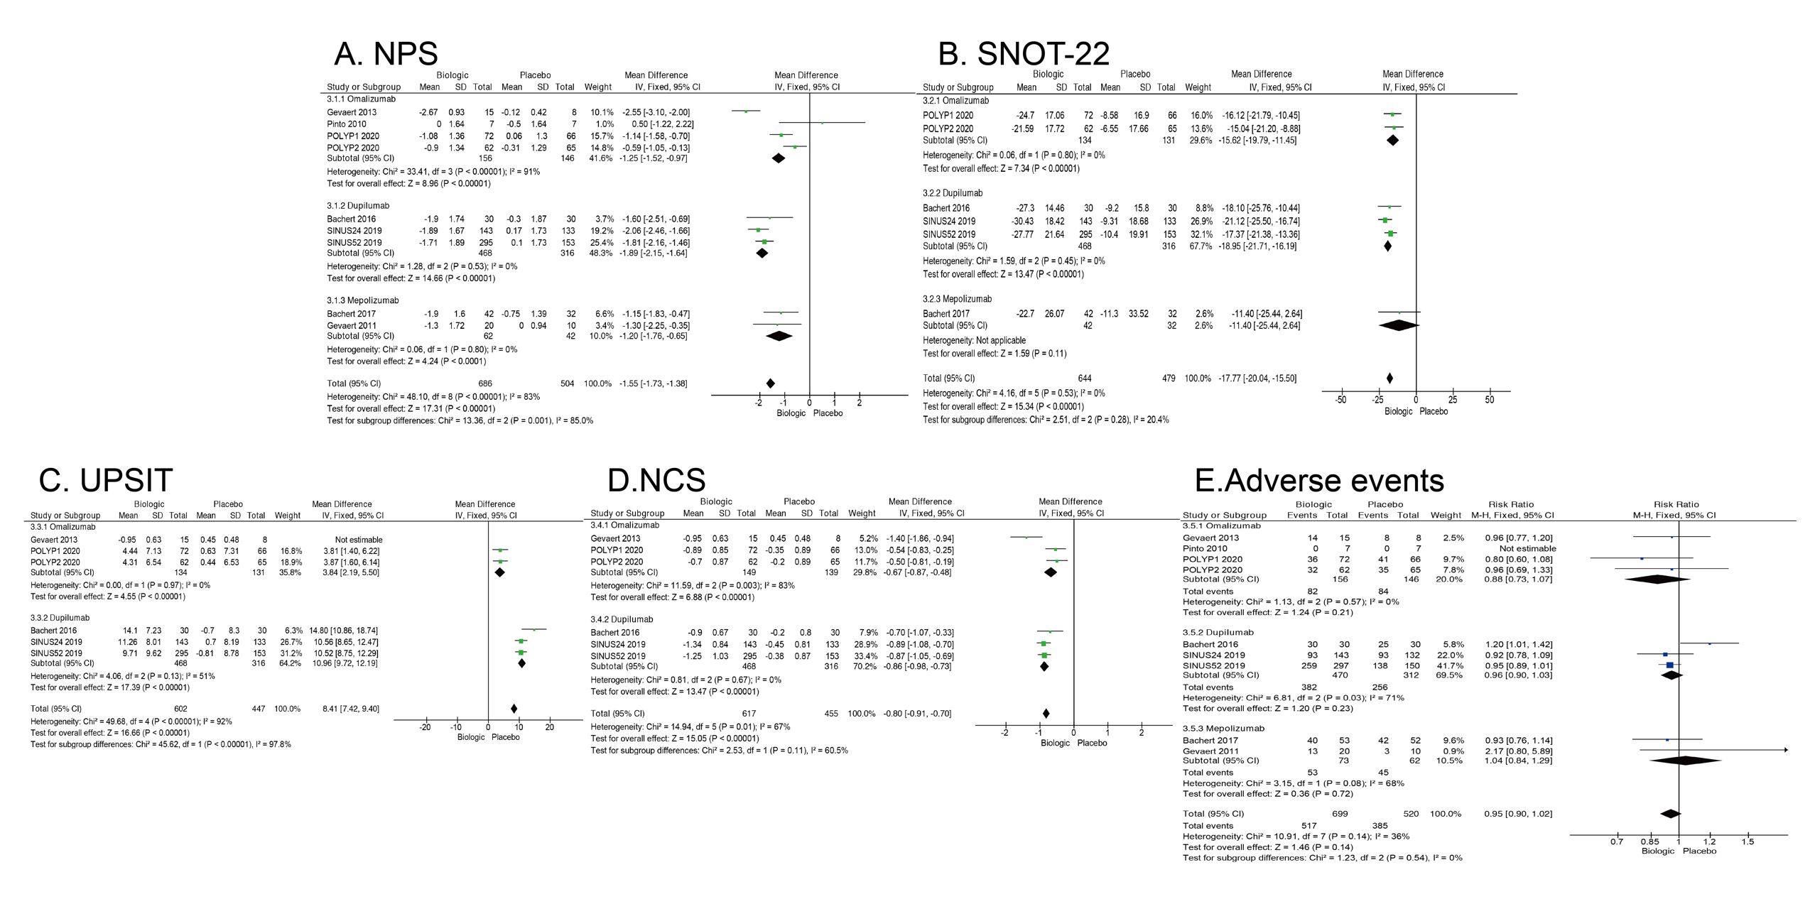

eFigure 2. Pair-wise meta-analysis comparing (A) NPS (nasal polyp score), (B) SNOT-22 (sino-nasal outcome test-22), (C) UPSIT (University of Pennsylvania smell identification test), (D) NCS (nasal congestion score), and (E) Adverse events.

