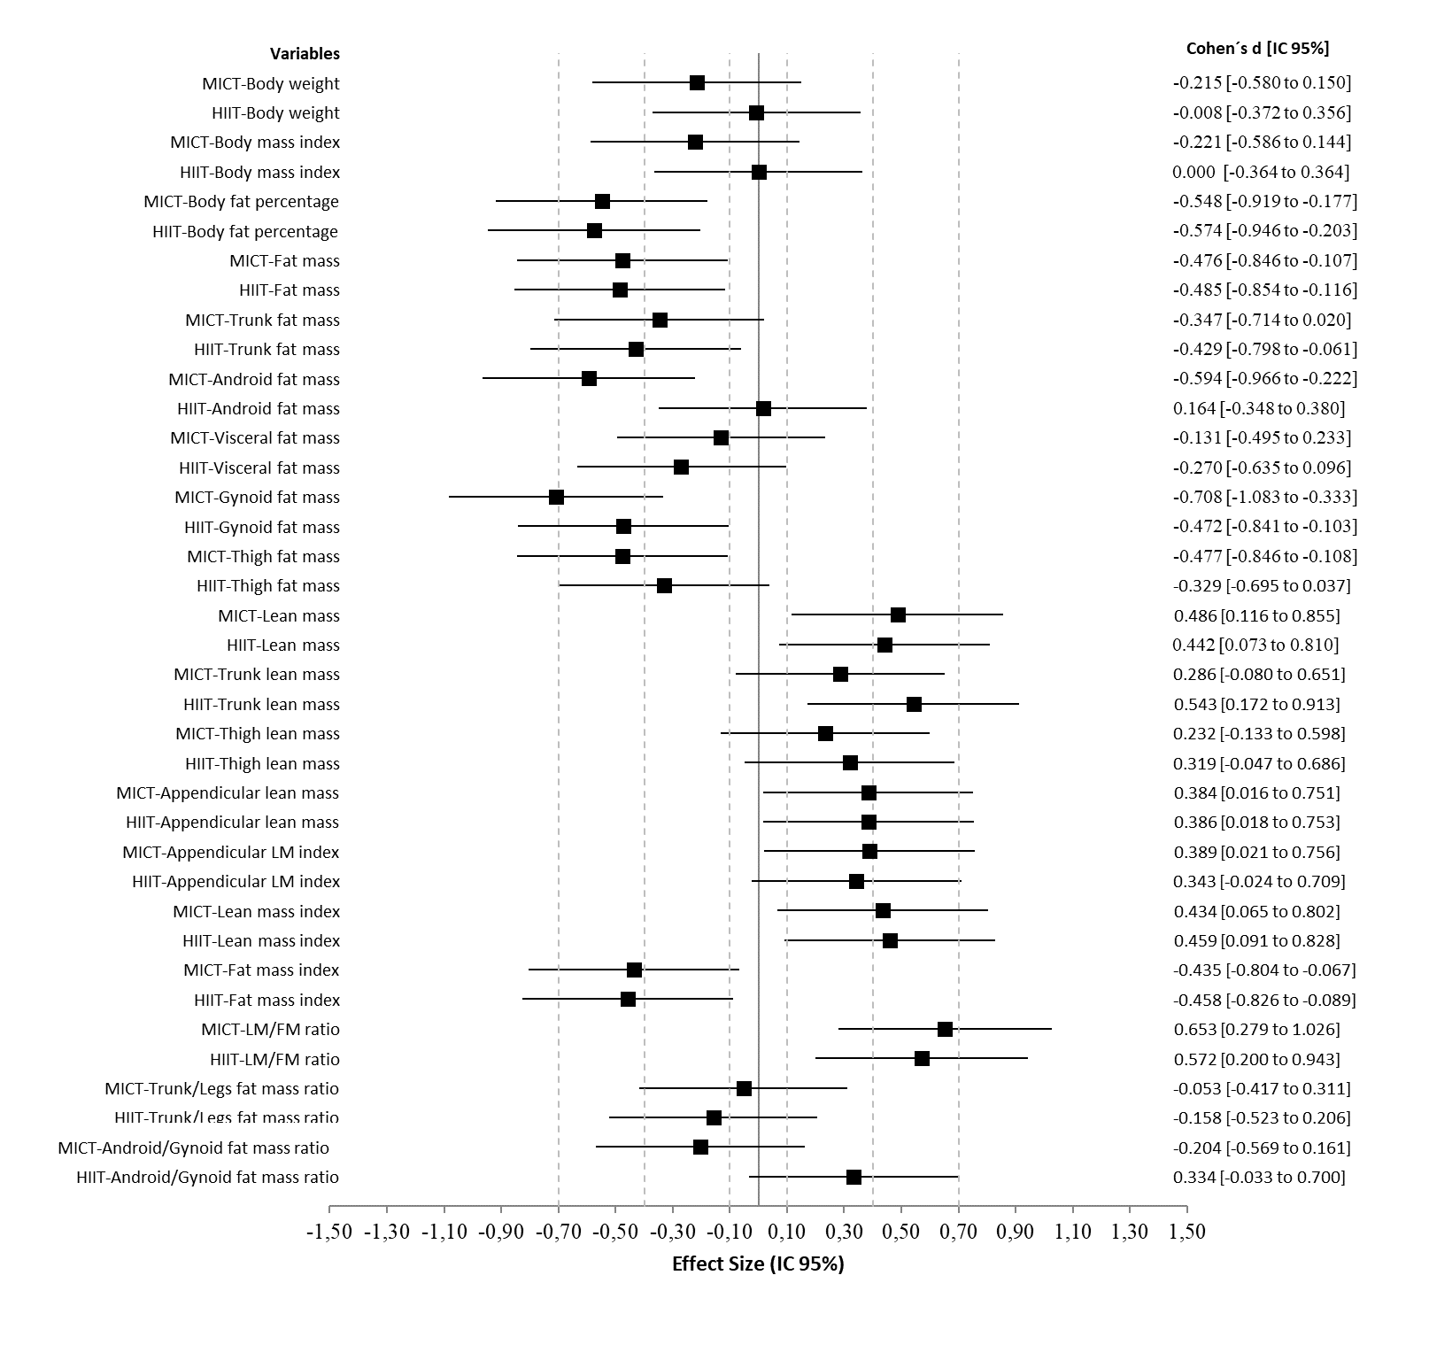Suppl. Fig. 1. Effect size before and after moderate-intensity continuous aerobic training (MICT) and low-volume, high-intensity interval training (HIIT) interventions on body weight and body composition measurements (Intention to treat analysis). FM: Fat mass; LM: Lean mass.

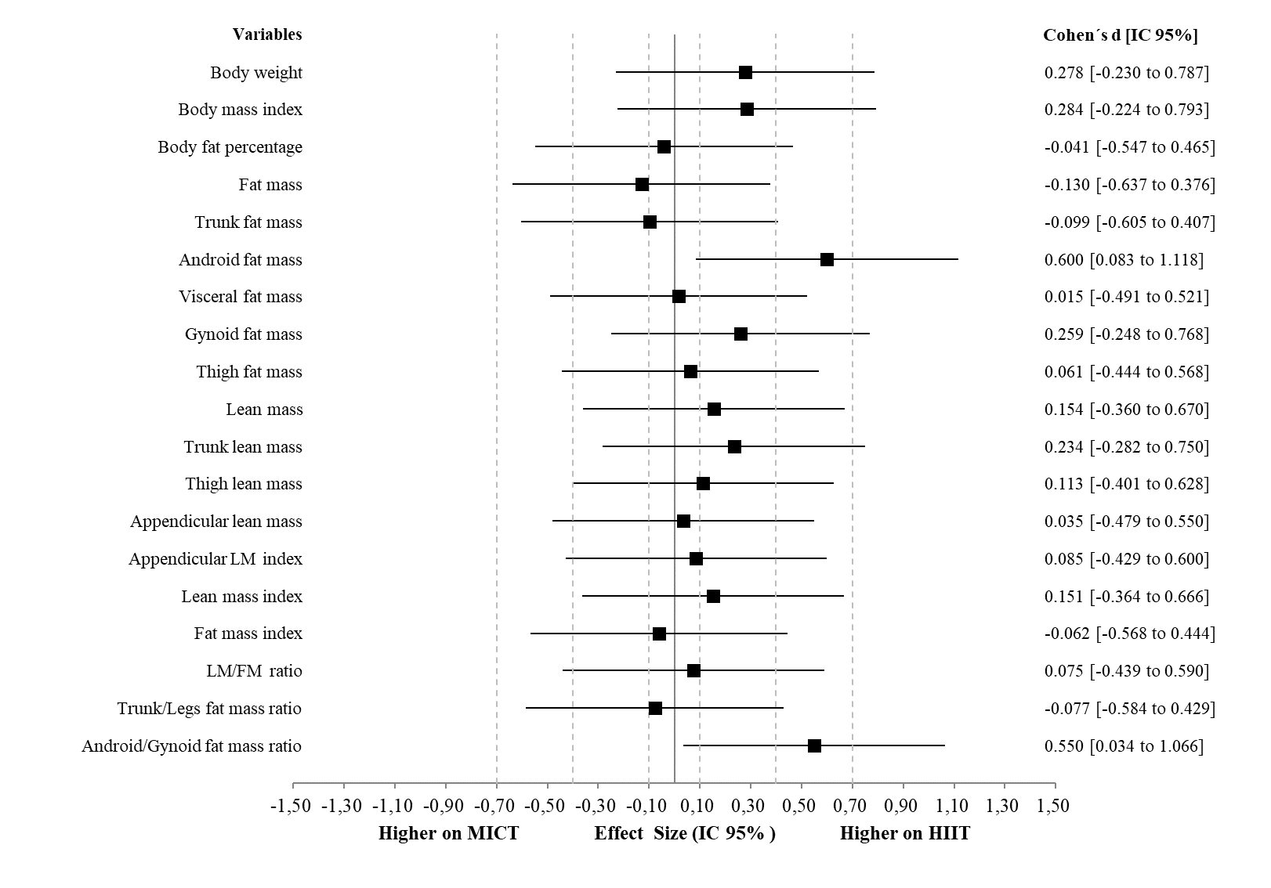
Suppl. Fig. 2. Effect size comparison post moderate-intensity continuous aerobic training (MICT) and low-volume, high-intensity interval training (HIIT) interventions on body weight and body composition measurements (Intention to treat analysis). FM: Fat mass; LM: Lean mass.

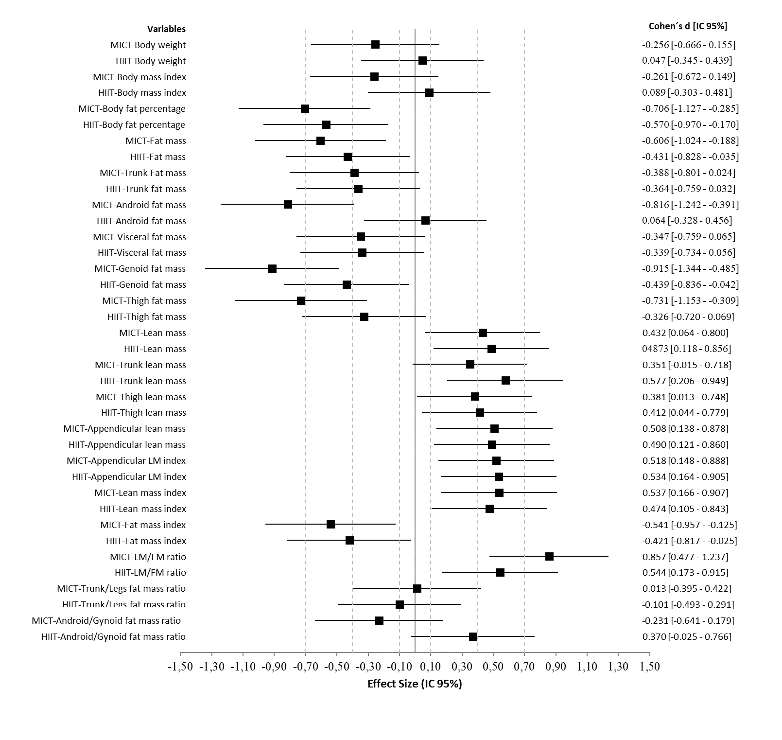Suppl. Fig. 3. Effect size before and after moderate-intensity continuous aerobic training (MICT) and low-volume, high-intensity interval training (HIIT) interventions on body weight and body composition measurements (per-protocol analysis). FM: Fat mass; LM: Lean mass.

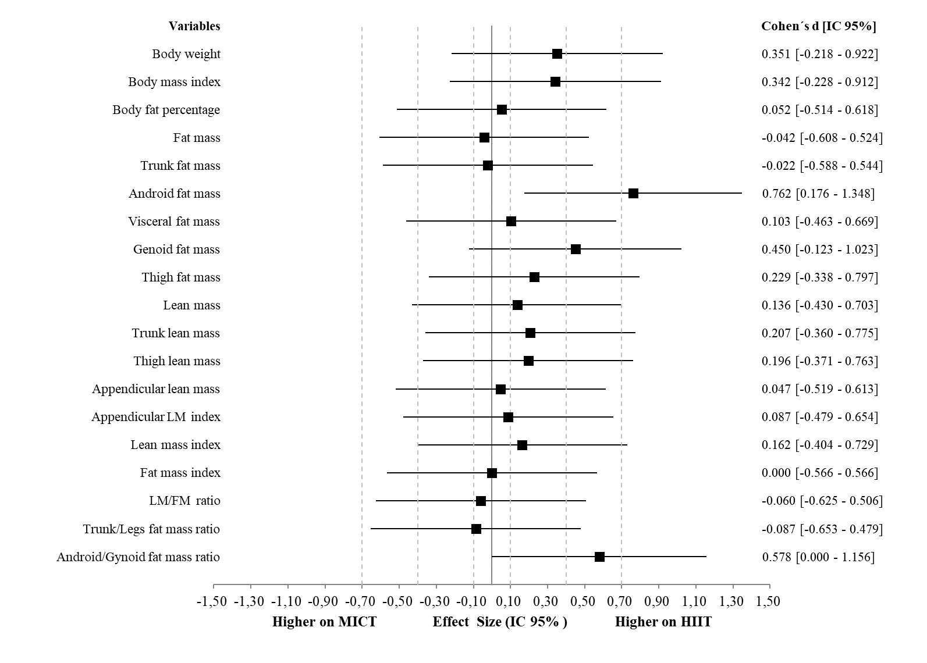
Suppl. Fig. 4. Effect size comparison post moderate-intensity continuous aerobic training (MICT) and low-volume, high-intensity interval training (HIIT) interventions on body weight and body composition measurements (per-protocol analysis). FM: Fat mass; LM: Lean mass.

