Supplementary Figures and Legends

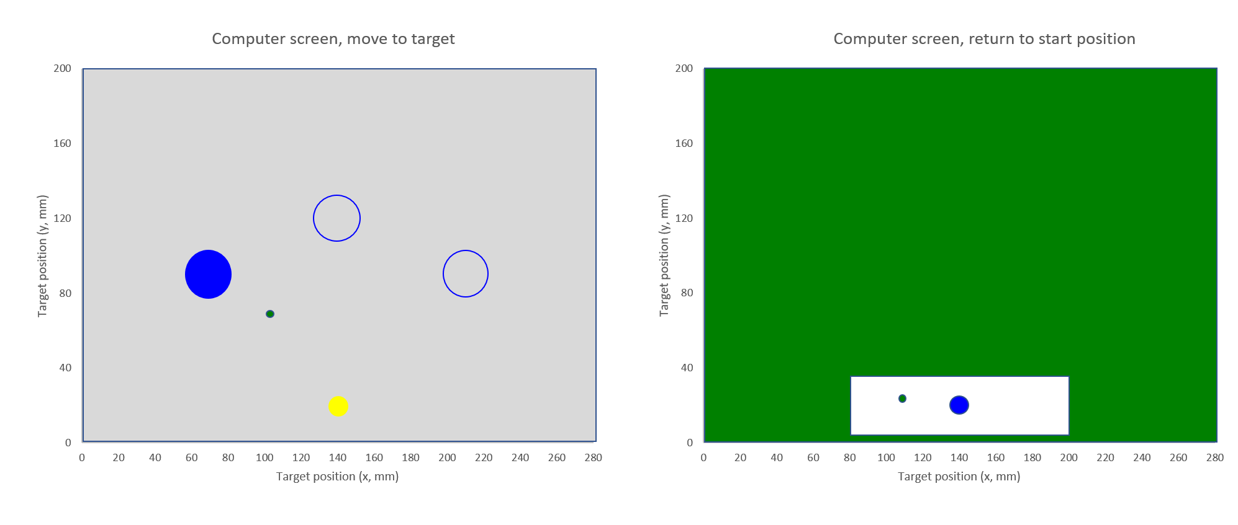
Supplementary Figure S1. Display of the computer screen during the rotation and gain adaptation task. The left panel shows the screen during reach trials, which required a fast ballistic ‘shooting’ movement of the pen from the yellow starting circle to the blue filled circle, one of three possible circular targets. Pen position was displayed on the screen by a green cursor, shown here somewhere between start and target. Each reach trial was followed by a return trial to the starting position. During adaptation trials, there was a perturbation when subjects had to reach the target but not when they had to return to the starting point. In order to conceal the perturbation during return trials, the screen was almost completely covered with a green mask, hiding from vision the perturbation. Visual feedback of the cursor was only presented in the white rectangle around the blue disk. As soon as the cursor reached this blue dot it changed to a yellow colour to signal the start of the next reach trial.

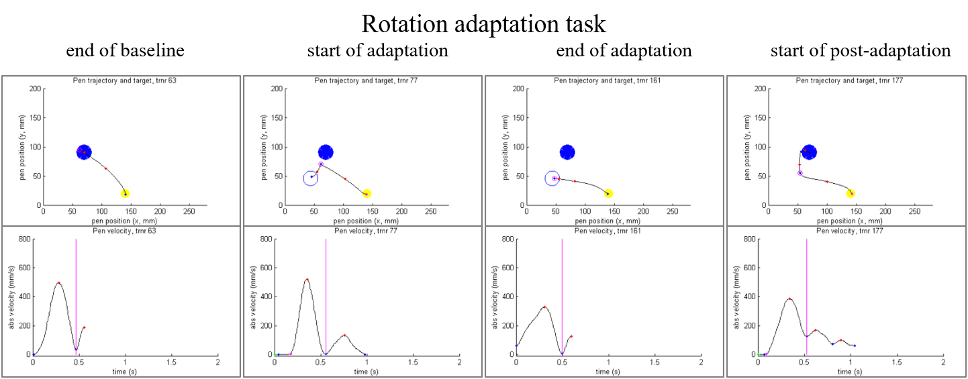

Supplementary Figure S2. Examples of pen trajectory (upper panels) and pen velocity (lower panels) of trials in the rotation adaptation task. These trials were chosen from the end of the baseline period (the 32nd of 36 baseline trials), the start of the adaptation period (the 3rd of 48 rotation adaptation trials), the end of the adaptation period (the 45th) and the start of the post-adaptation period (the 5th trial).
In all panels the end of the ballistic movement is marked with a vertical magenta line in the absolute velocity plots and a magenta circle in the pen trajectories. Velocity peaks and velocity local minima are marked with red and blue dots respectively.
On adaptation trials the display of the pen position by the cursor on the screen is rotated 30o clockwise. This perturbation had to be compensated by a 30o counter clockwise rotated movement of the pen on the digitizer. The resulting pen trajectories and the virtual target are displayed in the upper panels. Participants only saw the moving cursor, they did not see the pen trajectories.
The baseline trial shows a ballistic movement taking less than 0.5 s. At the end of the adaptation period the control participant that was chosen for these examples was able to reach the target again with a ballistic movement of about 0.5 s. In the 5th trial after removal of the perturbation the ballistic movement was still made in the 30o counter clockwise direction demonstrating a clear post-adaptation effect.

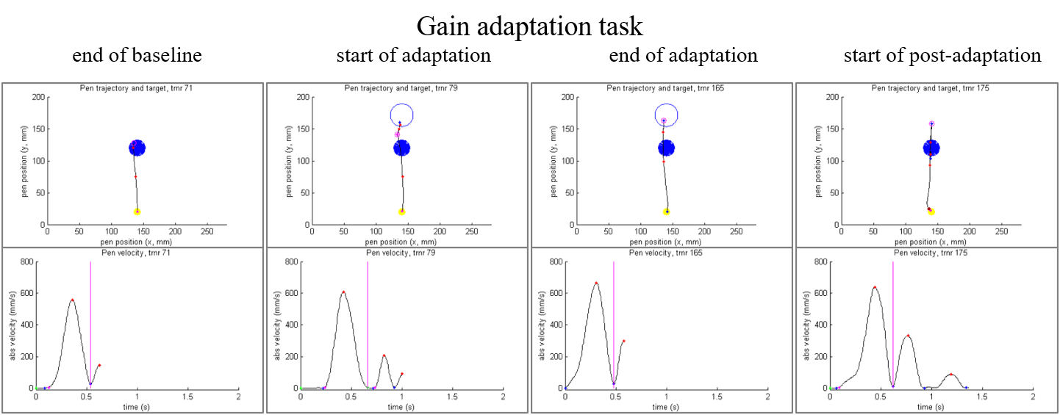

Supplementary Figure S3. This figure presents examples of pen trajectory (upper panels) and pen velocity (lower panels) of trials in the gain adaptation task. These trials were chosen from the end of the baseline period (the 36th of 37 baseline trials), the start of the adaptation period (the 3rd of 48 gain adaptation trials), the end of the adaptation period (the 45th) and the start of the post-adaptation period (the 3rd trial).
The markings are the same as in Supplementary Figure S2.
On adaptation trials the display of the pen position by the cursor on the screen is reduced by a factor of 0.7. This perturbation had to be compensated by a 1/0.7=1.43 larger movement of the pen on the digitizer. The resulting pen trajectories and the virtual target are displayed in the upper panels. Participants only saw the moving cursor, they did not see the pen trajectories.
Similar to the baseline trial displayed in Supplementary Figure S2, the baseline trial here shows a ballistic movement of about 0.5 s. At the start of the adaptation period an additional movement is necessary to reach the target. At the end of the adaptation period the participant had learned to reach the target in one ballistic movement. After the disturbance was removed this large ballistic movement was still executed (ending at 0.6 s) with an overshoot which was corrected by two small additional movements.

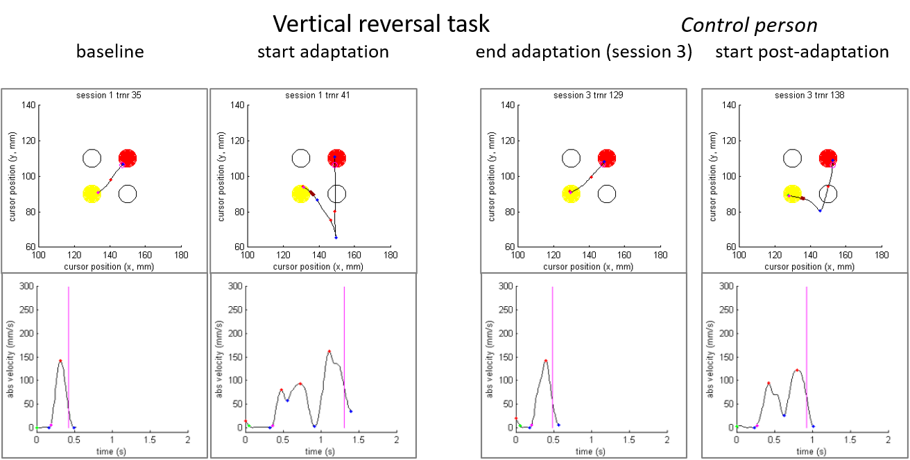

Supplementary Figure S4. Examples are shown of the cursor trajectory (upper panels) and pen velocity (lower panels) of trials in the vertical reversal task. These trials were chosen from the end of the baseline period (the 35th of 40 baseline trials), the start of the adaptation period (the 1st of 96 adaptation trials in session 1), the end of the adaptation period (the 89th trial in session 3) and the start of the post-adaptation period (the 3rd trial in session 3).
In contrast to Supplementary Figures S2 and S3 we have chosen to display in the upper panels the vertically reversed cursor trajectories and targets rather than the pen trajectories but. This is how the participants viewed the task, except that they only saw the cursor and not any trace of previous cursor positions. Movement distances in the VRT were much shorter (20 and 28 mm) than in the rotary and gain adaptation tasks (100 mm), therefore peak velocities were much lower.
On the first reversal trial the participant made a pen movement diagonally upwards which resulted (as shown) in a diagonally downward cursor movement which was subsequently quickly corrected. At the end of the adaptation period, (i.e. after 2*96+89=281 adaption trials), this control subject has reasonably well adapted to the vertical reversal by making a rather short ballistic diagonally downward pen movement resulting in a target hit with similar kinematics as those of the baseline movement presented in the left most panel. The rightmost panel shows a similar post-adaption effect as was presented in Supplementary Figures S2 and S3.

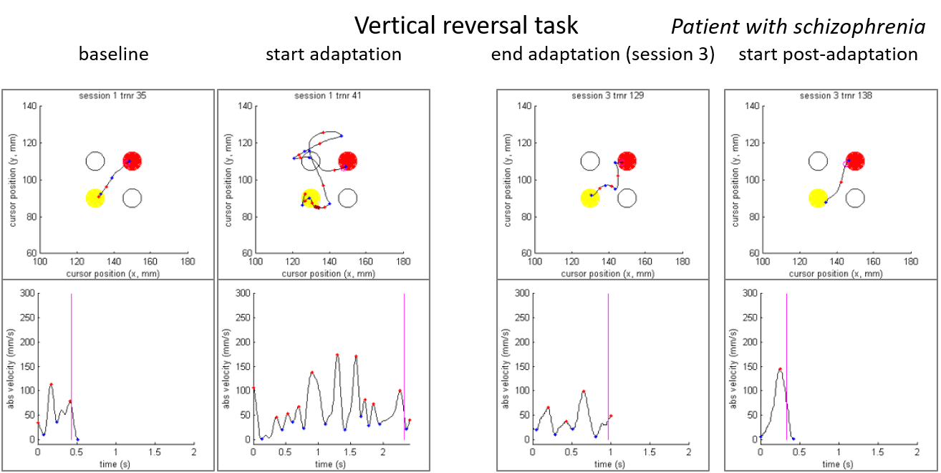

Supplementary Figure S5. In the same layout as of Supplementary Figure S4 this figure presents typical examples of trials of a patient with schizophrenia. This subject had much more trouble finding a solution to the reversal problem than the control subject presented in Supplementary Figure S4. At the end of the adaptation period in session 3, he had still not mastered a fast ballistic movement to the target. In the final post-adaptation period this person did not seem to be hampered by any learning in the previous adaptation trials and could quickly return to his normal movement habits.

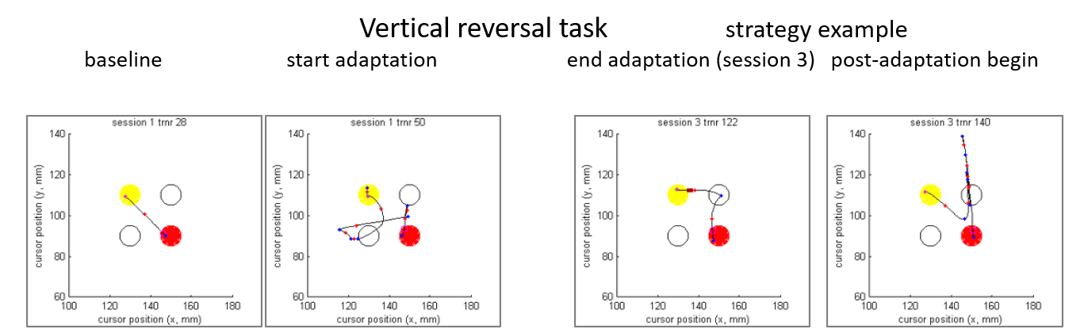

Supplementary Figure S6. This figure presents an image of the use of a specific strategy that was followed by a number of participants (in this instance, a control subject). The layout of the figures is similar as the one used in Figures S4 and S5. To avoid the problem of combining a normal horizontal movement direction and a reversed vertical direction the person splits the diagonal movements in a horizontal part (mostly produced first) and a (reversed) vertical movement. Interestingly, this rather explicit strategic way of performing the task seems to persist in the 5th post-adaptation trial.

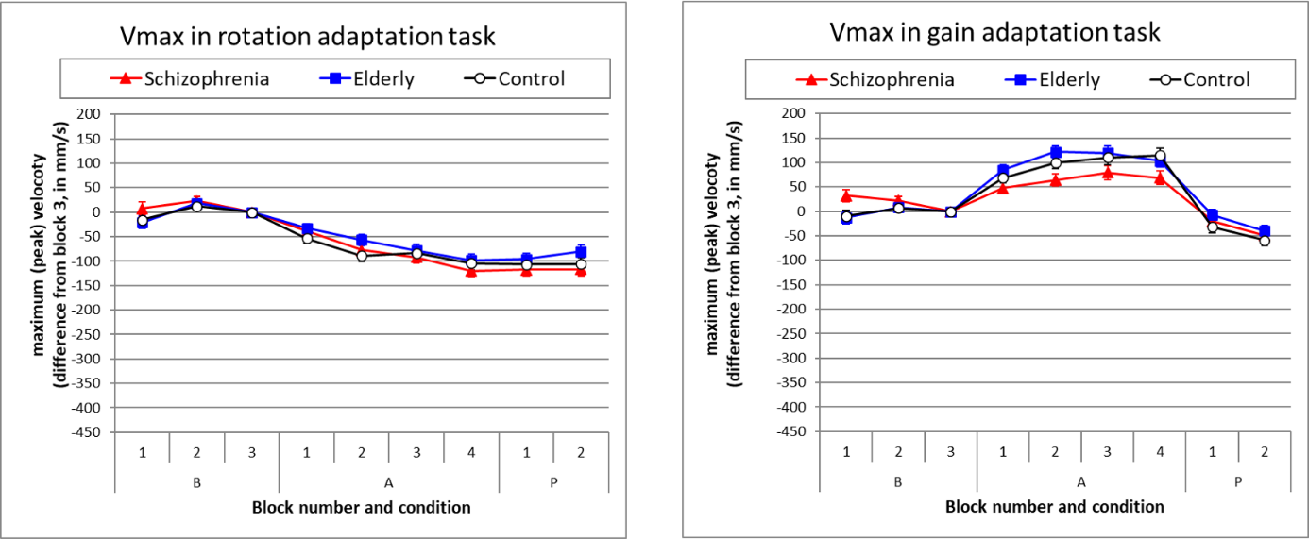

Supplementary Figure S7. Peak velocity (Vmax) in the rotation adaptation task and in the gain adaptation task. Group means (and SE) of the maximum absolute velocity (the peak value) of the initial ballistic movement on baseline (B1-B3), adaptation (A1-A4) and post-adaptation (P1-P2) trial blocks, corrected for group differences at baseline by taking the difference with the value at B3.
At baseline Vmax differed between groups (rotation adaptation task at B3: p=.079, groups S: 439 mm/s, E: 477 mm/s, C: 527 mm/s; gain adaptation task at B3: p=.004, groups S: 425 mm/s, E: 498 mm/s, C: 562 mm/s). Therefore we have chosen to display the differences with the B3 values (Vmaxd). Averaged over groups the zero point in the graphs lies on 481 mm/s in the rotation adaptation task and on 495 mm/s in the gain adaptation task, which explains the low minimum value that was chosen on the Y-axes.
During adaptation (blocks A1 – A4) we see a slight decrease over trials in the rotation adaptation task, possibly due to fatigue or decreased motivation, and no group differences (p=.415). However, in the gain adaptation task the peak velocity increased over adaptation blocks, which is understandable from the requirement to make larger movements, i.e. 143 mm instead of the 100 mm at baseline. Now groups differed significantly (p=.018), with group S showing a lower Vmaxd than group C (p=.035) and group E (p=.007).

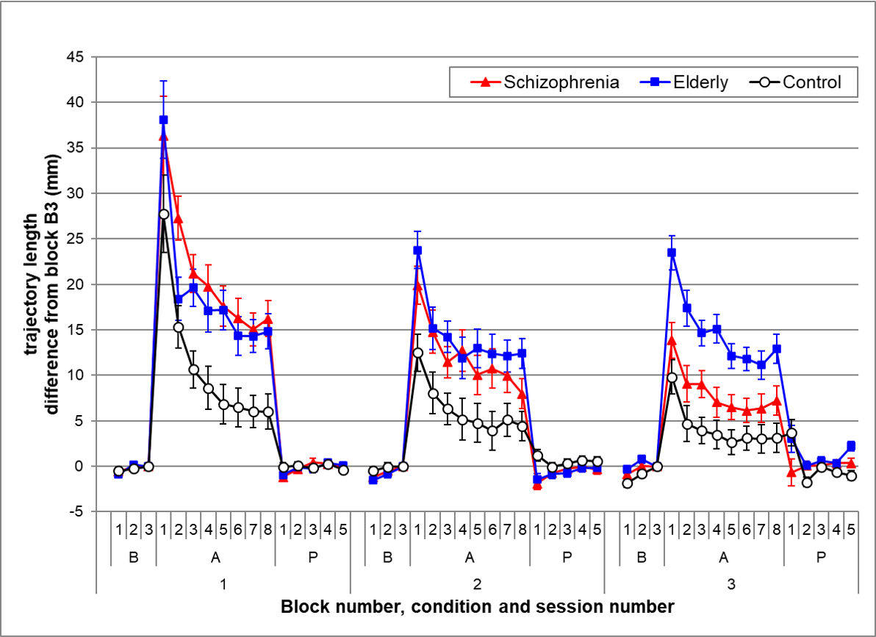
Supplementary Figure S8. Extra trajectory length (ETL) in the vertical reversal task. Group means (and SE) of ETL on baseline (B1-B3), adaptation (A1-A8) and post-adaptation (P1-P5) trial blocks in the three sessions. The extra trajectory length or detour is the length of the pen trajectory less the length of the shortest path from start to target. It was calculated by subtracting the trajectory length at B3 from all trajectory lengths.
Start and target circles (with a diameter of 10 mm) were close together with only 20 mm (or 28 mm for the diagonals) between their centers. Therefore, the shortest distances from the edge of the starting disk to the border of the target circle were 10 mm and 18 mm for the diagonal movements. The group means of the trajectory length over all trials at B3 were not significantly different (p=.169, S: 18.2 mm, E: 18.5, C: 19.4mm). Compared to the baseline values of on average 18.9 mm an extra trajectory length of 35 mm is a detour of nearly 200%.
In general this figure of ETL presents the same picture as that of MTd in Figure 4 of the manuscript. This strengthens the interpretation that the considerable increase in movement time during adaptation, shown in that Figure 4, is mainly caused by an initially inability to find the shortest route of the pen to the vertically reversed target.

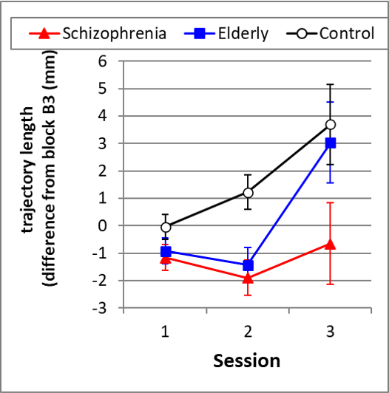

Supplementary Figure S9. Vertical reversal task: aftereffects. Group means (and SE) of extra trajectory length (ETL) on P1 in each session.
This figure zooms in on the values on P1, that were already visible in Supplementary Figure S8. It bears a striking resemblance to Figure 4 on MTd in the manuscript.

An ANOVA on these values reveals a significant effect of session (p=.005) and of group (p=.010). The session * group interaction was not significant (p=.097). T tests on session 3 values show that groups C and E are almost equal (p=.792), but that group S differs significantly from group C (p=.018).

The comparison of this figure with Figure 5 in the manuscript shows again that the movement time aftereffects in the vertical reversal task are mainly caused by erroneous extra movement (trajectories).

