Supplementary Data

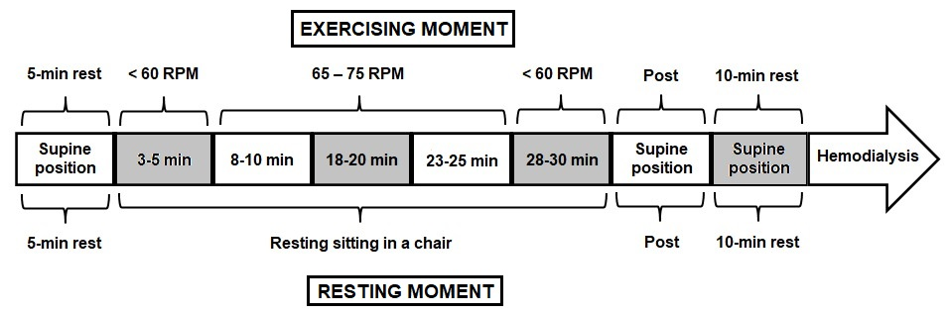
Fig. 1. Ultrasound measurements scheme. Legend: RPM: revolutions per minute.

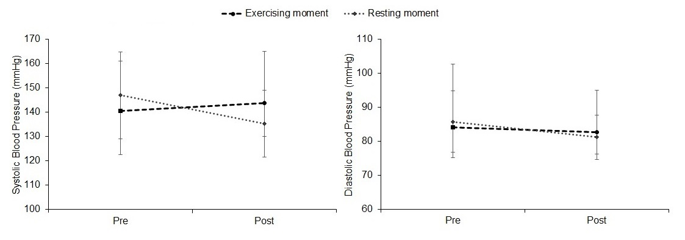
Fig. 2. Systolic and diastolic blood pressure variation between both occasions.

