Supplementary material

Value of cardiopulmonary exercise testing in the prognosis assessment of COPD patients – a retrospective, multicentre cohort study

Ralf Ewert, Anne Obst, Andreas Mühle, Michael Halank, Jörg Winkler, Bernd Trümper, Gerhard Hoheisel, Andreas Hoheisel, Mark Wiersbitzky, Alexander Heine, Alexander Maiwald, Sven Gläser, Beate Stubbe

Supplementary figures
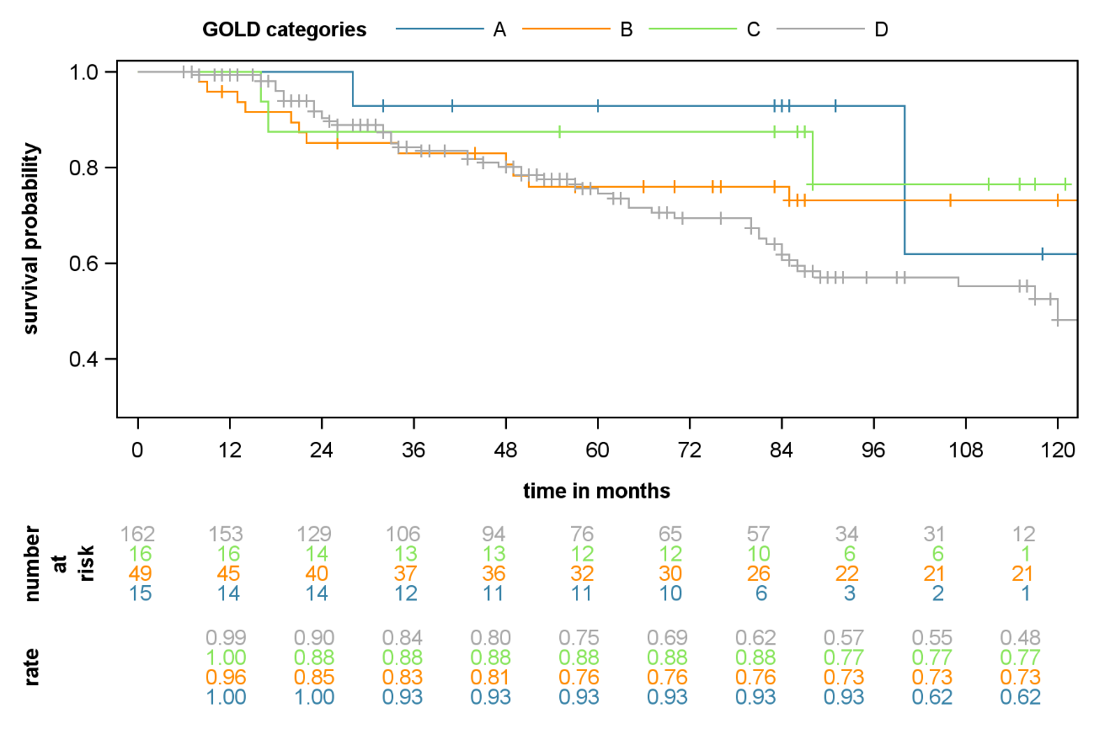

Figure S1: All-cause mortality according to GOLD categories
GOLD=Global Initiative for Chronic Obstructive Lung Disease.

Figure S2: VO₂peak (mL/kg/min) for discrimination of survival at 1 year
In receiver operating characteristic analysis (upper panel), VO₂peak=14.3 mL/kg/min was identified as the optimal threshold for prediction of survival at 1 year. Survival in patients with VO₂peak <14.3 mL/kg/min and ≥14.3 mL/kg/min is shown in a Kaplan–Meier plot (lower panel). AUC=area under the curve (reported with 95% confidence interval). VO₂peak=peak oxygen uptake.
Figure S3: VO₂peak (% predicted) for discrimination of survival at 1 year
In receiver operating characteristic analysis (upper panel), VO₂peak=44% predicted was identified as the optimal threshold for prediction of survival at 1 year. Survival in patients with VO₂peak <44% predicted and ≥44% predicted is shown in a Kaplan–Meier plot (lower panel). AUC=area under the curve (reported with 95% confidence interval). VO₂peak=peak oxygen uptake.

Figure S4: VO₂peak (mL/kg/min) for discrimination of prognosis at 3 years
In receiver operating characteristic analysis (upper panel), VO₂peak=14.3 mL/kg/min was identified as the optimal threshold for prediction of survival at 3 years. Survival in patients with VO₂peak <14.3 mL/kg/min and ≥14.3 mL/kg/min is shown in a Kaplan–Meier plot (lower panel). AUC=area under the curve (reported with 95% confidence interval). VO₂peak=peak oxygen uptake.
Figure S5: VO₂peak (% predicted) for discrimination of prognosis at 3 years
In receiver operating characteristic analysis (upper panel), VO₂peak=56% predicted was identified as the optimal threshold for prediction of survival at 3 years. Survival in patients with VO₂peak <56% predicted and ≥56% predicted is shown in a Kaplan–Meier plot (lower panel). AUC=area under the curve (reported with 95% confidence interval). VO₂peak=peak oxygen uptake.

Supplementary table
Table S1: Calculation of reference values for cardiopulmonary exercise test parameters¹
Parameter | Calculation
Maximum power
Female | −80·628−0·7698*age[years]+1·4038*height[cm]+0·2873*weight[kg]
Male | −103·512−1·5576*age[years]+2·2114*height[cm]−0·1198*weight[kg]
VO₂peak
Female | −54·739−9·8085*age[years]−2·9840*height[cm]+4·3668*weight[kg]
Male | 29·509−0·5930*age[years]+3·1646* height[cm]+3·9946*weight[kg]
VO₂@AT
Female | 298·823−1·5512*age[years]+2·3848*height[cm]+4·7977*weight[kg]
Male | 329·082−4·9426*age[years]+4·3686*height[cm]+5·4209*weight[kg]
VÉpeak
Female | −1·896−0·2959*age[years]+0·3516*height[cm]+0·1876*weight[kg]
Male | 13·148−0·5809*age[years]+0·4103*height[cm]+0·2887*weight[kg]
VO₂peak/HRpeak
Female | −1·720−0·0008*age[years]+0·0512*height[cm]+0·0547*weight[kg]
Male | 1·475−0·0613*age[years]+0·0621*height[cm]+0·0724*weight[kg]
HRpeak=peak heart rate. VÉpeak=peak ventilation. VO₂@AT=oxygen uptake at anaerobic threshold. VO₂peak=peak oxygen uptake.

Supplementary reference
1. Glaser S, Ittermann T, Schaper C, et al. [The Study of Health in Pomerania (SHIP) reference values for cardiopulmonary exercise testing]. Pneumologie 2013; 67: 58-63.

