Supplementary materials
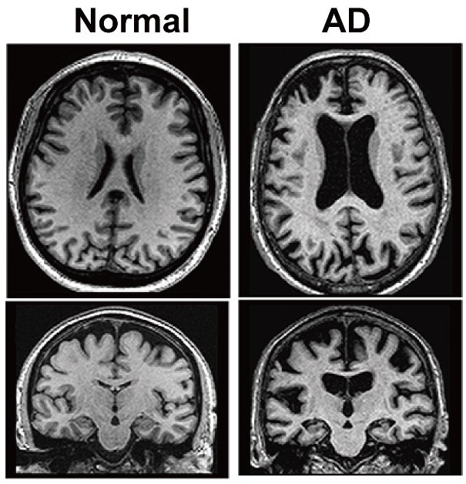
Figure S1. Axial and coronal CT images of normal person and AD patient.
Axial and coronal computed tomography (CT) images were acquired on a CT scanner (Philips) to evaluate hippocampus atrophy of a normal (female, 71 years old) and an AD patient (female, 76 years old) in Shandong Provincial Maternal and Child Health Care Hospital.

