Supplementary Table 1. The quality of evidence for each outcome.
Outcomes | Relative effect  (95% CI) | No of Participants  (studies) | Quality of the evidence  (GRADE)
mRS score 0-2 at 90 days | OR 1.1  (0.9 to 1.34) | 2095  (7 studies) | ⊕⊕⊕⊕  high
mRS score 0–1 at 90 days | OR 0.75  (0.46 to 1.23) | 971  (4 studies) | ⊕⊕⊕⊝  moderate
Recanalization during intervention (TICI score 2B/3) | OR 1.21  (0.9 to 1.62) | 1360  (5 studies) | ⊕⊕⊕⊕  high
Symptomatic intracranial haemorrhage | OR 1.23  (0.77 to 1.97) | 1695  (5 studies) | ⊕⊕⊕⊕  high
Parenchymal haemotoma type 2 | OR 1.01  (0.34 to 3.04) | 603  (2 studies) | ⊕⊕⊝⊝  low
Mortality at 90 days | OR 0.92  (0.68 to 1.23) | 1697  (5 studies) | ⊕⊕⊕⊕  high
*The basis for the assumed risk (e.g. the median control group risk across studies) is provided in footnotes. The corresponding risk (and its 95% confidence interval) is based on the assumed risk in the comparison group and the relative effect of the intervention (and its 95% CI). CI: Confidence interval; OR: Odds ratio.
GRADE Working Group grades of evidence
High quality: Further research is very unlikely to change our confidence in the estimate of effect.
Moderate quality: Further research is likely to have an important impact on our confidence in the estimate of effect and may change the estimate.
Low quality: Further research is very likely to have an important impact on our confidence in the estimate of effect and is likely to change the estimate.
Very low quality: We are very uncertain about the estimate.
CI: Confidence interval; OR: Odds ratio; mRS: modified Rankin Scale; TICI: thrombolysis in cerebral infarction.

Supplementary Figure 1. Scores on the modified Rankin Scale at 90 days
Distribution of scores at 90 days in the intervention and control groups in the overall trial population.

Supplementary Figure 2. Trial sequential analysis for mRS 0-2 at 90 days
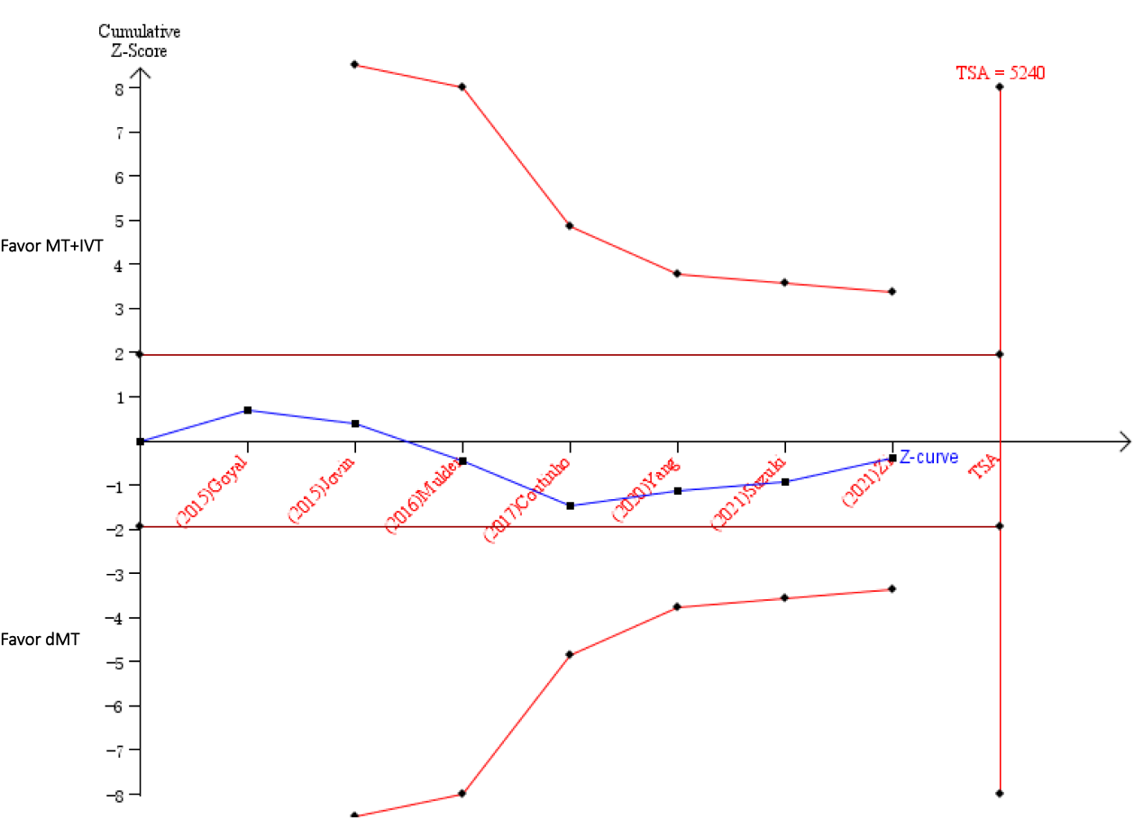

Supplementary Figure 3. Forest plot showing adjusted treatment effect for mRS at 90 days in prespecified subgroup with p values for heterogeneity across subgroups

