Supplemental data.
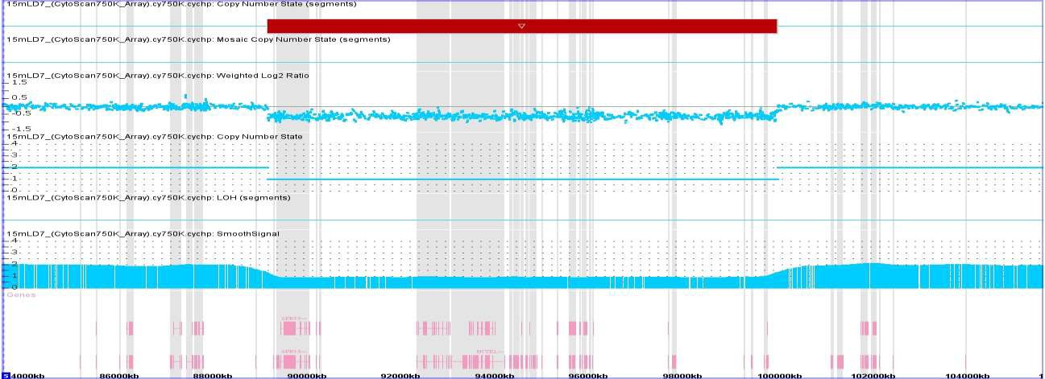
Figure 1. Results of Chromosomal microarray and cytogenetic studies.

5q14.3-q21.1

1b
1a

1a. Chromosomal microarray (CMA) plot showing the 10.8-Mb deletion at 5q14.3-q21.1 (Chr5:89571536-100420786 GRCh38). 1b. G-banding of patient´s chromosome pair 5 (normal chromosome, left; deletion-bearing chromosome, right) and respective ideograms showing the relevant bands at a resolution of 450-500 bands per haploid set.

Table 1. Other CNVs (than 5q14.3) documented in the patient´s array.
Region | type | size (kb) | Genomic coordinates (GRCh38/hg38) | % overlap (CNVs)* | Number of genes | Coding genes | Associated CLP phenotype
6p11.2 | deletion | 775.4 | 57296001-58071364 | 100% | 3 | 1 | None
OMIM database: PRIM2 (176636)
11p11.2-p11.12 | LOH | 5697 | 45853772-51550787 | 26% | 123 | 56 | None
OMIM database: CRY2 (603732), MAPK8IP1 (604641), PEX16 (603360), GYLTL1B (609709), PHF21A (608325), DGKZ (601441), MDK (162096), CHRM4 (118495), AMBRA1 (611359), HARBI1 (615086), ATG13 (615088), ARHGAP1 (602732), F2 (176930), CKAP5 (611142), LRP4 (604270), ARFGAP2 (606908), PACSIN3 (606513), DDB2 (600811), ACP2 (171650), NR1H3 (602423), MADD (603584), MYBPC3 (600958), SPI1 (165170), SLC39A13 (608735), PSMC3 (186852), RAPSN (601592), CELF1 (601074), PTPMT1 (609538), NDUFS3 (603846), C1QTNF4 (614911), MTCH2 (613221), FNBP4 (615265), NUP160 (607614), PTPRJ (600925), FOLH1 (600934), OR4C46 (614273)

11q12.3-q13.2 | LOH | 5135.9 | 63104007-68239940 | 13% | 224 | 171 | None
OMIM database: SLC22A9 (607579), HRASLS5 (611474), LGALS12 (606096), RARRES3 (605092), HRASLS2 (613866), PLA2G16 (613867), ATL3 (609369), RTN3 (604249), MARK2 (600526), COX8A (123870), OTUB1 (608337), MACROD1 (610400), FLRT1 (604806), STIP1 (605063), FERMT3 (607901), TRPT1 (610470), DNAJC4 (604189), VEGFB (601398), FKBP2 (186946), PPP1R14B (601140), PLCB3 (600230), BAD (603167), KCNK4 (605720), ESRRA (601998), PRDX5 (606583), CCDC88B (611205), RPS6KA4 (603606), SLC22A11 (607097), SLC22A12 (607096), NRXN2 (600566), RASGRP2 (605577), PYGM (608455), SF1 (601516), MAP4K2 (603166), MEN1 (613733), CDC42BPG (613991), EHD1 (605888), MIR192 (610939), MIR194-2 (610941), PPP2R5B (601644), GPHA2 (609651), BATF2 (614983), ARL2 (601175), SNX15 (605964), NAALADL1 (602640), CDCA5 (609374), TM7SF2 (603414), ZNHIT2 (604575), FAU (134690), MRPL49 (606866), SYVN1 (608046), SPDYC (614030), CAPN1 (114220), SLC22A20 (611696), CDC42EP2 (606132), DPF2 (601671), SLC25A45 (610825), NEAT1 (612769), MALAT1 (607924), SCYL1 (607982), LTBP3 (602090), SSSCA1 (606044), KCNK7 (603940), MAP3K11 (600050), SIPA1 (602180), RELA (164014), KAT5 (601409), RNASEH2C (610330), AP5B1 (614367), OVOL1 (602313), CFL1 (601442), MUS81 (606591), EFEMP2 (604633), CTSW (602364), FIBP (608296), CCDC85B (605360), FOSL1 (136515), DRAP1 (602289), SART1 (605941), BANF1 (603811), CST6 (601891), CATSPER1 (606389), GAL3ST3 (608234), SF3B2 (605591), PACS1 (607492), KLC2 (611729), RAB1B (612565), CNIH2 (611288), YIF1A (611484), CD248 (606064), RIN1 (605965), BRMS1 (606259), B3GNT1 (605517), SLC29A2 (602110), NPAS4 (608554), MRPL11 (611826), PELI3 (609827), DPP3 (606818), BBS1 (209901), ACTN3 (102574), CTSF (603539), CCS (603864), RBM14 (612409), RBM4 (602571), SPTBN2 (604985), RCE1 (605385), PC (608786), LRFN4 (612810), SYT12 (606436), RHOD (605781), KDM2A (605657), ADRBK1 (109635), ANKRD13D (615126), SSH3 (606780), POLD4 (611525), CLCF1 (607672), RAD9A (603761), PPP1CA (176875), TBC1D10C (610831), CARNS1 (613368), RPS6KB2 (608939), PTPRCAP (601577), CORO1B (609849), CABP4 (608965), AIP (605555), PITPNM1 (608794), CABP2 (607314), GSTP1 (134660), NDUFV1 (161015), TBX10 (604648), ACY3 (614413), ALDH3B2 (601917), UNC93B1 (608204), ALDH3B1 (600466), NDUFS8 (602141), TCIRG1 (604592), CHKA (118491), SUV420H1 (610881), C11orf24 (610880), LRP5 (603506), PPP6R3 (610879)
14q32.22 | amplification | 724.3 | 1061125344-106849677 | 100% | 73 | 2 | None
OMIM database: KIAA0125 (616623), ADAM6 (601533)
Xq11.1-q13.1 | LOH | 6724.4 | 62036670-68761102 | 95% | 60 | 19 | AMER1 (MIM *300647)  -Osteopathia striata with cranial sclerosis (MIM #300373)  EFNB1 (MIM *300035)  -Craniofrontonasal dysplasia (MIM #300373)
OMIM database: ARHGEF9 (300429), AMER1 (300647), ASB12 (300891), ZC4H2 (300897), ZC3H12B (300889), MSN (309845), MIR223 (300694), VSIG4 (300353), HEPH (300167), EDA2R (300276), AR (313700), OPHN1 (300127), STARD8 (300689), EFNB1 (300035), PJA1 (300420)
Xq13.2-q21.1 | LOH | 9478.5 | 72209123-81687671 | 5% | 94 | 35 | TBX22 (MIM *300307)  -X-linked Cleft palate with ankyloglossia (MIM #303400)
OMIM database: NAP1L2 (300026), CDX4 (300025), TSIX (300181), XIST (314670), JPX (300832), SLC16A2 (300095), RLIM (300379), KIAA2022 (300524), ABCB7 (300135), UPRT (300656), ZDHHC15 (300576), MAGEE2 (300760), MAGEE1 (300759), FGF16 (300827), ATRX (300032), MAGT1 (300715), COX7B (300885), ATP7A (300011), PGAM4 (300567), PGK1 (311800), TAF9B (300754), CYSLTR1 (300201), LPAR4 (300086), P2RY10 (300529), ITM2A (300222), TBX22 (300307), BRWD3 (300553), HMGN5 (300385), SH3BGRL (300190)
LOH: Loss of heterozygosity, CLP: cleft lip palate
*The percentage of overlap with healthy population

