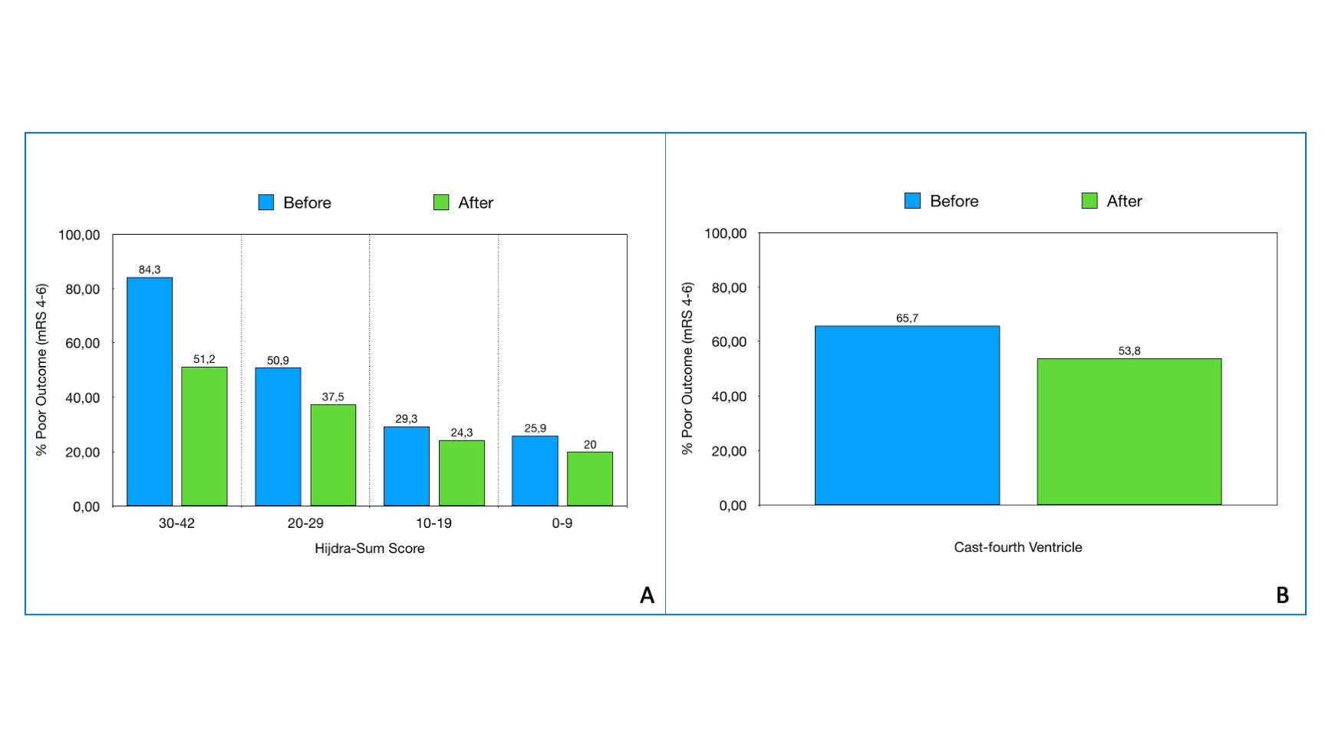

Figure legend:
A) Bar chart of the percentage of patients with poor neurological outcome (mRS) 6 months after ictus, categorized according to their Hijdra Score and their cohort group. B): Percentage of poor mRS scores as for cast fourth ventricle and cohort groups.

