Supplementary Figure 1: Publication bias and sensitivity analysis
Publication bias
a. Polypharmacy | b. Hyperpolypharmacy
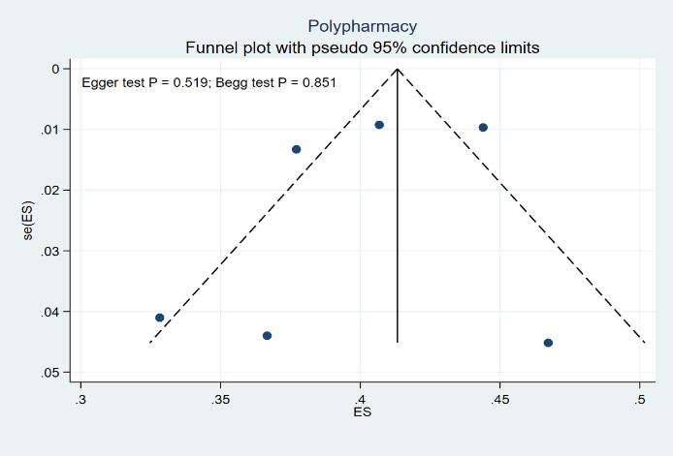 | 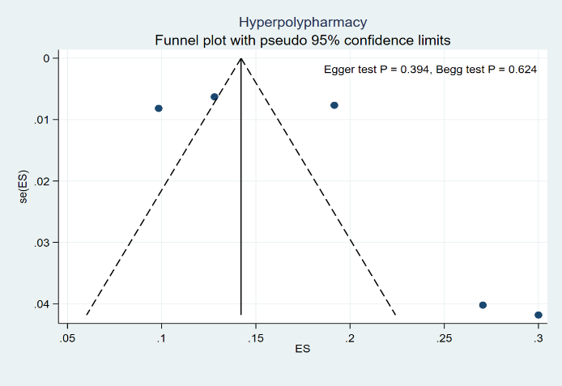
Sensitivity analysis
c. Polypharmacy | d. Hyperpolypharmacy
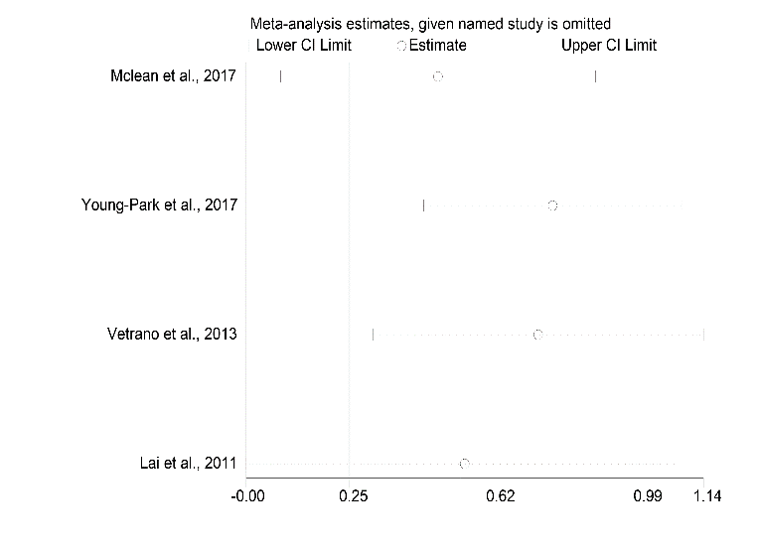 | 