Supplementary material 1

1. To further explore the data, we performed an additional exploratory analysis of subliminal drug cue vs. neutral cue using the AFNI software routine “3dClustSim” Monte-Carlo algorithm to compute cluster thresholds (p<0.05 at cluster level and p<0.05 peak voxel level) both within patients and controls (see also point #2 below). These analyses suggested that amphetamine users might show increased hippocampal activation in response to drug vs. neutral cues (supplementary figure 1a). However, it is important to note that this explorative analysis does not adhere to current recommendations for the use of cluster thresholding in functional neuroimaging data analysis (for further details, see Eklund et al., “Cluster failure: Why fMRI inferences for spatial extent have inflated false-positive rates”, PNAS, vol 113, no.28, 7900-7905, 2016). Accordingly, these explorative results are therefore included for the purpose of a visual inspection of image activation contrast only. We have refrained from discussing these explorative findings in the main text due to the high false positive rate associated with the statistical thresholds used here. In the given data set, the obtained spatial extent threshold for a cluster threshold of p<0.05 together with peak voxel threshold of p<0.05 was 524 voxels (3dClustSim algorithm).

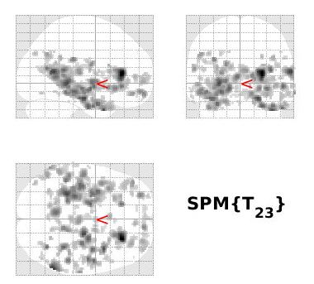
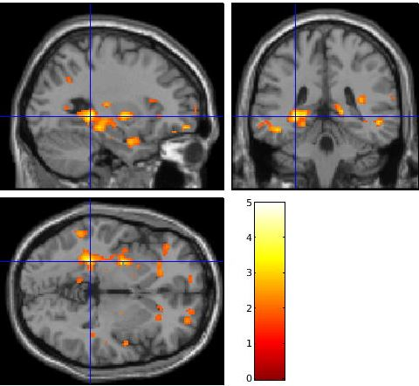
Supplementary figure 1a: Results of the amphetamine users for the contrast subliminal drug cue vs. neutral cue thresholded at peak level p<0.05 (voxel level) and cluster level p<0.05 using the AFNI 3dClustSim algorithm. A cluster localized in the left posterior hippocampus (size = 1713 voxels), local maximum at [x,y,z] = [-28,-38,-2]) was found to be significant (beta estimate = 0.499, CI = +/- 0.217). No other clusters were found to be significant.
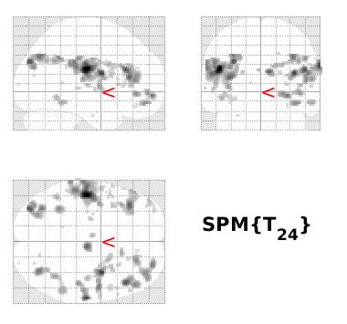
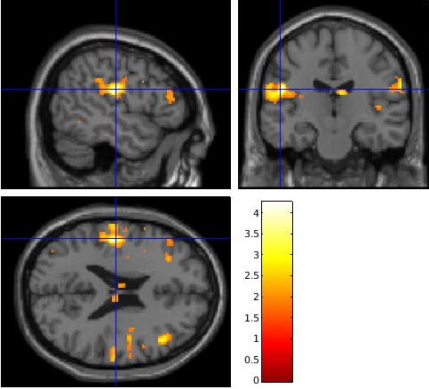

Supplementary figure 1b: Results of the healthy controls for the contrast subliminal drug cue vs. neutral cue, thresholded at peak level p<0.05 (voxel level) and cluster level p<0.05 using the AFNI 3dClustSim algorithm. A cluster localized in the left pre-central gyrus (size = 843 voxels), local maximum at [x,y,z] = [-50, -18, 22]) was found to be significant (beta estimate = 0.276, CI = +/- 0.252). No other clusters were found to be significant.

2. In an attempt at examining possible differences in general visual cue reactivity between amphetamine users and healthy controls, we analyzed the contrast cue > fixation cross, in both groups, and performed comparisons between them. Similar to the statistical thresholding procedure used for the contrasts presented in point #1 above, we here used the AFNI software routine “3dClustSim” Monte-Carlo algorithm to compute cluster thresholds. In the given data set, the obtained spatial extent threshold for a cluster threshold of p<0.05 together with peak voxel threshold of p<0.05 was 524 voxels (3dClustSim algorithm). The results suggested that amphetamine users might show enhanced activation in visual areas compared to healthy control (supplementary figure 2c), but these analyses share the limitations listed above (section 1), and should therefore be interpreted with great caution.

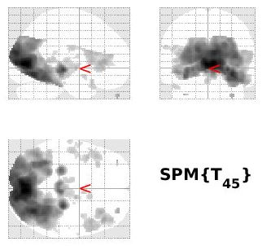
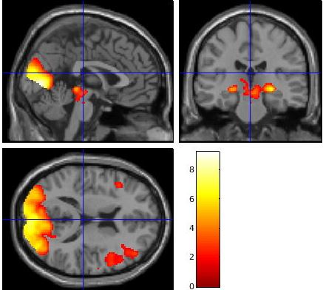
Supplementary figure 2a: Results for the Cue > fixation cross contrast in amphetamine users (peak threshold p<0.05 combined with a cluster threshold of p<0.05). A very large cluster (size 14590 voxels) covering substantial parts of the visual cortex (peak at [X,Y,Z] = (6,-78,4) beta estimate = 34.06, CU = +/- 7.119) and a smaller cluster (size = 538 voxels, peak at [X,Y,Z] = (44,34,6) beta estimate = 1.740, CI = +/- 0.806) located in the left dorsolateral cortex were found to be significantly activated.

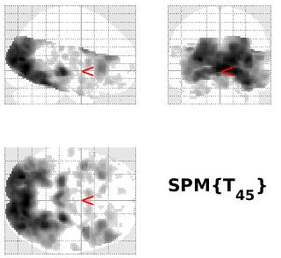
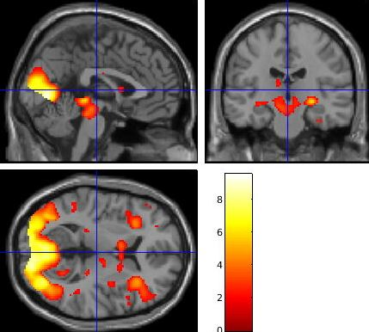
Supplementary figure 2b: Results for the Cue > fixation cross contrast in controls (peak threshold p<0.05 combined with a cluster threshold of p<0.05). A very large cluster (size 16392 voxels) covering substantial parts of the visual cortex (peak at [X,Y,Z] = (6,-74,2) beta estimate = 34.131, CI = +/- 5.886) was found to be significant. Additionally, clusters located in the left (size = 1050 voxels, peak at [X,Y,Z] = (-40,0,26) beta estimate = 4.311, CI = +/- 1.379) and right anterior insula (size = 1720 voxels, peak at [X,Y,Z] = (40,2,24) beta estimate = 3.352, CI = +/- 0.996) was found to be significantly activated.
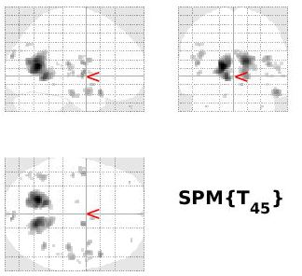
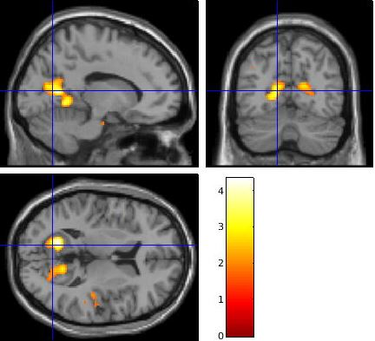
Supplementary figure 2c: Results from the two-sample t-test comparing cue > fixation cross in patients vs. healthy controls (peak threshold p<0.05 combined with a cluster threshold of p<0.05). Two significant clusters were located in the left (size = 798 voxels, [X,Y,Z] = (-16,-62,10) beta estimate = 14.36, CI = +/- 13.73) and right (size = 682 voxels, peak at [X,Y,Z] = (14,-64,16] beta estimate = 6.475, CI = +/- 2.882) medial part of the primary visual cortex.

In summary, we found wide-spread activations of the occipital and parietal cortices in both groups, as might be expected for a strong visual contrast, that included changes in luminance. We found no significant differences between amphetamine users and healthy controls after FWE- or FDR-correction. In other words, we found no evidence of differences in BOLD activations between the two groups in this basic visual contrast.

3. The healthy control group reported no history of psychiatric disorders (including substance use disorders), but earlier or on-going psychiatric co-morbidity was common among the amphetamine users. Among the 24 amphetamine users included in the final sample of this study, 7 reported a history of in-patient psychiatric care and 6 reported at least one earlier suicide attempt. 8 of them reported at least one episode of amphetamine-related psychosis. In order to be included in the study, their psychiatric status had to be stable, but 5 subjects were nevertheless judged to fulfil criteria for another current Axis 1 psychiatric disorder:
-Social phobia (2)
-Major depressive disorder, mild (2)
-Post-traumatic stress disorder (1)
None of them were treatment-seeking, but were offered a referral to the local out-patient clinic for addiction psychiatry.

4. As reported in the main manuscript, we did not find any significant differences in BOLD activations between the naltrexone- and placebo-treated groups of amphetamine users. However, we also performed a separate analysis of the placebo-treated amphetamine users, to explore if there could be evidence of an effect in this group that had not been exposed to naltrexone. No activations survived FWE or FDR correction, but using an un-corrected threshold of p<0.005 resulted in two small clusters:
Cluster 1:
MNI coordinates: -2, -64, 24
Peak-level p (FWE-corrected): 0.798
T-score: 4.38
Z-score: 3.62
Cluster size: 16

Cluster 2:
MNI coordinates: -30, -42, -14
Peak-level p (FWE-corrected): 0.997
T-score: 3.59
Z-score: 3.12
Cluster size: 1

In summary, these results for the placebo-treated group of amphetamine users were not significantly different from the whole group and did not change our earlier conclusions.

