Supplementary material 2

To make sure that our equipment for stimulus presentation exhibited the temporal precision necessary for our paradigm, we did a series of hardware checks, as described below. Specifically, we wanted to confirm that the very brief, subliminal pictures were actually presented to the participants as planned.

Experimental setup
The aim of the hardware check was to measure luminance from the goggles (Nordic Neurolab) when presenting very brief stimuli, similar to the ones used in the experiment. The only difference from the experimental paradigm was that the drug-related and neutral pictures in the experiment were changed to uniform colored backgrounds: the subliminal images were replaced by a full white background, the masks by a grey background, and the fixation crosses by a black background. Hence, if we would detect a luminance curve rising systematically from 0 to the highest value and going down again either to a black or grey level at the next frame, it would mean that the subliminal image was presented according to plan.
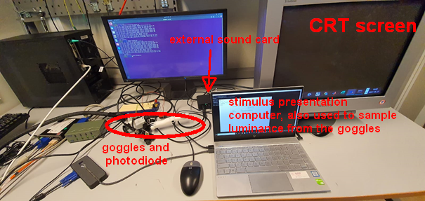
Figure 1: Overview of the experimental setup. The laptop was used to show the stimuli and to record the luminance from the goggles. The CRT screen and the goggles were connected as extended displays for the laptop.

Measurement of luminance
We used a BNC-mounted photodiode manufactured by Thorlabs and referred to as SM1PD1A. The actual photodiode inside was of type FDS1010 (the features are available at https://www.thorlabs.com/thorproduct.cfm?partnumber=SM1PD1A). The response time was given by the following formula: Tr = 0.35*2*pi*RL*CJ, where CJ = 375 pF. We wanted a response time of about 1 ms. Hence, the load resistance needed was RL = 0.001/(0.35*2*pi*0.000000000375) which should be less than 1,2 Mohm. We used a 1 Mohm resistance in our setup. We connected the photodiode to the following circuit, as recommended.

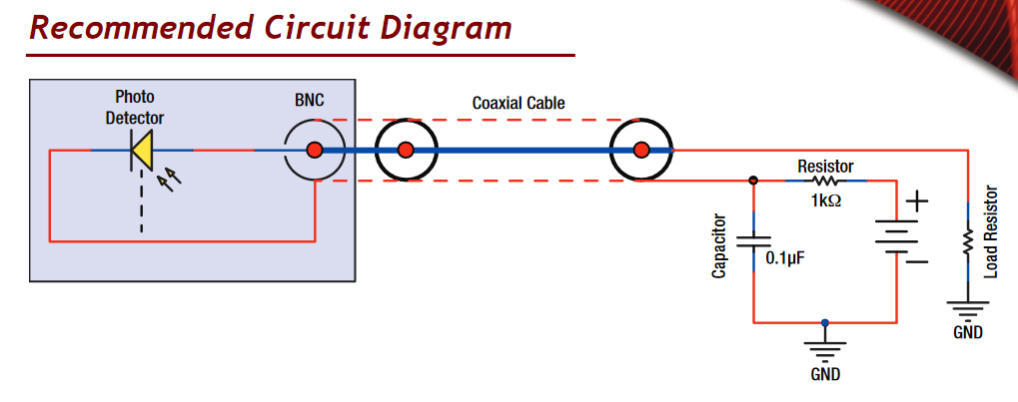
Figure 2: Recommended circuit for measuring luminance with the SM1PD1A photodiode.

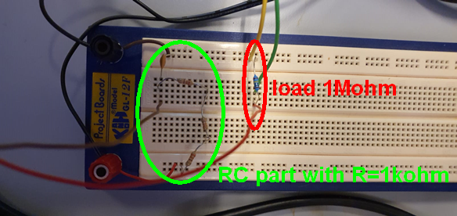
Figure 3: The same circuit as in Figure 2 in our setup.

Measurement from CRT screen
We first decided to test our setup with the CRT screen SONY GDM-F520, with a 75 Hz refresh rate and the same resolution as the goggles (800x600). The strong signal from the luminance of the CRT screen could be directly sampled by the sound card of a desktop PC (Intel Corporation 100Series/C230 Series Chipset Family HD Audio Control, shown on the left of Figure 1). A python script using pyaudio sampled and stored the input from the sound card at 1 kHz, which is more than enough to sample a luminance when the refresh rate is set to 75 Hz. The result is illustrated in the figures below:
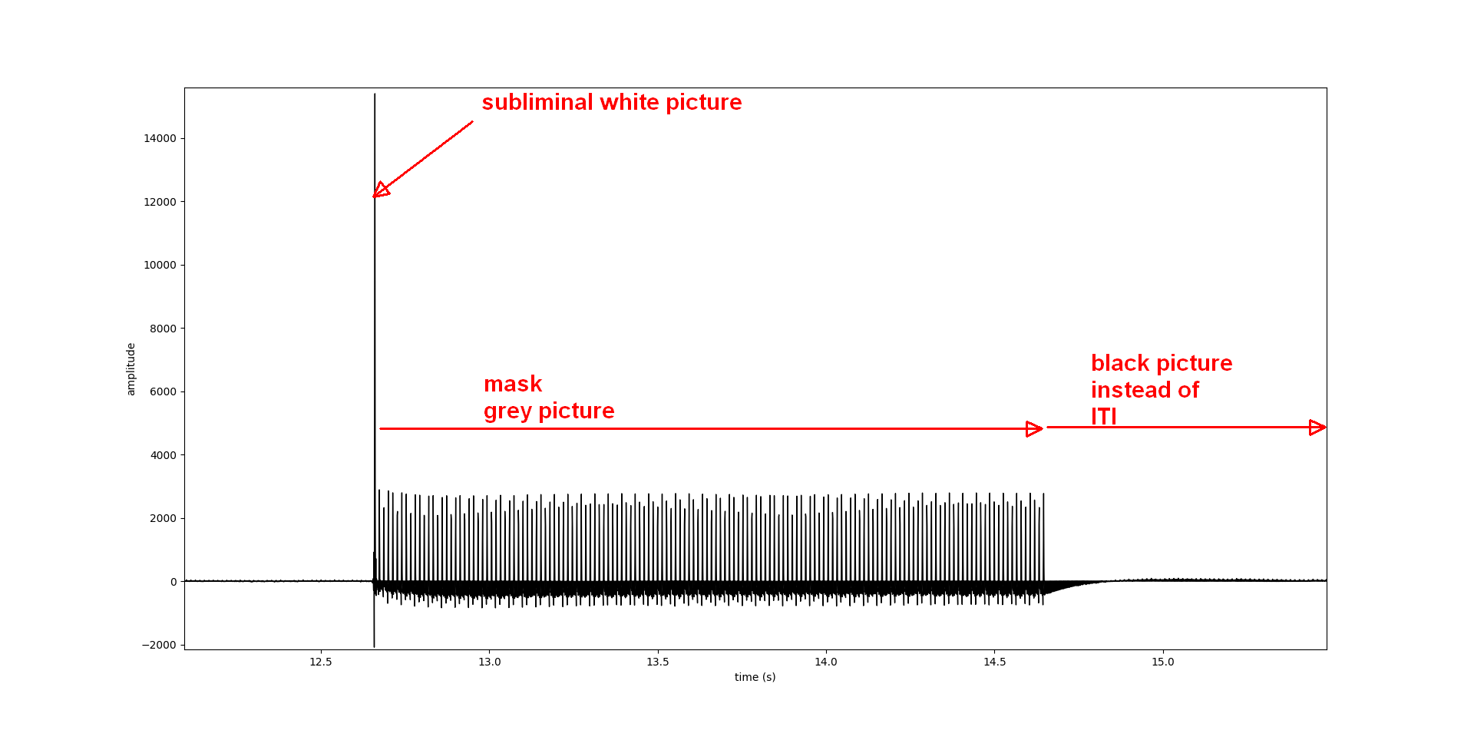
Figure 4: Detailed view of a trial including a subliminal white picture, a grey mask and a black picture replacing the ITI.
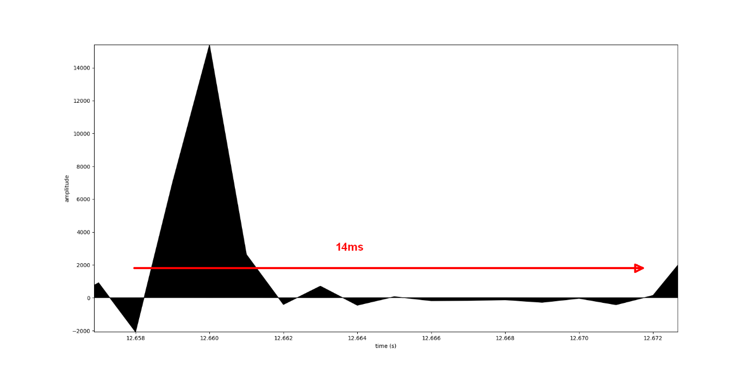
Figure 5: Detailed view on the refresh period of the subliminal white picture.
It shows a luminance curve specific to CRT screens and a refresh period of less than 14 ms, as expected (for background see Wiens et al. Keeping it short: a comparison of methods for brief picture presentation, Psychol. Sci., 15 (2004), pp. 282-285). We concluded that the setup was suitable for measuring the luminance from the goggles used in the experiment.

Measurement from the goggles
We reviewed technical documentation from the manufacturers of the goggles Nordic Neurolab and of the OLED display eMagin.
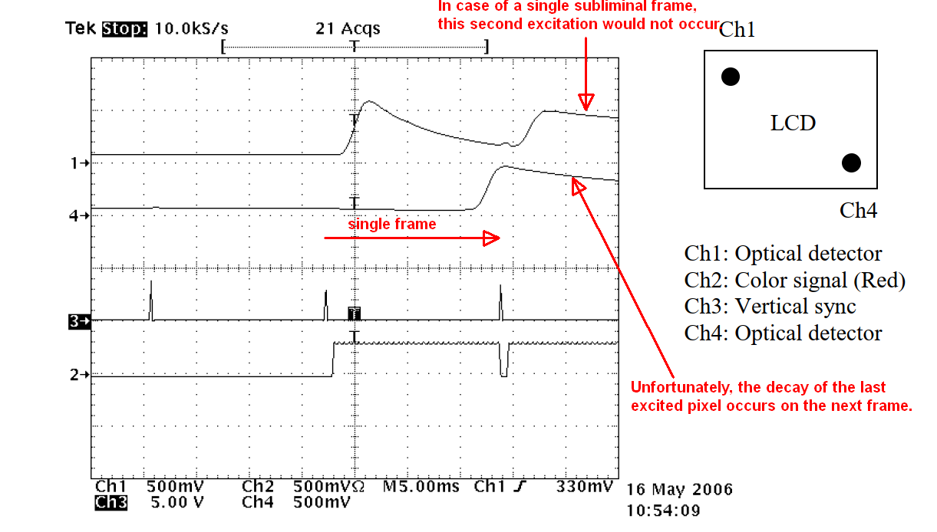
Figure 6: Measurement performed by the goggles manufacturer Nordic Neurolab showing that the luminance of all pixels has the time to rise within a frame duration but that the decay from the last excited pixels (Ch4) leaks on the next frame. Source: Oled display report, Andreas Sunnhordvik, 23 May 2006.
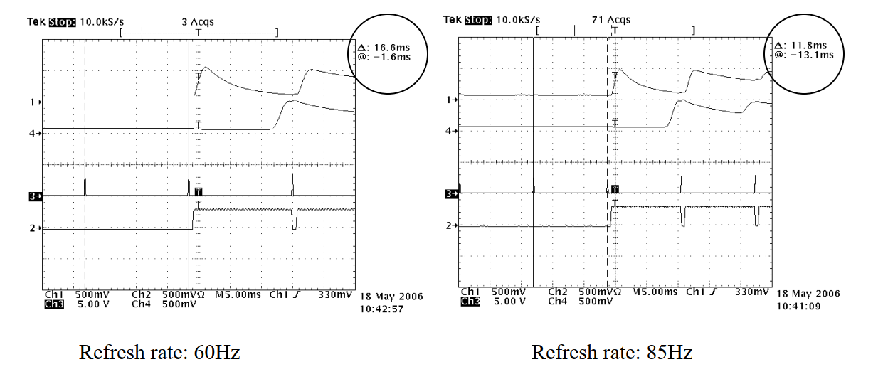
Figure 7: The manufacturer has performed these measurements at 60Hz and 85Hz, showing similar behaviour of the OLED. Source: Oled display report, Andreas Sunnhordvik, 23 May 2006.
The measurements performed by Nordic Neurolab in 2006 showed that the subliminal image would be displayed since each pixel can hold a refresh rate of 60, 72, 75 or even 85 Hz, with the corresponding luminance curve decaying to zero within a refresh time period. However, as the last excited pixels have their onsets close to the end of the time frame, the decay of their luminance occurs on the next frame (Figure 6). As our photodiode could only measure the luminance of the whole OLED display, it was expected that the luminance curve would look like a convolution of the response from one pixel by a pulse train. The luminance of the subliminal window could then last for more than 13.3 ms from its onset to its decay.
As the luminance from the goggles is very low, the voltage of the load resistor drowned in sound card noise when the OLED display was showing anything else than a white picture. Therefore, the load voltage was first amplified and then sampled by an external sound card Röde AI-1 (using that sound card for the CRT screen would lead to saturation). The same python script was used to sample data from the goggles. In order to maximize the signal, the optical elements of one of the goggles were removed so that the photodiode was directly mounted on the OLED.
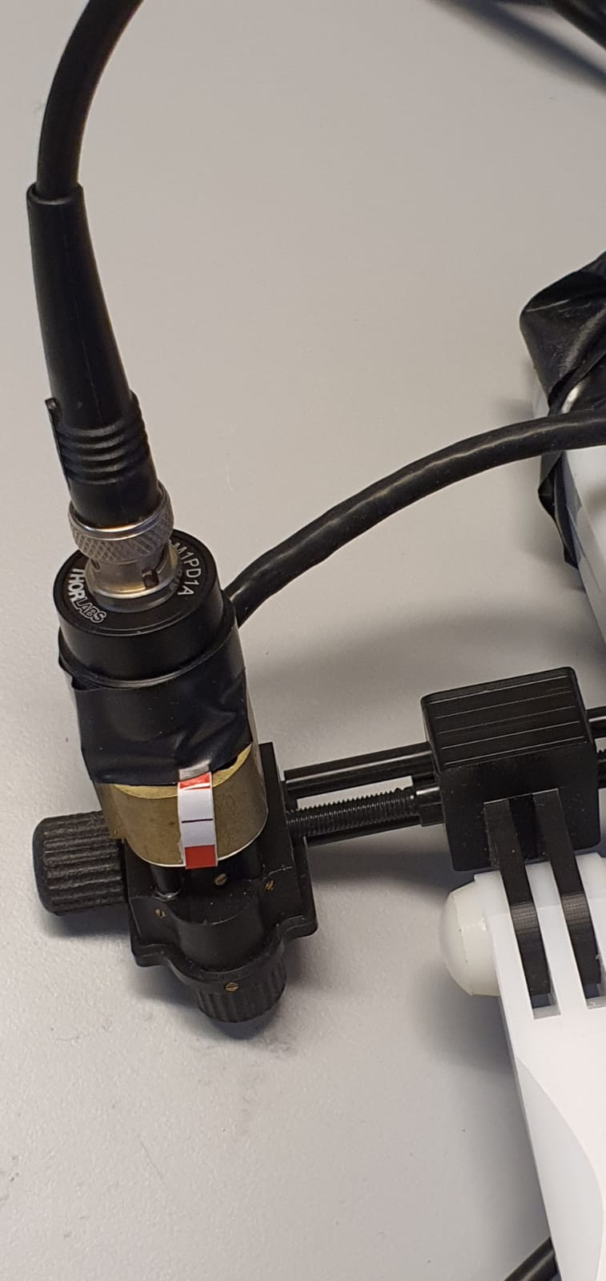
Figure 8: Photodiode SM1PD1A mounted on one of the OLED displays of the Nordic Neurolab goggles. Electrical tape was used to stabilize the sensor and isolate it from ambient light.

We examined two different types of trials: those directly masked by a 1980 ms grey window and those showing an 80 ms black screen before the mask. We focus on the trials for which the subliminal images were directly followed by a grey mask.
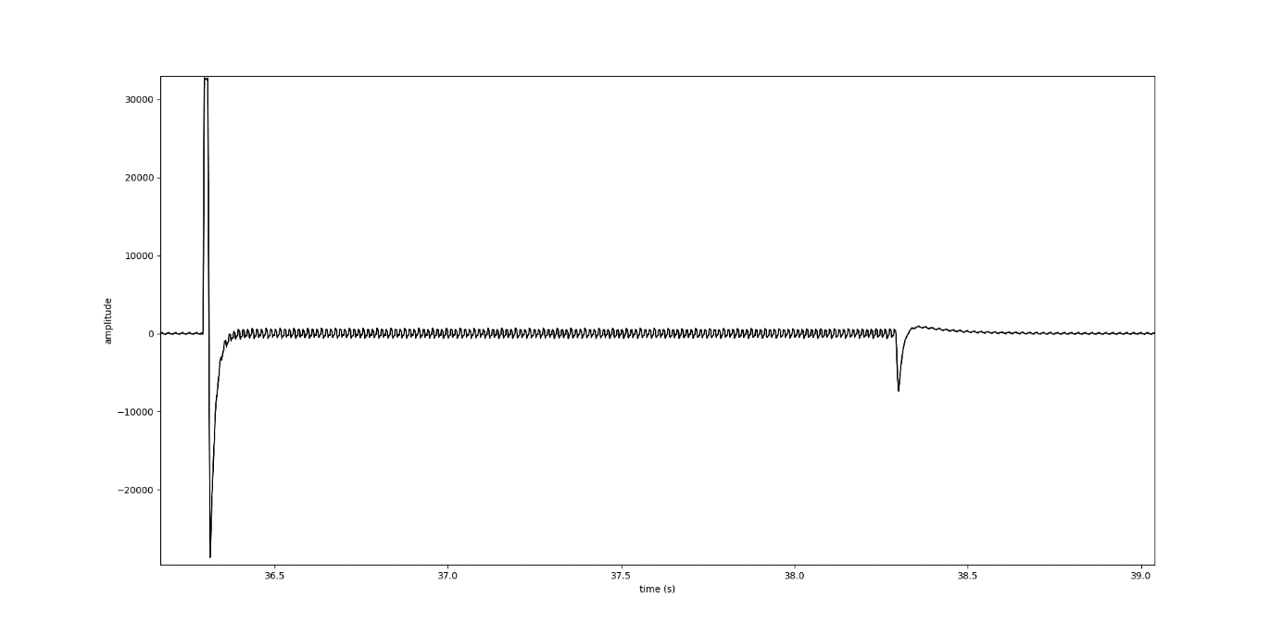
Figure 9: Luminance from the goggles during a trial where the mask follows directly after the subliminal image.
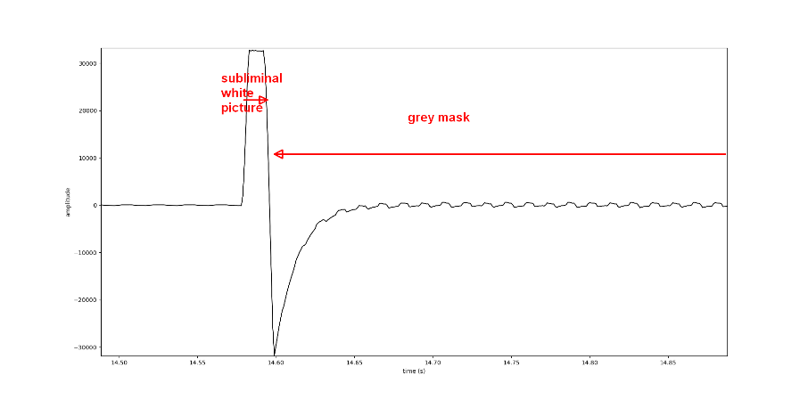
Figure 10: Detailed view over the time interval when the subliminal picture is presented and followed by the mask (a Gibbs artifact due to the step response of the filter in the sound card is visible).
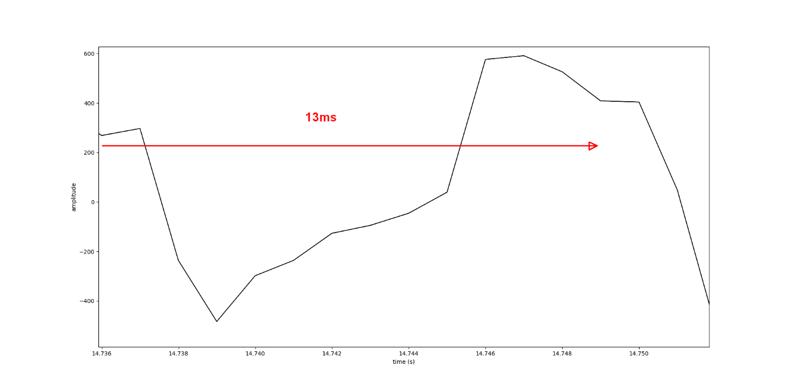
Figure 11: The luminance from the grey mask directly following the subliminal picture. It shows a period of about 13 ms, in accordance with the refresh rate of 75 Hz.
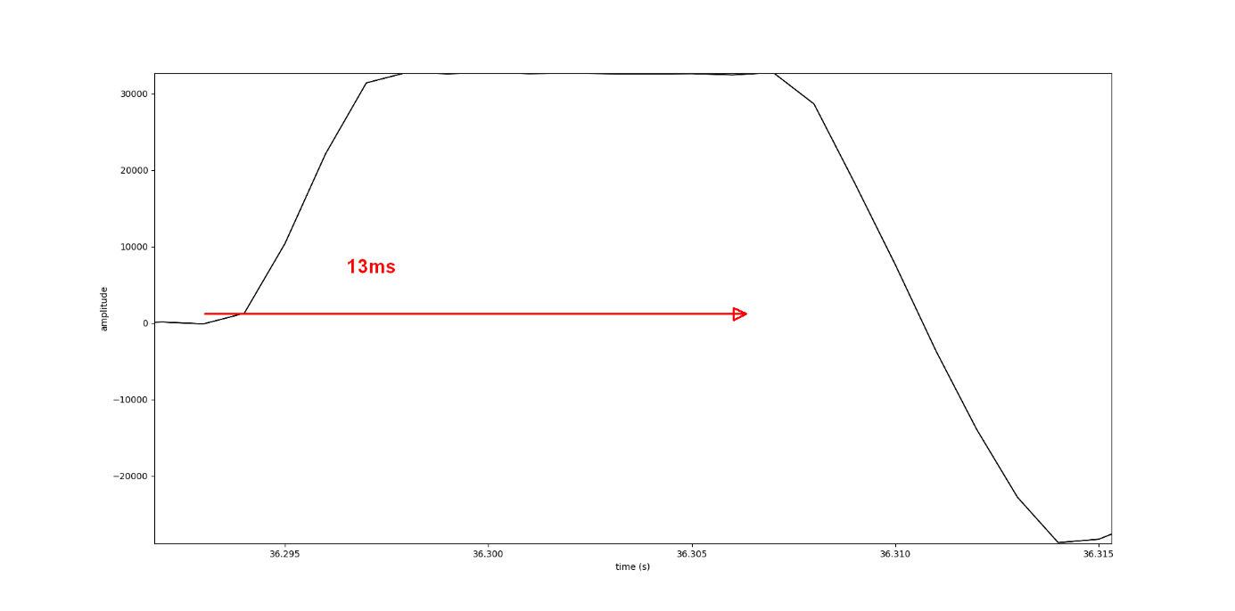
Figure 12: Detailed view of the luminance curve from one of the OLED displays of the goggles around a subliminal image. The white picture is displayed but the decay occurs after the 13.3 ms time interval.
From Figure 11, we can see that when successive frames show the same image, the amplified signal is stable and the refresh period as expected, i.e. 13.3ms. But when images are brighter and/or show larger differences in grey levels between two successive frames, the luminance curve lasts for almost 20 ms. It is important to remember that this is true for the OLED as a whole and not for each single pixel. At the pixel level, we expect the luminance curve to decay within a refresh time period. A drawback is that the next frame starts to be displayed at the top row before the end the current frame for the bottom row.

Analysis of the overshoots and undershoots
When the contrast between two successive pictures was too high, the amplified signal showed first an overshoot and then an undershoot, which made the measurement of the frame duration difficult. As this issue was (almost) invisible in the CRT measurements, we assumed that this artifact was a response from the filter in the sound card due to the frequency content of the luminance signal from the OLED display. In order to examine in more detail how the white picture was displayed, we modified the stimulus script by making the white picture non-subliminal, with a duration of 1 second. The result is displayed below.
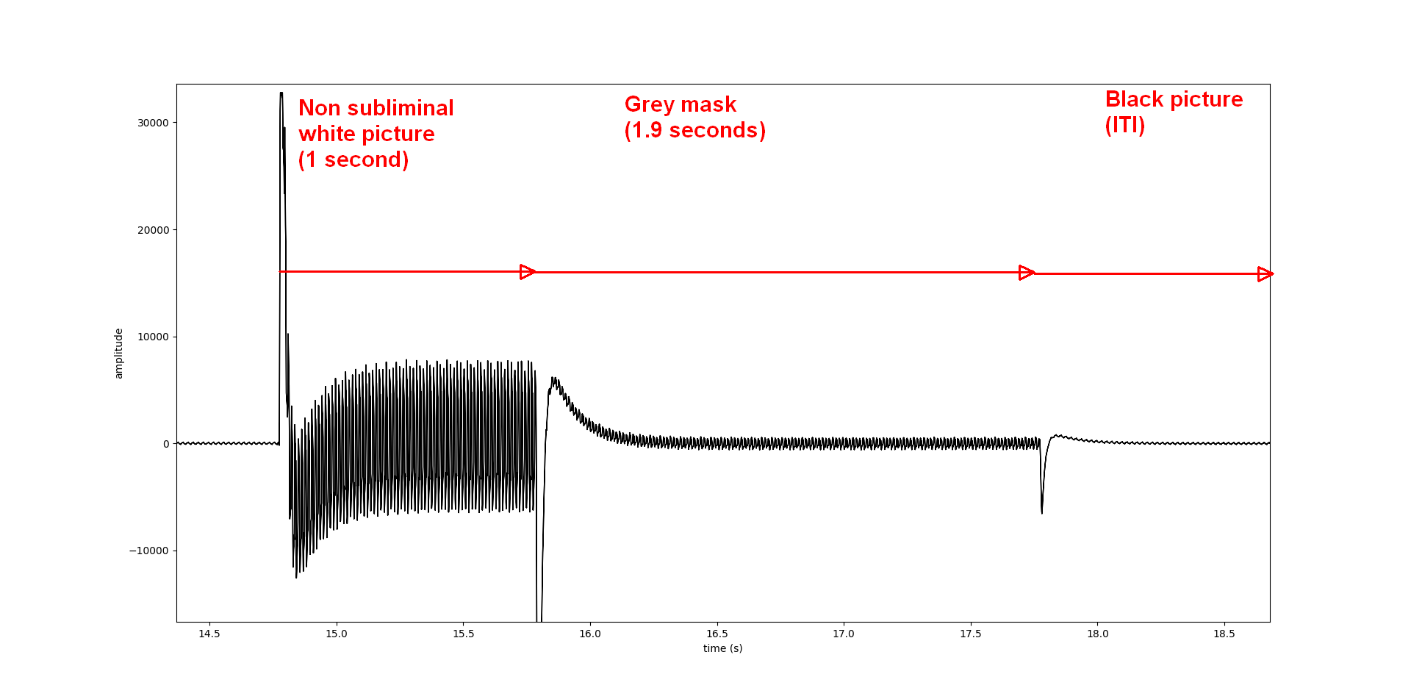
Figure 13: Non-subliminal trial, where the duration of the 13 ms white subliminal picture was extended to one second. It is then followed by the grey mask and the black ITI.
The artifact is present on each switch between two different grey levels. The higher the difference between the grey levels, the more visible is the artifact. Another amplifier and sampling device might be more suitable for the OLED signal in such cases.

Test of the paradigm
Figure 14 shows a recording over a whole fMRI session. One can see that the overshoots and undershoots due to the white subliminal images (seen as a pulse response from the amplifier) are present for each trial. Importantly, it shows that the Nordic Neurolab goggles display each of the scheduled subliminal images.
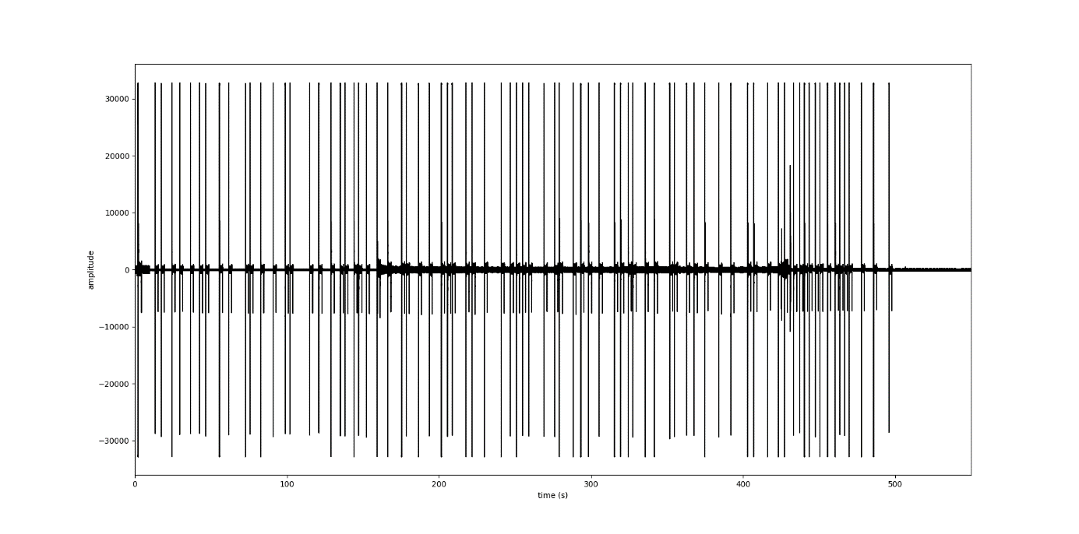
Figure 14: Luminance measurement from one of the OLED displays of the Nordic Neurolab goggles during a whole session.
This was also monitored in the log files from Presentation (Figure 15).
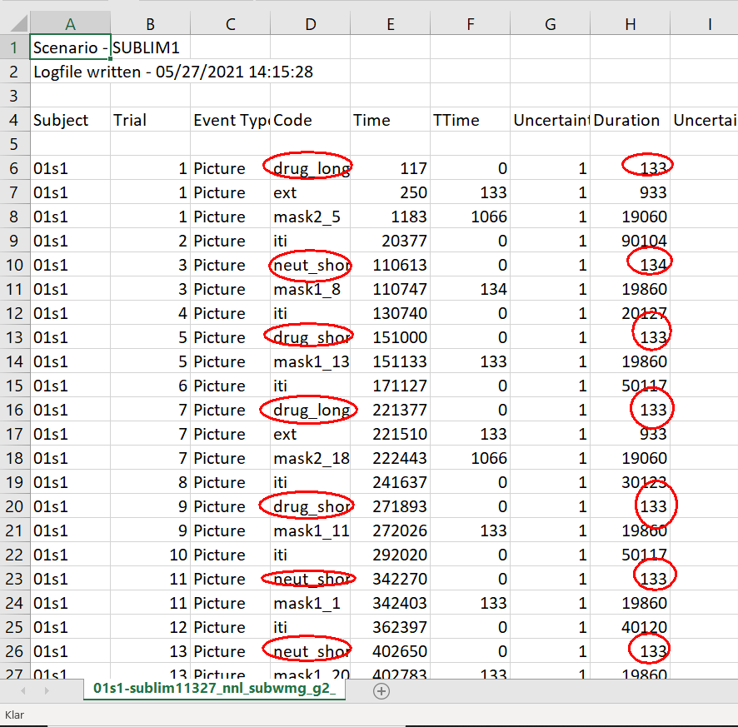
Figure 15: The log file of the session displayed in Figure 14. Each subliminal image and its duration in tenth of milliseconds is circled in red.

Conclusion
This hardware check confirmed that the equipment does indeed display the very brief stimuli as planned. Although some of the subliminal pictures might be displayed for slightly more than 13.3 ms, it was possible to show that they do not last longer than 20 ms. This is consistent with our behavioral pilot experiments, where these stimuli did not reach conscious awareness.

