Figure S1 (online supplementary material). Scatterplot of Y-BOCS scores for individuals of the intention-to-treat sample (n = 393). Marks are displayed for each individual patient indicating symptom severity at pretreatment (x-axis) plotted against symptom severity at post-treatment assessment (y-axis).
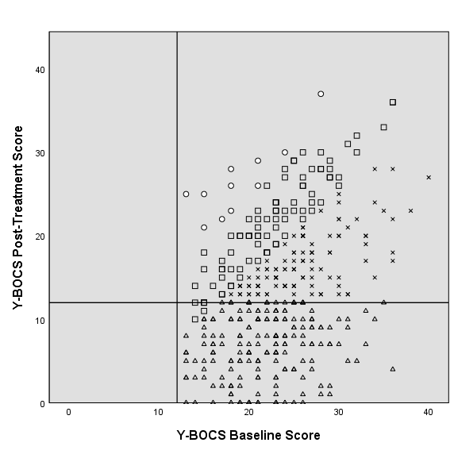
Note. Symbols denote outcome categories: △= Remission; × = Response without remission; □ = No change; = Deterioration. Vertical and horizontal lines indicate thresholds for subclinical symptom severity (Y-BOCS ≤ 12). Marks in the lower right quadrant highlight patients who had clinically relevant symptoms (> 12) before treatment but subthreshold symptoms (< 12) after treatment. Most were remitters according to our definition, but in fact were classified as unchanged if they did not reach a 35% reduction of symptom severity as well. Marks in the upper right quadrant highlight those patients presenting with clinically relevant symptoms before treatment and still after treatment (> 12). Nevertheless, they eventually could be responders if they had a reduction of their Y-BOCS score of 35% or more. Y-BOCS = Yale-Brown Obsessive-Compulsive Scale.

