Supplementary Material
Supplemental Table 1: Treatment characteristics according to lenvatinib dose at baseline
 | Overall  (n=205) | Standard dose (n=89) | Reduced dose (n=114)
Median overall survival (months) | 12.8 | 13.8 | 10.4
95% confidence interval of median overall survival (months) | 10.9-14.7 | 11.1-16.5 | 7.8-13.1
Median progression free survival (months) | 6.4 | 6.7 | 5.9
95% confidence interval of progression free survival (months) | 5.1- 7.7 | 4.8-8.6 | 4.5-7.3
Disease control | 117 (57.1) | 48 (53.9) | 68 (59.6)
Overall response | 48 (23.4) | 23 (25.8) | 25 (21.9)

Supplemental Table 2: Subsequent treatment after lenvatinib
Subsequent treatment (n=97)
Systemic second-line (n=88)
Sorafenib | 56 (63.3)
Ramucirumab | 9 (10.2)
Pembrolizumab | 4 (4.5)
Nivolumab | 2 (2.3)
Atezolizumab plus Bevacizumab | 3 (3.4)
Regorafenib | 2 (2.3)
Cabozantinib | 11 (12.5)
Ipilimumab plus Nivolumab | 2 (2.3)
Other | 1 (1.1)
Subsequent Immunotherapy independent from treatment line | 11 (12.5)
Anti cancer procedures (n=9)
Transplantation | 1 (1.1)
TACE | 0
SIRT | 3 (3.4)
Radiation | 3 (3.4)
Ablation | 2 (2.3)
Resection | 0

Supplemental Table 3: Frequency of adverse events
Frequency of adverse events | Overall  (n=205) | Standard  Dose  (n=89) | Reduced dose  (n=114) | Unknown dose  (n=2)
Adverse events | 160 (78.1) | 66 (74.2) | 94 (82.5) | 0
Diarrhea | 38 (18.5) | 16 (18.0) | 22 (19.3) | 0
Fatigue | 72 (35.1) | 29 (32.6) | 43 (37.7) | 0
Hypertension | 18 (8.8) | 8 (9.0) | 9 (7.9) | 1 (50)
Weight loss | 32 (15.6) | 13 (14.6) | 19 (16.7) | 0
Appetite loss | 42 (20.5) | 9 (10.1) | 31 (27.2) | 2 (100)
Skin reaction | 15 (7.3) | 7 (7.9) | 8 (7.0) | 0
No Adverse Events reported or documented | 45 (21.9) | 23 (25.8) | 20 (17.5) | 2 (100)
Severe adverse events (≥grade 3) | 97 (47.3) | 37 (41.6) | 58 (50.9) | 2 (100)
Treatment interruption due to AEs | 63 (30.7) | 24 (27.0) | 38 (33.3) | 1 (50)
Dose reduction due to AEs | 73 (35.6) | 30 (33.7) | 42 (36.8) | 1 (50)
End of treatment due to significantly liver dysfunction | 30 (14.6) | 12 (13.5) | 18 (15.8) | 0
Progress or onset of ascites | 34 (19.6) | 15 (16.9) | 19 (16.7) | 0
Ascitic decompensation under treatment | 6 (2.9) | 1 (1.1) | 5 (4.4) | 0
Newly diagnosed hepatic encephalopathy under treatment | 18 (8.8) | 9 (10.1) | 9 (7.9) | 0
Severe hepatic encephalopathy  (Grade III or IV) under treatment | 8 (3.9) | 5 (5.6) | 3 (2.6) | 0
Treatment discontinuation due to AEs (other than liver dysfunction) | 45 (21.9) | 19 (21.3) | 26 (22.8) | 0
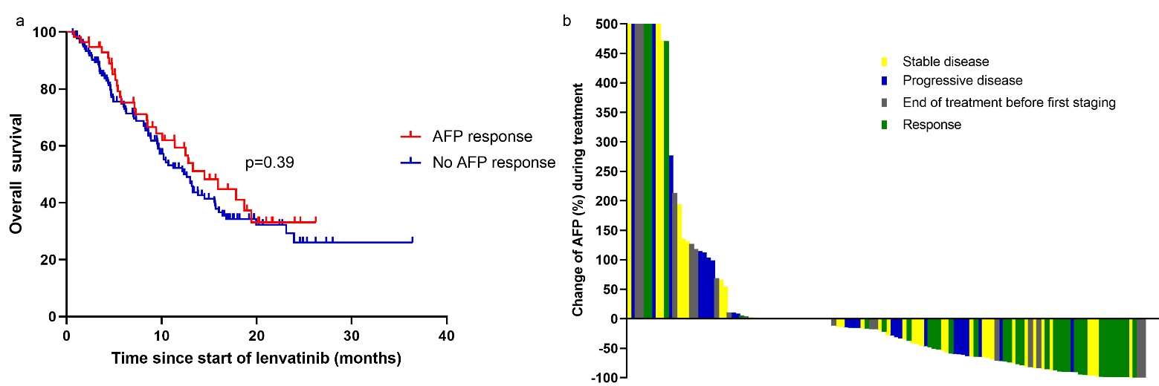

Supplemental Fig. 1. Kaplan-Meier analysis of progression free survival (Supplemental Fig 1a) and overall survival (Supplemental Fig 1b) divided by the number of TACE treatments before start of lenvatinib
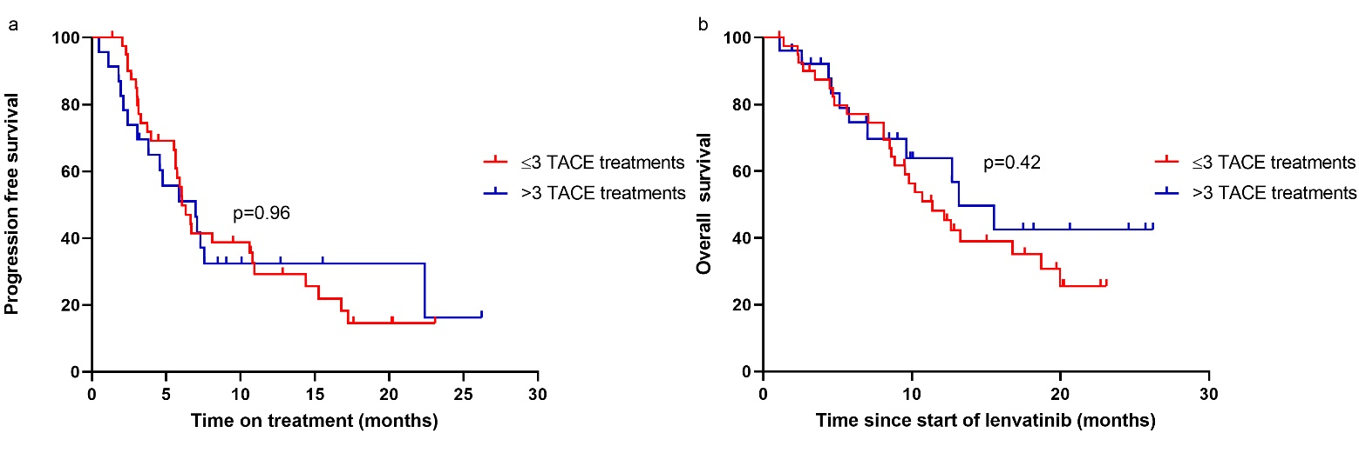
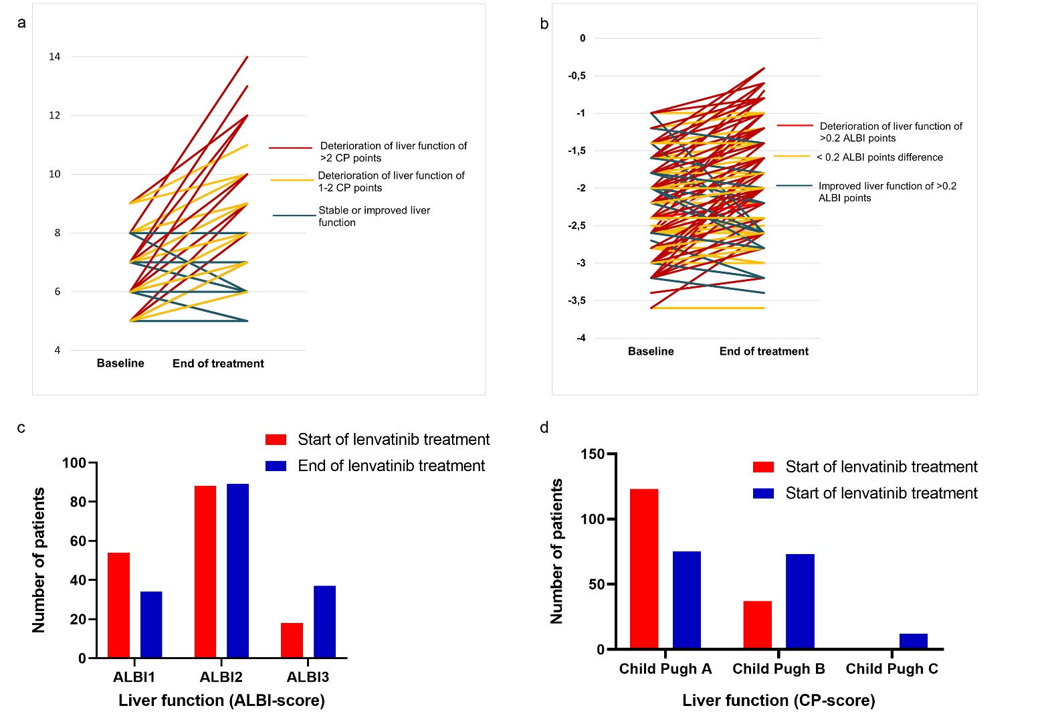
Supplemental Fig. 2. Kaplan-Meier analysis of overall survival according to AFP response (Supplemental Fig 2a), and correlation between AFP response and radiological response (Supplemental Fig 2b)

Supplemental Fig 3. Comparison of liver function at baseline and end of treatment measured by Child Pugh score (Supplemental Fig 3a, 3d) and ALBI Score (Supplemental Fig 3b, 3c)

