Supplementary Figure 1. Study flow chart.
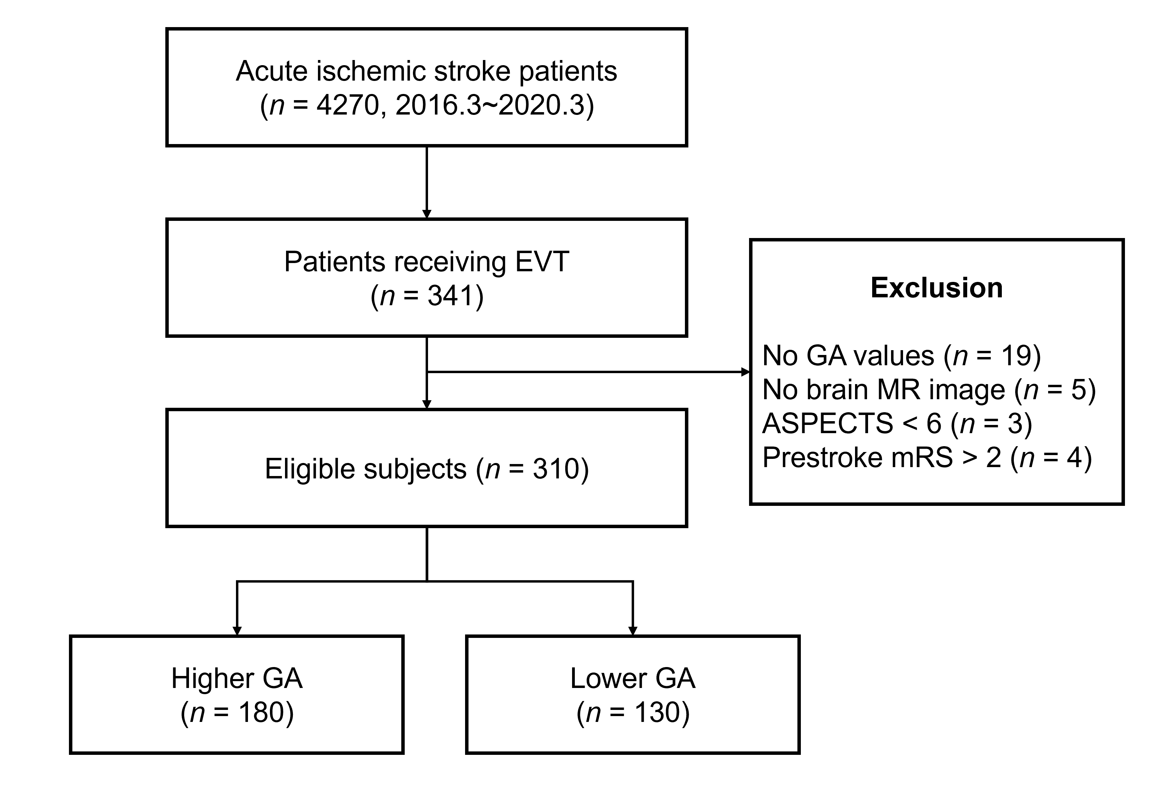
EVT, endovascular treatment; GA, glycated albumin; ASPECTS, Alberta Stroke Program Early CT score; mRS, modified Rankin Scale score.

Supplementary Figure 2. Distribution of outcomes according to glycated hemoglobin level.
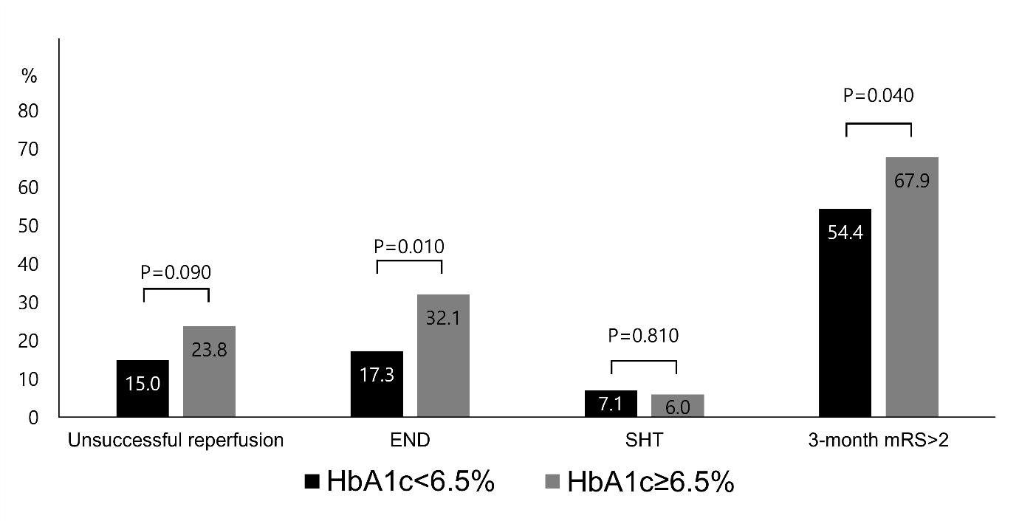
HbA1c, glycated hemoglobin; END, early neurological deterioration; SHT, symptomatic hemorrhagic transformation; mRS, modified Rankin Scale.

 | Model 1 |  | Model 2 |  | Model 3
 | OR | 95% CI | OR | 95% CI | OR | 95% CI
Age, years | 1.05 | 1.01–1.09 | 1.05 | 1.01–1.09 | 1.06 | 1.01–1.10
Male | 0.79 | 0.37–1.68 | 0.88 | 0.42–1.82 | 0.94 | 0.45–1.99
Stroke subtype
Others | 1.00 | reference | 1.00 | reference | 1.00 | reference
CE | 0.60 | 0.23–1.62 | 0.62 | 0.24–1.65 | 0.66 | 0.24–1.76
LAA | 0.38 | 0.13–1.15 | 0.46 | 0.16–1.35 | 0.53 | 0.18–1.60
NIHSS | 0.96 | 0.91–1.02 | 0.96 | 0.91–1.02 | 0.96 | 0.91–1.02
Hypertension | 1.58 | 0.70–3.60 | 1.50 | 0.66–3.37 | 1.51 | 0.67–3.44
Diabetes | 0.47 | 0.20–1.13 | 0.56 | 0.24–1.33 | 0.42 | 0.17–1.08
Current Smoking | 0.8 | 0.26–2.44 | 0.78 | 0.25–2.39 | 0.81 | 0.26–2.50
Atrial fibrillation | 0.64 | 0.22–1.86 | 0.63 | 0.23–1.76 | 0.59 | 0.21–1.68
Prior antithrombotics | 0.51 | 0.24–1.09 | 0.49 | 0.23–1.03 | 0.5 | 0.24–1.06
Combined IVT and EVT | 0.65 | 0.32–1.30 | 0.66 | 0.33–1.32 | 0.64 | 0.32–1.28
Creatinine, mg/dL | 0.82 | 0.36–1.84 | 0.78 | 0.35–1.77 | 0.71 | 0.28–1.76
Platelet, uL/10³ | 1.00 | 1.00–1.01 | 1.00 | 1.00–1.01 | 1.00 | 1.00–1.01
INR | 1.60 | 0.50–5.20 | 1.76 | 0.53–5.85 | 1.86 | 0.56–6.17
HbA1c, % | 0.98 | 0.72–1.33 | – | – | 0.93 | 0.98–1.01
CRP, mg/dL | 0.99 | 0.98–1.01 | 1.00 | 0.98–1.01 | 1.00 | 0.98–1.01
Initial glucose, mg/dL | 1.00 | 1.00–1.01 | 1.01 | 1.00–1.01 | 1.00 | 1.00–1.01
GA ≥16% | 4.13 | 1.93–8.85 | – | – | – | –
GA/HbA1c | – | – | 2.25 | 1.18–4.30 | – | –
raw GA, % | – | – | – | – | 1.17 | 1.06–1.29
Supplementary Table 1. Result of multivariate logistic regression analysis showing association other glycemic parameters and modified Thrombolysis in Cerebral Infarction 0 to 2a
OR, odds ratio; CI, confidence interval; CE, cardioembolism; LAA, large artery atherosclerosis; NIHSS, National Institute of Health Stroke Scale; IVT, intravenous thrombolysis; IAT, intraarticular thrombolysis; INR, international normalized ratio; CRP, C-reactive protein; GA, glycated albumin; HbA1c, glycated hemoglobin.
 | Model 1 |  | Model 2 |  | Model 3
 | OR | 95% CI | OR | 95% CI | OR | 95% CI
Age, years | 1.01 | 0.98–1.05 | 1.01 | 0.98–1.05 | 1.01 | 0.98–1.05
Male | 0.79 | 0.41–1.54 | 0.87 | 0.44–1.70 | 0.88 | 0.45–1.75
Stroke subtype
Others | 1.00 | reference | 1.00 | reference | 1.00 | reference
CE | 1.01 | 0.41–2.51 | 1.08 | 0.42–2.74 | 1.09 | 0.42–2.83
LAA | 0.23 | 0.08–0.65 | 0.27 | 0.09–0.81 | 0.29 | 0.09–0.89
NIHSS | 0.98 | 0.93–1.04 | 0.98 | 0.93–1.03 | 0.98 | 0.93–1.03
Hypertension | 1.37 | 0.65–2.87 | 1.47 | 0.68–3.16 | 1.47 | 0.68–3.20
Diabetes | 1.72 | 0.84–3.50 | 1.28 | 0.60–2.74 | 1.13 | 0.51–2.50
Current Smoking | 0.58 | 0.20–1.70 | 0.51 | 0.17–1.55 | 0.51 | 0.17–1.56
Atrial fibrillation | 2.37 | 0.88–6.39 | 2.07 | 0.74–5.77 | 2.05 | 0.72–5.82
Prior antithrombotics | 0.77 | 0.40–1.47 | 0.74 | 0.37–1.45 | 0.73 | 0.37–1.45
Combined IVT and EVT | 1.00 | 0.54–1.85 | 1.07 | 0.57–2.02 | 1.05 | 0.55–1.98
Creatinine, mg/dL | 1.41 | 0.75–2.63 | 1.24 | 0.65–2.35 | 1.24 | 0.64–2.39
Platelet, uL/10³ | 1.00 | 1.00–1.00 | 1.00 | 0.99–1.00 | 1.00 | 0.99–1.00
INR | 0.35 | 0.05–2.47 | 0.26 | 0.03–2.42 | 0.27 | 0.03–2.69
HbA1c, % | 1.09 | 0.84–1.41 | – | – | 1.02 | 0.75–1.38
CRP, mg/dL | 1.00 | 0.98–1.01 | 0.998 | 0.98–1.01 | 1.00 | 0.98–1.01
Initial glucose, mg/dL | 1.00 | 1.00–1.01 | 0.999 | 0.99–1.01 | 1.00 | 0.99–1.00
GA ≥16% | 1.99 | 1.04–3.81 | – | – | – | –
GA/HbA1c | – | – | 3.46 | 1.47–6.72 | – | –
raw GA, % | – | – | – | – | 1.23 | 1.11–1.36
Supplementary Table 2. Result of multivariate logistic regression analysis showing association other glycemic parameters and early neurological deterioration
OR, odds ratio; CI, confidence interval; CE, cardioembolism; LAA, large artery atherosclerosis; NIHSS, National Institute of Health Stroke Scale; IVT, intravenous thrombolysis; IAT, intraarticular thrombolysis; INR, international normalized ratio; CRP, C-reactive protein; GA, glycated albumin; HbA1c, glycated hemoglobin.

 | Model 1 |  | Model 2 |  | Model 3
 | OR | 95% CI | OR | 95% CI | OR | 95% CI
Age, years | 1.00 | 0.94–1.06 | 1.10 | 0.96–1.07 | 1.01 | 0.96–1.07
Male | 1.13 | 0.38–3.36 | 1.37 | 0.47–4.01 | 1.39 | 0.47–4.10
Stroke subtype
Others | 1.00 | reference | 1.00 | reference | 1.00 | reference
CE | 0.74 | 0.14–3.78 | 0.65 | 0.14–3.09 | 0.69 | 0.14–3.37
LAA | 0.85 | 0.15–4.95 | 0.90 | 0.1–4.81 | 1.05 | 0.19–5.82
NIHSS | 0.98 | 0.89–1.08 | 0.97 | 0.88–1.08 | 0.97 | 0.88–1.08
Hypertension | 0.59 | 0.18–1.99 | 0.58 | 0.17–1.94 | 0.57 | 0.17–1.95
Diabetes | 2.69 | 0.75–9.65 | 3.21 | 0.94–10.95 | 2.77 | 0.74–10.30
Current Smoking
Atrial fibrillation | 0.81 | 0.19–3.56 | 0.73 | 0.17–3.05 | 0.72 | 0.17–3.03
Prior antithrombotics | 0.82 | 0.27–2.54 | 0.91 | 0.30–2.73 | 0.89 | 0.29–2.68
Combined IVT and EVT | 10.31 | 2.50–42.51 | 10.16 | 2.43–42.48 | 10.18 | 2.43–42.61
Creatinine, mg/dL | 2.06 | 0.89–4.80 | 1.93 | 0.81–4.62 | 1.94 | 0.80–4.73
Platelet, uL/10³ | 1.00 | 0.99–1.01 | 1.00 | 0.99–1.01 | 1.00 | 0.99–1.01
INR | 0.76 | 0.02–33.19 | 1.05 | 0.04–31.35 | 1.19 | 0.04–35.15
HbA1c, % | 0.85 | 0.49–1.49 |  |  | 0.84 | 0.45–1.57
CRP, mg/dL | 1.01 | 0.99–1.03 | 1.01 | 0.99–1.03 | 1.01 | 0.99–1.03
Initial glucose, mg/dL | 0.99 | 0.98–1.01 | 0.99 | 0.98–1.01 | 0.99 | 0.98–1.00
GA ≥16% | 4.82 | 1.35–17.29 | – | – | – | –
GA/HbA1c | – | – | 2.47 | 0.84–7.25 | – | –
raw GA, % | – | – | – | – | 1.16 | 0.99–1.35
Supplementary Table 3. Result of multivariate logistic regression analysis showing association other glycemic parameters and symptomatic hemorrhagic transformation
OR, odds ratio; CI, confidence interval; CE, cardioembolism; LAA, large artery atherosclerosis; NIHSS, National Institute of Health Stroke Scale; IVT, intravenous thrombolysis; IAT, intraarticular thrombolysis; INR, international normalized ratio; CRP, C-reactive protein; GA, glycated albumin; HbA1c, glycated hemoglobin.
 | GA≥16% in the model |  | GA/HbA1c in the model |  | raw GA in the model
 | OR | 95% CI | OR | 95% CI | OR | 95% CI
Age, years | 1.02 | 0.99–1.05 | 1.02 | 0.99–1.05 | 1.02 | 0.99-1.04
Male | 0.74 | 0.40–1.38 | 0.78 | 0.42–1.45 | 0.74 | 0.39-1.41
Stroke subtype
Others | 1.00 | reference | 1.00 | reference | 1.00 | reference
CE | 0.81 | 0.34–1.90 | 0.78 | 0.34–1.79 | 0.90 | 0.37–2.17
LAA | 0.36 | 0.14–0.97 | 0.36 | 0.14–0.94 | 0.45 | 0.16–1.23
NIHSS | 1.13 | 1.07–1.19 | 1.12 | 1.07–1.18 | 1.14 | 1.08–1.20
Hypertension | 1.61 | 0.86–3.01 | 1.59 | 0.86–2.94 | 1.59 | 0.84–3.00
Diabetes | 1.07 | 0.53–2.15 | 1.35 | 0.97–2.66 | 0.72 | 0.34–1.52
Current Smoking | 0.56 | 0.24–1.31 | 0.51 | 0.22–1.19 | 0.53 | 0.22–1.29
Atrial fibrillation | 1.50 | 0.66–3.44 | 1.46 | 0.64–3.31 | 1.34 | 0.58–3.13
Prior antithrombotics | 0.98 | 0.54–1.78 | 0.89 | 0.49–1.62 | 0.91 | 0.49–1.67
Combined IVT and EVT | 0.61 | 0.35–1.06 | 0.62 | 0.36–1.07 | 0.61 | 0.35–1.06
Creatinine, mg/dL | 1.85 | 0.74–4.63 | 1.79 | 0.70–4.59 | 1.62 | 0.66–3.96
Platelet, uL/10³ | 1.00 | 1.00–1.00 | 1.00 | 1.00–1.01 | 1.00 | 1.00–1.01
INR | 2.24 | 0.33–15.42 | 3.27 | 0.54–19.72 | 2.16 | 0.30–15.70
HbA1c, % | 1.15 | 0.90–1.48 |  |  | 1.18 | 0.91–1.52
CRP, mg/dL | 1.00 | 0.99–1.02 | 1.01 | 0.99–1.02 | 1.00 | 0.99–1.02
Initial glucose, mg/dL | 1.00 | 0.99–1.01 | 1.00 | 1.00–1.01 | 1.00 | 0.99–1.00
GA ≥16% | 2.84 | 1.56–5.19 | – | – | – | –
GA/HbA1c | – | – | 2.54 | 1.40–4.61 | – | –
raw GA, % | – | – | – | – | 1.34 | 1.18–1.53
Supplementary Table 4. Result of multivariate logistic regression analysis showing association other glycemic parameters and 3-month mRS >2
OR, odds ratio; CI, confidence interval; CE, cardioembolism; LAA, large artery atherosclerosis; NIHSS, National Institute of Health Stroke Scale; IVT, intravenous thrombolysis; IAT, intraarticular thrombolysis; INR, international normalized ratio; CRP, C-reactive protein; GA, glycated albumin; HbA1c, glycated hemoglobin.
 | mTICI 0-2a |  | END |  | SHT |  | 3-month mRS >2
 | OR | 95% CI | OR | 95% CI | OR | 95% CI | OR | 95% CI
HbA1c ≥6.5% | 2.20 | 1.00–4.84 | 1.94 | 0.94–3.99 | 0.61 | 0.17–2.25 | 1.70 | 0.84–2.42
Age, years | 1.06 | 1.03–1.10 | 1.04 | 1.01–1.07 | 1.01 | 0.96–1.06 | 1.04 | 1.1–1.06
Male | 0.85 | 0.43–1.69 | 0.80 | 0.73–1.51 | 1.01 | 0.37–0.76 | 0.71 | 0.41–1.24
Stroke subtype
Others | 1.00 | reference | 1.00 | reference | 1.00 | reference | 1.00 | reference
CE | 0.72 | 0.29–1.76 | 1.07 | 0.45–2.52 | 0.72 | 0.17–3.09 | 0.89 | 0.41–1.96
LAA | 0.36 | 0.15–0.86 | 0.42 | 0.18–0.98 | 0.58 | 0.16–2.11 | 0.60 | 0.29–1.25
NIHSS | 0.97 | 0.92–1.03 | 0.99 | 0.94–1.04 | 1.00 | 0.92–1.08 | 1.12 | 1.07–1.17
Diabetes | 0.62 | 0.28–1.36 | 2.00 | 1.04–3.84 | 2.99 | 1.08–8.31 | 1.72 | 0.92–3.23
Hyperlipidemia | 0.80 | 0.31–1.95 | 0.96 | 0.43–2.13 | 1.14 | 0.33–3.95 | 0.74 | 0.36–1.49
LDL, mg/dL | 1.01 | 1.00–1.01 | 1.00 | 0.99–1.00 | 0.98 | 0.96–0.99 | 1.00 | 0.99–1.01
CRP, mg/dL | 1.00 | 0.99–1.01 | 1.00 | 0.98–1.01 | 0.99 | 0.97–1.01 | 1.01 | 1.00–1.02
Initial glucose, mg/dL | 1.00 | 1.00–1.01 | 1.00 | 1.00–1.01 | 1.00 | 0.99–1.01 | 1.00 | 1.00–1.01
Supplementary Table 5. Result of multivariate logistic regression analysis showing association higher glycated hemoglobin parameters and outcomes
mTICI, modified Thrombolysis in Cerebral infarction; END, early neurological deterioration; SHT, symptomatic hemorrhagic transformation; mRS, modified Rankin Scale Score; HbA1c, glycated hemoglobin; OR, odds ratio; CI, confidence interval; CE, cardioembolism; LAA, large artery atherosclerosis; NIHSS, National Institute of Health Stroke Scale; LDL, low-density lipoprotein; CRP, C-reactive protein.

Supplemental Table 6. Result of multivariate logistic regression analyses showing effects of higher glycated albumin on outcomes according to type of recanalization therapy
 | IV+EVT group (n=151) |  |  | EVT only group (n=159)
 | OR | 95% CI | p-value | OR | 95% CI | p-value
mTICI 0-2a | 1.69 | 0.56-5.08 | 0.35 | 6.05 | 2.19-16.69 | <0.001
END | 3.23 | 1.26-8.28 | 0.01 | 1.39 | 0.61-3.18 | 0.43
SHT | 4.80 | 1.38-16.75 | 0.01 | 1.70 | 0.28-12.07 | 0.42
3-month mRS >2 | 3.17 | 1.37-7.30 | 0.007 | 2.71 | 1.23-5.99 | 0.01
IV, intravenous recombinant tissue type plasminogen activator ; EVT, endovascular therapy; OR, odds ratio; CI, confidence interval; mTICI, modified Thrombolysis in Cerebral Infarction; END, early neurologic deterioration; SHT, symptomatic hemorrhagic transformation; mRS, modified Rankin Scale. Multivariate logistic regression models were adjusted for age, gender, stroke subtype, initial National Institute of Health Score Scale, type of endovascular therapy, creatinine, platelet count, C-reactive protein and initial glucose.

Supplemental Table 7. Result of multivariate logistic regression analyses showing effects of different criteria of higher glycated hemoglobin (6.5% vs 7.0%) on outcomes.
 | HbA1c≥6.5% |  |  | HbA1c≥7.0%
 | OR | 95% CI | p-value | OR | 95% CI | p-value
mTICI 0-2a | 2.20 | 0.998-4.84 | 0.05 | 1.92 | 0.81-4.58 | 0.14
END | 1.94 | 0.94-3.99 | 0.07 | 2.89 | 1.33-6.30 | 0.008
SHT | 0.61 | 0.17-2.25 | 0.46 | 2.16 | 0.57-8.18 | 0.26
3-month mRS >2 | 1.70 | 0.84-3.42 | 0.14 | 2.99 | 1.28-7.01 | 0.01
HbA1c, glycated hemoglobin; OR, odds ratio; CI, confidence interval; mTICI, modified Thrombolysis in Cerebral Infarction; END, early neurologic deterioration; SHT, symptomatic hemorrhagic transformation; mRS, modified Rankin Scale. Multivariate logistic regression models were adjusted for age, gender, stroke subtype, initial National Institute of Health Score Scale, type of endovascular therapy, creatinine, platelet count, C-reactive protein and initial glucose.

