Supplemental Data
Olesen et al. Development, Characterization and In Vivo Validation of a humanized C6 Monoclonal Antibody that Inhibits the Membrane Attack Complex.

SUPP. FIGURE 1
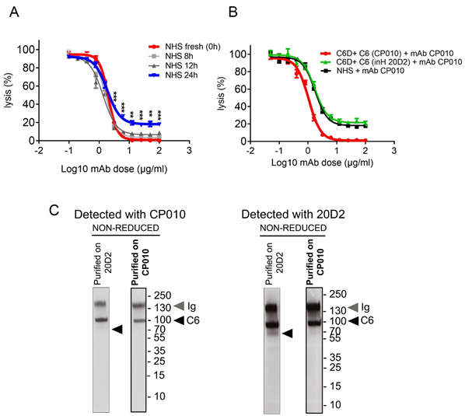
Suppl Fig. 1. CP010 blocks activity of intact C6 but does not inhibit an in vitro-generated clipped C6
A. Classical pathway haemolytic (CH50) assay showing that CP010-resistant haemolysis develops in vitro. Normal human serum (NHS) was used fresh or after incubation at 4⁰C for 8, 12 or 24h; serum was diluted to 2.5% and added to triplicate sets of wells containing CP010 dilution series (0-100 µg/ml). ShEA were added to each well and incubated. Haemolysis was measured and significance assessed as above. B. Classical pathway haemolytic (CH50) assays showing inhibition by CP010 of lytic activity of C6-depleted serum (C6D; NHS passed over immobilised in house anti-C6 mAb 20D2) reconstituted with physiological amounts of C6, affinity purified either using mAb CP010 or mAb 20D2. NHS was used as positive control. NHS and reconstituted depleted sera (C6D+C6) were diluted to 2.5% and added to triplicate sets of wells containing a dilution series of mAb CP010. ShEA were added to each well and incubated. The percentage lysis was calculated for each condition and shown as means of triplicates (+/-SEM). Statistical significance was obtained by unpaired t-test and P < 0.05 was considered significant (*p<0.05, ** p<0.01, *** p<0.001). C. Western blotting to detect clipped C6 in C6 prepared from NHS by affinity chromatography using either mAb CP010 or 20D2. The proteins were resolved on 10% PAGE gels under non-reducing conditions. Blots were probed with either mAb CP010 or 20D2. Both mAb detected intact C6 (~100 kDa); mAb 20D2 also detected a clipped C6 (~70 kDa) but only in 20D2-purified C6. Results are representative of multiple analyses.

SUPP. FIGURE 2
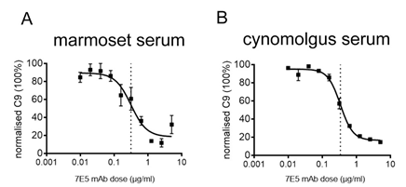

Suppl Fig. 2. Binding epitope of C6 monoclonal antibody
A, B. ELISA measuring C9 attached to the plate (MAC ELISA) showing that 7E5 is a potent inhibitor of complement-mediated lysis in the marmoset (A) and the cynomolgus (B) serum.

SUPP. FIGURE 3
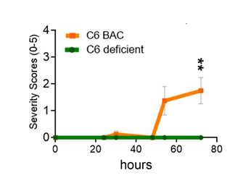
Suppl Fig. 3. Effect of C6 deficiency in EAMG
Experimental autoimmune myasthenia gravis (EAMG) was induced in humanized (h)C6 (n=8) and C6 deficient (n=8) rats by subcutaneous injection of a solution containing 2 mg/kg of an antibody against acetylcholine receptor mAb35 on day 0. In contrast to the hC6 rats, the C6 deficient group showed no clinical signs up to 72 hours post disease induction. Data represent the average clinical scores (mean) ± SEM. Statistical differences are indicated (**p < 0.01).

SUPP. FIGURE 4
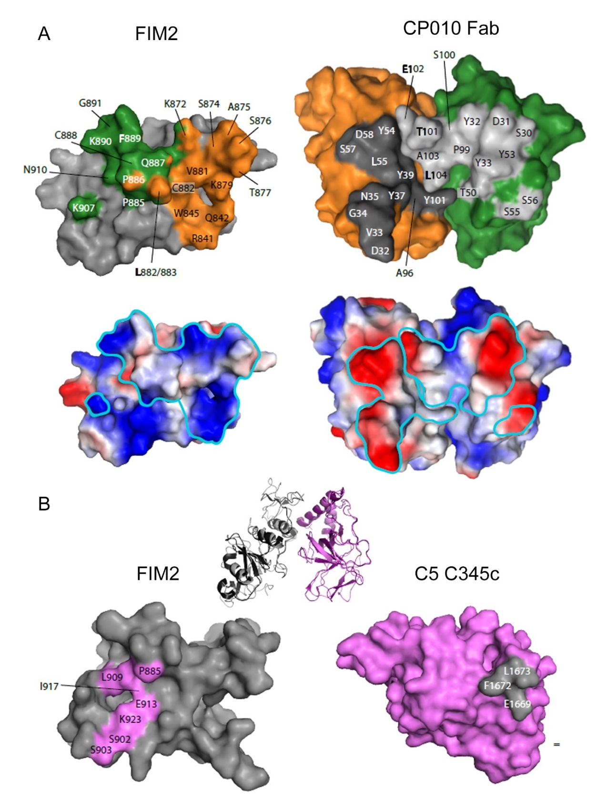
Suppl Fig. 4. Footprint analysis of the CP010-C6 FIM1-2 complex.
A. Left: Footprint of CP010 onto FIM2. The color coding from Fig. 7 is maintained. C6 residues within 3.8 Å from CP010 are labelled. Right: Footprint of FIM1-2 onto the CP010 Fab following the same principle. Dark grey denotes residues belonging to VL, while light grey denotes residues belonging to VH. Below are identical views of the surface with the electrostatic surface potentials calculated in PyMOL and mapped onto the separate molecules. the potential is colored in a gradient from red (negative) to blue (positive). The footprint is highlighted in turquoise. B. Inset: Cartoon representation of the crystal packing interaction present in two independent crystal structures of C5b6 (PDB ID: 4A5W and 4E0S) of FIM1-2 from one C5b6 complex (grey) with the C5 C345c domain from a symmetry-related C5b6 complex (violet). Left: Footprint of C5 C345c onto FIM2. C6 FIM1-2 residues within 3.8 Å from C5 C345c are labelled in violet. Right: Footprint of FIM2 onto the C5 C345c. Comparison with panel A demonstrates that the CP010 antibody binding site on C6 partially overlaps with the binding site for C5 C345c in this crystal packing interaction.

SUPP. FIGURE 5
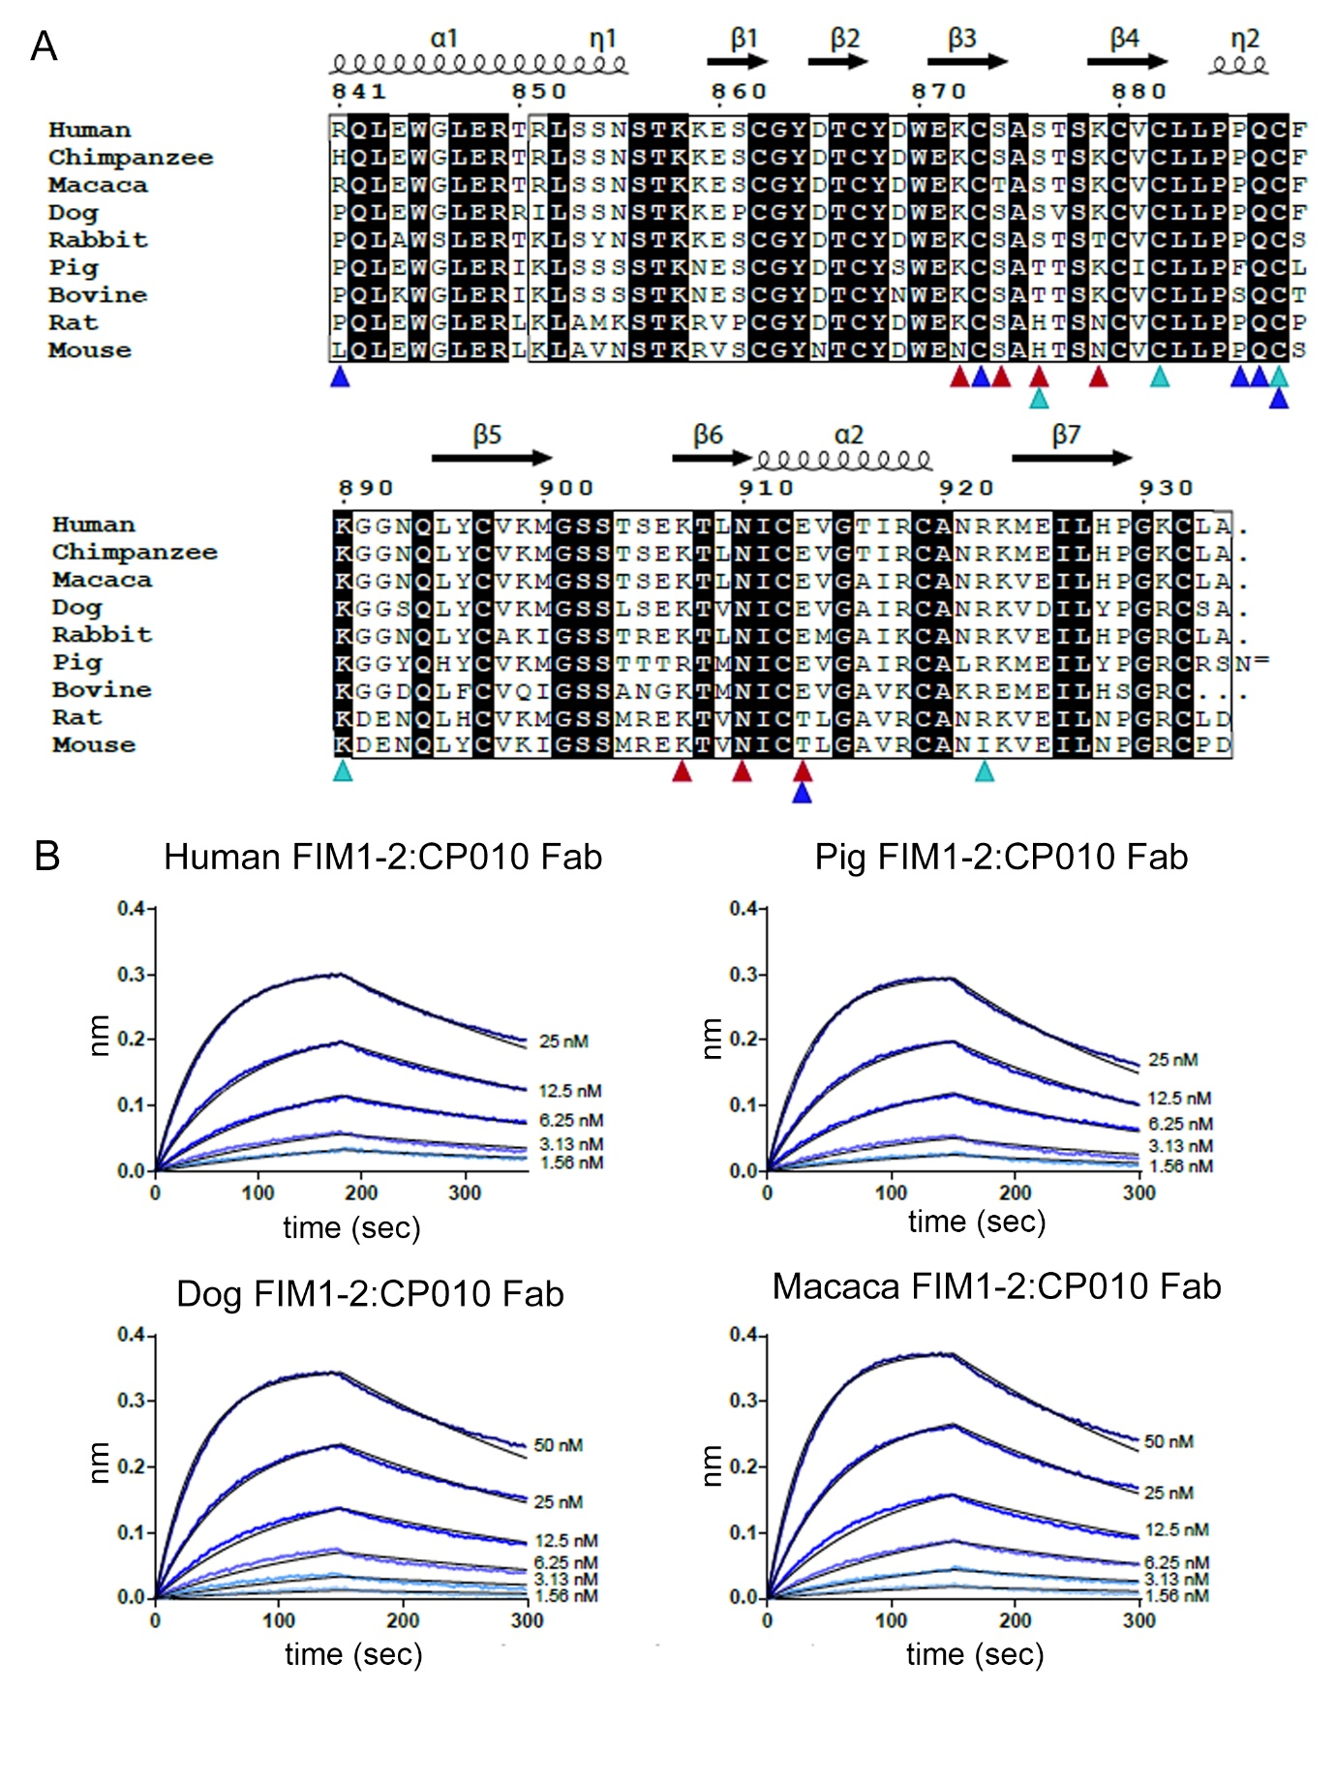

Suppl Fig. 5. CP010 has cross-species reactivity against C6 from pig, dog and macaca.
A. Sequence alignment of the region corresponding to C6 residues 841-934. Red triangles denotes residues making side chain interactions with CP010, whereas turquoise mark residues that interact via their main chain. Blue triangles show residues involved in water-mediated CP010 interactions. B. BLI sensorgrams for the interaction between CP010 Fab in solution and C6 FIM1-2 fragments from various species immobilized on PentaHis sensors. Values for the K_{D} are presented in suppl. table 2. The experimental data (blue curves) were fitted to a 1:1 binding model (Black curves) in GraphPad Prism.

Supplemental tables

Supplementary Table 1: The VH and VL sequences of the 7E5 NALAPG and MOTA NALAPG antibodies

Supplementary Table 2. Summary of dissociation constants derived from BLI data.
Ligand  (immobilized) | Analyte  (fluid phase) | averaged K_{D}  (nM) | coupling | Figure
C6 | CP10 Fab | 0.27 | Strept/bio | Fig. 6D
Human FIM1-2 | CP10 Fab | 2.807 | PentaHis | Fig. 6E
Dog FIM1-2 | CP10 Fab | 5.893 | PentaHis | Suppl Fig. 5B
Macaca FIM1-2 | CP10 Fab | 5.664 | PentaHis | Suppl Fig. 5B
Pig FIM1-2 | CP10 Fab | 4.773 | PentaHis | Suppl Fig. 5B
C6 | C5 C345c | 19.83 | Strept/bio | Suppl Fig. 5B
C5 C345c | C6 | 10.66 | Amine | Fig. 8B
C5 C345c | FIM1-2 | 4.84 | Amine | Fig. 8B

Supplementary table 3. Statistics for data collection and refinement. Values for the highest-resolution shell are shown in parentheses. The table was generated with the phenix.table_one program.
Data collection
Wavelength | 0.9763
Resolution range | 44.44 - 2.293 (2.375 - 2.293)
Space group | C 1 2 1
Unit cell | 161.057 63.527 128.589 90 128.363 90
Total reflections | 155998 (14531)
Unique reflections | 45106 (4197)
Multiplicity | 3.5 (3.5)
Completeness (%) | 97.93 (91.88)
Mean I/sigma(I) | 12.15 (0.82)
Wilson B-factor | 49.63
R-merge | 0.06473 (1.383)
CC1/2 | 0.999 (0.352)
Refinement
Reflections used in refinement | 45101 (4197)
Reflections used for R-free | 1988 (186)
R-work/R-free | 0.2102 (0.3406)/ 0.2353 (0.3321)
CC (work/free) | 0.956 (0.600) / 0.943 (0.642)
Number of non-hydrogen atoms | 5654
macromolecules | 5522
ligands | 7
solvent | 128
Protein residues | 723
RMS(bonds) | 0.005
RMS(angles) | 0.87
Ramachandran favored (%) | 96.36
Ramachandran allowed (%) | 3.50
Ramachandran outliers (%) | 0.14
Rotamer outliers (%) | 1.77
Clashscore | 0.83
Average B-factor | 60.62

