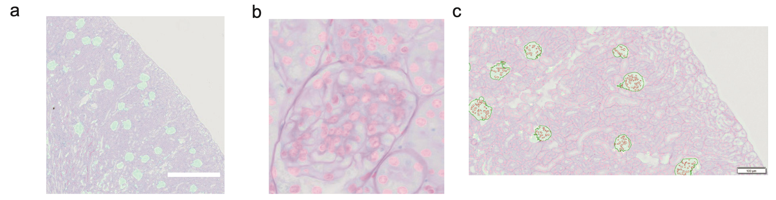
Supplementary figure 1: Graphs and schematic illustrations of employing deep-learning models. a. Perform the deep learning model on the PAS slices (all glomeruli were identified). The cyan parts are the identified areas. b. Perform the deep learning model on the slices (all renal nuclei were identified). The magenta parts are the identified areas. c. Perform measurement in the region of interest (ROI) for the identified glomerulus and nucleus. The glomerular model is used to provide a regional ROI for counting; the nucleus model is used to count all nuclei within the ROI.

Supplementary figure 2: The training information of CNN model. a. The IoU curve and training loss changes of glomeruli recognition with the training progress.
b. The IoU curve and training loss changes of nuclei recognition with the training progress.

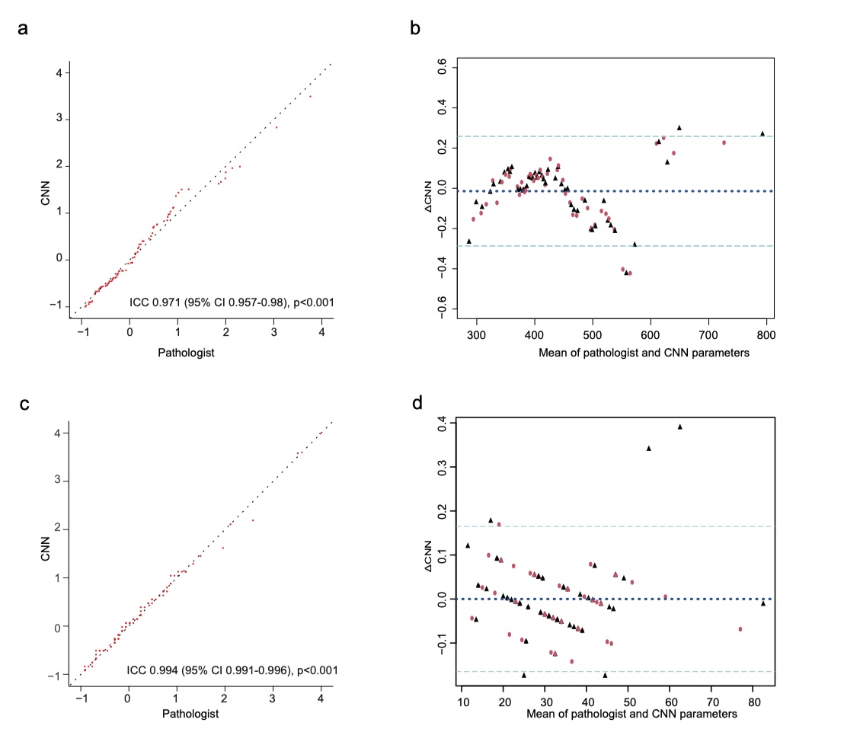
Supplementary figure 3: The features extraction consistency analysis. a. Concordance between perimeters estimated by CNN model and the pathologist. b. Bland-Altman plot for perimeter estimation. c. Concordance between the number of objects estimated by CNN model and the pathologist. d. Bland-Altman plot for the number of objects estimation.

Supplementary table 1. The list of abbreviations of all significant features.

result | abbreviation
mean1 counts
mean2 perimeter
mean3 Convex Perimeter | PC
mean4 mean gray level | MGL
mean5 shape factor | SF
mean6 convex curvature | CC
mean7 length-width ratio | LWR
mean8 Sphericity
mean9 Elongation
mean10 maximum inner width | MAXID
mean11 mean internal diameter | MID
mean12 minimum internal diameter | MINID
mean13 minimum internal equivalent width | MINIEW
mean14 mean internal equivalent width | MIEW
mean15 minimum distance to the center | MINDTC
mean16 maximum distance to the center | MAXDTC
mean17 mean distance to the center | MDTC
mean18 maximum radius | MAXR
mean19 mean radius | MR
mean20 minimum diameter (with an external caliper) | MINDEC
mean21 maximum diameter (with an external caliper) | MAXDEC
mean22 mean diameter (with an external caliper) | MDEC
mean23 minimum width | MINW
mean24 maximum width | MAXW
mean25 mean width | MW
mean26 maximum diameter | MAXD
mean27 mean diameter | MD
mean28 maximum equivalent width | MAXEW
mean29 mean equivalent width | MEW
mean30 mean convex curvature | MCC
mean31 number of classified objects | NCO
mean32 mean perimeter | MP
mean33 number of objects | NO
mean34 mean shape factor | MSF
mean35 area of region of interest | AROI

