Supplemental S1. Association between diabetes status and mortality in first-ever stroke patients
 |  |  | From onset (n=6331) |  |  |  |  |  | From 29 days after onset (n=5989)
 | Free of diabetes |  | Good diabetes control  (n=1045) |  | Poor diabetes control  (n=1077) |  | p for trend |  | Good diabetes control  (n=950) |  | Poor diabetes control  (n=1037) |  | p for trend
 |  |  | HR (95%CI) | p-value | HR (95%CI) | p-value |  |  | HR (95%CI) | p-value | HR (95%CI) | p-value
 |  | Large-artery infarction
Model 1 | Reference |  | 1.00 (0.65-1.53) | 0.987 | 1.57 (1.09-2.26) | 0.016 | 0.002 |  | 1.08 (0.79-1.46) | 0.640 | 1.71 (1.31-2.24) | <0.001 | <0.001
Model 2 | Reference |  | 1.16 (0.86-1.56) | 0.329 | 1.41 (1.07-1.85) | 0.013 | 0.013 |  | 1.09 (0.79-1.50) | 0.598 | 1.61 (1.22-2.13) | <0.001 | 0.001
Model 3 | Reference |  | 1.19 (0.88-1.60) | 0.251 | 1.40 (1.07-1.84) | 0.016 | 0.013 |  | 1.12 (0.81-1.54) | 0.496 | 1.61 (1.21-2.13) | 0.001 | 0.001
Model 4 | Reference |  | 1.13 (0.84-1.53) | 0.412 | 1.40 (1.07-1.84) | 0.015 | 0.017 |  | 1.06 (0.77-1.47) | 0.704 | 1.60 (1.21-2.13) | 0.001 | 0.002
 |  | Cardioembolic infarction
Model 1 | Reference |  | 1.10 (0.80-1.51) | 0.569 | 0.97 (0.66-1.44) | 0.895 | 0.012 |  | 1.29 (1.00-1.66) | 0.050 | 1.10 (0.81-1.49) | 0.544 | 0.209
Model 2 | Reference |  | 1.34 (1.07-1.69) | 0.012 | 1.24 (0.93-1.64) | 0.141 | 0.043 |  | 1.22 (0.94-1.59) | 0.141 | 1.11 (0.80-1.54) | 0.527 | 0.394
Model 3 | Reference |  | 1.31 (1.04-1.65) | 0.023 | 1.18 (0.89-1.57) | 0.251 | 0.100 |  | 1.20 (0.92-1.56) | 0.186 | 1.10 (0.79-1.52) | 0.587 | 0.471
Model 4 | Reference |  | 1.45 (1.14-1.83) | 0.002 | 1.30 (0.97-1.74) | 0.082 | 0.014 |  | 1.32 (1.00-1.73) | 0.048 | 1.17 (0.84-1.64) | 0.352 | 0.195
 |  | Lacunar infarction
Model 1 | Reference |  | 1.27 (0.68-2.38) | 0.458 | 1.88 (1.07-3.29) | 0.028 | 0.016 |  | 1.24 (0.82-1.89) | 0.310 | 1.51 (1.00-2.28) | 0.050 | 0.043
Model 2 | Reference |  | 1.04 (0.67-1.64) | 0.851 | 1.60 (1.05-2.43) | 0.030 | 0.071 |  | 1.01 (0.64-1.59) | 0.967 | 1.49 (0.97-2.29) | 0.072 | 0.161
Model 3 | Reference |  | 1.01 (0.65-1.59) | 0.954 | 1.66 (1.08-2.55) | 0.020 | 0.065 |  | 0.98 (0.62-1.55) | 0.943 | 1.55 (1.00-2.40) | 0.050 | 0.142
Model 4 | Reference |  | 1.17 (0.72-1.88) | 0.527 | 1.72 (1.11-2.66) | 0.014 | 0.031 |  | 1.13 (0.70-1.84) | 0.615 | 1.59 (1.02-2.49) | 0.040 | 0.078
Adjusted HRs and 95% CIs for mortality risk are shown according to diabetes status. Adjusted variables were age, sex for model 1, variables in model 1 plus smoking status and modified Rankin Scale before onset for model 2, variables in model 2 plus systolic blood pressure, LDLC, and HDLC for model 3, and variables in model 2 plus history of hypertension, history of dyslipidemia, and history of atrial fibrillation for model 4.

Abbreviations: HR, hazard ratio; CI, confidence interval.

Supplemental S2. Association between HbA1c status and mortality in first-ever stroke patients (n=6331)
 |  | Diabetes
 | Free of diabetes (n=4209) | 1st Tertile  HbA1c ≤ 6.5%  (n=682) |  |  | 2nd Tertile  6.5% < HbA1c ≤ 7.5%  (n=722) |  |  | 3rd Tertile  HbA1c > 7.5%  (n=718) |  | p for trend
 |  | HR (95%CI) | p-value |  | HR (95%CI) | p-value |  | HR (95%CI) | p-value
All stroke
Model 1 | Reference | 1.31 (1.07-1.60) | 0.008 |  | 0.87 (0.69-1.10) | 0.254 |  | 1.17 (0.94-1.47) | 0.167 | 0.001
Model 2 | Reference | 1.25 (1.07-1.46) | 0.004 |  | 1.08 (0.91-1.27) | 0.385 |  | 1.21 (1.02-1.43) | 0.031 | 0.015
Model 3 | Reference | 1.19 (1.02-1.39) | 0.030 |  | 1.07 (0.91-1.26) | 0.443 |  | 1.22 (1.03-1.45) | 0.025 | 0.018
Model 4 | Reference | 1.30 (1.11-1.52) | <0.001 |  | 1.13 (0.96-1.34) | 0.141 |  | 1.29 (1.08-1.53) | 0.004 | <0.001
Intracerebral hemorrhage
Model 1 | Reference | 1.44 (0.92-2.24) | 0.110 |  | 1.35 (0.82-2.20) | 0.236 |  | 1.38 (0.76-2.53) | 0.293 | 0.060
Model 2 | Reference | 1.07 (0.72-1.58) | 0.752 |  | 1.05 (0.68-1.61) | 0.826 |  | 1.38 (0.84-2.26) | 0.202 | 0.339
Model 3 | Reference | 1.02 (0.68-1.52) | 0.924 |  | 1.04 (0.68-1.60) | 0.853 |  | 1.36 (0.83-2.24) | 0.219 | 0.394
Model 4 | Reference | 1.15 (0.77-1.72) | 0.486 |  | 1.06 (0.68-1.66) | 0.790 |  | 1.45 (0.87-2.42) | 0.150 | 0.250
Cerebral infarction
Model 1 | Reference | 1.18 (0.92-1.52) | 0.190 |  | 0.90 (0.68-1.19) | 0.471 |  | 1.30 (1.01-1.68) | 0.042 | <0.001
Model 2 | Reference | 1.21 (1.01-1.45) | 0.044 |  | 1.16 (0.96-1.39) | 0.117 |  | 1.23 (1.02-1.50) | 0.031 | 0.008
Model 3 | Reference | 1.17 (0.97-1.40) | 0.101 |  | 1.15 (0.96-1.39) | 0.132 |  | 1.24 (1.03-1.51) | 0.026 | 0.009
Model 4 | Reference | 1.24 (1.03-1.49) | 0.023 |  | 1.23 (1.02-1.49) | 0.030 |  | 1.31 (1.08-1.59) | 0.007 | <0.001
Large-artery infarction
Model 1 | Reference | 1.32 (0.82-2.12) | 0.251 |  | 0.81 (0.48-1.35) | 0.414 |  | 1.81 (1.21-2.72) | 0.004 | 0.001
Model 2 | Reference | 1.18 (0.83-1.69) | 0.361 |  | 1.11 (0.79-1.55) | 0.548 |  | 1.57 (1.16-2.13) | 0.003 | 0.008
Model 3 | Reference | 1.22 (0.85-1.74) | 0.288 |  | 1.09 (0.78-1.53) | 0.615 |  | 1.61 (1.19-2.19) | 0.002 | 0.006
Model 4 | Reference | 1.17 (0.82-1.68) | 0.391 |  | 1.07 (0.76-1.50) | 0.700 |  | 1.58 (1.16-2.14) | 0.003 | 0.010
Cardioembolic infarction
Model 1 | Reference | 1.11 (0.76-1.60) | 0.596 |  | 0.99 (0.66-1.50) | 0.979 |  | 1.02 (0.62-1.69) | 0.925 | 0.026
Model 2 | Reference | 1.32 (1.01-1.73) | 0.041 |  | 1.45 (1.10-1.91) | 0.008 |  | 1.02 (0.69-1.51) | 0.923 | 0.083
Model 3 | Reference | 1.24 (0.95-1.63) | 0.115 |  | 1.49 (1.13-1.97) | 0.004 |  | 0.93 (0.62-1.37) | 0.700 | 0.169
Model 4 | Reference | 1.39 (1.06-1.82) | 0.017 |  | 1.60 (1.20-2.14) | 0.002 |  | 1.09 (0.74-1.62) | 0.664 | 0.026
Lacunar infarction
Model 1 | Reference | 1.52 (0.76-3.05) | 0.240 |  | 1.41 (0.70-2.84) | 0.330 |  | 1.77 (0.92-3.44) | 0.089 | 0.019
Model 2 | Reference | 1.10 (0.65-1.87) | 0.725 |  | 1.12 (0.67-1.88) | 0.662 |  | 1.73 (1.07-2.80) | 0.025 | 0.069
Model 3 | Reference | 1.06 (0.63-1.81) | 0.818 |  | 1.11 (0.66-1.86) | 0.704 |  | 1.83 (1.12-2.97) | 0.015 | 0.061
Model 4 | Reference | 1.21 (0.70-2.09) | 0.494 |  | 1.25 (0.73-2.13) | 0.422 |  | 1.89 (1.15-3.09) | 0.012 | 0.029
Adjusted HRs and 95% CIs for mortality risk are shown according to diabetes status. Adjusted variables were age, sex for model 1, variables in model 1 plus smoking status and modified Rankin Scale before onset for model 2, variables in model 2 plus systolic blood pressure, LDLC, and HDLC for model 3, and variables in model 2 plus history of hypertension, history of dyslipidemia, and history of atrial fibrillation for model 4.

Abbreviations: HR, hazard ratio; CI, confidence interval.

Supplemental S3. Association between diabetes status and functional outcomes during hospitalization in first-ever stroke patients
a) Survival analysis for evaluating the effects of diabetes status on functional outcome during hospitalization (mRS at discharge≧2)
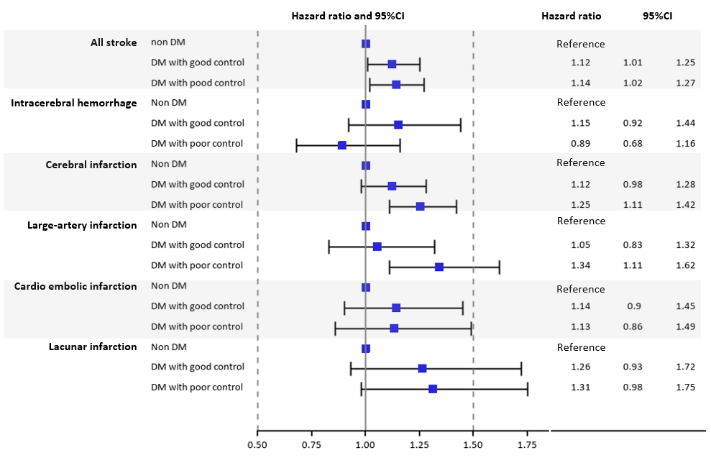
b) Survival analysis for evaluating the effects of diabetes status on mortality during hospitalization (mRS at discharge = 6)
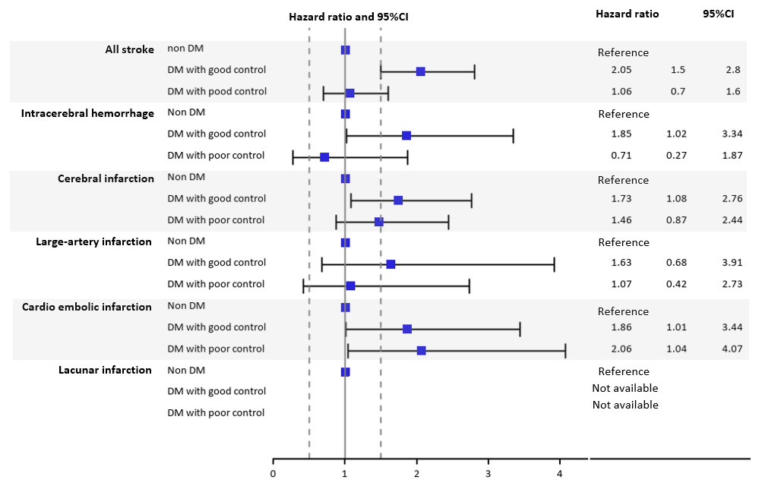
Supplemental S4. Absolute and relative survival proportion of all strokes from 29 days after stroke onset in first-ever stroke patients
 |  |  | Survival proportion |  |  |  |  | Relative Survival Proportion
 | age | sex | General Japanese | Free of diabetes | Good diabetic control | Poor diabetic control |  | Free of diabetes | Good diabetic control | Poor diabetic control
Survival proportion at  one years | 40 | male | 0.999 | 0.997 | 0.996 | 0.996 |  | 0.998 | 0.998 | 0.997
 |  | female | 0.999 | 0.998 | 0.997 | 0.997 |  | 0.998 | 0.998 | 0.998
 | 50 | male | 0.997 | 0.992 | 0.991 | 0.989 |  | 0.995 | 0.994 | 0.992
 |  | female | 0.998 | 0.994 | 0.994 | 0.992 |  | 0.996 | 0.995 | 0.994
 | 60 | male | 0.993 | 0.979 | 0.977 | 0.973 |  | 0.987 | 0.984 | 0.980
 |  | female | 0.997 | 0.985 | 0.984 | 0.980 |  | 0.988 | 0.987 | 0.984
 | 70 | male | 0.982 | 0.948 | 0.943 | 0.932 |  | 0.965 | 0.960 | 0.949
 |  | female | 0.993 | 0.962 | 0.958 | 0.951 |  | 0.970 | 0.966 | 0.958
 | 80 | male | 0.947 | 0.873 | 0.860 | 0.835 |  | 0.921 | 0.907 | 0.882
 |  | female | 0.975 | 0.907 | 0.897 | 0.879 |  | 0.930 | 0.920 | 0.902
Survival proportion at  two years | 40 | male | 0.998 | 0.995 | 0.994 | 0.993 |  | 0.997 | 0.996 | 0.995
 |  | female | 0.999 | 0.996 | 0.996 | 0.995 |  | 0.998 | 0.997 | 0.996
 | 50 | male | 0.994 | 0.987 | 0.985 | 0.982 |  | 0.992 | 0.991 | 0.988
 |  | female | 0.997 | 0.990 | 0.989 | 0.987 |  | 0.994 | 0.993 | 0.990
 | 60 | male | 0.985 | 0.966 | 0.962 | 0.955 |  | 0.981 | 0.977 | 0.970
 |  | female | 0.993 | 0.975 | 0.973 | 0.968 |  | 0.982 | 0.979 | 0.974
 | 70 | male | 0.963 | 0.916 | 0.907 | 0.890 |  | 0.951 | 0.942 | 0.924
 |  | female | 0.985 | 0.939 | 0.932 | 0.920 |  | 0.953 | 0.947 | 0.934
 | 80 | male | 0.894 | 0.798 | 0.779 | 0.743 |  | 0.893 | 0.871 | 0.831
 |  | female | 0.947 | 0.851 | 0.836 | 0.808 |  | 0.898 | 0.882 | 0.852
Survival proportion at three years | 40 | male | 0.996 | 0.993 | 0.992 | 0.990 |  | 0.996 | 0.995 | 0.994
 |  | female | 0.998 | 0.995 | 0.994 | 0.993 |  | 0.997 | 0.996 | 0.995
 | 50 | male | 0.991 | 0.981 | 0.979 | 0.975 |  | 0.990 | 0.988 | 0.984
 |  | female | 0.995 | 0.986 | 0.985 | 0.982 |  | 0.991 | 0.990 | 0.987
 | 60 | male | 0.977 | 0.952 | 0.947 | 0.937 |  | 0.975 | 0.970 | 0.960
 |  | female | 0.990 | 0.965 | 0.962 | 0.955 |  | 0.975 | 0.972 | 0.964
 | 70 | male | 0.943 | 0.882 | 0.870 | 0.848 |  | 0.936 | 0.923 | 0.899
 |  | female | 0.976 | 0.914 | 0.905 | 0.888 |  | 0.937 | 0.928 | 0.910
 | 80 | male | 0.838 | 0.727 | 0.702 | 0.656 |  | 0.867 | 0.837 | 0.783
 |  | female | 0.918 | 0.795 | 0.776 | 0.739 |  | 0.867 | 0.845 | 0.805
Footnote:
*Survival proportion of general Japanese was derived from death information in 2013 in vital statistics.
**The relative survival was calculated by dividing survival rate of stroke patients by survival rate of Japanese population. Survival rate is higher than general population if it exceeds one, and conversely, survival rate is lower than general population if it is lower than one.

