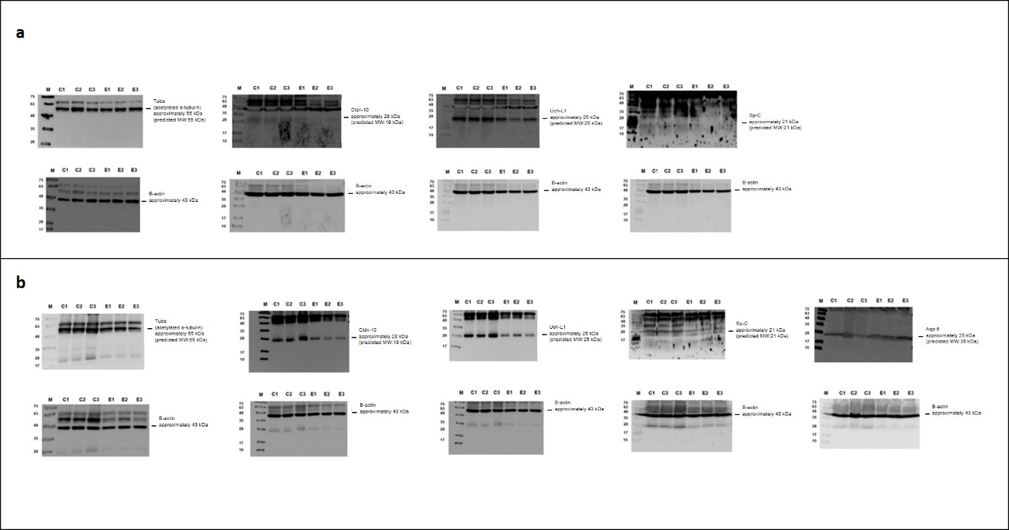
Supplementary Figure 1. Whole western blot images of Tuba, Cldn-10, Uch-L1, Sp-C and Aqp-5 in the fetal and adult lung tissue samples. Bands were visualized using peroxidase-labeled secondary antibodies. A specific band corresponding to Tuba, Cldn-10, UchL-1, Sp-C, and Aqp-5 could readily be detected in both fetal (a) and adult lung tissue samples (b), except for Aqp-5 in CG_{fetus} and EG_{fetus} (a). β-actin was used as an endogenous control. Pre-stained protein ladder V (Genaid, 10-180 kDa MW) was used as a protein marker. Sizes of bands for each protein are indicated. M: Markers; C1, C2, C3: Replications 1, 2, and 3 of the Control groups; E1, E2, E3: Replications 1, 2, and 3 of the Experimental groups.
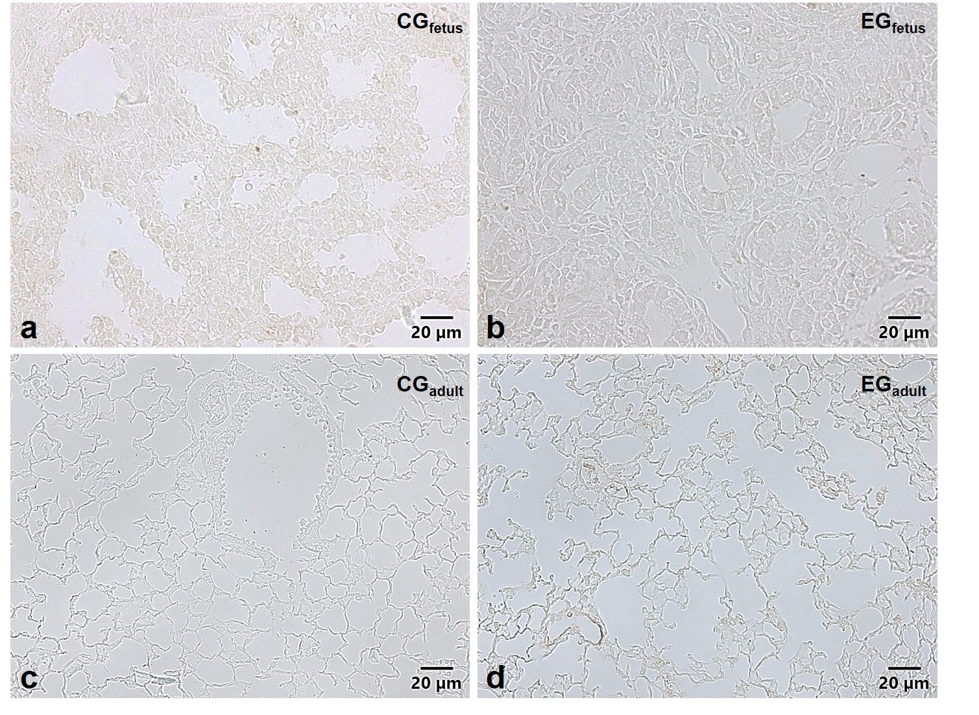
Supplementary Figure 2. The negative control sections were treated in an identical manner except for the use of TBS (pH 7.6) instead of the primary antibody. After a final rinse and wash in TBS, immune positive cells were detected using 3, 3’ diaminobenzidine tetrahydrochloride (DAB) solution (3 mg/ml in Tris-HCl, pH 7,6 with 3 % H₂O₂). The sections were observed on an Olympus BX51 microscope and images were captured using Olympus DP70 camera with DP controller software (Ver. 3.1.1.267). No immune-positivity were detected in any of the negative control sections used for each antibody in CG_{fetus} (a), EG_{fetus} (b), CG_{adult} (c) and EG_{adult} (d).

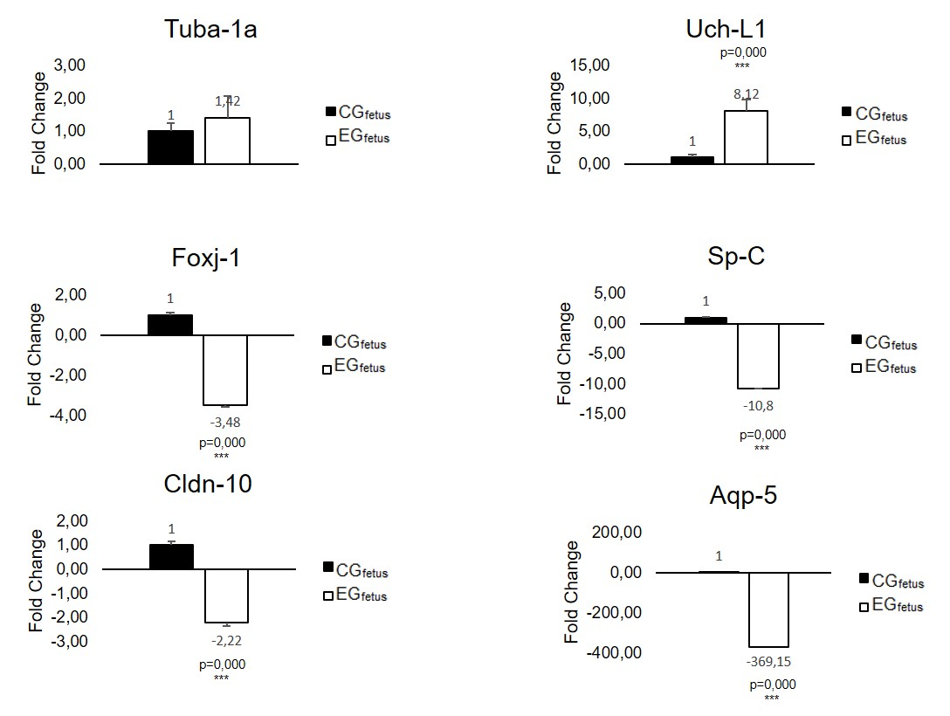
Supplementary Figure 3. Real-time PCR analyses of Tuba-1a, Foxj-1, Cldn-10, Uch-L1, Sp-C and Aqp-5 using pooled fetal lung tissue samples. Transcript levels were quantified using SYBR® Green quantitative real-time PCR. β-actin was used as an endogenous reference gene for normalization of Ct values obtained for each gene. Fold changes in gene expression were calculated using 2^{−ΔΔCt} method as described by Schmittgen and Livak (2008). ***p < .001.
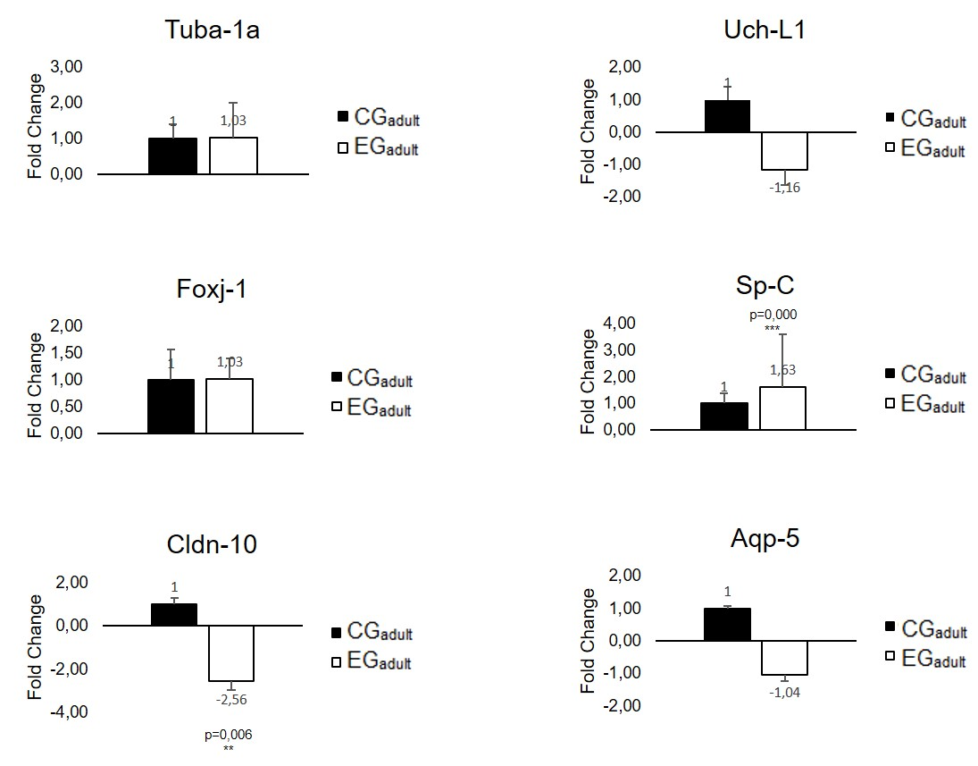
Supplementary Figure 4. Real-time PCR analyses of Tuba-1a, Foxj-1, Cldn-10, Uch-L1, Sp-C and Aqp-5 using pooled adult lung tissue samples. Transcript levels were quantified using SYBR® Green quantitative real-time PCR. β-actin was used as an endogenous reference gene for normalization of Ct values obtained for each gene. Fold changes in gene expression were calculated using 2^{−ΔΔCt} method as described by Schmittgen and Livak (2008). **p < .01; ***p < .001.

