Supplementary Table 1: Checklist of items included when reporting a systematic review and meta- analysis
Section/topic | Item No. | Checklist item | Reported on page No.
Title
Title | 1 | Identify the report as a systematic review, meta-analysis, or both | 1
Abstract
Structured summary | 2 | Provide a structured summary including, as applicable, background, objectives, data sources, study eligibility criteria, participants, interventions, study appraisal and synthesis methods, results, limitations, conclusions and implications of key findings, systematic review registration number | 2
Introduction
Rationale | 3 | Describe the rationale for the review in the context of what is already known | 2-3
Objectives | 4 | Provide an explicit statement of questions being addressed with reference to participants, interventions, comparisons, outcomes, and study design (PICOS) | 4
Methods
Protocol and registration | 5 | Indicate if a review protocol exists, if and where it can be accessed (such as web address), and, if available, provide registration information including registration number
Eligibility criteria | 6 | Specify study characteristics (such as PICOS, length of follow-up) and report characteristics (such as years considered, language, publication status) used as criteria for eligibility, giving rationale | 4
Information sources | 7 | Describe all information sources (such as databases with dates of coverage, contact with study authors to identify additional studies) in the search and date last searched | 3-4
Search | 8 | Present full electronic search strategy for at least one database, including any limits used, such that it could be repeated | 3-4
Study selection | 9 | State the process for selecting studies (that is, screening, eligibility, included in systematic review, and, if applicable, included in the meta-analysis) | 4
Data collection process | 10 | Describe method of data extraction from reports (such as piloted forms, independently, in duplicate) and any processes for obtaining and confirming data from investigators | 4
Data items | 11 | List and define all variables for which data were sought (such as PICOS, funding sources) and any assumptions and simplifications made | 4
Risk of bias in individual studies | 12 | Describe methods used for assessing risk of bias of individual studies  (including specification of whether this was done at the study or outcome level), and how this information is to be used in any data synthesis | 4-5
Summary measures | 13 | State the principal summary measures (such as risk ratio, difference in means). | 4
Synthesis of results | 14 | Describe the methods of handling data and combining results of studies, if done, including measures of consistency (such as I2 statistic) for each meta-analysis. | 4
Risk of bias across studies | 15 | Specify any assessment of risk of bias that may affect the cumulative evidence (such as publication bias, selective reporting within studies) | 4
Additional analyses | 16 | Describe methods of additional analyses (such as sensitivity or subgroup analyses, meta-regression), if done, indicating which were pre-specified | 4-5
Results
Study selection | 17 | Give numbers of studies screened, assessed for eligibility, and included in the review, with reasons for exclusions at each stage, ideally with a flow diagram | 5
Study characteristics | 18 | For each study, present characteristics for which data were extracted (such as study size, PICOS, follow-up period) and provide the citations | 5
Risk of bias within studies | 19 | Present data on risk of bias of each study and, if available, any outcome-level assessment (see item 12). | 8
Results of individual studies | 20 | For all outcomes considered (benefits or harms), present for each study (a) simple summary data for each intervention group and (b) effect estimates and confidence intervals, ideally with a forest plot | 5-6
Synthesis of results | 21 | Present results of each meta-analysis done, including confidence intervals and measures of consistency | 5-7
Risk of bias across studies | 22 | Present results of any assessment of risk of bias across studies (see item 15) | 8
Additional analysis | 23 | Give results of additional analyses, if done (such as sensitivity or subgroup analyses, meta-regression) (see item 16) | 6-8
Discussion
Summary of evidence | 24 | Summarize the main findings including the strength of evidence for each main outcome; consider their relevance to key groups (such as health care providers, users, and policy makers) | 8
Limitations | 25 | Discuss limitations at study and outcome level (such as risk of bias), and at review level (such as incomplete retrieval of identified research, reporting bias) | 11-12
Conclusions | 26 | Provide a general interpretation of the results in the context of other evidence, and implications for future research | 12
Funding
Funding | 27 | Describe sources of funding for the systematic review and other support (such as supply of data) and role of funders for the systematic review | 12

Supplementary Table 2. Search strategy for systematic review.
PubMed
#1 | (((((((((Neoplasms) OR Neoplasia) OR Neoplasias) OR Neoplasm) OR Tumors) OR Tumor) OR Malignancy) OR Malignancies) OR Cancer) OR Cancers | 5,217,382
#2 | ("Programmed Cell Death 1 Receptor/antagonists and inhibitors"[Mesh] OR PD-1[tiab] OR PD1[tiab] OR PD-L1[tiab] OR CTLA4[tiab] OR CTLA-4[tiab] OR cytotoxic T-lymphocyte-associated protein 4[tiab] OR PDL1[tiab] OR Programmed Cell Death 1*[tiab] OR Immune Checkpoint*[tiab] OR nivolumab[tiab] OR pembrolizumab[tiab] OR atezolizumab[tiab] OR durvalumab[tiab] OR cemiplimab[tiab] OR avelumab[tiab] OR monoclonal  antibodies [tiab] OR ipilimumab[tiab] OR tremelimumab[tiab]) | 162,392
#3 | (drug related side effects and adverse reactions [Mesh] OR adverse  reactio*[tiab] OR adverse even*[tiab] OR side effec*[tiab]) | 601,741
#4 | (risk factor [Mesh] OR risk facto*[tiab] OR predicto*[tiab] OR exposur*[tiab]) | 2,485,601
#5 | #1 AND #2 AND #3 AND #4 | Final research  795
EMBASE
#1 | 'tumor'/exp OR tumor OR tumor:ab,ti OR cancer:ab,ti OR neoplasm*:ab,ti | 6,607,210
#2 | 'pdl1 gene'/exp OR 'immune checkpoint inhibitor'/exp OR  'immunomodulating agent'/exp OR 'immunomodulating agent':ab,ti OR  'avelumab':ab,ti OR 'cemiplimab':ab,ti OR 'durvalumab':ab,ti OR  'atezolizumab':ab,ti OR 'pembrolizumab':ab,ti OR 'nivolumab':ab,ti OR  'pdl1':ab,ti OR 'pd1':ab,ti OR 'immune checkpoint inhibitor':ab,ti OR  'tremelimumab':ab,ti OR ' ipilimumab':ab,ti OR 'ctla4':ab,ti OR 'ctla-4':ab,ti OR 'cytotoxic T-lymphocyte-associated protein 4':ab,ti | 2,107,750
#3 | 'side effect'/exp OR 'side effect':ab,ti OR 'adverse drug reaction'/exp OR 'adverse drug reaction':ab,ti OR 'adverse event'/exp OR 'adverse event':ab,ti | 1,019,020
#4 | 'risk factor'/exp OR 'risk factor':ab,ti OR 'exposure'/exp OR exposure:ab,ti OR predicto*:ab,ti | 3,275,009
#5 | #1 AND #2 AND #3 AND #4 | Final research  12,776
Web of science
#1 | TS= ("neoplasms" OR "cance*" OR "neoplas*") | 6,855,505
#2 | TS= ("Immune Checkpoint Inhibit*" OR "PD-1" OR "PD-L1" OR "PD1" OR "PDL1" OR "avelumab" OR "cemiplimab" OR "durvalumab" OR "atezolizumab" OR "pembrolizumab" OR "nivolumab" OR "CTLA-4" OR "CTLA4" OR "'tremelimumab" OR " ipilimumab" OR " cytotoxic T-lymphocyte-associated protein 4") | 72,299
#3 | TS= ("drug related side effects" OR "adverse reactio*" OR "adverse even*" OR "side effec*") | 943,107
#4 | TS= ("risk facto*" OR "predicto*" OR "exposur*") | 4,361,695
#5 | #1 AND #2 AND #3 AND #4 | Final research  839

Supplementary Figure 1. Forest plot of the incidence of grade III-V CIP in cancer patients treated with immune checkpoint inhibitors. Abbreviation: CIP, checkpoint inhibitor pneumonitis.
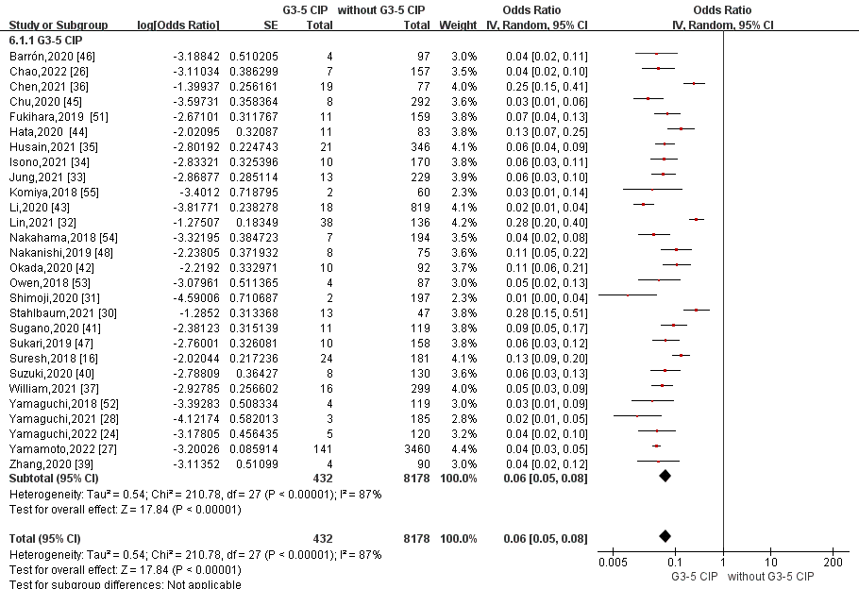

Supplementary Figure 2. Forest plot of the incidence of CIP in cancer patients treated with immune checkpoint inhibitors stratified by cancer types. Abbreviation: CIP, checkpoint inhibitor pneumonitis.
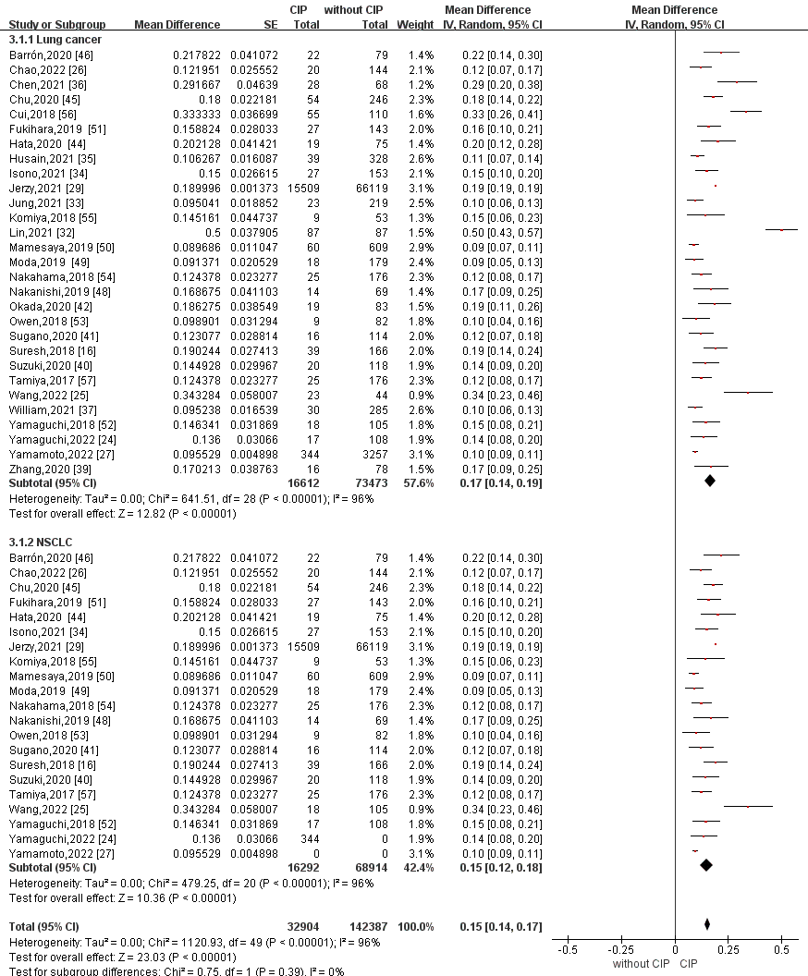

Supplementary Figure 3. Forest plot of the incidence of CIP in cancer patients treated with immune checkpoint inhibitors stratified by regional distributions. Abbreviation: CIP, checkpoint inhibitor pneumonitis.
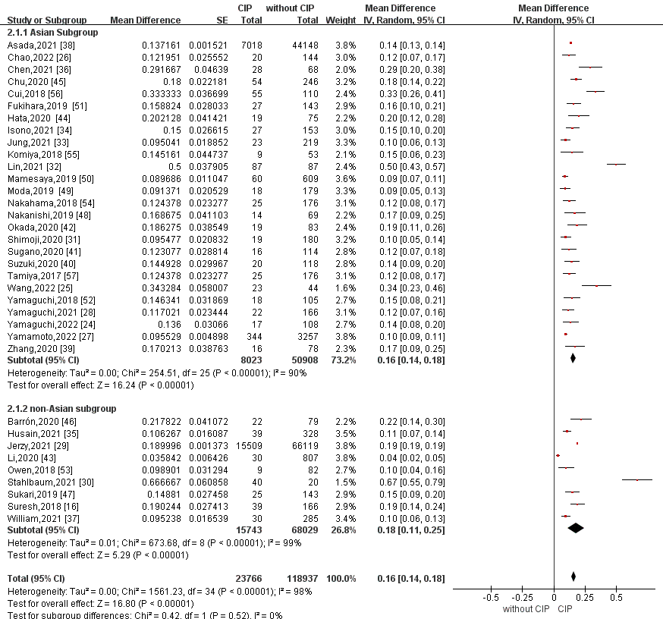

Supplementary Figure 4. Forest plot of the incidence of CIP in cancer patients treated with immune checkpoint inhibitors stratified by treatment regimes. Abbreviation: CIP, checkpoint inhibitor pneumonitis.
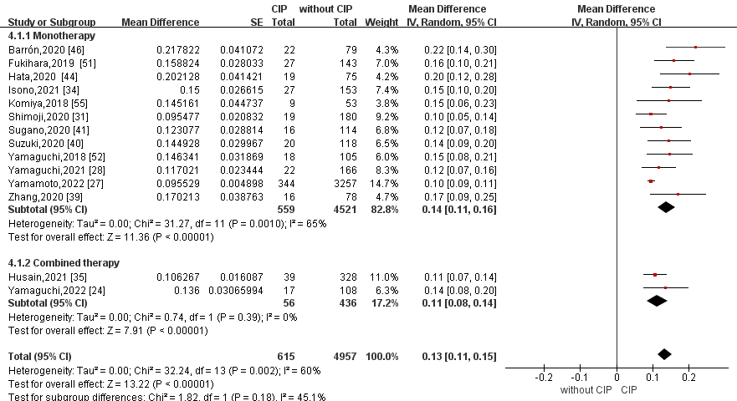

Supplementary Figure 5. Forest plot of the incidence of CIP in cancer patients treated with ICIs stratified by ICI types. Abbreviation: CIP, checkpoint inhibitor pneumonitis; ICI, immune checkpoint inhibitor.
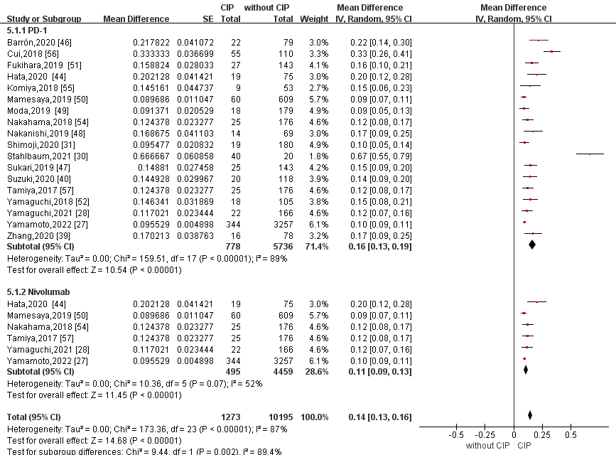

Supplementary Table 3. Classification of odds ratios assessing the risk factors for CIP in patients treated with ICIs.
Risk factor | Author/Year | OR | Lower CI | Upper CI | P value | Analysis
Age (≥ 65 vs <65) | Chao, 2022 | 0.796 | 0.311 | 2.036 | 0.634 | Univariate
 | Chen,2021 | 0.51 | 0.21 | 1.25 | 0.142 | Univariate
 | Chu, 2020 | 1.417 | 0.789 | 2.746 | 0.225 | Multivariate
 | Jung.2021 | 0.593 | 0.234 | 1.499 | 0.269 | Univariate
 | Li,2020 | 2.20 | 1.06 | 4.58 | 0.035 | Multivariate
 | Lin, 2021 | 1.59 | 0.87 | 2.9 | 0.13 | Univariate
 | Jerzy.2021 | 0.95 | 0.86 | 1.05 | 0.3388 | Multivariate
 | Sugano, 2020 | 4.47 | 0.88 | 22.7 | 0.07 | Multivariate
 | Wang, 2022 | 0.769 | 0.279 | 2.121 | 0.612 | Univariate
 | Yamaguchi,2018 | 2.15 | 0.71 | 8.01 | 0.18 | Univariate
 | Yamaguchi,2021 | 1.53 | 0.44 | 6.11 | 0.51 | Multivariate
 | Yamaguchi,2022 | 2.40 | 0.56 | 10.27 | 0.24 | Multivariate
Age | Fukihara,2019 | 0.980 | 0.939 | 1.023 | 0.347 | Univariate
 | Nakanishi,2019 | 1.003 | 0.949 | 1.068 | 0.919 | Univariate
 | Shimoji, 2020 | 1.25 | 0.08 | 18.80 | 0.86 | Multivariate
 | Sukari, 2019 | 0.99 | 0.96 | 1.03 | 0.665 | Multivariate
 | Suresh, 2018 | 1 | 0.96 | 1.04 | 0.69 | Univariate
 | Suzuki,2020 | 0.983 | 0.939 | 1.029 | 0.47 | Univariate
Age (per 10-y increase) | William,2021 | 0.90 | 0.62 | 1.3 |  | Univariate
Age (≥60) | Asada, 2021 | 1.70 | 1.61 | 1.80 | <0.001 | Univariate
Age (≥70) | Hata,2020 | 1.945 | 0.624 | 6.523 | 0.304 | Univariate
 | Suzuki,2020 | 0.522 | 0.201 | 1.353 | 0.18 | Univariate
Age (≥75) | Isono, 2021 | 0.251 | 0.059 | 1.058 | 0.060 | Univariate
 | Tamiya, 2017 | 2.01 | 0.95 | 4.23 | / | Univariate
Sex (female) | Asada, 2021 | 1.04 | 0.93 | 1.17 | 0.47 | Multivariate
 | Chao, 2022 | 1.315 | 0.403 | 4.293 | 0.650 | Univariate
 | Chen,2021 | 1.33 | 0.52 | 3.45 | 0.547 | Univariate
 | Chu, 2020 | 0.499 | 0.197 | 1.263 | 0.142 | Multivariate
 | Fukihara,2019 | 0.967 | 0.379 | 2.469 | 0.944 | Univariate
 | Hata,2020 | 0.982 | 0.245 | 3.378 | 1.000 | Univariate
 | Isono, 2021 | 0.589 | 0.204 | 1.704 | 0.329 | Univariate
 | Jung.2021 | 0.510 | 0.167 | 1.558 | 0.237 | Univariate
 | Li,2020 | 0.662 | 0.311 | 1.408 | 0.291 | Univariate
 | Lin, 2021 | 1.67 | 0.78 | 3.5 | 0.19 | Univariate
 | Jerzy.2021 | 0.870 | 0.787 | 0.962 | 0.0051 | Multivariate
 | Nakahama,2018 | 0.505 | 0.141 | 1.818 | 0.296 | Multivariate
 | Nakanishi,2019 | 0.914 | 0.230 | 3.086 | 0.889 | Univariate
 | Shimoji, 2020 | 0.556 | 0.156 | 2 | 0.36 | Multivariate
 | Sugano, 2020 | 3.06 | 0.69 | 13.6 | 0.14 | Multivariate
 | Suresh, 2018 | 1.09 | 0.54 | 2.20 | 0.81 | Univariate
 | Suzuki,2020 | 0.215 | 0.028 | 1.638 | 0.15 | Univariate
 | Wang, 2022 | 2.778 | 0.666 | 11.627 | 0.161 | Univariate
 | William,2021 | 0.55 | 0.25 | 1.20 |  | Univariate
 | Yamaguchi,2018 | 0.58 | 0.079 | 2.98 | 0.53 | Multivariate
 | Yamaguchi,2021 | 0.179 | 0.048 | 0.99 | 0.049 | Multivariate
 | Yamaguchi,2022 | 0.69 | 0.14 | 3.31 | 0.64 | Multivariate
 | Yamamoto,2022 | 0.971 | 0.694 | 1.351 |  | Multivariate
Smoking history (ever smoker) | Chao, 2022 | 1.217 | 0.458 | 3.234 | 0.694 | Univariate
 | Chu, 2020 | 1.438 | 0.794 | 2.607 | 0.231 | Univariate
 | Hata,2020 | 0.660 | 0.139 | 4.267 | 0.691 | Univariate
 | Isono, 2021 | 2.549 | 0.604 | 10.770 | 0.203 | Univariate
 | Jung.2021 | 2.178 | 0.604 | 7.859 | 0.234 | Multivariate
 | Li,2020 | 1.54 | 0.72 | 3.29 | 0.267 | Univariate
 | Lin, 2021 | 1.15 | 0.63 | 2.1 | 0.65 | Univariate
 | Nakahama,2018 | 1.24 | 0.27 | 5.69 | 0.778 | Multivariate
 | Nakanishi,2019 | 3.925 | 0.696 | 73.997 | 0.136 | Univariate
 | Shimoji, 2020 | 0.32 | 0.09 | 1.10 | 0.07 | Multivariate
 | Sugano, 2020 | 1.62 | 0.23 | 11.6 | 0.63 | Multivariate
 | Suresh, 2018 | 1.36 | 0.53 | 3.53 | 0.52 | Univariate
 | Wang, 2022 | 2.314 | 0.679 | 7.881 | 0.180 | Multivariate
 | William,2021 | 3.03 | 0.4 | 23.17 | 0.28 | Univariate
 | Yamaguchi,2018 | 2.63 | 0.69 | 17.35 | 0.17 | Univariate
 | Yamaguchi,2021 | 1.52 | 0.53 | 5.50 | 0.45 | Univariate
 | Yamaguchi,2022 | 2.33 | 0.63 | 8.64 | 0.205 | Univariate
 | Yamamoto,2022 | 1.47 | 1.01 | 2.15 |  | Multivariate
Smoking history (<40 pack-year) | Chen,2021 | 3.18 | 1.22 | 8.30 | 0.018 | Univariate
Smoking (pack-years) | Fukihara,2019 | 0.994 | 0.981 | 1.007 | 0.362 | Univariate
Smoking history (≥50 pack-year) | Okada,2020 | 3.01 | 1.04 | 8.72 | 0.042 | Multivariate
 | Owen, 2018 | 0.98 | 0.32 | 3.03 | 0.97 | Univariate
Race (African vs. Caucasian) | Jerzy.2021 | 0.94 | 0.79 | 1.11 | 0.4602 | Multivariate
 | Suresh, 2018 | 1.08 | 0.43 | 2.69 | 0.87 | Univariate
 | William,2021 | 1.40 | 0.57 | 3.43 |  | Univariate
Race (Asian vs. Caucasian) | Jerzy.2021 | 1.26 | 0.88 | 1.81 | 0.2114 | Multivariate
 | Suresh, 2018 | 1.44 | 0.28 | 7.43 | 0.66 | Univariate
History of thoracic radiotherapy | Barrón, 2020 | 6.04 | 2.03 | 18.0 | < 0.001 | Univariate
 | Cui.2018 | 3.34 | 1.51 | 7.39 | / | Multivariate
 | Fukihara,2019 | 0.888 | 0.362 | 2.178 | 0.795 | Univariate
 | Isono, 2021 | 1.369 | 0.543 | 3.448 | 0.506 | Univariate
 | Jung.2021 | 2.08 | 0.87 | 4.95 | 0.10 | Univariate
 | Mamesaya,2019 | 1.95 | 1.13 | 3.34 | / | Multivariate
 | Lin, 2021 | 1.95 | 0.75 | 5.02 | 0.19 | Multivariate
 | Jerzy.2021 | 1.33 | 1.19 | 1.49 | <0.0001 | Multivariate
 | Nakahama,2018 | 3.96 | 1.35 | 11.60 | 0.012 | Multivariate
 | Nakanishi,2019 | 0.622 | 0.158 | 2.069 | 0.449 | Univariate
 | Owen, 2018 | 0.99 | 0.32 | 3.08 | 0.98 | Univariate
 | Stahlbaum,2021 | 9.14 | 1.15 | 408.78 | 0.018 | Multivariate
 | Sugano, 2020 | 1.26 | 0.33 | 4.82 | 0.73 | Multivariate
 | William,2021 | 2.03 | 0.94 | 4.38 |  | Univariate
Concurrent thoracic radiation therapy | William,2021 | 4 | 0.74 | 21.6 |  | Univariate
Chemotherapy prior to ICI | Jung.2021 | 0.619 | 0.260 | 1.478 | 0.280 | Univariate
 | Li,2020 | 1.21 | 0.56 | 2.62 | 0.636 | Univariate
 | Suresh, 2018 | 0.66 | 0.31 | 1.39 | 0.27 | Univariate
Tumors proximal to the subsegmental branch | Moda, 2019 | 8.27 | 6.63 | 14.4 | <0.01 | -
Imaging findings of airway obstruction adjacent to lung tumors | Nakahama,2018 | 6.59 | 1.82 | 23.90 | 0.004 | Multivariate
Radiation dose prior to ICI (cGy≥6,000) | Jung.2021 | 2.642 | 0.932 | 7.490 | 0.068 | Multivariate
ECOG (PS=0) | Chen,2021 | 1.54 | 0.53 | 4.48 | 0.423 | Univariate
ECOG (PS=1) | Hata,2020 | 1.592 | 0.504 | 4.982 | 0.432 | Univariate
ECOG (PS≥1) | Wang, 2022 | 0.512 | 0.031 | 8.575 | 0.641 | Univariate
ECOG (PS≥2) | Chao, 2022 | 1.343 | 0.275 | 6.555 | 0.715 | Univariate
 | Chen,2021 | 1.04 | 0.06 | 17.18 | 0.98 | Univariate
 | Chu, 2020 | 0.412 | 0.094 | 1.813 | 0.241 | Univariate
 | Fukihara,2019 | 1.757 | 0.923 | 4.878 | 0.280 | Univariate
 | Isono, 2021 | 1.787 | 0.537 | 5.945 | 0.344 | Univariate
 | Jung.2021 | 1.091 | 0.461 | 2.578 | 0.843 | Univariate
 | Lin, 2021 | 0.38 | 0.12 | 1.17 | 0.09 | Multivariate
 | Nakahama,2018 | 0.63 | 0.18 | 2.21 | 0.471 | Multivariate
 | Nakanishi,2019 | 0.983 | 0.140 | 4.367 | 0.984 | Univariate
 | Okada,2020 | 3.44 | 1.01 | 11.80 | 0.048 | Multivariate
 | Shimoji, 2020 | 0.64 | 0.229 | 1.818 | 0.39 | Univariate
 | Sugano, 2020 | 0.77 | 0.2 | 2.92 | 0.70 | Multivariate
 | Yamaguchi,2018 | 0.38 | 0.020 | 2.11 | 0.31 | Univariate
 | Yamaguchi,2021 | 0.75 | 0.17 | 2.38 | 0.64 | Univariate
 | Yamaguchi,2022 | 1.57 | 0.40 | 6.19 | 0.52 | Univariate
 | Zhang, 2020 | 6.53 | 1.74 | 24.46 | 0.005 | Multivariate
Stage I | Suresh, 2018 | 0.33 | 0.01 | 1.83 | 0.3 | Univariate
Stage II | Suresh, 2018 | 1.24 | 0.26 | 4.39 | 0.74 | Univariate
Stage III | Chen,2021 | 0.68 | 0.22 | 2.14 | 0.509 | Univariate
 | Suresh, 2018 | 1.44 | 0.62 | 3.26 | 0.38 | Univariate
Stage IV | Chen,2021 | 0.68 | 0.22 | 2.14 | 0.51 | Univariate
 | Isono, 2021 | 1.007 | 0.406 | 2.496 | 0.988 | Univariate
 | Jung.2021 | 0.682 | 0.217 | 2.148 | 0.513 | Multivariate
 | Suresh, 2018 | 0.8 | 0.4 | 1.61 | 0.54 | Univariate
 | Suzuki,2020 | 0.940 | 0.362 | 2.439 | 0.90 | Univariate
Stage III/IV | Wang, 2022 | 1.781 | 0.502 | 6.317 | 0.371 | Univariate
Cancer type Lung cancer | Li,2020 | 2.29 | 1.05 | 5.00 | 0.038 | Multivariate
Cancer type (NSCLC) | Sukari, 2019 | 1.00 | 0.35 | 2.80 | 0.999 | Multivariate
 | Yamaguchi,2021 | 1.79 | 0.73 | 4.70 | 0.21 | Univariate
Pulmonary metastasis | Nakahama,2018 | 0.89 | 0.33 | 2.41 | 0.821 | Multivariate
 | Shimoji, 2020 | 0.42 | 0.14 | 1.23 | 0.11 | Univariate
Brain metastasis | Wang, 2022 | 1.500 | 0.306 | 7.358 | 0.617 | Univariate
Liver metastasis | Wang, 2022 | 2 | 0.263 | 15.209 | 0.503 | Univariate
Bone metastasis | Wang, 2022 | 1.125 | 0.398 | 3.178 | 0.824 | Univariate
Squamous cell carcinoma | Chao, 2022 | 1.551 | 0.561 | 4.291 | 0.398 | Univariate
 | Chen,2021 | 1.06 | 0.41 | 2.77 | 0.901 | Univariate
 | Fukihara,2019 | 0.760 | 0.311 | 1.857 | 0.547 | Univariate
 | Hata,2020 | 1.10 | 0.39 | 3.13 | 0.86 | Univariate
 | Isono, 2021 | 1.051 | 0.424 | 2.605 | 0.915 | Univariate
 | Lin, 2021 | 3.02 | 1.41 | 6.43 | 0.004 | Multivariate
 | Jerzy.2021 | 1.32 | 1.18 | 1.47 | <0.0001 | Multivariate
 | Nakahama,2018 | 1.28 | 0.44 | 3.78 | 0.648 | Multivariate
 | Nakanishi,2019 | 1.609 | 0.323 | 6.327 | 0.529 | Univariate
 | Sugano, 2020 | 0.81 | 0.23 | 2.85 | 0.75 | Multivariate
 | Suresh, 2018 | 2.12 | 1.02 | 4.40 | 0.04 | Univariate
 | William,2021 | 1.40 | 0.61 | 3.24 |  | Univariate
 | Yamaguchi,2018 | 2.00 | 0.63 | 5.81 | 0.23 | Univariate
 | Yamaguchi,2022 | 0.36 | 0.044 | 2.90 | 0.34 | Univariate
Adenocarcinoma | Hata,2020 | 1.010 | 0.297 | 3.206 | 1.000 | Univariate
 | Isono, 2021 | 1.289 | 0.495 | 3.356 | 0.603 | Univariate
 | Suresh, 2018 | 0.28 | 0.19 | 0.8 | 0.01 | Univariate
 | Suzuki,2020 | 3.000 | 0.993 | 9.005 | 0.052 | Multivariate
 | Wang, 2022 | 2.047 | 0.732 | 5.722 | 0.172 | Univariate
Small cell | Chen,2021 | 0.81 | 0.30 | 2.19 | 0.682 | Univariate
 | William,2021 | 0.94 | 0.30 | 2.96 |  | Univariate
History of autoimmune disease | William,2021 | 1.06 | 0.13 | 8.65 |  | Univariate
Pre-existing respiratory disease | Chu, 2020 | 0.902 | 0.329 | 2.474 | 0.841 | Univariate
 | Cui，2018 | 2.86 | 1.45 | 5.64 | / | Multivariate
 | Isono, 2021 | 1.36 | 1.11 | 1.66 | 0.003 | Multivariate
 | Jerzy.2021 | 2.91 | 2.6 | 3.25 | <0.0001 | Multivariate
 | Komiya, 2018 | 15.33 | 3.02 | 77.96 | 0.001 | Univariate
 | Stahlbaum,2021 | 5.4 | 1.02 | 53.2 | 0.026 | Multivariate
 | William,2021 | 2.79 | 1.07 | 7.29 |  | Multivariate
Pre-existing Abnormal CT findings | Fukihara,2019 | 1.530 | 0.669 | 3.500 | 0.313 | Univariate
 | Nakanishi,2019 | 0.725 | 0.225 | 2.334 | 0.585 | Univariate
 | Shimoji, 2020 | 1.83 | 0.40 | 8.35 | 0.43 | Univariate
 | Yamamoto,2022 | 1.36 | 1.02 | 1.81 |  | Multivariate
Pleural effusion | Nakahama,2018 | 0.77 | 0.30 | 1.98 | 0.587 | Multivariate
Pre-existing ILD | Chen,2021 | 2.8 | 0.52 | 15.19 | 0.233 | Univariate
 | Hata,2020 | 4.626 | 1.289 | 16.686 | 0.008 | Univariate
 | Isono, 2021 | 4.350 | 1.225 | 15.440 | 0.023 | Multivariate
 | Komiya, 2018 | 15.33 | 3.02 | 77.96 | 0.001 | Univariate
 | Nakanishi,2019 | 6.643 | 1.782 | 24.761 | 0.005 | Univariate
 | Okada,2020 | 0.78 | 0.14 | 4.24 | 0.77 | Multivariate
 | Shimoji, 2020 | 6.42 | 1.96 | 21.03 | 0.002 | Multivariate
 | Sugano, 2020 | 14.7 | 2.16 | 99.6 | 0.006 | Multivariate
 | William,2021 | 15.7 | 2.52 | 98.2 |  | Univariate
 | Yamaguchi,2018 | 9.53 | 2.47 | 44.79 | 0.0008 | Multivariate
 | Yamaguchi,2021 | 5.92 | 2.07 | 18.54 | 0.0008 | Multivariate
 | Yamaguchi,2022 | 19.07 | 4.24 | 85.67 | 0.0001 | Multivariate
 | Yamamoto,2022 | 2.62 | 1.85 | 3.7 |  | Multivariate
 | Zhang, 2020 | 20.13 | 3.64 | 111.44 | 0.001 | Multivariate
Pre-existing Ground glass attenuation | Nakanishi,2019 | 44.040 | 5.830 | 997.528 | <0.001 | Multivariate
 | Shimoji, 2020 | 4.05 | 1.29 | 12.71 | 0.01 | Multivariate
 | William,2021 | 2.18 | 0.98 | 4.85 |  | Univariate
Pre-existing Honeycombing | Nakanishi,2019 | 1.932 | 0.037 | 83.463 | 0.729 | Multivariate
 | William,2021 | 6.61 | 2.48 | 17.7 |  | Multivariate
Pre-existing Reticular shadow | Nakanishi,2019 | 2.863 | 0.543 | 12.699 | 0.198 | Univariate
 | Shimoji, 2020 | 2.28 | 0.63 | 8.21 | 0.20 | Multivariate
Pre-existing radiation-induced pulmonary fibrosis | Isono, 2021 | 3.096 | 0.735 | 13.040 | 0.124 | Multivariate
 | Nakahama,2018 | 3.96 | 1.35 | 11.60 | 0.012 | Multivariate
 | Nakanishi,2019 | 0.331 | 0.017 | 1.907 | 0.246 | Univariate
 | Shimoji, 2020 | 1.94 | 0.21 | 17.56 | 0.55 | Univariate
Pre-existing COPD | Chao, 2022 | 7.194 | 1.130 | 45.798 | 0.037 | Multivariate
 | Li,2020 | 1.67 | 0.72 | 3.90 | 0.234 | Univariate
 | William,2021 | 2.42 | 1.12 | 5.22 |  | Univariate
 | Yamamoto,2022 | 1.33 | 0.98 | 1.80 |  | Multivariate
Pre-existing pulmonary emphysema | Chen,2021 | 5.67 | 1.66 | 19.37 | 0.006 | Multivariate
 | Isono, 2021 | 2.088 | 0.645 | 6.760 | 0.219 | Multivariate
 | Nakanishi,2019 | 0.977 | 0.275 | 3.161 | 0.971 | Univariate
 | Shimoji, 2020 | 0.36 | 0.08 | 1.63 | 0.18 | Univariate
 | Stahlbaum,2021 | 7.28 | 1.37 | 71.32 | 0.007 | Multivariate
 | William,2021 | 1.39 | 0.65 | 2.99 |  | Univariate
 | Yamaguchi,2018 | 0.68 | 0.16 | 2.73 | 0.58 | Multivariate
Pre-existing pulmonary mass(es) | William,2021 | 0.80 | 0.36 | 1.76 |  | Univariate
ICI types (PD-1) | Chen,2021 | 1.29 | 0.36 | 4.54 | 0.694 | Univariate
 | Jung.2021 | 0.94 | 0.11 | 7.79 | 0.96 | Univariate
ICI types (PD-L1) | Jung.2021 | 1.909 | 0.213 | 17.084 | 0.563 | Univariate
Corticosteroid use | Chu, 2020 | 0.729 | 0.362 | 1.467 | 0.375 | Univariate
 | Sukari, 2019 | 4.14 | 1.51 | 13.29 | 0.009 | Multivariate
Inhaled corticosteroids | Li,2020 | 3.09 | 1.32 | 7.24 | 0.009 | Multivariate
ICI Monotherapy | Chao, 2022 | 0.95 | 0.36 | 2.54 | 0.92 | Univariate
 | Lin, 2021 | 6.56 | 1.79 | 23.98 | 0.004 | Multivariate
 | Jerzy.2021 | 1.64 | 0.89 | 3.02 | 0.1104 | Multivariate
Combination therapy | Cui，2018 | 2.73 | 1.40 | 5.31 | / | Multivariate
 | Chao, 2022 | 1.050 | 0.394 | 2.796 | 0.923 | Univariate
 | Jerzy.2021 | 1.06 | 0.78 | 1.44 | 0.6984 | Multivariate
 | Suresh, 2018 | 0.66 | 0.31 | 1.39 | 0.27 | Univariate
 | Wang, 2022 | 0.771 | 0.276 | 2.153 | 0.620 | Univariate
Combined chemotherapy | Chao, 2022 | 1.050 | 0.394 | 2.796 | 0.923 | Univariate
 | Suresh, 2018 | 0.66 | 0.31 | 1.39 | 0.27 | Univariate
Combined chemotherapy (pemetrexed vs. paclitaxel) | Yamaguchi,2022 | 5.67 | 1.28 | 25.11 | 0.022 | Multivariate
Combination ICI | Suresh, 2018 | 1.72 | 0.8 | 3.67 | 0.16 | Univariate
Pembrolizumab | Fukihara,2019 | 3.259 | 1.361 | 7.807 | 0.008 | Multivariate
 | Isono, 2021 | 1.129 | 0.522 | 2.442 | 0.758 | Univariate
 | Li, 2020 | 3.63 | 0.96 | 13.70 |  | Univariate
 | Suresh, 2018 | 0.37 | 0.08 | 1.66 | 0.20 | Univariate
 | William,2021 | 2.57 | 1.08 | 6.11 |  | Multivariate
Nivolumab | Isono, 2021 | 0.91 | 0.39 | 2.12 | 0.83 | Univariate
 | Li, 2020 | 2.63 | 0.76 | 9.17 | / | Univariate
 | Suresh, 2018 | 4.06 | 1.19 | 13.89 | 0.03 | Univariate
Atezolizumab | Isono, 2021 | 0.603 | 0.079 | 4.589 | 0.626 | Univariate
 | Yamaguchi,2022 | 0.70 | 0.21 | 2.31 | 0.56 | Univariate
Ipilimumab + Nivolumab | Li, 2020 | 2.79 | 0.56 | 13.81 | / | Univariate
 | William,2021 | 3.48 | 0.36 | 33.2 |  | Multivariate
Bevacizumab | Yamaguchi,2022 | 0.68 | 0.18 | 2.54 | 0.56 | Univariate
Treatment line（=1） | Chao, 2022 | 0.88 | 0.34 | 2.29 | 0.80 | Univariate
 | Chen,2021 | 0.52 | 0.22 | 1.21 | 0.128 | Univariate
 | Isono, 2021 | 1.256 | 0.447 | 3.535 | 0.665 | Univariate
Treatment line (≥1) | Wang, 2022 | 1.905 | 0.655 | 5.543 | 0.237 | Univariate
Treatment line（=2） | Chao, 2022 | 1.020 | 0.311 | 3.346 | 0.974 | Univariate
 | Li,2020 | 0.48 | 0.19 | 1.23 | / | Univariate
Treatment line（=3） | Chao, 2022 | 1.233 | 0.416 | 3.651 | 0.705 | Univariate
 | Li,2020 | 0.62 | 0.26 | 1.45 | 0.244 | Univariate
Treatment line (≥2) | Chao, 2022 | 1.13 | 0.44 | 2.94 | 0.80 | Univariate
 | Chen,2021 | 1.92 | 0.83 | 4.55 | 0.128 | Univariate
 | Chu, 2020 | 1.277 | 0.673 | 2.421 | 0.455 | Univariate
 | Fukihara,2019 | 0.455 | 0.178 | 1.164 | 0.100 | Univariate
 | Isono, 2021 | 0.75 | 0.28 | 2.03 | 0.57 | Univariate
 | Lin, 2021 | 1.66 | 0.82 | 3.36 | 0.16 | Univariate
 | Shimoji, 2020 | 0.75 | 0.233 | 2.439 | 0.53 | Univariate
 | Yamaguchi,2018 | 0.775 | 0.244 | 2.941 | 0.68 | Univariate
 | Yamamoto,2022 | 1.12 | 0.88 | 1.43 |  | Multivariate
Driver mutation positive | Nakanishi,2019 | 0.454 | 0.024 | 2.699 | 0.430 | Univariate
EGFR positive | Jerzy.2021 | 0.82 | 0.69 | 0.98 | 0.0273 | Multivariate
PD-L1≥1% | Jerzy.2021 | 1.16 | 0.8 | 1.69 | 0.441 | Multivariate
 | Wang, 2022 | 1.422 | 0.340 | 5.941 | 0.629 | Univariate
 | Nakanishi,2019 | 0.686 | 0.065 | 7.235 | 0.754 | Univariate
 | Suzuki,2020 | 1.470 | 0.567 | 3.812 | 0.43 | Univariate
 | William,2021 | 1.44 | 0.36 | 5.67 |  | Univariate
 | Isono, 2021 | 0.257 | 0.06 | 1.098 | 0.067 | Multivariate
 | Yamaguchi,2022 | 2.06 | 0.55 | 7.70 | 0.28 | Univariate
PD-L1≥50% | Chao, 2022 | 7.184 | 1.154 | 44.721 | 0.035 | Multivariate
 | Isono, 2021 | 2.488 | 0.660 | 9.38 | 0.178 | Multivariate
 | Yamaguchi,2022 | 1.38 | 0.48 | 3.95 | 0.55 | Univariate
WBC (10³/mm³) | Fukihara,2019 | 1.090 | 1.000 | 1.188 | 0.051 | Univariate
 | Nakanishi,2019 | 1.00005 | 0.99999 | 1.0002 | 0.062 | Univariate
WBC (/μL) ≥9000 | Isono, 2021 | 1.263 | 0.492 | 3.243 | 0.627 | Multivariate
NLR | Fukihara,2019 | 1.060 | 0.993 | 1.131 | 0.080 | Univariate
 | Lin, 2021 | 1.28 | 0.25 | 6.70 | 0.77 | Multivariate
 | Nakanishi,2019 | 1.03783 | 0.99754 | 1.1014 | 0.066 | Univariate
NLR≥ 5 | Isono, 2021 | 1.394 | 0.626 | 3.108 | 0.416 | Univariate
 | Owen, 2018 | 1.00 | 0.32 | 3.09 | 1.00 | Univariate
 | Yamaguchi,2021 | 0.68 | 0.21 | 1.82 | 0.45 | Univariate
NLR≥ 2.5 | Yamaguchi,2021 | 0.87 | 0.35 | 2.22 | 0.76 | Univariate
lymphocyte-to-monocyte ratio < 3 | Isono, 2021 | 2.256 | 0.985 | 5.166 | 0.054 | Univariate
platelet-to-lymphocyte ratio | Lin, 2021 | 1.76 | 0.36 | 8.60 | 0.48 | Multivariate
platelet-to-lymphocyte ratio ≥ 300 | Isono, 2021 | 1.843 | 0.828 | 4.106 | 0.135 | Univariate
platelet-to-lymphocyte ratio ≥237 | Owen, 2018 | 0.93 | 0.24 | 3.70 | 0.92 | Univariate
Neutrophils (/μL) ≥ 6000 | Isono, 2021 | 1.593 | 0.714 | 3.553 | 0.255 | Univariate
 | Nakanishi,2019 | 1.00003 | 0.99999 | 1.0001 | 0.125 | Univariate
Lymphocytes (/μL) ≥ 1500 | Isono, 2021 | 1.686 | 0.789 | 3.604 | 0.178 | Univariate
 | Nakanishi,2019 | 0.99933 | 0.99834 | 1.0003 | 0.170 | Univariate
absolute lymphocyte count (≥1.15 vs. <1.15) | Lin, 2021 | 0.19 | 0.03 | 1.08 | 0.06 | Multivariate
LDH | Lin, 2021 | 1.83 | 0.73 | 4.58 | 0.19 | Univariate
 | Nakanishi,2019 | 0.99987 | 0.99908 | 1.0007 | 0.659 | Univariate
LDH (U/L) ≥ 230 | Isono, 2021 | 1.066 | 0.488 | 2.331 | 0.872 | Univariate
LDH >240 vs. ≤240 IU/L | Nakahama,2018 | 2.10 | 0.81 | 5.38 | 0.126 | Multivariate
 | Yamaguchi,2018 | 0.45 | 0.12 | 1.34 | 0.16 | Univariate
 | Yamaguchi,2021 | 1.52 | 0.59 | 3.74 | 0.37 | Univariate
Platelets (/μL) ≥ 300000 | Isono, 2021 | 1.142 | 0.513 | 2.543 | 0.745 | Univariate
CRP (mg/dL) | Nakanishi,2019 | 1.06826 | 0.96172 | 1.1866 | 0.236 | Univariate
 | Fukihara,2019 | 1.090 | 0.993 | 1.197 | 0.071 | Univariate
CRP (mg/dL) ≥1 | Isono, 2021 | 1.711 | 0.645 | 4.537 | 0.281 | Multivariate
 | Yamaguchi,2018 | 0.67 | 0.23 | 1.85 | 0.44 | Univariate
 | Yamaguchi,2021 | 0.71 | 0.27 | 1.75 | 0.46 | Univariate
CRP >0.3 vs. ≤0.3 mg/dl | Nakahama,2018 | 0.95 | 0.30 | 2.95 | 0.925 | Multivariate
KL-6 (U/mL) | Nakanishi,2019 | 0.99975 | 0.99860 | 1.0001 | 0.297 | Univariate
AST (U/L) | Fukihara,2019 | 0.987 | 0.949 | 1.028 | 0.538 | Univariate
ALT (U/L) | Fukihara,2019 | 1.017 | 0.992 | 1.041 | 0.185 | Univariate
Creatinine (mg/dL) | Fukihara,2019 | 1.356 | 0.414 | 4.445 | 0.615 | Univariate
Peak eosinophilia | Husain, 2021 | 0.56 | 0.139 | 2.226 | / | Multivariate
Absolute eosinophil count (≥ 0.125 vs. < 0.125) | Chu, 2020 | 3.518 | 1.851 | 6.686 | 0.001 | Multivariate
Eosinophils (/μL) ≥500 | Isono, 2021 | 1.853 | 0.705 | 4.873 | 0.211 | Multivariate
Albumin (g/dL) | Fukihara,2019 | 0.381 | 0.179 | 0.808 | 0.012 | Multivariate
 | Lin, 2021 | 0.16 | 0.04 | 0.64 | 0.009 | Multivariate
Albumin (g/dL) <4 | Isono, 2021 | 2.090 | 0.588 | 7.420 | 0.254 | Multivariate
Monocytes (/μL) ≥600 | Isono, 2021 | 2.080 | 0.875 | 4.941 | 0.097 | Multivariate
IL-8 (pg/mL) | Chao, 2022 | 0.758 | 0.587 | 0.978 | 0.033 | Multivariate
TNF (pg/mL) | Chao, 2022 | 1.021 | 0.931 | 1.120 | 0.657 | Univariate
IL-1β (pg/mL) | Chao, 2022 | 0.838 | 0.470 | 1.496 | 0.551 | Univariate
IL-2R (U/mL) | Chao, 2022 | 1.000 | 0.999 | 1.001 | 0.776 | Univariate
IL-6 (pg/mL) | Chao, 2022 | 1.006 | 0.977 | 1.035 | 0.691 | Univariate
IL-6 (≥11.81 vs. <11.81) | Lin, 2021 | 5.23 | 1.15 | 23.86 | 0.033 | Multivariate
IL-10 (pg/mL) | Chao, 2022 | 1.095 | 0.989 | 1.213 | 0.082 | Univariate
IL-10 (≥3.79 vs. <3.79) | Lin, 2021 | 1.85 | 0.45 | 7.63 | 0.39 | Multivariate
IL-10 (≥0.704 vs.＜0.704) | Wang, 2022 | 9.969 | 1.144 | 86.843 | 0.037 | Multivariate
Baseline IL-12 | Wang, 2022 | 3.461 | 0.961 | 12.461 | 0.058 | Multivariate
FVC, % pred. | Suzuki,2020 | 0.734 | 0.891 | 0.979 | 0.0044 | Multivariate
FEV1, % pred. | Suzuki,2020 | 1.026 | 0.994 | 1.059 | 0.110 | Multivariate
FVC, % pred., ≤ 77.6% | Suzuki,2020 | 1.838 | 0.446 | 7.571 | 0.400 | Multivariate
FEV1, % pred., ≤75.6% | Suzuki,2020 | 3.077 | 0.676 | 14.00 | 0.150 | Multivariate
TLC, % pred. | Suzuki,2020 | 0.961 | 0.938 | 0.984 | 0.00093 | Univariate
FRC, % pred. (functional residual capacity) | Suzuki,2020 | 0.967 | 0.943 | 0.992 | 0.0093 | Univariate
FVC, % pred., ≤77.6%, and FEV, % pred., ≤75.6% | Suzuki,2020 | 2.408 | 1.370 | 4.232 | 0.0023 | Univariate
Grade 2-5 CIP
Age | Sukari, 2019 | 1.00 | 0.96 | 1.04 | 0.879 | Multivariate
Pre-existing Lung disease | Sukari, 2019 | 0.65 | 0.20 | 2.41 | 0.487 | Multivariate
Steroid use | Sukari, 2019 | 4.19 | 1.53 | 13.50 | 0.009 | Multivariate
Grade 3-5 CIP
IL-6 (≥11.81 vs. <11.81) | Lin, 2021 | 5.23 | 1.15 | 23.86 | 0.033 | Multivariate
IL-10 (≥3.79 vs. <3.79) | Lin, 2021 | 1.85 | 0.45 | 7.63 | 0.39 | Multivariate
absolute lymphocyte count (≥1.15 vs. <1.15) | Lin, 2021 | 0.19 | 0.03 | 1.08 | 0.06 | Multivariate
neutrophil to lymphocyte ratio | Lin, 2021 | 1.28 | 0.25 | 6.70 | 0.77 | Multivariate
platelet-to-lymphocyte ratio | Lin, 2021 | 1.76 | 0.36 | 8.60 | 0.48 | Multivariate
albumin | Lin, 2021 | 0.16 | 0.04 | 0.64 | 0.009 | Multivariate
LDH | Lin, 2021 | 1.83 | 0.73 | 4.58 | 0.19 | Univariate
ECOG (PS≥2) | Okada,2020 | 4.36 | 1.02 | 18.71 | 0.048 | Multivariate
Smoking history (≥50 pack-year) | Okada,2020 | 3.65 | 0.85 | 15.57 | 0.084 | Multivariate
 | Yamamoto,2022 | 1.6 | 1.04 | 2.46 | 0.03 | Univariate
Pre-existing ILD | Okada,2020 | 0.72 | 0.075 | 6.88 | 0.77 | Multivariate
 | Yamamoto,2022 | 3.4 | 2.14 | 5.39 | ＜0.001 | Univariate
Abnormal CT finding other than lung cancer | Yamamoto,2022 | 2.43 | 1.71 | 3.44 | ＜0.001 | Univariate
Development of CIP at 1 Year
Adenocarcinoma | Suresh, 2018 | 0.38 | 0.17 | 0.82 | 0.01 | Univariate
Sex(female) | Suresh, 2018 | 1.12 | 0.53 | 2.35 | 0.75 | Univariate
Smoking history (ever smoker) | Suresh, 2018 | 0.86 | 0.41 | 1.82 | 0.70 | Univariate
Age | Suresh, 2018 | 1 | 0.96 | 1.04 | 0.69 | Univariate
Race (Asian vs. Caucasian) | Suresh, 2018 | 2.09 | 0.28 | 10.2 | 0.39 | Univariate
Race (African vs. Caucasian) | Suresh, 2018 | 1.08 | 0.37 | 2.72 | 0.87 | Univariate
Stage I | Suresh, 2018 | 0.33 | 0.01 | 1.83 | 0.3 | Univariate
Stage II | Suresh, 2018 | 1.24 | 0.26 | 4.39 | 0.74 | Univariate
Stage III | Suresh, 2018 | 1.44 | 0.62 | 3.26 | 0.38 | Univariate
Prior chemotherapy | Suresh, 2018 | 0.86 | 0.38 | 2 | 0.72 | Univariate
Pembrolizumab | Suresh, 2018 | 0.39 | 0.06 | 1.44 | 0.22 | Univariate
Combination ICI | Suresh, 2018 | 1.72 | 0.8 | 3.67 | 0.16 | Univariate
Abbreviation: ALT, Alanine transaminase; AST, Aspartate transaminase; CI, confidence interval; CIP, checkpoint inhibitor pneumonitis; CRP, c-reactive protein; COPD, Chronic obstructive pulmonary disease; ECOG, Eastern Cooperative Oncology Group; EGFR, epidermal growth factor receptor; ICI, immune checkpoint inhibitor; ILD, Interstitial lung disease; LDH, lactate dehydrogenase; NLR, neutrophil to lymphocyte ratio; NSCLC, non-small cell lung cancer; OR, odd ratio; PD-L1, programmed death-ligand 1; PS, performance status.

Supplementary Table 4. Pooled crude and adjusted odds ratios assessing the risk factors for CIP in patients treated with ICIs.
Risk factors | Pooled OR | Lower CI | Upper CI | I² | P value | Number of studies | Number of participants
Age (years) | 0.99 | 0.97 | 1.01 | 0% | 0.30 | 6 | 963
Age (≥ 65 vs < 65) | 1.08 | 0.93 | 1.25 | 38% | 0.33 | 12 | 84,074
Age (≥70 vs < 70) | 0.97 | 0.27 | 3.51 | 67% | 0.96 | 2 | 232
Age (≥75 vs < 75) | 0.78 | 0.10 | 5.95 | 84% | 0.81 | 2 | 381
Sex (male vs female) | 2.39 | 0.98 | 5.82 | 0% | 0.06 | 23 | 14,0426
Smoking history (ever smoker vs never smoker) | 1.39 | 1.14 | 1.71 | 0% | 0.001 | 18 | 7,228
Smoking history (≥50 vs < 50 packs/year) | 1.74 | 0.58 | 5.23 | 51% | 0.32 | 2 | 193
Race (African vs. Caucasian) | 1.00 | 0.88 | 1.13 | 0% | 0.94 | 3 | 82,148
Race (Asian vs. Caucasian) | 1.12 | 0.86 | 1.47 | 0% | 0.40 | 2 | 81,833
Previous thoracic radiotherapy vs no radiotherapy | 1.57 | 1.29 | 1.92 | 49% | <0.001 | 14 | 84,209
Previous chemotherapy vs no chemotherapy | 0.82 | 0.55 | 1.22 | 0% | 0.32 | 3 | 1284
ECOG (PS≥2 vs <2) | 1.14 | 0.78 | 1.67 | 27% | 0.49 | 16 | 2,571
Stage III | 1.09 | 0.54 | 2.22 | 8% | 0.81 | 2 | 301
Stage IV | 0.83 | 0.55 | 1.25 | 0% | 0.37 | 5 | 861
Cancer type (NSCLC) | 1.40 | 0.71 | 2.77 | 0% | 0.33 | 2 | 356
Squamous cell carcinoma | 1.28 | 1.18 | 1.40 | 0% | <0.001 | 14 | 83,688
Adenocarcinoma | 0.95 | 0.44 | 2.02 | 70% | 0.89 | 5 | 684
Small cell | 0.86 | 0.41 | 1.83 | 0% | 0.70 | 2 | 411
Pulmonary metastasis | 0.64 | 0.30 | 1.33 | 0% | 0.23 | 2 | 400
Pre-existing respiratory disease | 2.51 | 1.90 | 3.32 | 86% | <0.001 | 7 | 82,710
Pre-existing abnormal CT findings | 1.35 | 1.04 | 1.75 | 0% | 0.03 | 4 | 4,053
Pre-existing ILD | 5.66 | 3.48 | 9.21 | 50% | <0.001 | 13 | 5,330
Pre-existing ground glass attenuation | 5.49 | 1.39 | 21.65 | 73% | 0.01 | 3 | 597
Pre-existing honeycombing | 6.11 | 2.37 | 15.79 | 0% | <0.001 | 2 | 398
Pre-existing reticular shadow | 2.48 | 0.90 | 6.87 | 0% | 0.08 | 2 | 282
Pre-existing radiation-induced pneumonitis | 1.91 | 0.65 | 5.63 | 49% | 0.24 | 4 | 663
Pre-existing COPD | 1.77 | 1.11 | 2.81 | 39% | 0.02 | 4 | 4,917
Pre-existing pulmonary emphysema | 1.60 | 0.80 | 3.22 | 55% | 0.18 | 7 | 1,056
ICI types (PD-1 vs other ICIs) | 1.19 | 0.40 | 3.56 | 0% | 0.76 | 2 | 338
Pembrolizumab vs other ICIs | 1.56 | 0.79 | 3.09 | 57% | 0.20 | 5 | 1,707
Nivolumab vs other ICIs | 1.95 | 0.76 | 5.02 | 56% | 0.17 | 3 | 1,222
Atezolizumab vs other ICIs | 0.67 | 0.24 | 1.90 | 0% | 0.45 | 2 | 305
Ipilimumab + Nivolumab vs other ICIs | 3.00 | 0.81 | 11.14 | 0% | 0.10 | 2 | 1,152
ICI monotherapy | 1.94 | 0.79 | 4.75 | 64% | 0.15 | 3 | 81,966
Combined therapy vs ICI monotherapy | 1.27 | 0.92 | 1.74 | 48% | 0.15 | 5 | 82,229
Combined chemotherapy vs ICI monotherapy | 1.36 | 0.34 | 5.46 | 87% | 0.67 | 2 | 369
Treatment line (=1) | 0.79 | 0.46 | 1.35 | 0% | 0.39 | 3 | 440
Treatment line (=2) | 0.64 | 0.31 | 1.33 | 0% | 0.23 | 2 | 1,001
Treatment line (=3) | 0.81 | 0.41 | 1.60 | 0% | 0.54 | 2 | 1,001
Treatment line (≥2) | 1.12 | 0.92 | 1.35 | 0% | 0.26 | 9 | 5,007
Baseline corticosteroid therapy | 2.02 | 0.66 | 6.20 | 81% | 0.22 | 3 | 1,305
PD-L1≥1%vs < 1% | 1.02 | 0.80 | 1.30 | 0% | 0.85 | 7 | 82,536
PD-L1 ≥50%vs < 50% | 2.30 | 0.99 | 5.32 | 16% | 0.05 | 3 | 469
WBC (/μL) | 1.03 | 0.95 | 1.12 | 74% | 0.44 | 2 | 253
NLR | 1.04 | 1.01 | 1.08 | 0% | 0.01 | 3 | 427
NLR (≥ 5 vs < 5) | 1.08 | 0.61 | 1.92 | 0% | 0.79 | 3 | 459
Lymphocytes (/μL) ≥ 1500 vs <1500 | 1.12 | 0.73 | 1.73 | 45% | 0.59 | 2 | 263
LDH (U/L) | 1.13 | 0.70 | 1.81 | 40% | 0.62 | 2 | 257
LDH (>240 vs ≤240 IU/L) | 1.26 | 0.56 | 2.84 | 44% | 0.58 | 3 | 512
CRP (mg/dL) | 1.08 | 1.01 | 1.16 | 0% | 0.03 | 2 | 253
CRP (mg/dL) ≥1 vs <1 | 0.95 | 0.52 | 1.73 | 7% | 0.86 | 3 | 491
Albumin (g/dL) | 0.30 | 0.14 | 0.64 | 14% | 0.002 | 2 | 344
Abbreviation: CI, confidence interval; CIP, checkpoint inhibitor pneumonitis; CRP, c-reactive protein; COPD, Chronic obstructive pulmonary disease; ECOG, Eastern Cooperative Oncology Group; ICI, immune checkpoint inhibitor; ILD, interstitial lung disease; LDH, lactate dehydrogenase; NLR, neutrophil to lymphocyte ratio; NSCLC, non-small cell lung cancer; OR, odd ratio; PD-L1, programmed death-ligand 1; PS, performance status.

Supplementary Table 5. Subgroup analysis. Pooled odd ratios assessing the risk factors for grade III-V CIP in patients treated with ICIs.
Risk factors | Pooled OR | Lower CI | Upper CI | I² | P value | Number of studies | Number of participants
Smoking history (≥50 vs < 50 packs-year) | 1.78 | 1.04 | 3.06 | 12% | 0.04 | 2 | 3,703
Pre-existing ILD | 2.36 | 0.65 | 8.58 | 42% | 0.19 | 2 | 3,703
Abbreviation: CI, confidence interval; CIP, checkpoint inhibitor pneumonitis; ICI, immune checkpoint inhibitor; ILD, interstitial lung disease; OR, odd ratio.

Supplementary Table 6. Subgroup analysis. Pooled odds ratios assessing the risk factors for CIP in patients treated with ICIs according to regions.
Risk factors | Region | Pooled OR | Lower CI | Upper CI | I² | P value | Number of studies | Number of participants
Age (years) | Asia | 0.99 | 0.96 | 1.01 | 0% | 0.33 | 4 | 590
 | USA | 0.99 | 0.97 | 1.02 | 0% | 0.61 | 2 | 373
Age (≥ 65 vs < 65) | Asia | 1.19 | 0.83 | 1.69 | 31% | 0.35 | 10 | 1,609
 | USA | 1.03 | 0.89 | 1.18 | 54% | 0.71 | 2 | 82,465
Sex (male vs female) | Asia | 1.03 | 0.87 | 1.22 | 6% | 0.75 | 19 | 57,441
 | USA | 3.18 | 0.49 | 20.50 | 0% | 0.22 | 4 | 82,985
Smoking history (ever smoker vs never smoker) | Asia | 1.43 | 1.14 | 1.80 | 0% | 0.002 | 15 | 5,871
 | USA | 1.25 | 0.79 | 1.96 | 0% | 0.34 | 3 | 1,357
Previous thoracic radiotherapy vs no radiotherapy | Asia | 1.81 | 1.30 | 2.53 | 19% | ＜0.001 | 9 | 2,014
 | USA | 1.31 | 1.13 | 1.53 | 34% | ＜0.001 | 4 | 82,094
Previous chemotherapy vs no chemotherapy | USA | 0.88 | 0.56 | 1.38 | 0% | 0.58 | 2 | 1042
Stage IV | Asia | 0.84 | 0.51 | 1.40 | 0% | 0.51 | 4 | 656
Squamous cell carcinoma | Asia | 1.31 | 0.96 | 1.80 | 0% | 0.09 | 11 | 1,540
 | USA | 1.28 | 1.17 | 1.40 | 0% | ＜0.001 | 3 | 82,148
Adenocarcinoma | Asia | 1.70 | 1.00 | 2.89 | 0% | 0.05 | 5 | 479
Pre-existing respiratory disease | Asia | 2.14 | 1.00 | 4.58 | 77% | 0.05 | 4 | 707
 | USA | 2.91 | 2.68 | 3.16 | 0% | ＜0.001 | 3 | 82,003
Pre-existing ILD | Asia | 5.34 | 3.27 | 8.71 | 50% | ＜0.001 | 12 | 5,015
Pre-existing ground glass attenuation | Asia | 11.48 | 1.13 | 116.74 | 75% | 0.04 | 2 | 282
Pre-existing COPD | Asia | 2.39 | 0.49 | 11.56 | 68% | 0.28 | 2 | 3,675
 | USA | 2.04 | 1.16 | 3. 61 | 0% | 0.01 | 2 | 1,152
Pre-existing pulmonary emphysema | Asia | 1.31 | 0.52 | 3.29 | 59% | 0.57 | 5 | 681
 | USA | 2.67 | 0.55 | 13.06 | 68% | 0.22 | 2 | 375
Pembrolizumab vs other ICIs | Asia | 1.88 | 0.67 | 5.31 | 69% | 0.23 | 2 | 350
 | USA | 1.26 | 0.41 | 3.85 | 64% | 0.69 | 3 | 1,357
Nivolumab vs other ICIs | USA | 3.28 | 1.37 | 7.84 | 0% | 0.008 | 2 | 1,042
ICI monotherapy | Asia | 2.37 | 0.36 | 15.73 | 82% | 0.37 | 2 | 338
Combined therapy | Asia | 1.41 | 0.62 | 3.18 | 61% | 0.41 | 3 | 396
 | USA | 1.19 | 0.86 | 1.63 | 41% | 0.31 | 2 | 81,833
PD-L1 ≥1%vs < 1% | Asia | 1.07 | 0.52 | 2.18 | 25% | 0.86 | 5 | 593
 | USA | 1.01 | 0.77 | 1.31 | 0% | 0.96 | 2 | 81,943
NLR (≥ 5 vs < 5) | Asia | 1.11 | 0.57 | 2.15 | 0% | 0.76 | 2 | 368
Abbreviation: CI, confidence interval; CIP, checkpoint inhibitor pneumonitis; COPD, Chronic obstructive pulmonary disease; ICI, immune checkpoint inhibitor; ILD, interstitial lung disease; NLR, neutrophil lymphocyte ratio; OR, odd ratio; PD-L1, programmed death-ligand 1.

Supplementary Table 7. Subgroup analysis. Pooled odds ratios assessing the risk factors for CIP in patients treated with ICIs according to cancer types.
Risk factors | Cancer type | Pooled OR | Lower CI | Upper CI | I² | P value | Number of studies | Number of participants
Age (years) | NSCLC | 0.99 | 0.97 | 1.01 | 0% | 0.42 | 4 | 596
Age (≥ 65 vs < 65) | NSCLC | 1.03 | 0.91 | 1.16 | 23% | 0.66 | 7 | 82,537
 | Lung cancer | 0.84 | 0.38 | 1.82 | 64% | 0.65 | 3 | 512
Sex (male vs female) | NSCLC | 2.31 | 0.93 | 5.72 | 0% | 0.07 | 15 | 87,209
 | Lung cancer | 1.05 | 0.58 | 1.92 | 41% | 0.87 | 4 | 827
Smoking history (ever smoker vs never smoker) | NSCLC | 1.45 | 1.14 | 1.84 | 0% | 0.002 | 12 | 5,283
 | Lung cancer | 1.37 | 0.81 | 2.31 | 0% | 0.24 | 3 | 731
Race (African vs. Caucasian) | NSCLC | 0.99 | 0.87 | 1.12 | 0% | 0.86 | 2 | 81,833
Previous thoracic radiotherapy vs no radiotherapy | NSCLC | 1.40 | 1.15 | 1.69 | 46% | ＜0.001 | 10 | 83,418
 | Lung cancer | 2.46 | 1.63 | 3.71 | 0% | ＜0.001 | 4 | 896
ECOG (PS≥2 vs <2) | NSCLC | 1.16 | 0.73 | 1.83 | 0% | 0.53 | 9 | 1,476
 | Lung cancer | 1.58 | 0.56 | 4.45 | 69% | 0.38 | 5 | 708
Stage IV | NSCLC | 0.85 | 0.55 | 1.32 | 0% | 0.48 | 4 | 619
Squamous cell carcinoma | NSCLC | 1.27 | 1.17 | 1.38 | 0% | ＜0.001 | 11 | 82,939
 | Lung cancer | 1.72 | 0.92 | 3.23 | 40% | 0.09 | 3 | 585
Pre-existing respiratory disease | NSCLC | 2.40 | 1.74 | 3.30 | 91% | ＜0.001 | 4 | 82,170
 | Lung cancer | 2.84 | 1.63 | 4.94 | 0% | ＜0.001 | 2 | 480
Pre-existing abnormal CT findings | NSCLC | 1.33 | 1.02 | 1.74 | 0% | 0.03 | 3 | 3,854
Pre-existing ILD | NSCLC | 5.81 | 3.07 | 10.99 | 54% | ＜0.001 | 7 | 4,336
 | Lung cancer | 5.06 | 1.13 | 22.72 | 67% | 0.03 | 4 | 607
Pre-existing radiation-induced pneumonitis | NSCLC | 1.82 | 0.46 | 7.26 | 66% | 0.40 | 3 | 464
Pre-existing COPD | NSCLC | 2.39 | 0.49 | 11.56 | 68% | 0.28 | 2 | 3,765
Pre-existing pulmonary emphysema | NSCLC | 1.20 | 0.57 | 2.52 | 0% | 0.63 | 3 | 386
 | Lung cancer | 2.58 | 0.66 | 10.11 | 73% | 0.18 | 2 | 411
Pembrolizumab vs other ICIs | NSCLC | 1.05 | 0.40 | 2.78 | 65% | 0.92 | 3 | 488
Nivolumab vs other ICIs | NSCLC | 1.79 | 0.42 | 7.72 | 74% | 0.43 | 2 | 385
ICI monotherapy | NSCLC | 1.40 | 0.84 | 2.36 | 0% | 0.20 | 2 | 81,792
Combined therapy | NSCLC | 1.15 | 0.90 | 1.47 | 14% | 0.25 | 4 | 82,064
Treatment line (=1) | NSCLC | 1.04 | 0.51 | 2.09 | 0% | 0.92 | 2 | 344
Treatment line (≥2) | NSCLC | 1.06 | 0.86 | 1.30 | 0% | 0.60 | 6 | 4,538
 | Lung cancer | 1.76 | 1.03 | 3.02 | 0% | 0.04 | 2 | 270
PD-L1 ≥1%vs < 1% | NSCLC | 1.01 | 0.78 | 1.30 | 2% | 0.94 | 6 | 82,221
NLR | NSCLC | 1.04 | 1.01 | 1.08 | 0% | 0.01 | 2 | 253
NLR (≥ 5 vs < 5) | NSCLC | 1.25 | 0.65 | 2.40 | 0% | 0.51 | 2 | 271
LDH (>240 vs ≤240 IU/L) | NSCLC | 1.04 | 0.23 | 4.69 | 71% | 0.96 | 2 | 324
CRP (mg/dL) ≥1 vs <1 | NSCLC | 1.10 | 0.44 | 2.75 | 38% | 0.84 | 2 | 303
Abbreviation: CI, confidence interval; CIP, checkpoint inhibitor pneumonitis; CRP, c-reactive protein; COPD, Chronic obstructive pulmonary disease; CT, computed tomography; ECOG, Eastern Cooperative Oncology Group; ICI, immune checkpoint inhibitor; ILD, interstitial lung disease; LDH, lactate dehydrogenase; NLR, neutrophil lymphocyte ratio; OR, odd ratio; PD-L1, programmed death-ligand 1; PS, performance status.

Supplementary Table 8. Subgroup analysis. Pooled odds ratios assessing the risk factors for CIP in patients treated with ICIs according to treatment regime.
Risk factors | Treatment | Adjusted OR | Lower CI | Upper CI | I² | P value | Number of studies | Number of participants
Age (years) | Monotherapy | 0.98 | 0.95 | 1.01 | 0% | 0.24 | 3 | 507
Age (≥ 65 vs < 65) | Monotherapy | 2.14 | 1.06 | 4.33 | 0% | 0.03 | 3 | 441
Sex (male vs female) | Monotherapy | 1.23 | 0.83 | 1.82 | 15% | 0.29 | 9 | 4,823
Smoking history (ever smoker vs never smoker) | Monotherapy | 1.32 | 0.84 | 2.08 | 22% | 0.23 | 7 | 4,515
Previous thoracic radiotherapy vs no radiotherapy | Monotherapy | 1.71 | 0.75 | 3.92 | 60% | 0.21 | 4 | 581
ECOG (PS≥2 vs <2) | Monotherapy | 1.20 | 0.63 | 2.28 | 48% | 0.57 | 7 | 1,084
Stage IV | Monotherapy | 0.97 | 0.50 | 1.88 | 0% | 0.94 | 2 | 318
Squamous cell carcinoma | Monotherapy | 1.04 | 0.66 | 1.64 | 0% | 0.86 | 5 | 697
Adenocarcinoma | Monotherapy | 1.58 | 0.85 | 2.95 | 0% | 0.15 | 3 | 412
Pre-existing respiratory disease | Monotherapy | 3.97 | 0.38 | 41.97 | 88% | 0.25 | 2 | 242
Pre-existing abnormal CT findings | Monotherapy | 1.39 | 1.06 | 1.82 | 0% | 0.02 | 3 | 3,970
Pre-existing ILD | Monotherapy | 5.49 | 3.21 | 9.40 | 47% | ＜0.001 | 8 | 4,609
Pre-existing radiation-induced pneumonitis | Monotherapy | 2.70 | 0.81 | 9.02 | 0% | 0.11 | 2 | 379
Pre-existing pulmonary emphysema | Monotherapy | 0.87 | 0.31 | 2.49 | 43% | 0.80 | 3 | 502
Pembrolizumab vs other ICIs | Monotherapy | 1.88 | 0.67 | 5.31 | 69% | 0.23 | 2 | 350
Treatment line (≥2) | Monotherapy | 0.97 | 0.74 | 1.28 | 6% | 0.83 | 5 | 4,273
PD-L1 ≥1%vs < 1% | Monotherapy | 0.67 | 0.12 | 3.68 | 74% | 0.65 | 2 | 318
NLR (≥ 5 vs < 5) | Monotherapy | 1.11 | 0.57 | 2.15 | 0% | 0.76 | 2 | 368
LDH (>240 vs ≤240 IU/L) | Monotherapy | 0.91 | 0.28 | 2.95 | 54% | 0.87 | 2 | 311
Abbreviation: CI, confidence interval; CIP, checkpoint inhibitor pneumonitis; CT, computed tomography; ECOG, Eastern Cooperative Oncology Group; ICI, immune checkpoint inhibitor; ILD, interstitial lung disease; LDH, lactate dehydrogenase; NLR, neutrophil lymphocyte ratio; OR, odd ratio; PD-L1, programmed death-ligand 1; PS, performance status.

Supplementary Table 9. Subgroup analysis. Pooled odds ratios assessing the risk factors for CIP in patients treated with ICIs according to ICI types.
Risk factors | ICI type | Pooled OR | Lower CI | Upper CI | I² | P value | Number of studies | Number of participants
Age (years) | PD-1 | 0.99 | 0.97 | 1.01 | 0% | 0.25 | 5 | 758
Age (≥ 65 vs < 65) | PD-1 | 1.81 | 0.83 | 3.95 | 0% | 0.14 | 2 | 311
Sex (male vs female) | PD-1 | 1.22 | 0.90 | 1.67 | 0% | 0.20 | 9 | 4,797
 | Nivolumab | 1.47 | 0.76 | 2.86 | 39% | 0.25 | 4 | 4,084
Smoking history (ever smoker vs never smoker) | PD-1 | 1.30 | 0.80 | 2.12 | 29% | 0.29 | 7 | 4,489
 | Nivolumab | 1.41 | 1.01 | 1.97 | 0% | 0.05 | 4 | 4,084
Previous thoracic radiotherapy vs no radiotherapy | PD-1 | 2.09 | 0.90 | 4.87 | 64% | 0.09 | 5 | 679
ECOG (PS≥2 vs <2) | PD-1 | 1.23 | 0.64 | 2.37 | 45% | 0.53 | 7 | 1,058
 | Nivolumab | 1.06 | 0.45 | 2.47 | 0% | 0.90 | 2 | 389
Squamous cell carcinoma | PD-1 | 1.17 | 0.72 | 1.91 | 0% | 0.52 | 5 | 671
 | Nivolumab | 1.18 | 0.56 | 2.49 | 0% | 0.66 | 2 | 295
Adenocarcinoma | PD-1 | 1.80 | 0.62 | 5.22 | 40% | 0.28 | 2 | 232
Pre-existing respiratory disease | PD-1 | 4.98 | 1.85 | 13.37 | 46% | 0.001 | 3 | 287
Pre-existing ILD | PD-1 | 5.42 | 3.10 | 9.48 | 49% | ＜0.001 | 7 | 4,382
 | Nivolumab | 3.27 | 2.00 | 5.33 | 23% | ＜0.001 | 3 | 3,883
Pre-existing ground glass attenuation | PD-1 | 11.48 | 1.13 | 116.74 | 75% | 0.04 | 2 | 282
Pre-existing radiation-induced pneumonitis | PD-1 | 1.49 | 0.31 | 7.27 | 64% | 0.62 | 3 | 483
Pre-existing pulmonary emphysema | PD-1 | 1.09 | 0.34 | 3.47 | 60% | 0.88 | 4 | 465
Treatment line (≥2) | PD-1 | 0.91 | 0.61 | 1.35 | 23% | 0.62 | 4 | 4,093
PD-L1 (TPS) ≥1%vs < 1% | PD-1 | 1.32 | 0.55 | 3.19 | 0% | 0.54 | 2 | 221
NLR | PD-1 | 1.04 | 1.01 | 1.08 | 0% | 0.01 | 2 | 253
CRP (mg/dL) ≥1 vs <1 | PD-1 | 0.69 | 0.34 | 1.42 | 0% | 0.31 | 2 | 311
Abbreviation: CI, confidence interval; CIP, checkpoint inhibitor pneumonitis; CRP, c-reactive protein; ECOG, Eastern Cooperative Oncology Group; ICI, immune checkpoint inhibitor; ILD, interstitial lung disease; NLR, neutrophil lymphocyte ratio; OR, odd ratio; PD-L1, programmed death-ligand 1; PS, performance status.

Supplementary Table 10. Sensitivity analysis of incidence of CIP in patients treated with ICIs by omitting the study one by one.
ID | First author | Year | Incidence | Study exclude, incidence (95%CI) | Study exclude, I²
1 | Asada [38] | 2021 | 0.14 | 0.17 [0.17, 0.18] | 97%
2 | Barrón [46] | 2020 | 0.22 | 0.16 [0.16, 0.16] | 98%
3 | Chao [26] | 2022 | 0.12 | 0.16 [0.16, 0.16] | 98%
4 | Chen [36] | 2021 | 0.29 | 0.16 [0.16, 0.16] | 98%
5 | Chu [45] | 2020 | 0.18 | 0.16 [0.16, 0.16] | 98%
6 | Cui [56] | 2018 | 0.33 | 0.16 [0.16, 0.16] | 98%
7 | Fukihara [51] | 2019 | 0.16 | 0.16 [0.16, 0.16] | 98%
8 | Hata [44] | 2020 | 0.20 | 0.16 [0.16, 0.16] | 98%
9 | Husain [35] | 2021 | 0.11 | 0.16 [0.16, 0.16] | 98%
10 | Isono [34] | 2021 | 0.15 | 0.16 [0.16, 0.16] | 98%
11 | Jerzy [29] | 2021 | 0.19 | 0.13 [0.13, 0.13] | 94%
12 | Jung [33] | 2021 | 0.10 | 0.16 [0.16, 0.16] | 98%
13 | Komiya [55] | 2018 | 0.15 | 0.16 [0.16, 0.16] | 98%
14 | Li [43] | 2020 | 0.04 | 0.16 [0.16, 0.16] | 97%
15 | Lin [32] | 2021 | 0.50 | 0.16 [0.16, 0.16] | 98%
16 | Mamesaya[50] | 2019 | 0.09 | 0.16 [0.16, 0.16] | 98%
17 | Moda [49] | 2019 | 0.09 | 0.16 [0.16, 0.16] | 98%
18 | Nakahama [54] | 2018 | 0.12 | 0.16 [0.16, 0.16] | 98%
19 | Nakanishi [48] | 2019 | 0.17 | 0.16 [0.16, 0.16] | 98%
20 | Okada [42] | 2020 | 0.19 | 0.16 [0.16, 0.16] | 98%
21 | Owen [53] | 2018 | 0.10 | 0.16 [0.16, 0.16] | 98%
22 | Shimoji [31] | 2020 | 0.10 | 0.16 [0.16, 0.16] | 98%
23 | Stahlbaum [30] | 2021 | 0.67 | 0.16 [0.16, 0.16] | 98%
24 | Sugano [41] | 2020 | 0.12 | 0.16 [0.16, 0.16] | 98%
25 | Sukari [47] | 2019 | 0.15 | 0.16 [0.16, 0.16] | 98%
26 | Suresh [16] | 2018 | 0.19 | 0.16 [0.16, 0.16] | 98%
27 | Suzuki [40] | 2020 | 0.14 | 0.16 [0.16, 0.16] | 98%
28 | Tamiya [57] | 2017 | 0.12 | 0.16 [0.16, 0.16] | 98%
29 | Wang [25] | 2022 | 0.34 | 0.16 [0.16, 0.16] | 98%
30 | William [37] | 2021 | 0.10 | 0.16 [0.16, 0.16] | 98%
31 | Yamaguchi [52] | 2018 | 0.15 | 0.16 [0.16, 0.16] | 98%
32 | Yamaguchi [28] | 2021 | 0.12 | 0.16 [0.16, 0.16] | 98%
33 | Yamaguchi [24] | 2022 | 0.14 | 0.16 [0.16, 0.16] | 98%
34 | Yamamoto [27] | 2022 | 0.10 | 0.16 [0.16, 0.16] | 98%
35 | Zhang [39] | 2020 | 0.17 | 0.16 [0.16, 0.16] | 98%
Abbreviation: CI, confidence interval; CIP, checkpoint inhibitor pneumonitis; ICI, immune checkpoint inhibitor.

Supplementary Table 11. Sensitivity analysis by omitting the study one by one (risk factor: previous thoracic radiotherapy).
ID | First author | Year | Pooled OR | Study exclude, pooled OR | Study exclude, I²
1 | Cui [56] | 2018 | 3.34 [1.51, 7.39] | 1.32 [1.21, 1.45] | 46%
2 | Jerzy [29] | 2021 | 1.29 [1.18, 1.41] | 2.40 [1.67, 3.43] | 0%
3 | Lin [32] | 2021 | 1.95 [0.75, 5.07] | 1.33 [1.22, 1.46] | 60%
4 | Mamesaya [50] | 2019 | 1.95 [1.13, 3.37] | 1.33 [1.21, 1.45] | 57%
5 | Nakahama [54] | 2018 | 3.96 [1.35, 11.62] | 1.33 [1.22, 1.45] | 50%
6 | Stahlbaum [30] | 2021 | 9.14 [1.15, 72.64] | 1.33 [1.22, 1.46] | 52%
7 | Sugano [41] | 2020 | 1.26 [0.33, 4.81] | 1.34 [1.23, 1.46] | 61%

Supplementary Table 12. Sensitivity analysis by omitting the study one by one (risk factor: pre-existing respiratory disease).
ID | First author | Year | Pooled OR | Study exclude, pooled OR | Study exclude, I²
1 | Cui [56] | 2018 | 2.86 [1.45, 5.64] | 2.50 [1.86, 3.35] | 89%
2 | Isono [34] | 2021 | 1.36 [1.11, 1.67] | 2.91 [2.68, 3.16] | 0%
3 | Jerzy [29] | 2021 | 2.91 [2.68, 3.16] | 2.22 [1.23, 4.02] | 64%
4 | Stahlbaum [30] | 2021 | 5.40 [1.02, 28.59] | 2.48 [1.87, 3.28] | 89%
5 | William [37] | 2021 | 2.79 [1.07, 7.27] | 2.51 [1.88, 3.35] | 89%

Supplementary Table 13. Sensitivity analysis by omitting the study one by one (risk factor: pre-existing ILD).
ID | First author | Year | Pooled OR | Study exclude, pooled OR | Study exclude, I²
1 | Isono [34] | 2021 | 4.35 [1.22, 15.45] | 6.10 [2.99, 12.44] | 66%
2 | Okada [42] | 2020 | 0.78 [0.14, 4.35] | 6.82 [3.61, 12.88] | 60%
3 | Shimoji [31] | 2020 | 6.42 [1.96, 21.03] | 5.78 [2.85, 11.70] | 65%
4 | Sugano [41] | 2020 | 14.70 [2.16, 100.05] | 5.37 [2.81, 10.26] | 63%
5 | Yamaguchi [52] | 2018 | 9.53 [2.47, 36.77] | 5.46 [2.79, 10.71] | 63%
6 | Yamaguchi [28] | 2021 | 5.92 [2.07, 16.93] | 5.87 [2.85, 12.06] | 65%
7 | Yamaguchi [24] | 2022 | 19.07 [4.24, 85.76] | 5.00 [2.71, 9.24] | 56%
8 | Yamamoto [27] | 2022 | 2.62 [1.85, 3.71] | 6.98 [3.75, 13.01] | 36%
9 | Zhang [39] | 2020 | 20.13 [3.64, 111.33] | 5.11 [2.74, 9.51] | 58%

Supplementary Table 14. Sensitivity analysis by omitting the study one by one (risk factor: pre-existing pulmonary emphysema).
ID | First author | Year | Pooled OR | Study exclude, pooled OR | Study exclude, I²
1 | Chen [36] | 2021 | 5.67 [1.66, 19.37] | 2.06 [0.61, 6.98] | 53%
2 | Isono [34] | 2021 | 2.09 [0.64, 6.76] | 3.02 [0.70, 12.96] | 68%
3 | Stahlbaum [30] | 2021 | 7.28 [1.37, 38.68] | 2.11 [0.67, 6.62] | 58%
4 | Yamaguchi [52] | 2018 | 0.68 [0.16, 2.89] | 3.94 [1.85, 8.40] | 0%

Supplementary Figure 6. Quality assessment of the included studies.
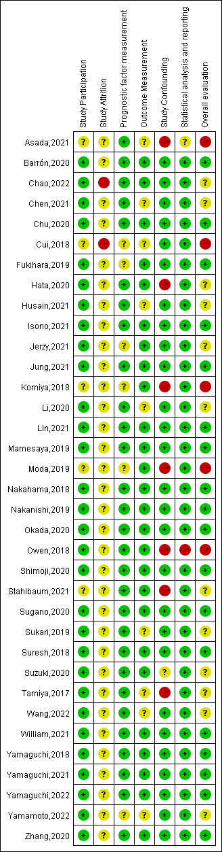
Supplementary Figure 7. Funnel plot of the incidence of CIP for the search of publication bias.
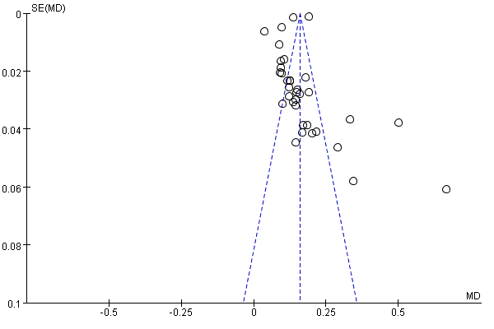

Supplementary Figure 8. Funnel plot of the risk factors of CIP for the search of publication bias.
