Supplementary File II: Supplementary data and methods
Data
Setting
We studied England, Finland, France, Italy, Norway, and the United States of America. These countries were selected because of the availability of health survey data on obesity over a long period of time, and because the obesity prevalence across these countries is indicative of different stages of the obesity epidemic based on the levels of obesity prevalence (1, 2).
We focused on the adult population in these countries and to ensure representability we aimed to include the widest age range possible. To ensure the validity of the measure for obesity and educational attainment, we selected adults above the age of 25.
Included national representative health surveys
We selected all nationally representative health surveys available from England, Finland, France, Italy, Norway, and the USA. For England, we collected the Health Survey for England (3). For Finland, we collected the AVTK (4), EVTK (5), ATH (6), and FinSote (7). For France, we collected EDS (8) and Health aBarometre (9). In Italy, we collected the National Multipurpose Social Survey, Aspects of Daily Life (10), and the Health and Healthcare Utilisation Study (10). For Norway, we collected the Norwegian Health Survey and Survey on Living Conditions (11). For the USA, we collected NHANES (12).
Although in all of the included countries large-scale nationally representative health surveys are conducted, the design, target sample, and topics vary over time. We selected those that we could harmonise over time. Furthermore, some national health surveys are not conducted yearly. For Finland, we decided to present unweighted trends to ensure that the time series was as consistent and as long as possible. Hence, we did not include ATH and FinSote in the analyses.
Table S1 contains an overview of the included health surveys by country with details regarding the variables such as the survey years, survey name, number of respondents, method of assessing height and weight (measured or self-reported), the age range and size of the age groups, the weighting and lastly, whether we obtained individual- or aggregated-level data.
Operationalisation of obesity
Obesity was defined as a Body Mass Index (BMI) greater than or equal to 30 kg/m² (WHO 2000). Although it is a rather crude measure at the individual level, at the population level BMI is considered an accurate predictor for morbidity and mortality (13). Furthermore, BMI is relatively easy to obtain and in the majority of the cases the only available indicator for adiposity in large health surveys.
In England and the USA, measured height and weight were used to calculate BMI since Health Survey for England and the National Health and Nutrition Examination Survey only collect measured weight and height. In the other countries, self-reported height and weight were used because no measured height and weight is available.
Operationalisation of educational attainment
Educational attainment was based on the highest level of degree obtained in all countries, except for Finland where educational attainment was based on the years of school attended rather than completed degrees. Educational attainment was harmonised according to the International Standard Classification of Education (ISCED) 1997 and reclassified into lower educated (levels 0-2: no, primary or lower secondary education), middle educated (levels 3-4: upper secondary and post-secondary non-tertiary education), and higher educated (levels 5-6: tertiary education). (14, 15). To facilitate the conversion several reports were used (15-17).
In the following sections, more detailed information is available regarding the conversion of the educational classification to the ISCED 1997 classification by country.
In the Health Survey for England, educational attainment was clubbed according to the National Vocational Qualifications (NVQ), A levels, and degree level. More specifically, NVQ 4 and 5, education at or above degree level, and equivalents were classified as higher educated (ISCED 5-6). NVQ 2 and 3, higher education below degree level, GCE A Level and GCE O Level, and equivalents were classified as middle educated (ISCED 3-4). CSE and equivalents, and no qualifications were qualified as lower educated (ISCED 0-2). “Other” or “no answer” were classified as missing and dropped from analysis.
In all Finnish surveys, educational attainment was based on the number of years of school attended full time. We converted the number of years to lower (ISCED 0-2), middle (ISCED 3-4), higher (ISCED 5-6) with the assistance of the national statistics office. Using the ISCED conversion based on the number of years yields a high proportion of missing strata (5.0%) of particularly higher educated older individuals in earlier survey years and lower educated younger individuals in recent years. To ensure comparability across countries in the main article, we decided to present the analysis using ISCED 1997 classification.
We also requested the Finnish data using tertiles as a classification system which yields a significantly smaller proportion of missing strata (1.1%). For the tertiles, the educational attainment was classified into lower, middle, and higher educated based on the tertiles cut points taking into account the sex and age of the respondent and the year of the response. Furthermore, the trends by educational tertiles also align better over recent years. The unweighted trends in the tertiles are similar to the trends using the ISCED 1997 classification for educational attainment (Figure S2).
In France, the educational attainment was based on the degree obtained. First, we selected the surveys in which the questions regarding educational attainment were consistent over time and could be used to classify respondents into lower educated (levels 0-2: no, primary or lower secondary education), middle educated (levels 3-4: upper secondary and post-secondary non-tertiary education), and higher educated (levels 5-6: tertiary education) according to ISCED 1997. Based on this criterion, we excluded the French ESPS survey which interchanged attained and attended education over the years. Furthermore, for the French EDS two options for educational attainment were posed; one including and one excluding vocational training. We opted for the question that included vocational training because it aligned better with the questions posed in Barometre, the other nationally representative health survey. With no degree, primary school certificates, certificate d’étude primaires (CEP), CAP, BEP, BEPC, brevet élémentaire, brevet de compagnon classified as lower educated. Baccalauréat général, baccalauréat technologique ou professionnel ou technicien, BEA, BEC, BEI, BEH, capacité en droit, diplôme de 1er cycle universitaire, BTS, DUT, DEUG, diplôme des progressions sociales ou de la santé, d’infirmier as middle educated. Bac +4 (maitrise) Bac +5 (DEA, DESS, Master2, MBA, doctorat, médicine, pharmacie, dentaire, diplôme d’ingénieur, d’un grande école, or autre as higher educated.
In Italy, educational attainment was based on obtained degrees. Higher educated included the following degrees: Dottorato di ricerca, Master's degree, and postgraduate specialization school); Academic diploma of Higher Artistic, Musical and Choreutical Education (A.F.A.M) of the Second Level); Bachelor's degree of 3 years of the first level, including First Level Master's degree; Academic diploma of Higher Artistic, Musical and Choreutical Education (A.F.A.M) of the first level; University degree of 2-3 years (Laurea (di II livello), Master di II livello e Scuola di specializzazione post- laurea); Diploma accademico di Alta Formazione Artistica, Musicale e Coreutica (A.F.A.M) di II livello); Laurea di 3 anni di I livello, compreso Master di I livello; Diploma accademico di Alta Formazione Artistica, Musicale e Coreutica (A.F.A.M) di I livello; Diploma universitario di 2-3 anni). Middle educated contained the following degrees: (Diploma scuola media superiore (4-5 anni); Diploma scuola media superiore di 2-3 anni (incluso attestato di qualifica professionale di 2-3 anni)). Lower educated contained the following certificates: (Licenza elementare (o valutazione finale equivalente)), ("Licenza di scuola media"), or no qualification. Lastly, illiterate individuals were also considered lower educated.
In Norway, educational attainment was classified according to Standard for utdanningsgruppering (NUS2000). NUS2000 levels zero (no education and pre-school education), one (primary education), and two (lower secondary education) were classified as lower educated (ISCED 0-2). NUS2000 levels three (upper secondary, basic), four (upper secondary, final year), and five (post-secondary, not higher education) were classified as middle educated (ISCED 3-4). NUS2000 levels six (first stage of higher education, undergraduate level), seven (first stage of higher education, graduate level), and eight (second stage of higher education) were classified as higher educated. NUS level five included both Fagskole 0.5 and 1.5 ar and Fagskole 2 ar, which would be converted to ISCED 4 (middle) and ISCED 5 (higher). We decided to club NUS level 5 as middle educated in line with the recommendations of the national statistics office during correspondence. Furthermore, in 1998 a health survey was conducted which used a previous version of NUS (NUS89) that could not be converted to ISCED or NUS2000 and was therefore not included.
In the American NHANES, the completed grade of school was used to define educational attainment. Less than 9th grade or no education attended was classified as lower educated (ISCED 0-2). 9th – 11th grade and high school grad/GED or equivalent were classified as middle educated. Some college or AA degree, college graduate or above was classified as higher educated (ISCED 5-6). “Refused”, “don’t know” and “missing” were dropped from analysis.
A general limitation of research on time trends by educational group is that educational expansion can influence trends. As a consequence of educational expansion, an increasingly larger proportion of the population is classified as middle and/or higher while the proportion of lower educated individuals decreases. This could leave a select group of lower educated individuals, which could result in extreme obesity estimates for lower educated groups. For Finland, we performed a sensitivity analysis that classifies respondents as lower, middle, and higher educated based on the tertiles of attended school years by sex, age group, and year and is thus insensitive to the educational expansion. The trends using this classification were similar to those using the ISCED 1997 classification (Supplementary Data and Methods: Figure S2).
Age limits and groups
We used a lower limit of age 25 across all surveys and countries. Until age 25, educational status is still likely to increase, and therefore, educational attainment might not the most appropriate measure for socio-economic status at younger ages. Furthermore, Body Mass Index (BMI) as defined by height and weight is only valid as a measure of adiposity above age 20 (WHO 2000). The upper age limit was 64 for Finland, and 74 for France. This was based on the age limit used in the survey with the most conservative upper age limit to ensure consistency for the time trends. In the other countries, no upper age limit was imposed to include a sample as representative as possible of the entire population.
For the majority of surveys, age was available or requested as a continuous variable or in five-year intervals. Except, in the Italian AVQ (after 2013) and the English HSE (2007 and 2008) where a 10 year-age interval was used for some age groups. We rearranged the 10-year data into 5-year age groups by applying the (weighted) prevalence of the 10 year age group to the underlying 5 year age groups. For example, the prevalence for the age group 25-34 was then assumed to be the prevalence for both the 25-29 and 30-34 age groups.
Surveys conducted over multiple years or multiple surveys conducted in one year
When surveys were conducted over two years (e.g. the American NHANES, French Barometre, and Italian NMS, and HHCU), we always selected the year in which data collection started as the survey year. When multiple health surveys were conducted in a single year (Italy, 2004 and 2013 and Finland 2013 and 2014), we selected a single survey. For Italy, we selected the Activities of Daily Life (AVQ) to generate a time trend that was as consistent as possible. In Finland, we selected AVTK, and not ATH, to create a consistent time series.
Individual and aggregate level data
For some surveys, data was only obtainable in an aggregated format, while for others individual-level information was available. More specifically, aggregate level data was requested for all surveys in Norway and Finland, and some surveys in Italy and France (Table S1). We requested the aggregated data from age 15 until the oldest ages available with 5 years interval. When data was available on the individual level, we aggregated the data to 15-80+ with five-year age intervals where possible.
Weighting
For all surveys, except the Finnish AVTK (1978-2014) and part of the English Health Survey for England (1991-2002), survey weights were available and applied to generate a weighted nationally representative prevalence. The trends for Finland and England are unweighted. For the Finnish data, we attempted to weight the data using post-stratification weights (18). However, applying post-stratification weights distorted trends (Figure S1b) and consequently, we decided to present the unweighted time trend instead. For England, survey weights were available from 2003 onwards. We compared the weighted and unweighted trends from 2003 onwards and confirmed that unweighted and weighted trends were comparable (Figure S1a).
The effect of weighting on obesity trends was examined by graphing unweighted age-standardised and age-specific trends in the obesity prevalence by sex and educational level. For most countries, the unweighted trends resembled the weighted trends (Figure S1). In the USA, the weighted obesity prevalence among women is lower than the unweighted obesity prevalence because of the large proportion of female respondents. The difference between weighted and unweighted estimates is relatively comparable across educational levels and over time.
Missings
In England, Finland, and France, several missing strata were identified. For England, all missing strata are the result of no respondents for that strata. In Finland, it could either be because of no respondents in that strata or because the number of respondents for that strata is smaller than 10. For France, the reason for missing strata is unknown. See Table S2 for a list of all missing strata by country, sex, education, and age group. No missing strata were identified in Italy, Norway and the USA. To handle missing strata in survey years, linear interpolation was applied to the (weighted) prevalence with the minimal prevalence set to zero and the maximum prevalence set to 100%. In case the missing strata occurred in the earliest survey year (only England 1991), linear extrapolation was used to determine the rate of increase for the two subsequent years and then used to calculate the prevalence.
Methods
Figures: age-standardised obesity prevalence by educational attainment
To visualise the trends in age-standardised obesity prevalence across educational levels, we age-standardised the linear-interpolated weighted age-specific obesity prevalence using the European Standard Population (ESP) 2013 (19). Age-standardisation using the European Standard Population allows for comparison of the prevalence rates across countries and over time despite differences in age structures. The ESP 2013 contains age groups 0-95+ with a five-year interval with the respective proportion of each age group in the total population which is based on the age distribution in the EU-27 and EFTA countries and the 2010-based population projections (19). The ESP was rescaled to the age range and intervals in the respective countries so that the sum of the proportions across age groups was always one. In other words, in France the upper age limit was 74 and so the ESP was rescaled to 25-74, and in Finland, this was 64 and so the ESP was rescaled to only include age groups 25-64. The prevalence in each age group is then multiplied by its respective proportion in the ESP 2013 and summed to generate age-standardised estimates.
The figures were produced using the ggplot package in R using the geom_smooth command for the Loess smoothing. Different Loess smoothing settings were tried and based on visual inspection, we selected degree one and span 0.6. These settings were robust enough to generate smooth time trends despite data fluctuations and sensitive enough to display the stagnation across the educational levels.
Prevalence rate differences and ratios
To examine the diffusion of obesity from high to low educational groups in early survey years, the prevalence rate ratio in the obesity prevalence between higher and lower educated groups was calculated by country, and sex. We used the predict Loess function in R to generate yearly estimates of the interpolated weighted age-specific obesity prevalence (Cleveland and Loader 1995). These smoothed estimated were subsequently age-standardise with the ESP 2013 to facilitate cross-national and temporal comparison (19). The ESP was rescaled to the age range and intervals in the respective countries so that the sum of the proportions across age groups was always one. In other words, in France the upper age limit was 74 and so the ESP was rescaled to 25-74, and in Finland, this was 64 and so the ESP was rescaled to only include age groups 25-64. The smoothed age-specific prevalence is then multiplied by its respective proportion in the ESP 2013 and summed to generate age-standardised estimates.
To calculate the prevalence rate difference in Table 2, we subtracted the prevalence of the higher educated (ISCED 5-6) groups from the lower educated (ISCED 0-2) groups by sex, country, and five-year interval. We selected the prevalence rate difference for the main article because rate differences are an absolute measure that aligns well with Figure 1 and Table 3. To calculate the prevalence rate ratios (Table S1), we divided the prevalence of the lower educated (ISCED 0-2) by the prevalence of the higher education (ISCED 5-6) groups by sex, country, and five-year interval.
Segmented regression: the Annual Percentage Change (APC)
The APC in the obesity prevalence by educational attainment, sex, and decade was calculated using linear segmented regression using the decades as cut-offs to examine the steep increase (stage two) and the stagnation (stage three) in obesity prevalence. Although the decades are a rather crude cut-off, it does facilitate comparison across countries and ensures that there are sufficient data points for each country compared to using a shorter time interval. A separate linear regression model was fitted for each decade, country, sex, and educational group. The independent variable was the linear-interpolated weighted age-specific obesity prevalence, except in England and Finland where the unweighted prevalence was used. The dependent variables were year and age group to adjust for the different age structures in the data and facilitate comparison. This ensured optimal use of the available data without using smoothed values that were not originally present in the data.

Table S1. List of included countries and national health surveys with details on the number of respondents, assessment of height and weight, age range, weighing, and aggregation.
Country | Survey name | Survey year | Number of respondents per year | Assessment of height and weight | Age range (age group) | Weighting | Individual or aggregated data
Finland | Health Behaviour and Health of Adult Population (AVTK) | 1978-2014 | 2520 ~ 5110 | Self-reported | 15-64 (5 year age group) | Unweighted | Aggregated
 | Adult Health, Welfare and Service Research (ATH) | 2013-2017 | 2305 ~ 49846 | Self-reported | 20-95+ (5 year age group) | Weighted | Aggregated
 | FinSote | 2018-2019 | 6134 ~ 26371 | Self-reported | 20-95+ (5 year age group) | Weighted | Aggregated
France | Barometre | 1996, 2000, 2002, 2005, 2008, 2010, 2014, 2016, 2017 | 1984 ∼ 25319 | Self-reported | 18-75 (5 year age group) | Weighted | Aggregated
 | Enquete Decennale Sante (EDS) | 1980/1981, 1991/1992, 2002/2003 | 21007 ~ 40796 | Self-reported | 15-85+ (5 year age group) | Weighted | Individual
England | Health Survey for England (HSE) | 1991-2018 | 7658 ∼ 22619 | Measured | 15-85+ (5 year age group, except 2014: 10 year age group) | Unweighted until 2002  From 2003, both | Individual
Italy | National Multipurpose Social Survey | 1990/1 | 65264 ~ 67400 | Self-reported | 18-80+ (5 year age group) | Weighted | Aggregated
 | Aspects of Daily Life (AVQ) | 2001-2018 | 44682 ~ 55294 | Self-reported | 18-75+ (5 year age group until 2012, from 2013, 10 year age groups) | Weighted/  unweighted | Individual
 | Health conditions and use of Health Services | 1994, 1999/2000, 2004/5, 2013 | 62461 ~ 128039 | Self-reported | 15-85+ (5 year age group) | Weighted/  unweighted | Individual
USA | National Health and Nutrition Examination Survey | 1999/2000, 2001/2, 2003/4, 2005/6, 2007/8, 2009/10, 2011/12, 2013/14, 2015/16, 2017/18 | 9254 ~ 11039 | Measured | 15-85+ (5 year age group) | Weighted/  unweighted | Individual
Norway | Health Survey | 1995 | 8005 | Self-reported | 15-85+ (5 year age group) | Weighted/  unweighted | Aggregated
 | Health, care and social relations: Survey on Living Conditions | 2002, 2005, 2008, 2012, 2015, 2019 | 5660 ∼ 8164 | Self-reported | 15-85+ (5 year age group) | Weighted/  unweighted | Aggregated

Table S2. List of missing strata by country, year, sex, educational attainment, and age group
Country | Year | Sex | Educational attainment | Age group
England (n=3) | 1991 | Women | Higher | 70-74
 | 1992 | Women | Higher | 65-69
 | 1993 | Women | Higher | 70-74
Finland (n=177) | 1978 | Men | Middle | 50-54
 |  |  | Higher | 55-59
 |  | Women | Middle | 55-59
 |  |  | Higher | 40-44, 60-64
 | 1979 | Men | Middle | 45-49, 50-54, 55-59, 60-64
 |  |  | Higher | 50-54, 55-59
 |  | Women | Middle | 45-49
 |  |  | Higher | 25-29
 | 1980 | Women | Middle | 55-59
 |  | Women | Higher | 35-39
 | 1981 | Men | Higher | 60-64
 |  | Women | Higher | 25-29, 45-49
 | 1982 | Men | Middle | 50-54
 |  |  | Higher | 60-64
 |  | Women | Lower | 30-34
 |  |  | Higher | 25-29
 | 1983 | Men | Middle | 55-59
 |  |  | Higher | 50-54, 60-64
 |  | Women | Middle | 30-34
 |  |  | Higher | 30-34
 | 1984 | Men | Middle | 50-54
 |  |  | Higher | 25-29
 |  | Women | Higher | 60-64
 | 1985 | Men | Lower | 25-29
 |  |  | Middle | 55-59, 60-64
 |  |  | Higher | 55-59
 |  | Women | Higher | 30-34, 35-39
 | 1986 | Women | Higher | 50-54
 | 1987 | Men | Lower | 25-29
 |  |  | Higher | 30-34, 60-64
 |  | Women | Lower | 25-29
 |  |  | Higher | 60-64
 | 1988 | Men | Lower | 25-29
 |  |  | Higher | 30-34
 |  | Women | Lower | 25-29
 | 1989 | Men | Lower | 30-34
 |  |  | Higher | 50-54
 |  | Women | Lower | 25-29
 | 1990 | Men | Middle | 50-54
 | 1991 | Men | Higher | 60-64
 |  | Women | Lower | 25-29
 | 1992 | Men | Lower | 25-29, 30-34
 |  |  | Middle | 60-64
 |  |  | Higher | 60-64
 |  | Women | Higher | 25-29
 | 1993 | Men | Lower | 30-34
 |  |  | Middle | 25-29
 | 1994 | Men | Lower | 25-29
 |  | Women | Lower | 25-29, 30-34, 35-39
 | 1995 | Men | Lower | 25-29
 |  | Women | Lower | 30-34,
 | 1996 | Men | Lower | 25-29
 |  | Women | Middle | 25-29
 | 1997 | Men | Lower | 35-39
 |  | Women | Lower | 25-29, 30-34
 | 1998 | Men | Lower | 25-29
 | 1998 | Women | Lower | 25-29, 30-34
 | 1999 | Men | Lower | 25-29
 |  |  | Middle | 25-29
 | 2000 | Men | Lower | 25-29, 30-34
 |  | Women | Lower | 25-29, 30-34
 | 2001 | Men | Lower | 25-29
 |  | Women | Lower | 25-29, 35-39
 | 2002 | Women | Lower | 25-29
 | 2003 | Men | Lower | 25-29, 30-34
 |  | Women | Lower | 25-29, 30-34
 |  |  | Middle | 25-29
 | 2004 | Men | Lower | 25-29, 30-34
 |  | Women | Lower | 25-29, 35-39
 | 2005 | Men | Lower | 25-29, 30-34
 |  | Women | Lower | 25-29, 30-34
 | 2006 | Men | Lower | 25-29, 30-34
 |  | Women | Lower | 25-29, 30-34
 | 2007 | Men | Lower | 25-29, 30-34
 | 2008 | Men | Lower | 25-29
 |  | Women | Lower | 25-29, 35-39
 | 2009 | Men | Lower | 25-29, 30-34, 40-45
 |  | Women | Lower | 25-29, 30-34, 35-39
 | 2010 | Men | Lower | 25-29, 30-34, 40-44
 |  | Women | Lower | 25-29, 30-34, 35-39, 40-44
 | 2011 | Men | Lower | 25-29, 30-34, 35-39, 40-44
 |  | Women | Lower | 25-29, 30-34, 35-39, 45-49
 | 2012 | Men | Lower | 25-29, 30-34, 35-39, 40-44
 |  | Women | Lower | 25-29, 30-34, 35-39, 45-49
 |  |  | Middle | 30-34
 | 2013 | Men | Lower | 25-29, 30-34, 35-39, 40-44
 |  | Women | Lower | 25-29, 30-34, 35-39
 |  |  | Middle | 35-39
 | 2014 | Men | Lower | 25-29, 30-34
 |  | Women | Lower | 25-29, 30-34, 35-39, 40-44
France (n=5) | 1990 | Men | Higher | 30-34, 55-59
 |  | Women | Higher | 25-29, 30-34, 35-39

Figure S1a. Loess-smoothed age-standardised weighted (black) and unweighted (red) obesity (BMI ≥30 kg/m²) prevalence (%) in England for men and women by educational attainment (lower: ISCED 0-2, middle: ISCED 3-4, higher: ISCED 5-6) from 2003 to 2018
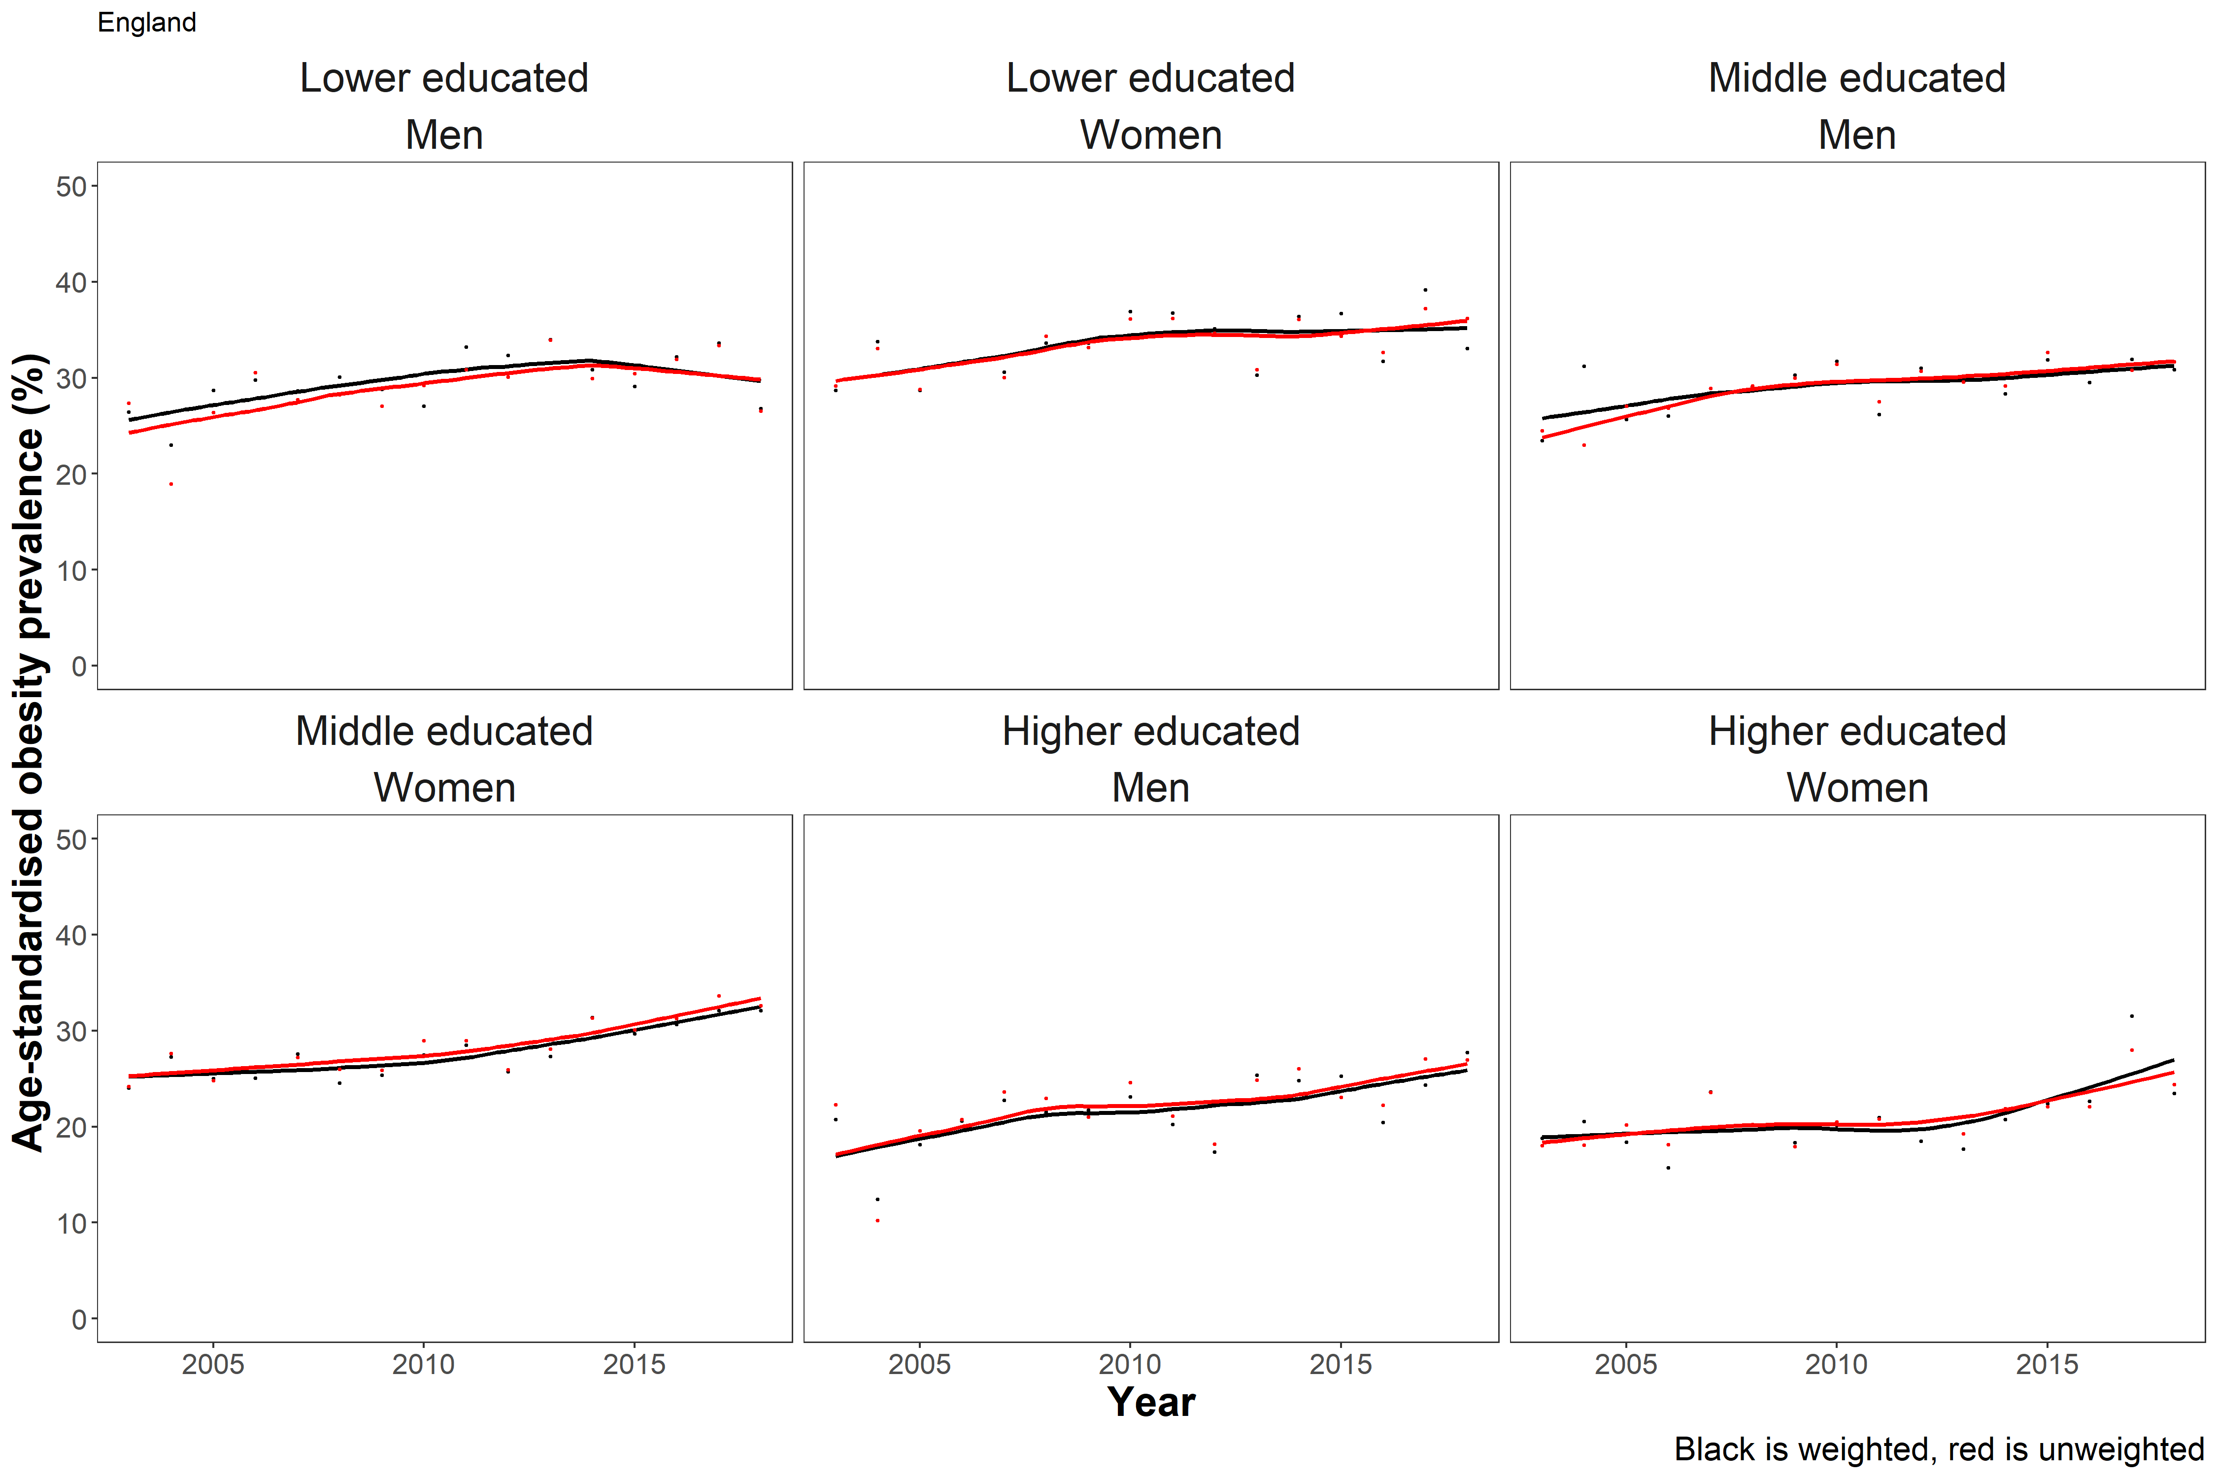
Figure S1b. Loess-smoothed age-standardised weighted (black) and unweighted (red) obesity (BMI ≥30 kg/m²) prevalence (%) in Finland for men and women by educational attainment (lower: ISCED 0-2, middle: ISCED 3-4, higher: ISCED 5-6) from 1978 to 2019.
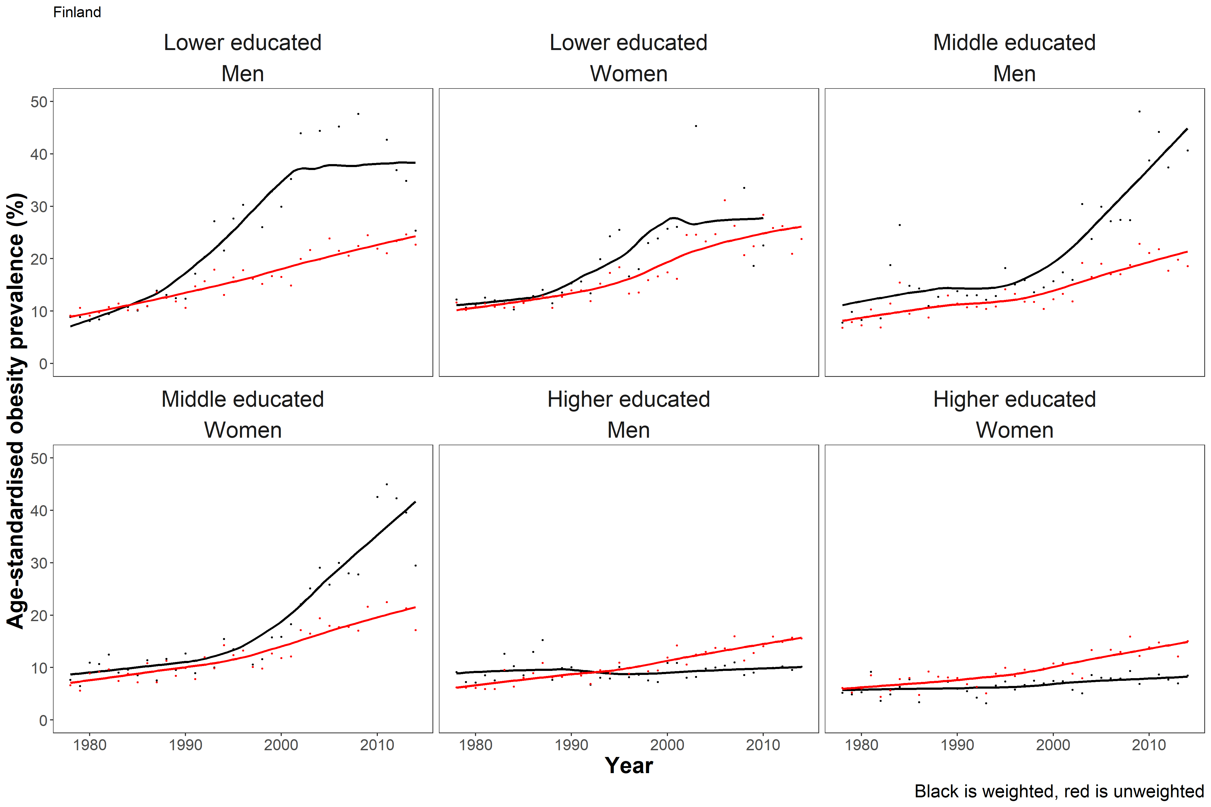
Figure S1c. Loess-smoothed age-standardised weighted (black) and unweighted (red) obesity (BMI ≥30 kg/m²) prevalence (%) in France for men and women by educational attainment (lower: ISCED 0-2, middle: ISCED 3-4, higher: ISCED 5-6) from 1980 to 2017
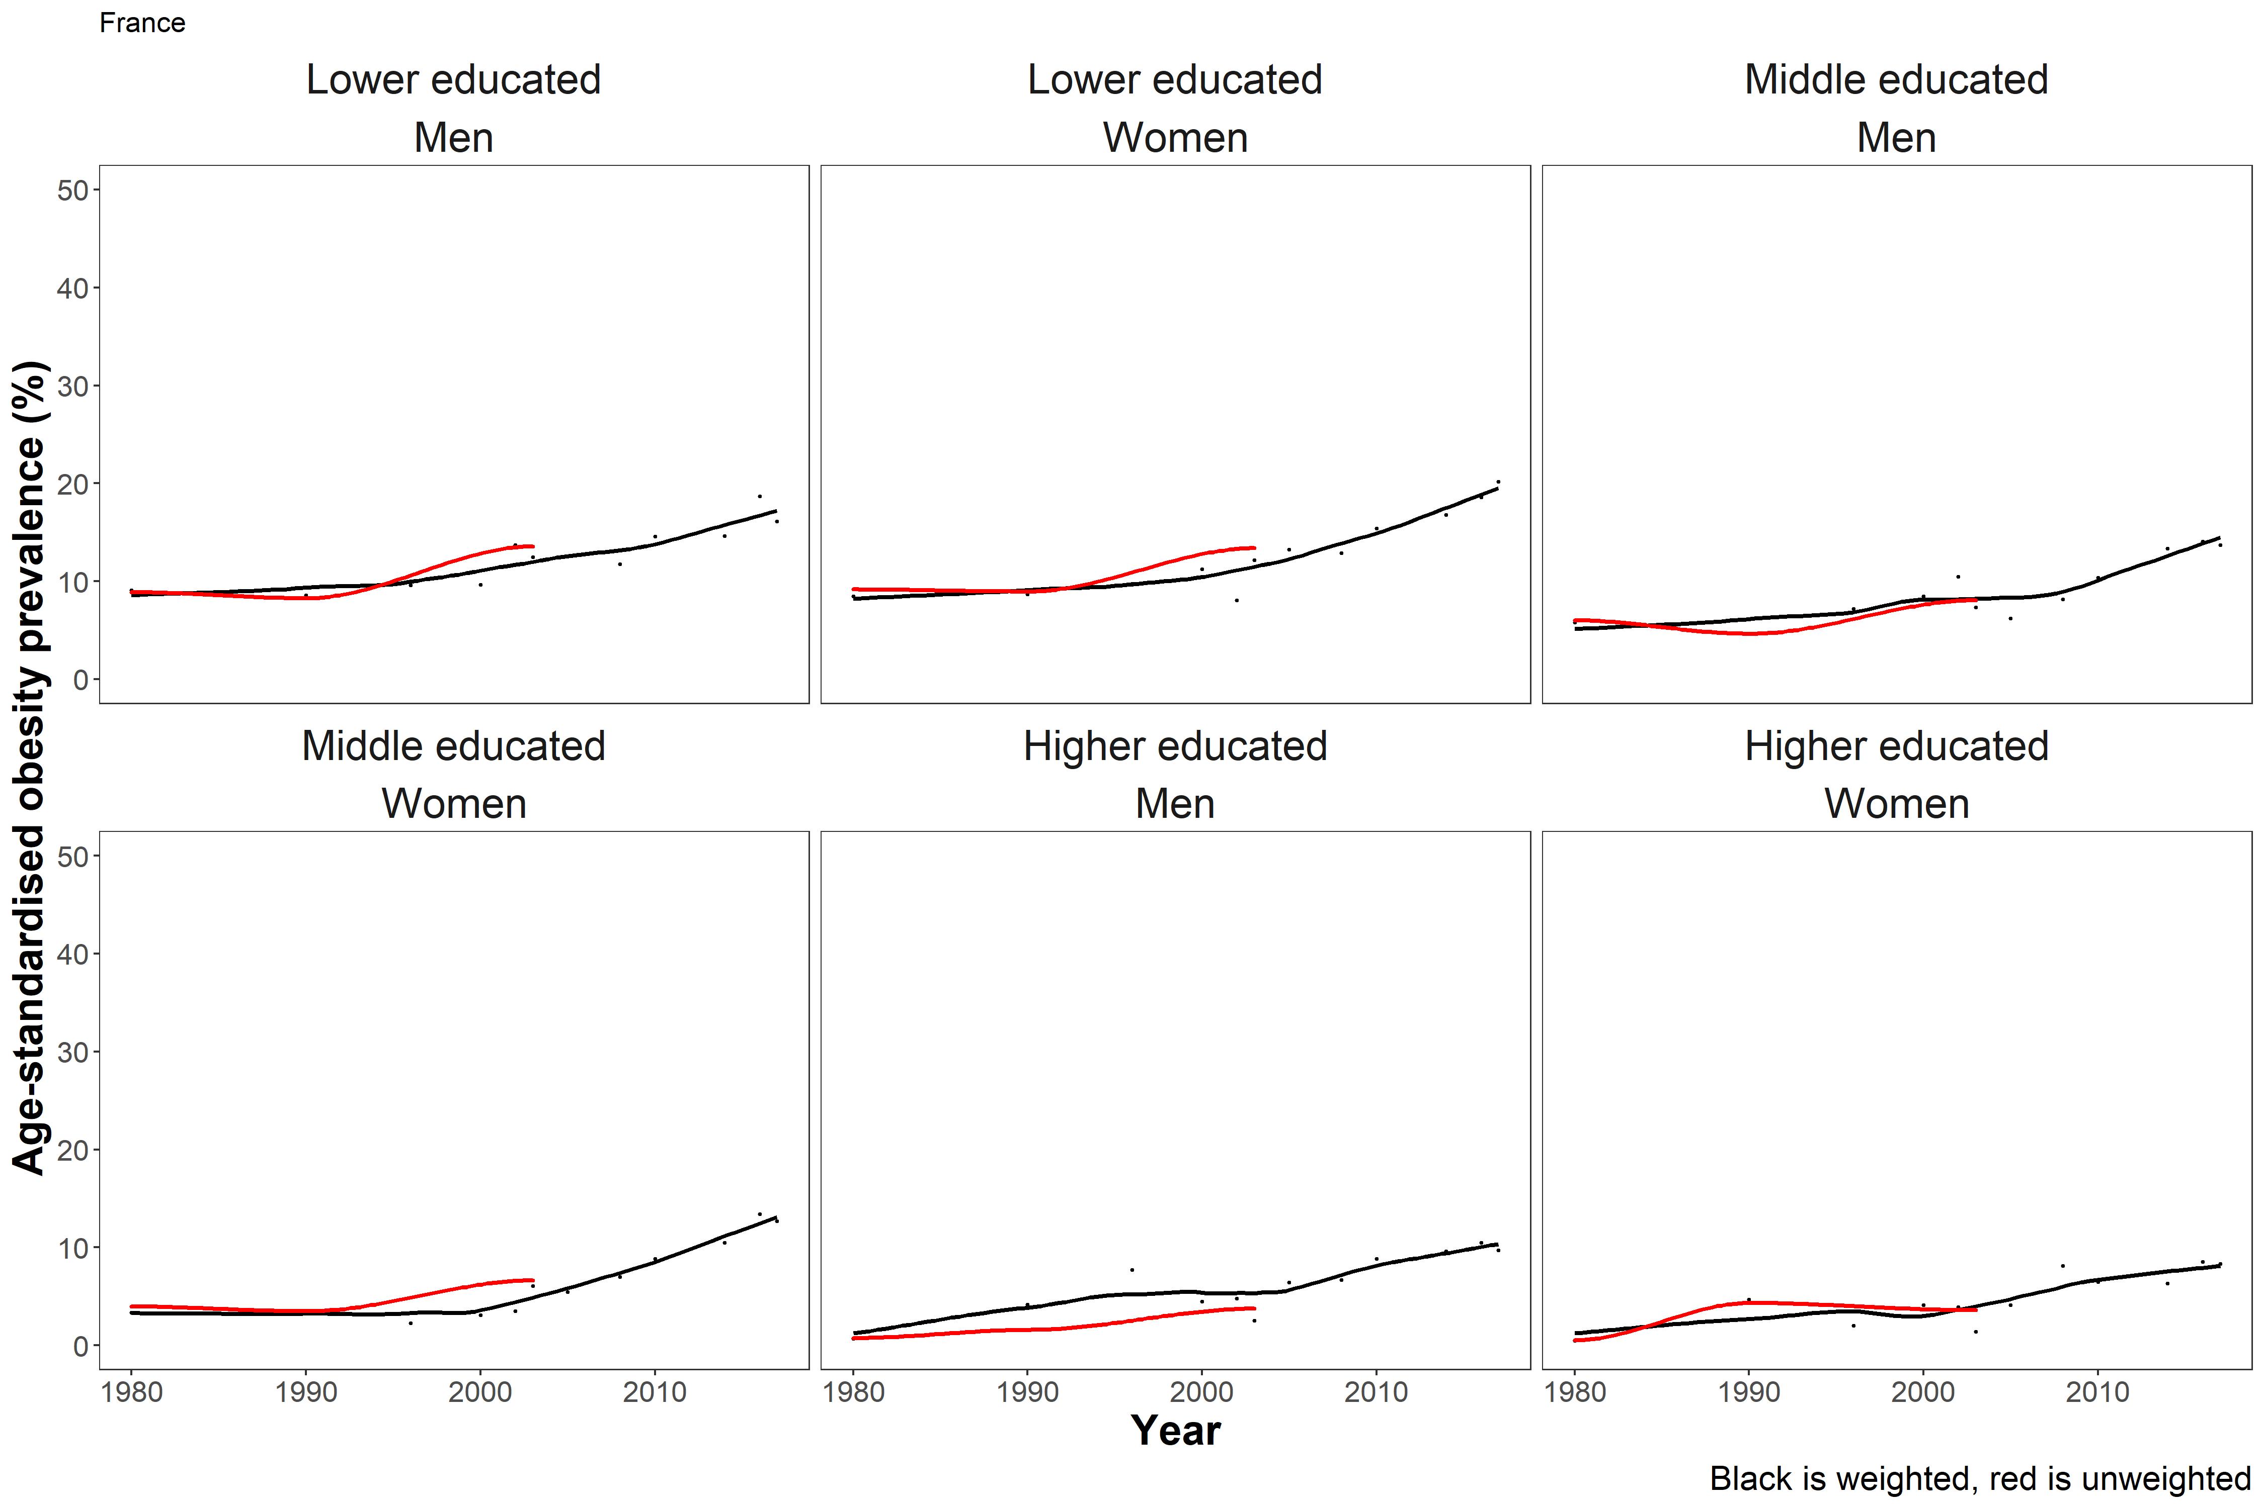
Figure S1d. Loess-smoothed age-standardised weighted (black) and unweighted (red) obesity (BMI ≥30 kg/m²) prevalence (%) in Norway for men and women by educational attainment (lower: ISCED 0-2, middle: ISCED 3-4, higher: ISCED 5-6) from 1995 to 2019
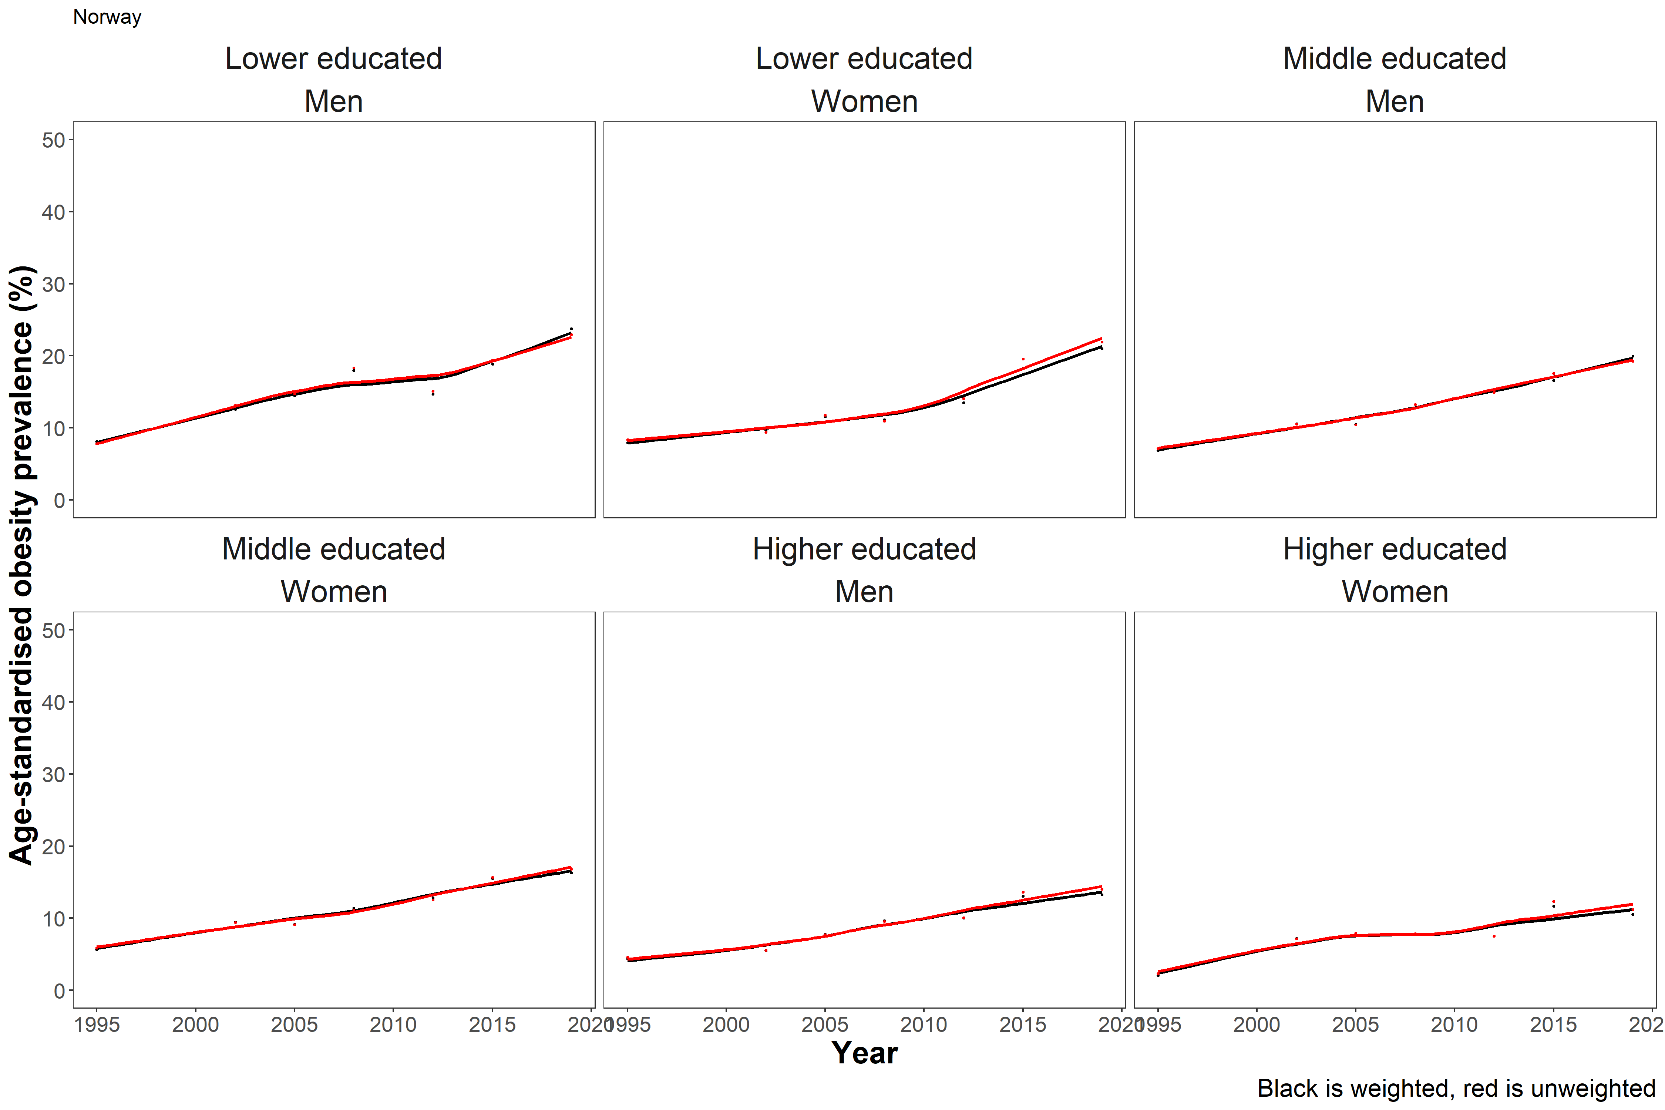
Figure S1e. Loess-smoothed age-standardised weighted (black) and unweighted (red) obesity (BMI ≥30 kg/m²) prevalence (%) in the USA for men and women by educational attainment (lower: ISCED 0-2, middle: ISCED 3-4, higher: ISCED 5-6) from 1999 to 2017
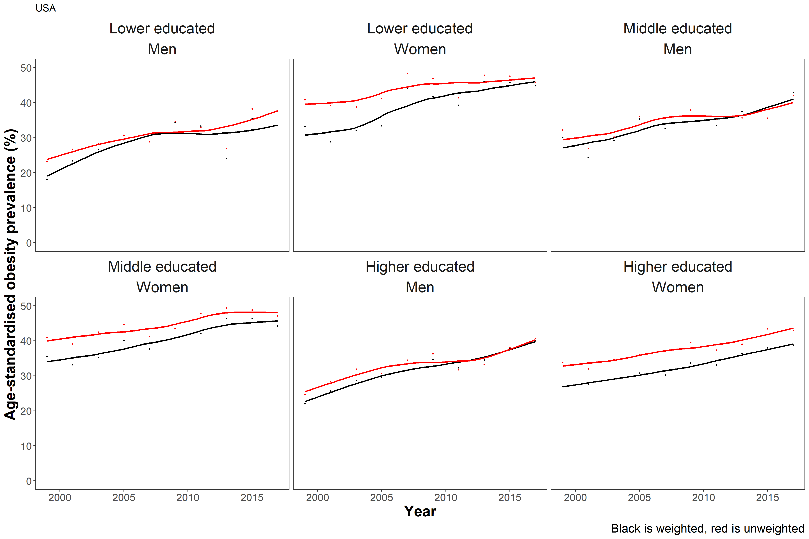

Figure S2. Loess-smoothed age-standardised prevalence (%) of obesity (BMI ≥30 kg/m²) in men and women in Finland by educational attainment (for ISCED: lower: ISCED 0-2, middle: ISCED 3-4, higher: ISCED 5-6 and by tertiles) from 1978-2014
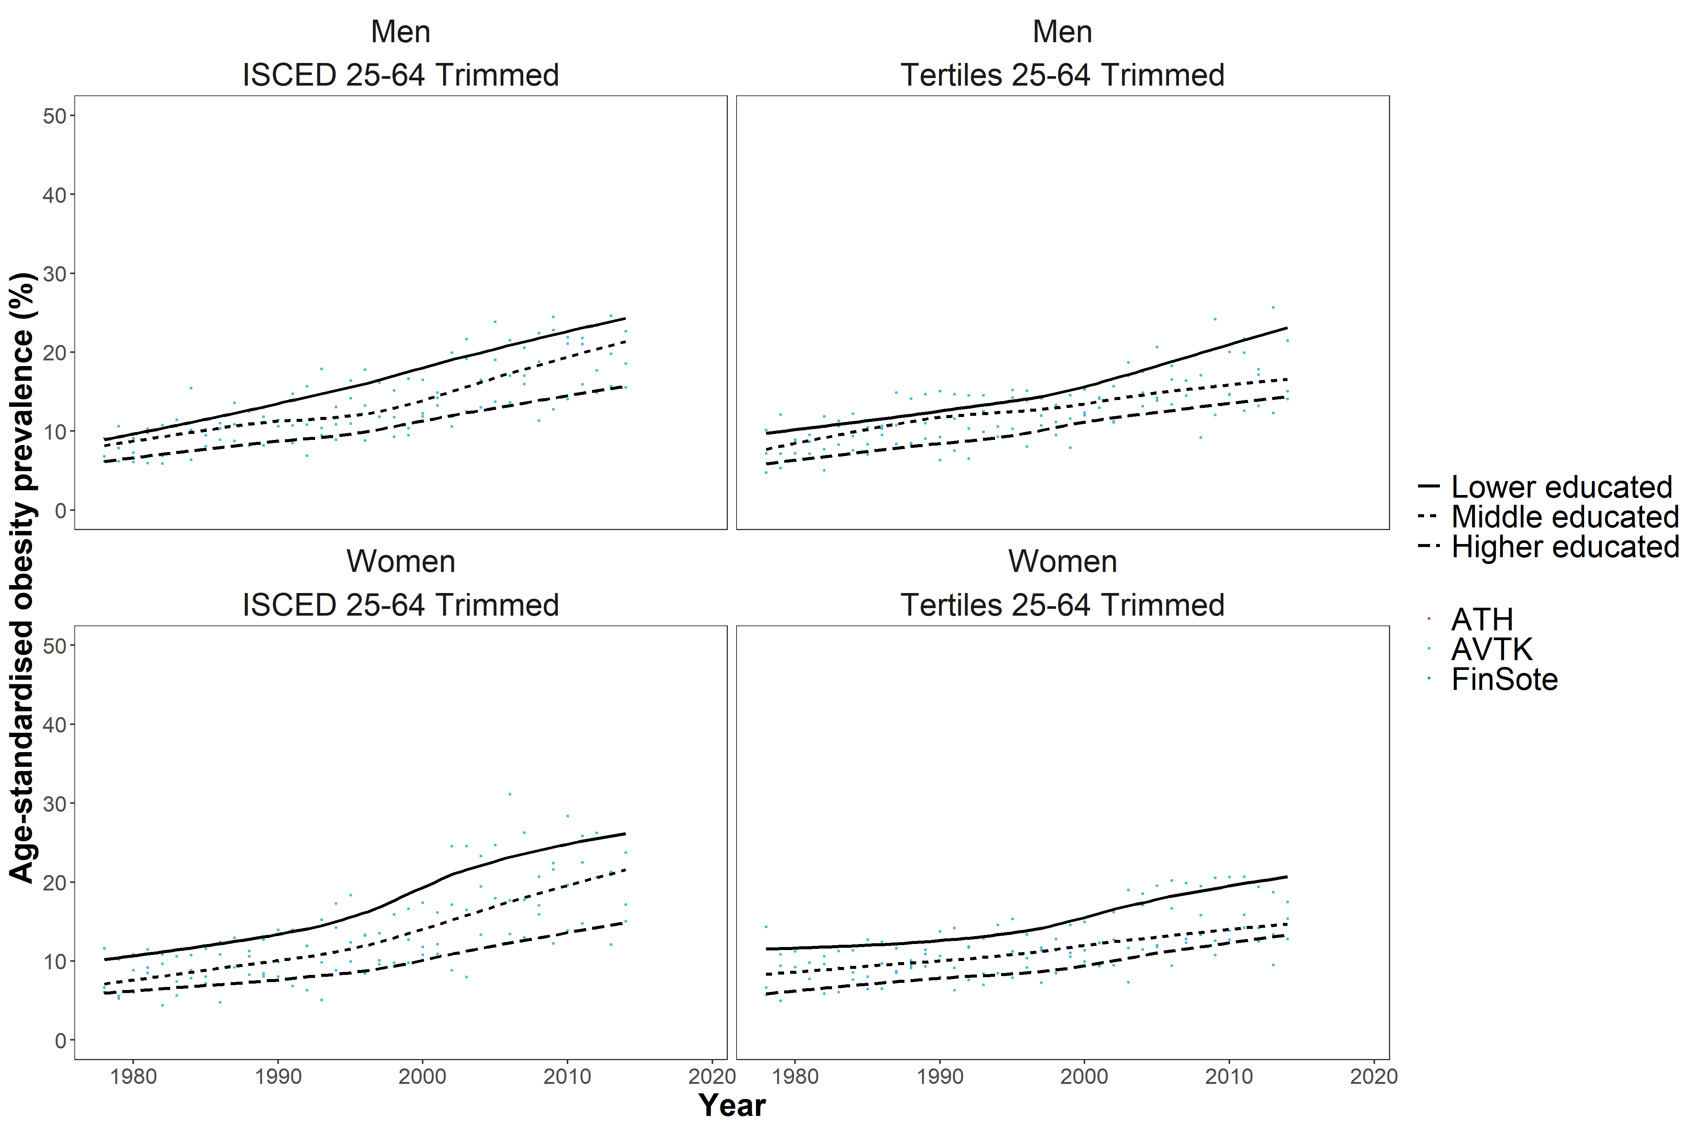

References
1. Janssen F, Bardoutsos A, Vidra N. Obesity Prevalence in the Long-Term Future in 18 European Countries and in the USA. Obesity Facts. 2020;13(5):514-27. doi: 10.1159/000511023
2. Xu L, Lam TH. Stage of obesity epidemic model: Learning from tobacco control and advocacy for a framework convention on obesity control. Journal of diabetes. 2018;10(7):564-71. PubMed PMID: 29380940. Epub 2018/01/31. eng. doi: 10.1111/1753-0407.12647
3. Health Survey for England (HSE) - National Health Service (NHS) (UK Dataservice); http://content.digital.nhs.uk/healthsurveyengland ; www.ukdataservice.ac.uk/
4. Health Behaviour and Health among the Finnish Adult Population (AVTK) – National Institute for Health and Welfare (Satu Helakorpi); https://http://www.thl.fi/en/web/thlfi-en/research-and-expertwork/population-studies ; https://www.thl.fi/en/web/thlfi-en/statistics/information-for-researchers
5. Health Behaviour and Health among the Finnish Retirement-Age Population – National Institute for Health and Welfare (Satu Helakorpi); https://thl.fi/fi/tutkimus-ja-kehittaminen/tutkimukset-ja-hankkeet/finsote-tutkimus/aiemmat-tutkimukset/elakeikaisen-vaeston-terveyskayttaytyminen-ja-terveys-evtk-
6. Adult Health, Welfare and Service Research (ATH) - National Institute for Health and Welfare (Suvi Parikka); https://thl.fi/fi/tutkimus-ja-kehittaminen/tutkimukset-ja-hankkeet/finsote-tutkimus/aiemmat-tutkimukset/aikuisten-terveys-hyvinvointi-ja-palvelututkimus-ath-
7. FinSote National Survey of Health - National Institute for Health and Welfare (Suvi Parikka, Anna-Mari Aalto); https://thl.fi/en/web/thlfi-en/research-and-development/research-and-projects/national-finsote-survey
8. Enquête Décennale Santé - Santé Publique France (Gwenn Menvielle & Jean-Baptiste Richard); http://quetelet.progedo.fr/?rubrique75 ; http://inpes.santepubliquefrance.fr/Barometres/index.asp
9. Health Barometer, Santé publique France, the French national public health agency, France, YEAR(S). (Health Barometer was funded and carried out by Santé publique France, the French national public health agency)
10. Aspects of Daily Life (1993- 2015) & Health conditions and use of Health Services - Italian National Institute of Statistics (ISTAT) (Lidia Gargiulo). http://www.istat.it/it/archivio/4630 ; http://www.istat.it/it/archivio/129956 ; http://www.istat.it/it/archivio/5471
11. Norwegian Health Surveys, Norwegian surveys on Living conditions - Statistics Norway (Elin S. Lunde). http://www.ssb.no/en/helse/statistikker/helseforhold/hvert-3-aar/2016-06-20?fane=om#content
12. National Health and Nutrition Examination Survey - Centers for Disease Control and Prevention; https://www.cdc.gov/nchs/nhanes/index.htm.
13. Di Angelantonio E, Bhupathiraju Sh N, Wormser D, et al. Body-mass index and all-cause mortality: individual-participant-data meta-analysis of 239 prospective studies in four continents. The Lancet. 2016;388(10046):776-86. doi:10.1016/S0140-6736(16)30175-1
14. UNESCO. International Standard Classification of Education: ISCED 1997. 2006.
15. OECD. Classifying Educational Programmes - Manual for ISCED-97 Implementation in OECD Countries. 1999.
16. Statistics NCfE. Apendix A. The Education Systems of the G-8 Countries. 2011.
17. UNESCO. International Classification of Education: ISCED 1997. 2006.
18. WFP. Lesson 9: Introduction to post-stratification 2017. https://docs.wfp.org/api/documents/WFP-0000121326/download/
19. EUROSTAT. Revision of the European Standard Population. EUROSTAT Methodologies and Working Papers: 2013.

