Baseline clinical characteristics and complement biomarkers of patients with C3G enrolled in two Phase II studies investigating the factor D inhibitor danicopan
Steven D. Podosª, Howard Trachtman^{b*}, Gerald Appel^{c}, Andrew S. Bomback^{c}, Bradley P. Dixon^{d}, Jack Wetzels^{e}, H. Terence Cook^{f}, Samir V. Parikh^{g}, Matthew C. Pickering^{f}, James Tumlin^{h**}, Craig Langman^{i}, Liz Lightstone^{f}, C. John Sperati^{j}, Erica Daina^{k}, Koenraad Peter Bouman^{l}, Kara Rice^{m}, Jane A Thanassiª, Mingjun Huangª, Carla Nester^{n} and Giuseppe Remuzzi^{k}

Supplementary figure

Supplementary Figure 1. Patient disposition

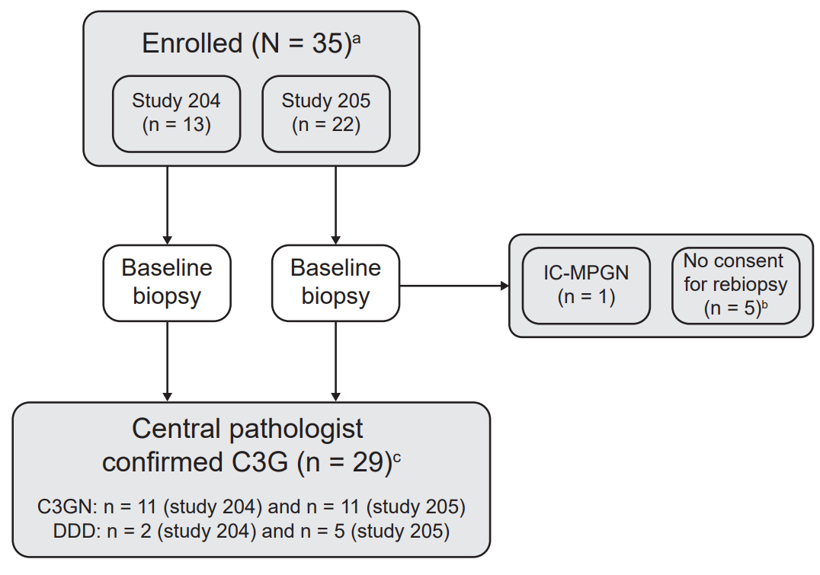

ªN = 35 patients with C3G or IC-MPGN based on local laboratory biopsy analysis and medical history enrolled in Studies 204 and 205 (see methods for study design); ^{b}n = 5 patients did not provide consent/excluded for a re-biopsy to confirm their C3G diagnosis by analysis at a central laboratory and were not included in the biomarker analysis (three were adolescents who were not subjected to rebiopsy based on protocol and two did not provide consent); ^{c}n = 29 patients with biopsy-confirmed C3G at baseline based on new biopsies taken at baseline and analyzed at a single central laboratory.

