SUPPLEMENTARY MATERIAL

Supplementary Table S1: Reasons for GLM treatment discontinuation during the 52-week observation period

Safety analysis set
Reasons for treatment discontinuation, n (%) | Overall  (n=391) | Biologic naïve  (n=168) | Biologic experienced  (n=223)
Discontinued patients | 183 (46.8) | 79 (47.0) | 104 (46.6)
Lack of efficacy | 117 (29.9) | 49 (29.2) | 68 (30.5)
AE | 28 (7.2) | 14 (8.3) | 14 (6.3)
Transfer hospital | 22 (5.6) | 9 (5.4) | 13 (5.8)
Patient request | 10 (2.6) | 4 (2.4) | 6 (2.7)
Not visit | 3 (0.8) | 1 (0.6) | 2 (0.9)
Other | 3 (0.8) | 2 (1.2) | 1 (0.4)
GLM, golimumab; AE, adverse event.

Supplementary Table S2: Proportion of patients who continued GLM treatment during the 52-week observation period

Efficacy analysis set
Patients, n (%) |  | Baseline | Week 6 | Week 22 | Week 36 | Week 52
Overall |  | 336 (100.0) | 302 (89.9) | 258 (76.8) | 216 (64.3) | 171 (50.9)
Medical history | Biologic naïve | 149 (100.0) | 137 (91.9) | 119 (79.9) | 97 (65.1) | 75 (50.3)
 | Biologic experienced | 187 (100.0) | 165 (88.2) | 139 (74.3) | 119 (63.6) | 96 (51.3)
Reasons for switching previous biologic treatment | Lack of efficacy | 149 (100.0) | 132 (88.6) | 112 (75.2) | 95 (63.8) | 75 (50.3)
 | AE | 33 (100.0) | 29 (87.9) | 23 (69.7) | 16 (48.5) | 14 (42.4)
 | Other | 23 (100.0) | 21 (91.3) | 18 (78.3) | 17 (73.9) | 15 (65.2)
GLM, golimumab; AE, adverse event.

Supplementary Table S3: Univariable and multivariable analysis showing variables associated with clinical remission at week 52

Efficacy analysis set (n=336)
Predictors | n | Univariate |  | Multivariate
 |  | OR (95% CI) | P-value | OR (95% CI) | P-value
Age (years)
<65 | 295 | Reference | 0.248
≥65 | 41 | 1.474 (0.763–2.845)
Weight (kg)
<55.10 | 157 | Reference | 0.102 | Reference | 0.079
≥55.10 | 158 | 1.448 (0.929–2.256) |  | 1.565 (0.950–2.579)
Gender
Male | 176 | Reference | 0.405
Female | 160 | 1.200 (0.781–1.843)
Disease duration (years)
<2 | 75 | Reference | 0.197 | Reference | 0.172
2 to <10 | 155 | 0.722 (0.415–1.256) |  | 0.999 (0.514–1.943)
≥10 | 93 | 1.132 (0.616–2.082) |  | 1.698 (0.821–3.510)
Prior surgery related to UC
No | 328 | Reference | 0.401
Yes | 8 | 1.860 (0.437–7.912)
Prior treatment with biologics
No | 149 | Reference | 0.184 |  | 0.487
Yes | 187 | 0.746 (0.485–1.149) |  | 0.738 (0.313–1.738)
Number of prior biologic treatments
None | 149 | Reference | 0.285
1 | 143 | 0.801 (0.506–1.269)
≥2 | 44 | 0.589 (0.296–1.170)
Switched from IFX treatment
No | 239 | Reference | 0.598
Yes | 97 | 0.880 (0.548– 1.414)
Switched from ADA treatment
No | 254 | Reference | 0.125 | Reference | 0.584
Yes | 82 | 0.673 (0.406–1.116) |  | 0.822 (0.407–1.658)
Switched from other biologic treatment
No | 328 | Reference | 0.138 | Reference | 0.205
Yes | 8 | 3.390 (0.674–17.041) |  | 4.446 (0.442–44.706)
Reason for switch from previous biologics is lack of efficacy
No | 187 | Reference | 0.081 | Reference | 0.645
Yes | 149 | 0.680 (0.441–1.049) |  | 0.820 (0.353–1.906)
Reason for switch from previous biologics is AEs
No | 303 | Reference | 0.530
Yes | 33 | 0.792 (0.383–1.638)
Reason for switch from previous biologics is lack of efficacy & AEs
No | 325 | Reference | 0.884
Yes | 11 | 0.914 (0.274–3.055)
Prior treatment with tacrolimus/ciclosporin
No | 272 | Reference | 0.214
Yes | 64 | 0.705 (0.405–1.224)
Concomitant use of CSs during the study
No | 127 | Reference | 0.032* | Reference | 0.054
Yes | 209 | 0.616 (0.395–0.960) |  | 0.596 (0.352–1.009)
Concomitant use of IMs during the study
No | 190 | Reference | 0.908
Yes | 146 | 0.975 (0.633–1.502)
Disease extent
Pancolitis | 245 | Reference | 0.615
Left-sided | 75 | 0.874 (0.519–1.470)
Proctitis | 13 | 2.502 (0.750–8.432)
Right-sided or segmental | 1 | <0.001
Other | 2 | NC
Smoking history
No | 240 | Reference | 0.037* | Reference | 0.040*
Yes | 63 | 1.827 (1.038–3.214) |  | 1.911 (1.030–3.546)
Patient hospitalisation status at baseline
Outpatient | 281 | Reference | 0.955
Inpatient | 55 | 0.984 (0.551–1.755)
Factors with P<0.2 in the univariate analysis were used for multivariate analysis. Clinical remission was defined as a partial Mayo score of ≤2 [1]. The P-value was calculated using the Wald χ² test. *, P<0.05. An OR>1.0 is favourable for clinical remission, whereas an OR<1.0 is unfavourable for clinical remission compared with reference categories. Where the 95% CI does not cross OR=1.0, there is a statistically significant association between categories. ADA, adalimumab; AE, adverse event; CI, confidence interval; CS, corticosteroid; IFX, infliximab; IM, immunomodulator; NC, not calculated; OR, odds ratio; UC, ulcerative colitis.

Supplementary Table S4: List of ADRs by preferred term
Safety analysis set (n=391)
 | Serious | Non-serious | Overall
Safety analysis set, n | 391 | 391 | 391
Patients with ADRs, n (%) | 40 (10.2) | 37 (9.5) | 71 (18.2)
Number of ADRs | 49 | 46 | 95
Type of ADR, patient number (%)
System Organ Class
Preferred Term
Infections and infestations | 15 (3.8) | 8 (2.0) | 21 (5.4)
Cellulitis | 1 (0.3) | 0 | 1 (0.3)
Cystitis | 0 | 1 (0.3) | 1 (0.3)
Fungal infection | 0 | 1 (0.3) | 1 (0.3)
Herpes zoster | 2 (0.5) | 3 (0.8) | 5 (1.3)
Influenza | 0 | 1 (0.3) | 1 (0.3)
Nasopharyngitis | 0 | 2 (0.5) | 2 (0.5)
Pneumonia | 3 (0.8) | 0 | 3 (0.8)
Pneumonia legionella | 1 (0.3) | 0 | 1 (0.3)
Pyelonephritis acute | 1 (0.3) | 0 | 1 (0.3)
Anal abscess | 1 (0.3) | 0 | 1 (0.3)
Cytomegalovirus enterocolitis | 1 (0.3) | 0 | 1 (0.3)
Candida sepsis | 1 (0.3) | 0 | 1 (0.3)
Enteritis infectious | 1 (0.3) | 0 | 1 (0.3)
Pneumonia bacterial | 2 (0.5) | 0 | 2 (0.5)
Atypical mycobacterial infection | 1 (0.3) | 0 | 1 (0.3)
Listeria sepsis | 1 (0.3) | 0 | 1 (0.3)
Neoplasms benign, malignant and unspecified (incl cysts and polyps) | 2 (0.5) | 1 (0.3) | 3 (0.8)
Acute myeloid leukaemia | 1 (0.3) | 0 | 1 (0.3)
Lymphoma | 1 (0.3) | 0 | 1 (0.3)
Duodenal neoplasm | 0 | 1 (0.3) | 1 (0.3)
Blood and lymphatic system disorders | 1 (0.3) | 0 | 1 (0.3)
Disseminated intravascular coagulation | 1 (0.3) | 0 | 1 (0.3)
Leukopenia | 1 (0.3) | 0 | 1 (0.3)
Nervous system disorders | 0 | 1 (0.3) | 1 (0.3)
Headache | 0 | 1 (0.3) | 1 (0.3)
Eye disorders | 0 | 1 (0.3) | 1 (0.3)
Ocular hyperaemia | 0 | 1 (0.3) | 1 (0.3)
Vascular disorders | 1 (0.3) | 1 (0.3) | 2 (0.5)
Hypertension | 0 | 1 (0.3) | 1 (0.3)
Jugular vein thrombosis | 0 | 1 (0.3) | 1 (0.3)
Shock | 1 (0.3) | 0 | 1 (0.3)
Respiratory, thoracic and mediastinal disorders | 3 (0.8) | 1 (0.3) | 4 (1.0)
Interstitial lung disease | 3 (0.8) | 0 | 3 (0.8)
Upper respiratory tract inflammation | 0 | 1 (0.3) | 1 (0.3)
Gastrointestinal disorders | 11 (2.8) | 1 (0.3) | 11 (2.8)
Colitis ulcerative | 8 (2.0) | 0 | 8 (2.0)
Diarrhoea | 0 | 1 (0.3) | 1 (0.3)
Melaena | 1 (0.3) | 0 | 1 (0.3)
Pancreatitis acute | 1 (0.3) | 0 | 1 (0.3)
Lower gastrointestinal haemorrhage | 1 (0.3) | 0 | 1 (0.3)
Hepatobiliary disorders | 2 (0.5) | 0 | 2 (0.5)
Hepatic function abnormal | 2 (0.5) | 0 | 2 (0.5)
Skin and subcutaneous tissue disorders | 3 (0.8) | 16 (4.1) | 19 (4.9)
Acne | 0 | 1 (0.3) | 1 (0.3)
Alopecia | 0 | 1 (0.3) | 1 (0.3)
Drug eruption | 0 | 2 (0.5) | 2 (0.5)
Eczema | 0 | 1 (0.3) | 1 (0.3)
Erythema | 0 | 2 (0.5) | 2 (0.5)
Pruritus | 0 | 2 (0.5) | 2 (0.5)
Psoriasis | 0 | 1 (0.3) | 1 (0.3)
Rash | 2 (0.5) | 7 (1.8) | 9 (2.3)
Toxic skin eruption | 1 (0.3) | 0 | 1 (0.3)
Dermatitis psoriasiform | 0 | 2 (0.5) | 2 (0.5)
Musculoskeletal and connective tissue disorders | 0 | 3 (0.8) | 3 (0.8)
Arthralgia | 0 | 1 (0.3) | 1 (0.3)
Pain in extremity | 0 | 2 (0.5) | 2 (0.5)
Renal and urinary disorders | 1 (0.3) | 0 | 1 (0.3)
Acute kidney injury | 1 (0.3) | 0 | 1 (0.3)
Pregnancy, puerperium and perinatal conditions | 1 (0.3) | 0 | 1 (0.3)
Abortion | 1 (0.3) | 0 | 1 (0.3)
Reproductive system and breast disorders | 1 (0.3) | 0 | 1 (0.3)
Cervical dysplasia | 1 (0.3) | 0 | 1 (0.3)
General disorders and administration site conditions | 1 (0.3) | 6 (1.5) | 7 (1.8)
Discomfort | 0 | 1 (0.3) | 1 (0.3)
Gait disturbance | 0 | 1 (0.3) | 1 (0.3)
Injection site rash | 0 | 1 (0.3) | 1 (0.3)
Malaise | 0 | 1 (0.3) | 1 (0.3)
Pyrexia | 1 (0.3) | 1 (0.3) | 2 (0.5)
Paradoxical drug reaction | 0 | 1 (0.3) | 1 (0.3)
Investigations | 4 (1.0) | 3 (0.8) | 6 (1.5)
Blood creatinine increased | 0 | 1 (0.3) | 1 (0.3)
Blood lactate dehydrogenase increased | 0 | 1 (0.3) | 1 (0.3)
C-reactive protein increased | 0 | 1 (0.3) | 1 (0.3)
Neutrophil count decreased | 1 (0.3) | 0 | 1 (0.3)
Platelet count decreased | 1 (0.3) | 0 | 1 (0.3)
White blood cell count decreased | 3 (0.8) | 0 | 3 (0.8)
Types of ADR or AE are as listed in MedDRA/J ver.23.1. ADR, adverse drug reaction; AE, adverse event.

Supplementary Table S5: Univariable and multivariable analysis showing variables associated with ADR
Safety analysis set (n=391)
Predictors | n | Univariate |  | Multivariate
 |  | OR (95% CI) | P-value | OR (95% CI) | P-value
Age (years)
<65 | 340 | Reference | 0.288
≥65 | 51 | 1.466 (0.724–2.967)
Gender
Male | 200 | Reference | 0.543
Female | 191 | 1.173 (0.701–1.963)
Disease duration (years)
<2 | 80 | Reference | 0.346
2 to <10 | 185 | 0.671 (0.354–1.274)
≥10 | 113 | 0.608 (0.296–1.250)
Comorbidities
No | 209 | Reference | 0.010* | Reference | 0.010*
Yes | 182 | 2.000 (1.183–3.380) |  | 2.000 (1.183–3.380)
Allergic history
No | 273 | Reference | 0.764
Yes | 115 | 0.916 (0.518–1.621)
Smoking history
No | 277 | Reference | 0.295
Yes | 74 | 0.676 (0.325–1.405)
Prior treatment with biologics
No | 168 | Reference | 0.896
Yes | 223 | 0.966 (0.575–1.622)
Number of prior use of biologics
None | 168 | Reference | 0.983
1 | 169 | 0.954 (0.548–1.661)
≥2 | 54 | 1.004 (0.456–2.212)
Prior treatment with IFX
No | 239 | Reference | 0.914
Yes | 152 | 1.029 (0.608–1.742)
Prior treatment with ADA
No | 280 | Reference | 0.806
Yes | 111 | 1.073 (0.610–1.888)
Prior treatment with IFX & ADA
No | 341 | Reference | 0.718
Yes | 50 | 1.148 (0.544–2.420)
Prior treatment with tacrolimus/ciclosporin
No | 313 | Reference | 0.703
Yes | 78 | 0.879 (0.454–1.702)
Concomitant use of CSs during the study
No | 151 | Reference | 0.875
Yes | 240 | 0.959 (0.566–1.623)
Concomitant use of IMs during the study
No | 218 | Reference | 0.524
Yes | 173 | 0.844 (0.501–1.422)
Baseline partial Mayo score
Mild (0–4) | 133 | Reference | 0.335
Moderate (5–7) | 223 | 1.002 (0.579–1.737)
Severe (8, 9) | 28 | 0.332 (0.074–1.493)
Patient hospitalisation status at baseline
Outpatient | 335 | Reference | 0.756
Inpatient | 56 | 1.120 (0.548–2.292)
Factors with P<0.2 in the univariate analysis were used for multivariate analysis. The P-value was calculated using the Wald χ2 test. *, P<0.05. An OR>1.0 is favourable for ADR incidence, whereas an OR<1.0 is unfavourable for ADR incidence compared with reference categories. Where the 95% CI does not cross OR=1.0, there is a statistically significant association between categories. ADA, adalimumab; CI, confidence interval; CS, corticosteroid; IFX, infliximab; IM, immunomodulator; OR, odds ratio.

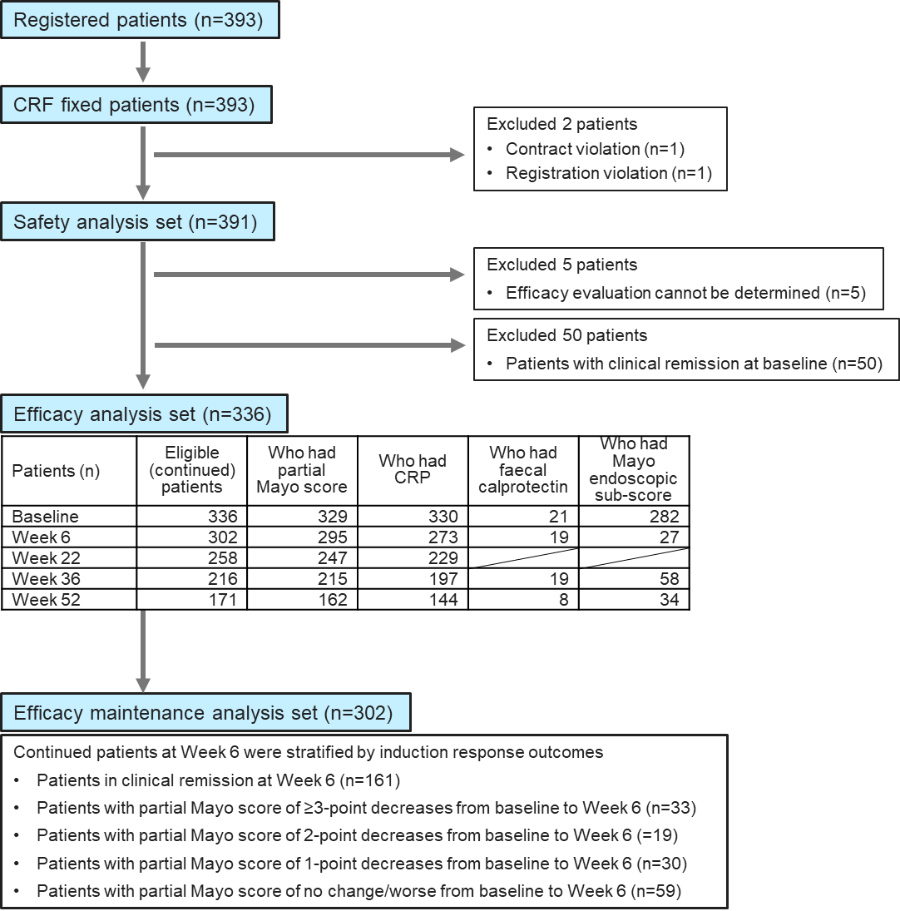

Supplementary Fig. S1: Patient flow diagram
CRF, case report form; CRP, c-reactive protein.

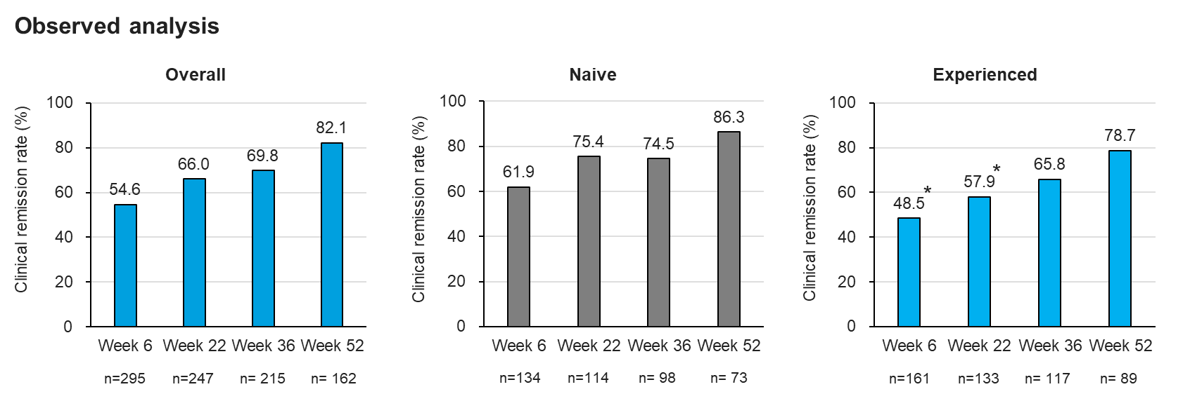

Supplementary Fig. S2: Clinical remission in observed analyses. Clinical remission rate in all patients (overall), biologic-naïve (naïve), and biologic-experienced (experienced) populations were indicated in the observed analyses. The P-value at each timepoint was calculated using Fisher’s exact test. *, P <0.05 (versus naïve population).

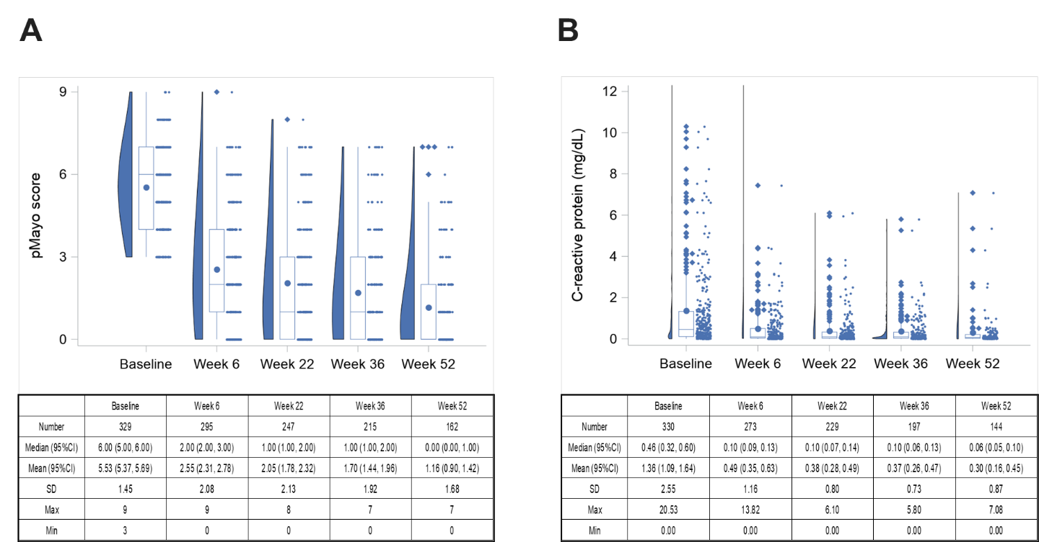

Supplementary Fig. S3: Mean partial Mayo scores and serum CRP levels (mg/dl) during the 52-week period (observed analysis). (A) Mean partial Mayo scores. (B) Serum CRP levels (mg/dl). Values are mean±95% CI. CI, confidence interval; CRP, c-reactive protein; SD, standard deviation.

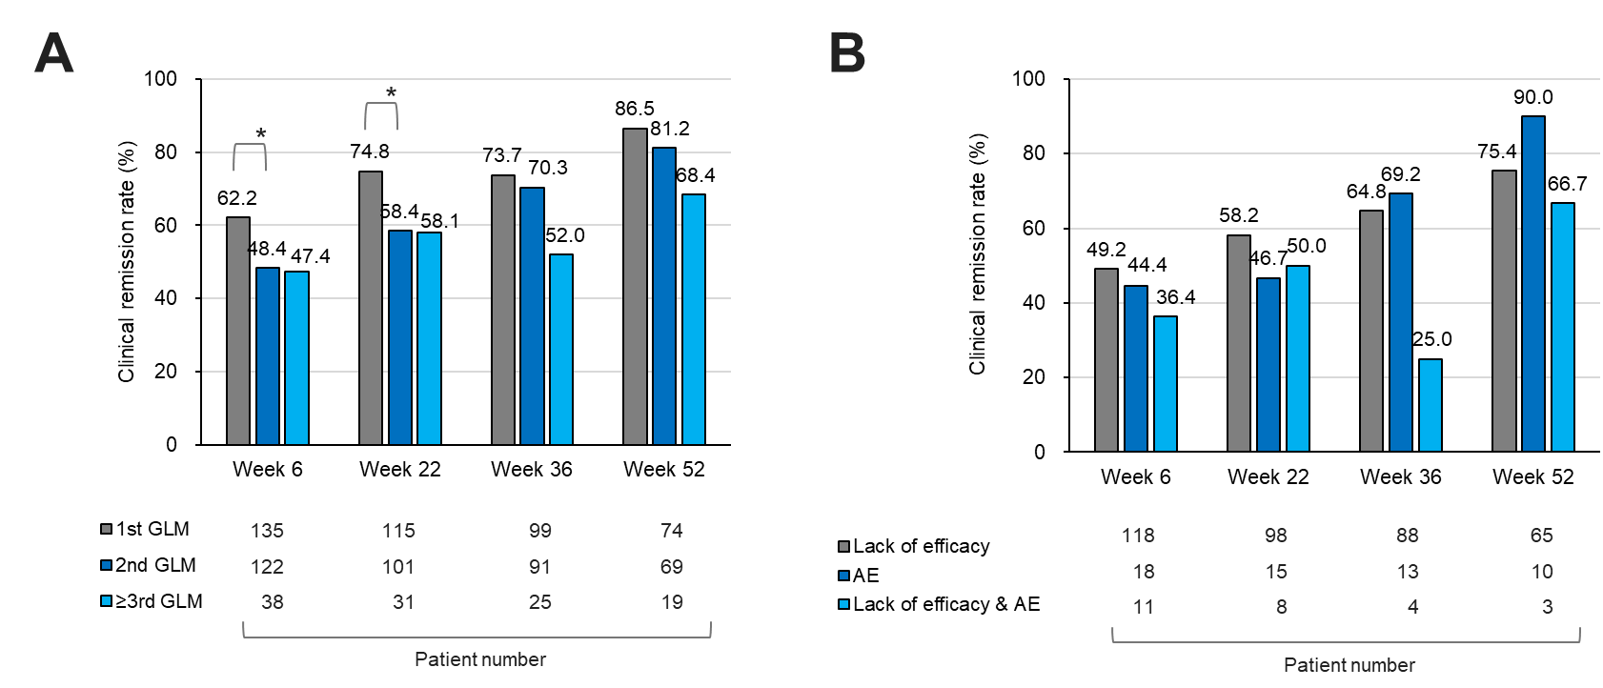

Supplementary Fig. S4: Clinical remission in subgroups by previous biologic use (observed analysis). (A) Subgroups based on the number of prior biologic treatments. 1st golimumab (GLM); GLM as first biologic, 2nd GLM; GLM as second biologic, ≥3rd GLM; GLM as third- or later biologic. *, P <0.05 (1st GLM versus 2nd GLM). (B) Subgroups based on the reason for switching from previous biologic: lack of efficacy, adverse event (AE), and lack of efficacy and AE. P-values were calculated using Fisher’s exact test or the Wald χ² test.

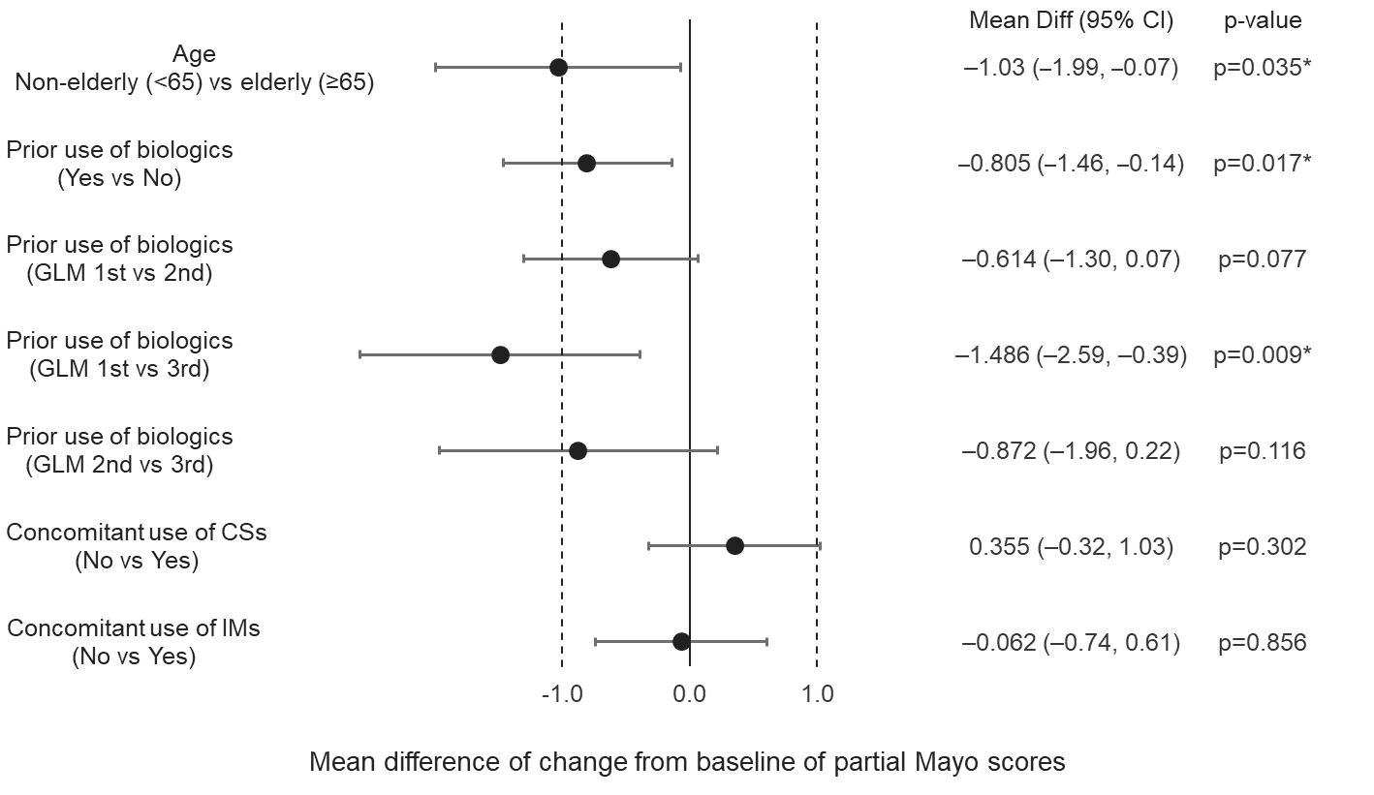

Supplementary Fig. S5: Factors associated with changes in partial Mayo score by univariate analysis. Patient factors affecting GLM treatment effectiveness were determined by forest plot analysis. Changes in mean partial Mayo scores from baseline to week 52 were used. Patients aged <65 or ≥65 years were classified as non-elderly or elderly, respectively. P-values were calculated using an independent t-test. *, P <0.05. CI, confidence interval; CS, corticosteroid; GLM, golimumab; IMs, immunomodulators. Where the CI does not cross the vertical line (0.0), a statistically significant difference exists between two groups.

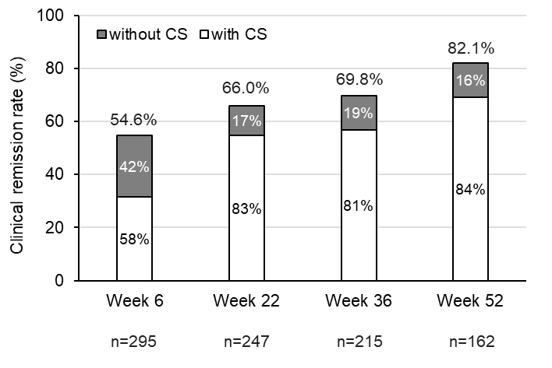

Supplementary Fig. S6: Clinical remission in subgroups according to concomitant corticosteroid (CS) use (observed analysis). Values placed in the centre of the bar indicate the proportion of patients with or without CS among remitters at each time point.

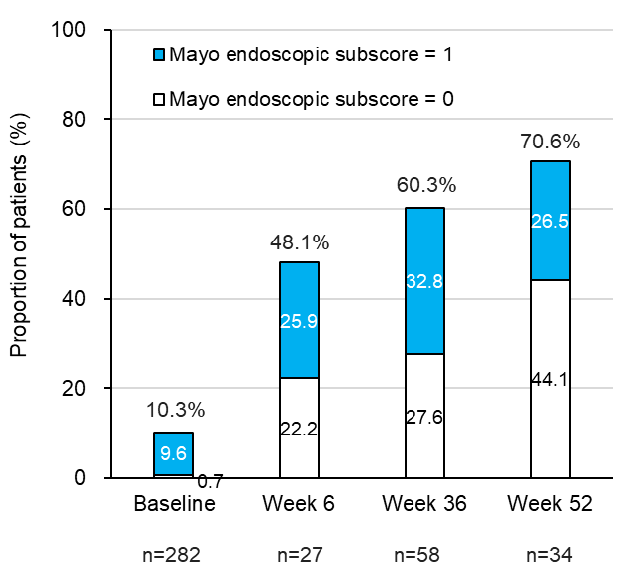

Supplementary Fig. S7: Proportion of patients with Mayo endoscopic sub-scores of 0 or 1 (observed analysis). Values placed in the centre of the bar indicate the proportion of patients with Mayo endoscopic sub-scores of 0 or 1 at each timepoint.

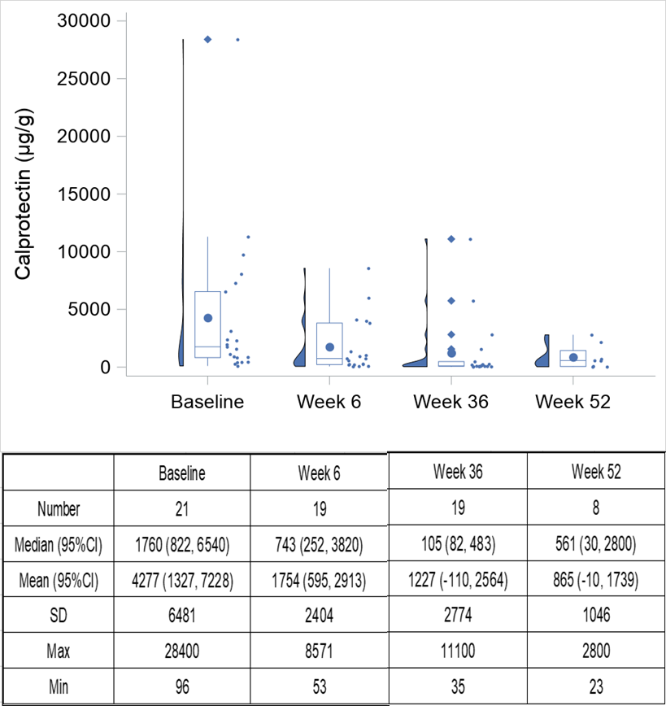

Supplementary Fig. S8: Faecal calprotectin concentration (μg/g) during the 52-week period (observed analysis). Values were expressed as the median and 95% CI. CI, confidence interval; SD, standard deviation.

