SUPPLEMENTARY INFORMATION
Sternocleidomastoid muscle thickness correlates with exercise tolerance in COPD patients
Authors’ full names:
Masashi Shiraishi,^{1,2} Yuji Higashimoto,¹ Ryuji Sugiya,¹ Hiroki Mizusawa,¹ Yu Takeda,¹ Shuhei Hujita,¹ Osamu Nishiyama,² Shintarou Kudo,³ Tamotsu Kimura,¹ Yasutaka Chiba,⁴ Kanji Fukuda,¹ Yuji Tohda²
Authors’ affiliation(s):
¹Department of Rehabilitation Medicine, Kindai University School of Medicine, Osaka, Japan
²Department of Respiratory Medicine and Allergology, Kindai University School of Medicine, Osaka, Japan
³Graduate School of Health Sciences, Morinomiya University of Health Sciences, Osaka, Japan
⁴Division of Biostatistics, Clinical Research Center, Kindai University School of Medicine, Osaka, Japan

Table 1S: Multiple regression analysis performed with the peak VO₂ as the dependent variable
Table 2S: SCM thickness and intra-class correlation coefficient
Figure 1S: Correlation between maximum sternocleidomastoid muscle thickness at end-expiration and IC in patients with chronic obstructive pulmonary disease (n = 44)
Figure 2S: Correlation between the maximum sternocleidomastoid muscle thickness at end-expiration and the predicted FEV1% in patients with chronic obstructive pulmonary disease (n = 44).
Figure 3S: Correlation between the maximum sternocleidomastoid muscle thickness at end-expiration and the MIP in patients with chronic obstructive pulmonary disease (n = 44).
Figure 4S: Correlation between the maximum sternocleidomastoid muscle thickness at end-expiration and BMI in patients with chronic obstructive pulmonary disease (n = 44).
Figure 5S: Correlation between the maximum sternocleidomastoid muscle thickness at end-expiration and SCM TF from end-expiration to resting inspiration in patients with chronic obstructive pulmonary disease (n = 44).

Table 1S.

Model 1 | β | B | SE | 95% CI | R² | t | p
End-expiration to end-inspiration  SCM thickness fraction, % | 0.712 | 0.083 | 0.015 | 0.054 to 0.113 | 0.470 | 5.719 | <0.001
Model 2 | β | B | SE | 95% CI | R² | t | p
End-expiration to end-inspiration  SCM thickness fraction, % | 0.627 | 0.054 | 0.017 | 0.019 to 0.089 | 0.572 | 3.105 | 0.003
FEV1, % | 0.377 | 0.065 | 0.024 | 0.017 to 0.112 |  | 2.745 | 0.009
Model 3 | β | B | SE | 95% CI | R² | t | p
End-expiration to end-inspiration  SCM thickness fraction, % | 0.542 | 0.049 | 0.016 | 0.016 to 0.082 | 0.670 | 3.008 | 0.005
FEV₁, % predicted | 0.257 | 0.044 | 0.023 | -0.003 to 0.091 |  | 1.885 | 0.067
IC, L | 0.303 | 2.135 | 0.811 | 0.012 to 0.495 |  | 2.631 | 0.012

Abbreviations: SCM = sternocleidomastoid muscle, FEV₁ = forced expiratory volume in one second, IC = inspiratory capacity

Table 2S.
 | Intraclass  Correlation | 95% Confidence Interval |  | F Test With True Value 0
 |  | Lower Bound | Upper Boound | Vaiue | df 1 | df 2 | Sig
End-expiration | 0.94 | 0.463 | 0.986 | 128.056 | 19 | 38 | .000
Resting inspiration | 0.88 | 0.654 | 0.956 | 14.001 | 20 | 40 | .000
End-inspiration | 0.92 | 0.374 | 0.981 | 90.213 | 19 | 38 | .000

Figure 1S. Correlation between the maximum sternocleidomastoid muscle thickness at end-expiration and the IC in patients with chronic obstructive pulmonary disease (n = 44). IC = Inspiratory Capacity. The IC had a significantly positive correlation with the sternocleidomastoid muscle thickness in patients with chronic obstructive pulmonary disease (r = 0.51, p < 0.01).

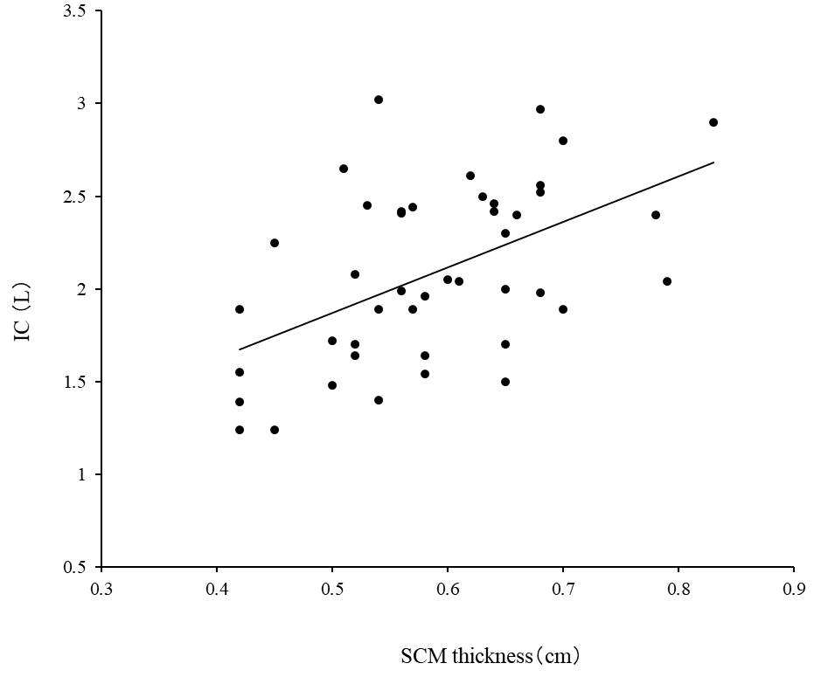

Figure 2S. Correlation between the maximum sternocleidomastoid muscle thickness at end-expiration and the predicted FEV1% in patients with chronic obstructive pulmonary disease (n = 44). FEV1% = percent predicted Forced Expiratory Volume in one second. The predicted FEV1% had a significantly positive correlation with the sternocleidomastoid muscle thickness in patients with chronic obstructive pulmonary disease (r = 0.46, p < 0.05).

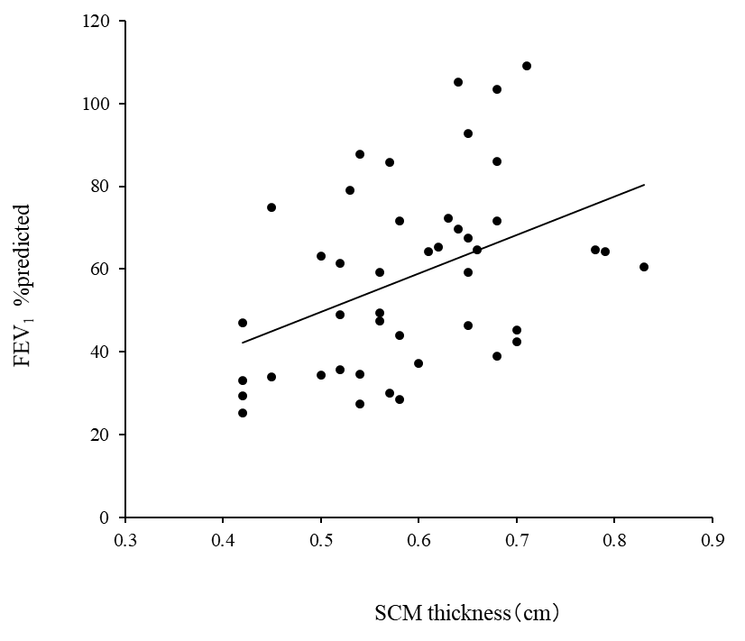

Figure 3S. Correlation between the maximum sternocleidomastoid muscle thickness at end-expiration and MIP in patients with chronic obstructive pulmonary disease (n = 44). MIP = maximum inspiratory pressure. The MIP had a significantly positive correlation with the sternocleidomastoid muscle thickness in patients with chronic obstructive pulmonary disease (r = 0.49, p < 0.05).

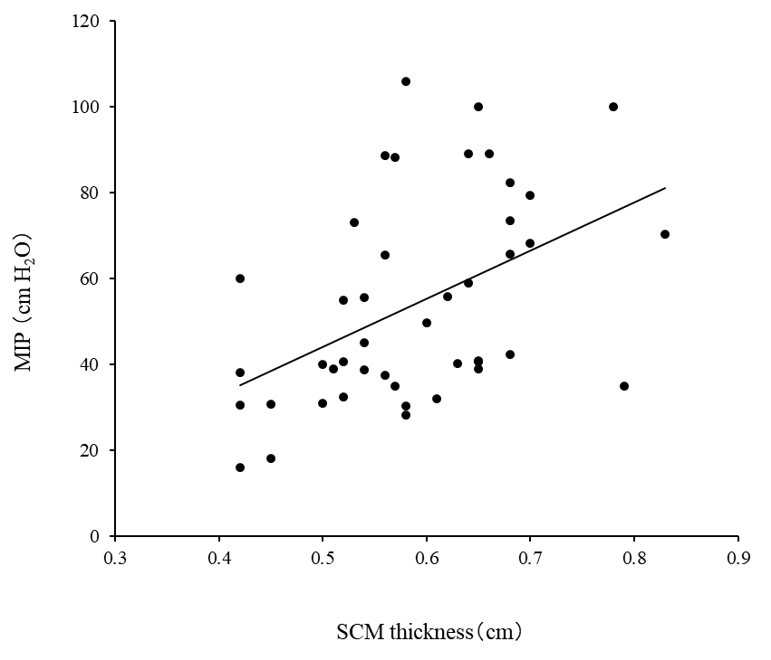

Figure 4S. Correlation between the maximum sternocleidomastoid muscle thickness at end-expiration and BMI in patients with chronic obstructive pulmonary disease (n = 44). BMI = Body Mass Index. BMI had a significantly positive correlation with the sternocleidomastoid muscle thickness in patients with chronic obstructive pulmonary disease (r = 0.39, p < 0.05).

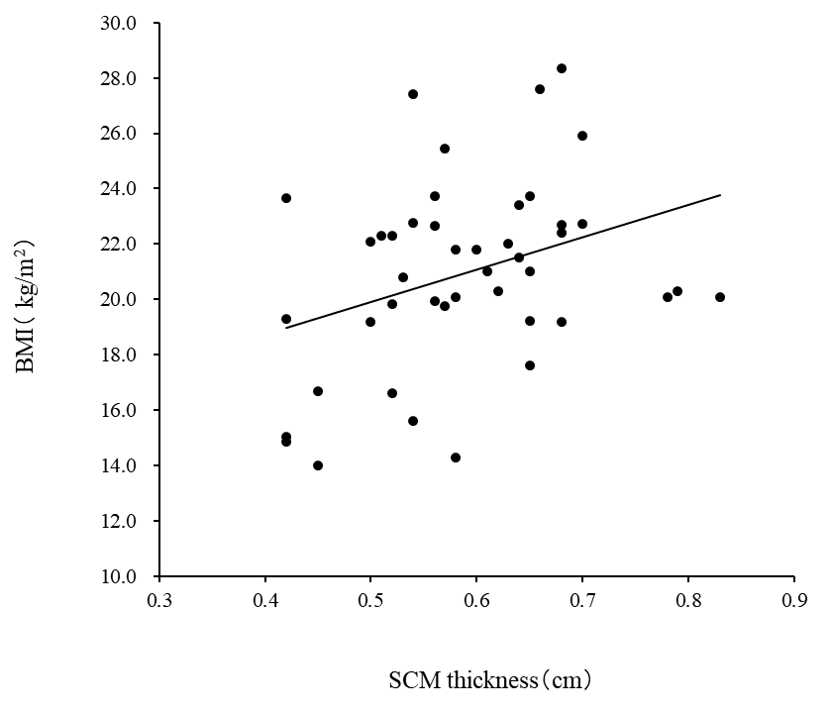

Figure 5S. Correlation between the maximum sternocleidomastoid muscle thickness at end-expiration and sternocleidomastoid muscle thickening fraction in patients with chronic obstructive pulmonary disease (n = 44). Sternocleidomastoid muscle thickening fraction had a significantly negativity correlation with the sternocleidomastoid muscle thickness in patients with chronic obstructive pulmonary disease (r = -0.62, p < 0.01).

