Supplementary Material

Supplementary Table 1. Quality assessment of the included studies according to the Appraisal Tool for Cross-Sectional Studies (AXIS).
 | Hong et at, 2016 [14] | Valassi et al, 2016 [19] | Kuzma et al, 2019 [18] | Valassi et al, 2019 [20] | Calatayud et al, 2021 [13] | Sala et al, 2021 [15] | Sohoran et al, 2021 [16] | Jawiarczyk-Przybyłowska et al, 2022 [17]
1. Were the aims/objectives of the study clear? | Y | Y | Y | Y | Y | Y | Y | Y
2. Was the study design appropriate for the stated aim(s)? | Y | Y | Y | Y | Y | Y | Y | Y
3. Was the sample size justified? | Y | N | N | N | N | N | N | N
4. Was the target/reference population clearly defined? (Is it clear who the research was about?) | Y | Y | Y | Y | Y | Y | Y | Y
5. Was the sample frame taken from an appropriate population base so that it closely represented the target/reference population under investigation? | Y | Y | Y | Y | Y | Y | Y | Y
6. Was the selection process likely to select subjects/participants that were representative of the target/reference population under investigation? | Y | Y | Y | Y | Y | Y | Y | Y
7. Were measures undertaken to address and categorise non-responders? | N | N | N | N | N | N | N | N
8. Were the risk factor and outcome variables measured appropriate to the aims of the study? | Y | Y | Y | Y | Y | Y | Y | Y
9. Were the risk factor and outcome variables measured correctly using instruments/ measurements that had been trialled, piloted or published previously? | Y | Y | Y | Y | Y | Y | Y | Y
10. Is it clear what was used to determined statistical significance and/or precision estimates? (eg, p values, confidence intervals) | Y | Y | Y | Y | Y | Y | Y | Y
11. Were the methods (including statistical methods) sufficiently described to enable them to be repeated? | Y | Y | Y | Y | Y | Y | Y | Y
12. Were the basic data adequately described? | Y | N | Y | Y | Y | Y | Y | Y
13. Does the response rate raise concerns about non-response bias? | U | U | N | N | U | N | U | U
14. If appropriate, was information about non-responders described? | N | N | N | N | N | N | N | N
15. Were the results internally consistent? | Y | Y | Y | Y | Y | Y | Y | Y
16. Were the results for the analyses described in the methods presented? | Y | Y | Y | Y | Y | Y | Y | Y
17. Were the authors’ discussions and conclusions justified by the results? | Y | Y | Y | Y | Y | Y | Y | Y
18. Were the limitations of the study discussed? | Y | Y | Y | Y | Y | Y | Y | Y
19. Were there any funding sources or conflicts of interest that may affect the authors’ interpretation of the results? | N | N | Y | N | N | N | N | N
20. Was ethical approval or consent of participants attained? | Y | Y | Y | Y | Y | Y | Y | Y

Abbreviations: N, no; Y, yes; U, unknown/unclear.

Supplementary Figure 1. Head-to-head comparison of TBS values between patients with active acromegaly and patients with controlled/cured disease.
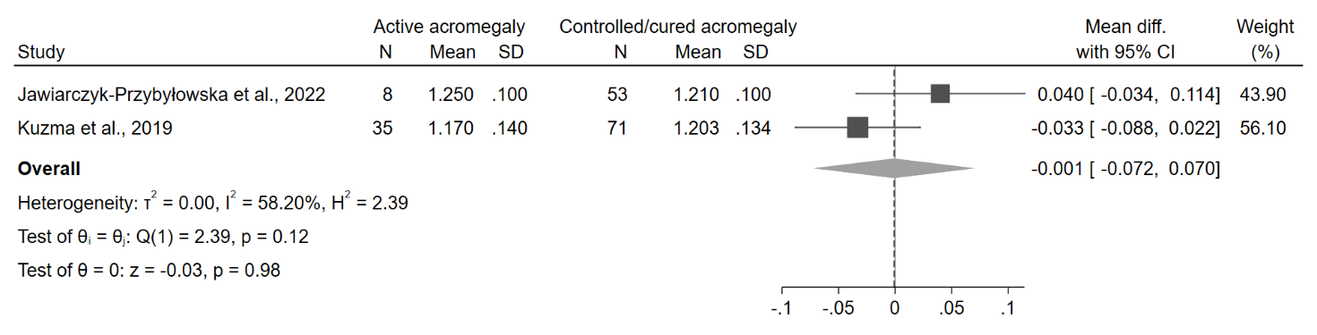
Abbreviations: CI, confidence interval; N, number; SD, standard deviation; TBS, trabecular bone score.
Supplementary Figure 2. Comparison of BMD values between acromegalic patients and controls at lumbar spine (A), femoral neck (B) and total hip (C). Data from the study by Hong et al. [14] are reported separately by sex, as the authors did not provide the overall estimates of the outcomes in the study population as a whole.
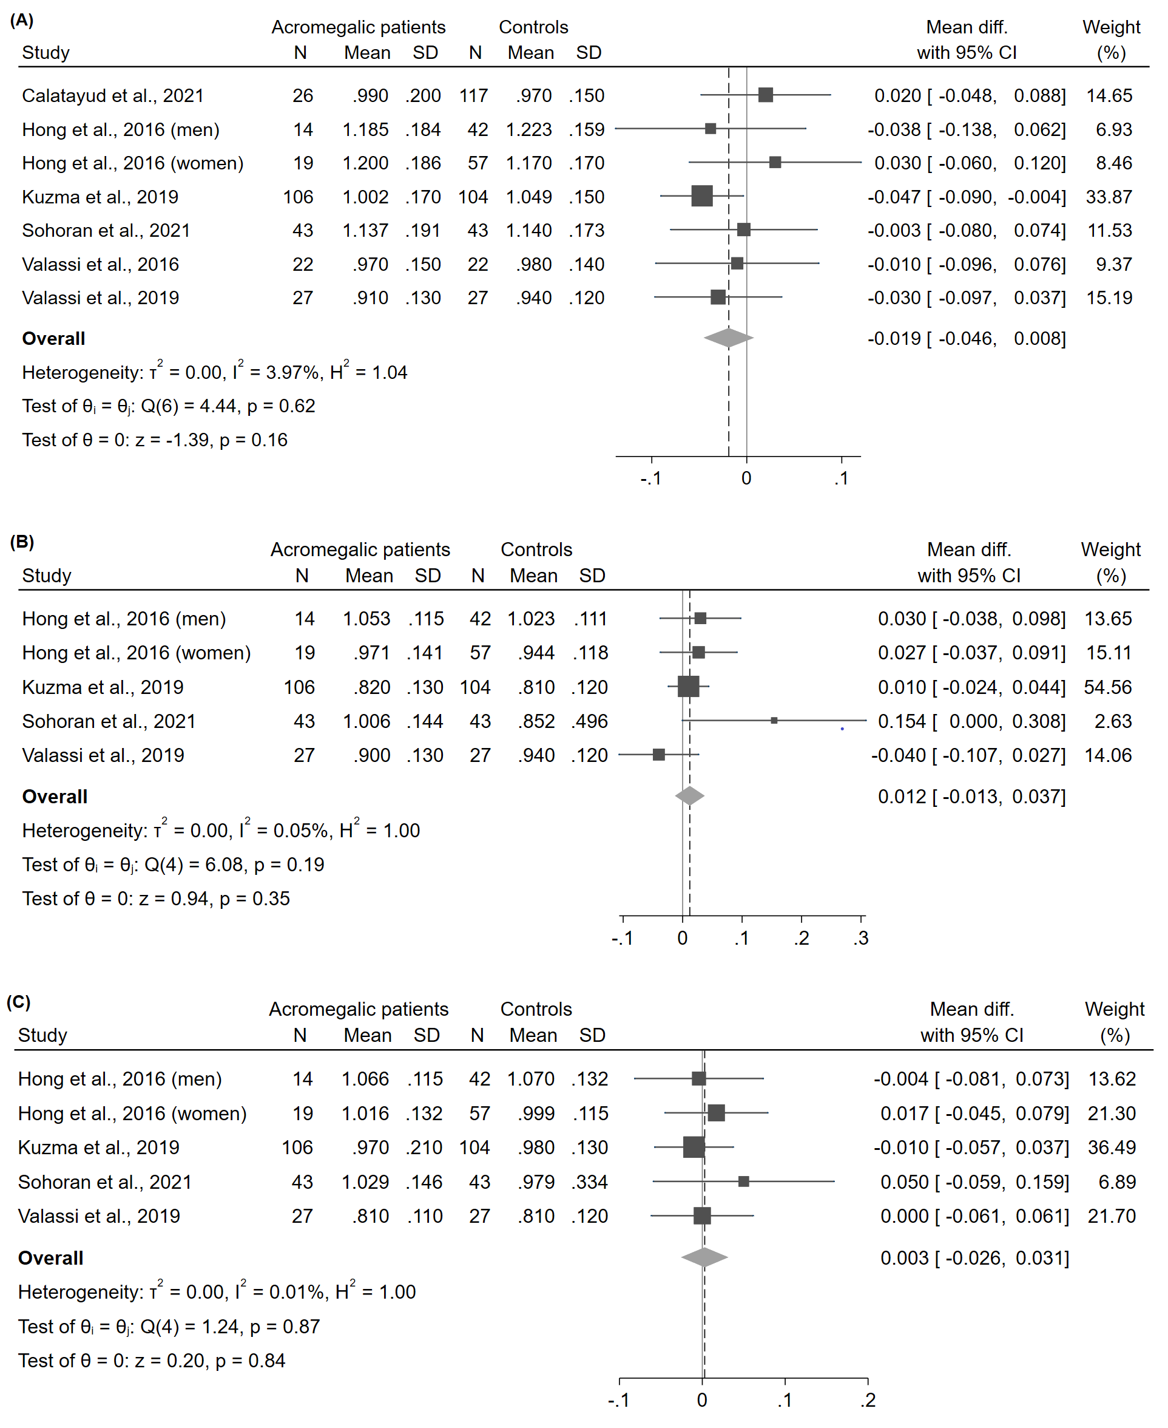
Abbreviations: BMD, bone mineral density; CI, confidence interval; N, number; SD, standard deviation.
Appendix 1. Electronic search strategy

PUBMED
Advanced search, All fields
#1 “acromegaly” AND “trabecular bone score”
#2 “acromegaly” AND “TBS”

EMBASE
Quick search, All fields
#1 “acromegaly” AND “trabecular bone score”
#2 “acromegaly” AND “TBS”

COCHRANE LIBRARY
Advanced search, All text
#1 “acromegaly” AND “trabecular bone score”
#2 “acromegaly” AND “TBS”

OVID
All resources, Multi-field search, All fields
#1 “acromegaly” AND “trabecular bone score”
#2 “acromegaly” AND “TBS”

CINAHL
Advanced search, No field selected
#1 “acromegaly” AND “trabecular bone score”
#2 “acromegaly” AND “TBS”

