Supplemental Figure 3. Effect of thiazide prescription on urine calcium
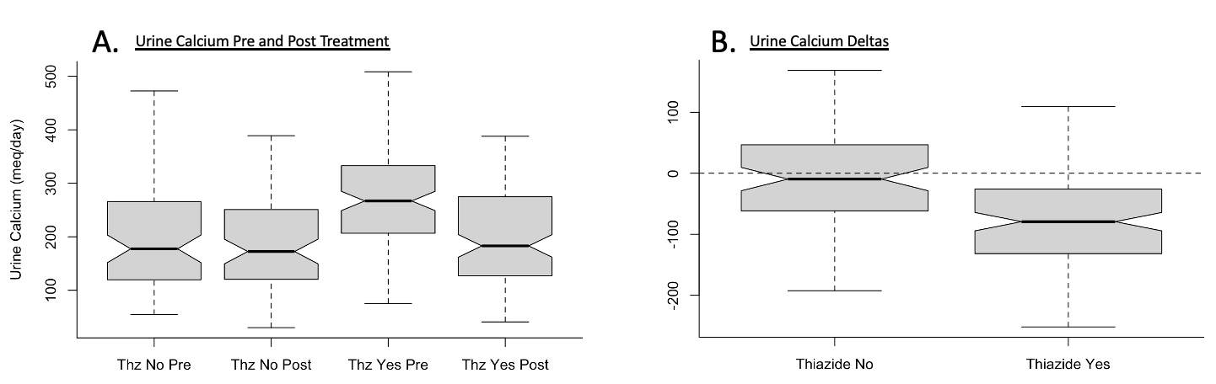

Abbreviations: Thz, thiazide
Panel A: P value comparing No Advice Pre to Advice Pre <0.001, p value comparing Advice Pre to Advice Post <0.001. Panel B: p value comparing Advice to No Advice <0.001.

