Supplemental Figure 4. Sodium restriction and thiazide prescription on urine calcium
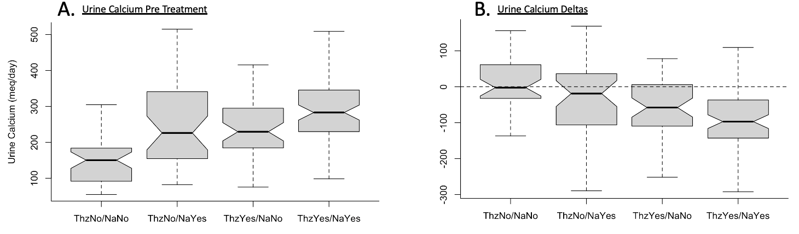
Abbreviations: ThzNo, no thiazide prescription; NaNo, no dietary sodium restriction; ThzYes, thiazide prescription; NaYes, dietary sodium restriction.
Panel A: P value comparing baseline urine calcium in the group with no thiazide prescription and no dietary sodium restriction to thiazide and dietary sodium restriction <0.001. Panel B: P value comparing delta urine calcium in the group with no thiazide prescription and no dietary sodium restriction to thiazide and dietary sodium restriction <0.001.

