Supplementary Material
Table 1: General characteristics of our study
Variable |  | Total(n=876) | non-AR(n=847) | AR(n=29) | P-value
Gender |  |  |  |  | 0.880
Male, n (%) |  | 441 (50.3) | 426 (50.3) | 15 (51.7)
Female, n (%) |  | 435 (49.7) | 421 (49.7) | 14 (48.3)
Age (months) |  | 49.78±29.82 | 50.15±30.02 | 38.82±20.54 | 0.086
Height (cm) |  | 102.30±16.24 | 102.46±16.36 | 97.48±11.51 | 0.183
Weight (kg) |  | 16.16±6.40 | 16.22±6.44 | 14.34±4.45 | 0.181
BSA (m²) |  | 0.68±0.17 | 0.68±0.18 | 0.62±0.12 | 0.162
Defect diameter (TTE)/ BSA (mm/m²) |  | 9.2±3.9 | 9.2±3.9 | 9.7±3.3 | 0.663
Defect diameter (angio)/ BSA (mm/m²) |  | 5.6±3.1 | 5.5±3.0 | 7.5±4.0 | 0.002
Defect diameter (TTE) (mm) |  | 5.95±2.18 | 5.95±2.20 | 5.86±1.63 | 0.709
Defect diameter (angio) (mm) |  | 3.62±1.82 | 3.59±1.80 | 4.45±2.02 | 0.018
LVEF (%) |  | 67.32±6.04 | 67.32±6.08 | 67.19±4.76 | 0.903
LVFS (%) |  | 36.93±3.81 | 36.94±3.81 | 36.73±3.77 | 0.992
Sub-aortic rim (mm) |  | 3.4±1.0 | 3.5±1.0 | 0.9±1.0 | ＜0.001
Preoperative arrhythmia, n (%) |  | 76 (8.7) | 74 (8.7) | 2 (6.9) | 0.729
Aortic leaflet prolapse, n (%) |  |  |  |  | ＜0.001
Absent |  | 752 (85.8) | 743 (87.7) | 9 (31.0)
Prolapse |  | 124 (14.2) | 104 (12.3) | 20 (69.0)
Right coronary leaflet |  | 59 (6.7) | 50 (5.9) | 9 (31.0)
Non-coronary leaflet |  | 33 (3.8) | 31 (3.7) | 2 (6.9)
Right coronary and  non-coronary leaflet |  | 32 (3.7) | 23 (2.7) | 9 (31.0)
Pulmonary hypertension, n (%)
Absent |  | 709 (80.9) | 687 (81.1) | 22 (75.9)
Mild |  | 91 (10.4) | 89 (10.5) | 2 (6.9)
Moderate and above |  | 76 (8.7) | 71 (8.4) | 5 (17.2)
Preoperative mild AR, n (%) |  | 43 (4.9) | 20 (2.4) | 23 (79.3) | ＜0.001
VSD type, n (%) |  |  |  |  | ＜0.001
Perimembranous/ AMS |  | 841 (96.0)/  287 (32.8) | 821 (96.9)/  280 (33.1) | 20 (69.0)/  7 (24.1)
Intracristal﹡ |  | 24 (2.7) | 15 (1.8) | 9 (31.0)
Muscular |  | 11 (1.3) | 11 (1.3) | 0 (0)
PASP (mmHg) |  | 30.2±8.8 | 30.1±8.7 | 34.5±11.7 | 0.006
Occluder Type, n (%) |  |  |  |  | ＜0.001
Symmetric |  | 780 (89.0) | 766 (90.4) | 14 (48.3)
Asymmetric |  | 96 (11.0) | 81 (9.6) | 15 (51.7)
Muscular |  | 28 (3.2) | 28 (3.3) | 0 (0)
Eccentric |  | 62 (7.1) | 49 (5.8) | 13 (44.8)
Small-waist |  | 6 (0.7) | 4 (0.5) | 2 (6.9)
Occluder size (mm) |  | 6.4±1.6 | 6.3±1.5 | 7.4±1.9 | 0.001
Occluder size/ BSA (mm/m2) |  | 9.8±3.1 | 9.8±9.7 | 12.1±4.1 | 0.001
Sheath Size (F) |  | 6.3±0.7 | 6.3±0.7 | 6.8±0.8 | 0.002
Sheath Size/ BSA (F/ m2) |  | 9.8±2.2 | 9.7±2.1 | 11.1±2.7 | 0.002
﹡A defect located at the 12:00-to 1:30-o’clock position in the transthoracic echocardiographic short-axis parasternal view was diagnosed as intracristal VSD. TTE, transthoracic echocardiography; VSD, ventricular septal defect; BSA, body surface area; LVEF, left ventricular ejection fractions; LVFS, left ventricular fractional shortening; AMS, aneurysm of membranous septum; PASP, pulmonary arterial systolic pressure; AR, aortic regurgitation; SAR, children with new-onset or increased aortic regurgitation; non-AR, children without new-onset or increased aortic regurgitation; sub-aortic rim, the distance from the upper edge of the defect to the aortic valve; angio, angiography.

Table 2: Univariate and multivariate logistic regression analysis of risk factors for new-onset or increasing AR requiring unplanned surgery after transcatheter closure.

Factors | Univariate analysis |  | Multivariate analysis  (adjusted)
 | OR (95%CI) | P-value | OR (95%CI) | P-value
Gender (Male) | 0.94(0.45,1.98) | 0.880 | - | -
Age (months) | 0.98(0.97, 1.00) | 0.093 | - | -
Weight (kg) | 0.94(0.86,1.03) | 0.182 | - | -
Defect diameter(angio)/BSA  (mm/m²) | 1.15(1.05,1.26) | 0.003 | 1.25(1.01,1.55) | 0.039
Sub-aortic rim (mm) | 0.07(0.04,0.14) | ＜0.001 | 0.12(0.05,0.27) | ＜0.001
Aortic right coronary leaflet prolapse | 14.86(5.65,39.09) | ＜0.001 | - | -
Aortic non-coronary leaflet prolapse | 5.33(1.10,25.70) | 0.037 | - | -
Aortic right coronary and non-cornary leaflet prolapse | 32.30(11.73,88.95) | ＜0.001 | - | -
Preoperative mild aortic regurgitation | 158.51(58.20,431.73) | ＜0.001 | 60.39(11.53,316.30) | ＜0.001
Intracristal VSD | 24.96(9.77,63.76) | ＜0.001 | 34.09(4.07,285.65) | ＜0.001
PASP (mmHg) | 1.04(1.01,1.08) | 0.007 | - | -
Asymmetric occluder | 10.13(4.72,21.74) | ＜0.001 | - | -
Occluder size/ BSA (mm/m2) | 1.19(1.09, 1.29) | ＜0.001 | - | -
AR, aortic regurgitation; VSD, ventricular septal defect; BSA, body surface area; PASP, pulmonary arterial systolic pressure; OR, odds ratio; CI, confidence interval; angio, angiography; sub-aortic rim, the distance from the upper edge of the defect to the aortic valve. Adjusted is that gender, age and weight were included for multivariate analysis.

Table 3. Threshold effect analysis of the sub-aortic rim on new-onset or increasing AR using piecewise linear regression.

Models | New-onset or increasing AR
 | Crude β (95% CI) | P-value | Adjusted β (95% CI) | P-value
Model I
One line slope | 0.07(0.04, 0.14) | <0.001 | 0.12(0.05, 0.27) | <0.001
Model Ⅱ
Turing point (K) | 3.52 (3.5*) |  | 1.95 (2.0*)
＜K slop 1 | 0.05(0.02, 0.11) | <0.001 | 0.00 (0.00,0.08) | 0.001
＞K slop 2 | 2.80(1.01, 7.64) | 0.048 | 1.11 (0.29, 4.26) | 0.871
LRT test |  | 0.002 |  | 0.002
* Value after taking into account the precision. AR, aortic regurgitation; Model I, linear analysis; Model II, non-linear analysis. LRT test, Logarithmic likelihood ratio test. (P-value＜0.05 menas Model II is significantly different from Model I, which indicates a non-linear relationship); Crude: no adjustment; Adjusted: adjusted for age, sex, weight, defect diameter (angio)/ body surface area, preoperative mild aortic regurgitation, ventricular septal defect type.

Fig. 1.
Fig. 1. Flow chart

Fig. 2.
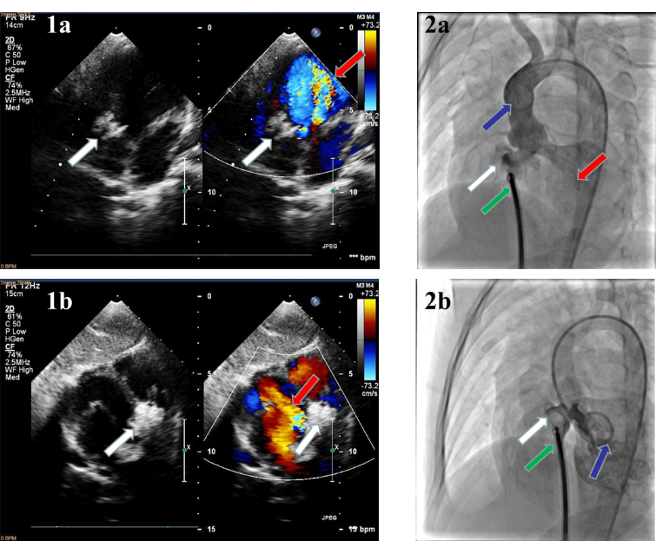
Fig. 2. An example of a 14kg girl with PMVSD underwent conventional ascending aorta angiography in postero anterior position and transthoracic echocardiogram was identified as new-onset or increasing AR after occluder placing and before occluder releasing. With an 8.6 mm echo diameter, and an 8.5 mm diameter and 2 mm sub-aortic rim by angiography, a 12 mm symmetric occluder (Starway Medical) was selected. 1a and 1b were echo results. 1a showed the massive regurgitation back to left ventricular on the five-chamber view. 1b showed regurgitation on the subcostal long-axis left ventricular view. 2a and 2b were angiographic results. 2a was the aortic angiography that the contrast media in blood was regurgitated back into left ventricle during the period of ventricular diastole. 2b was the left ventriculography, showing the position of the occluder. The white, red, blue, green arrows pointed to the occluders, the regurgitation, the pig tail and the sheath respectively.
Fig. 3.
Fig. 3. The sub-aortic rim of children without and with AR requiring unplanned surgery after transcatheter closure of VSD. P＜0.01.

Fig. 4.
Fig. 4. The relationship between the sub-aortic rim and the risk of new-onset or increasing AR following unplanned surgery. An L-shaped non-linear relationship between the sub-aortic rim and risk of new-onset or increasing AR was observed after adjusting for age, sex, weight, (angio) diameter/ BSA, preoperative mild AR, VSD type.

