Supplementary Fig. S1 Model Projection of optimal condition
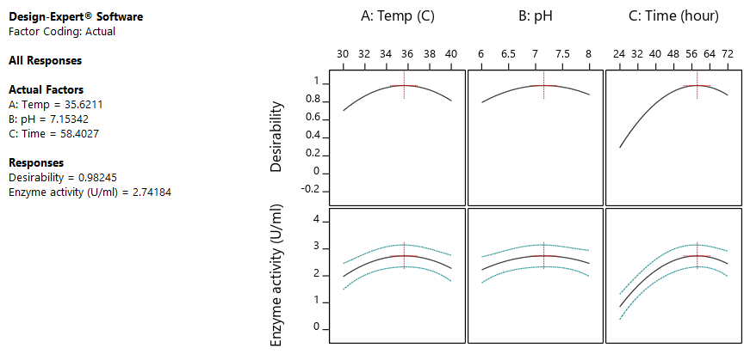

Supplementary Fig. S2 Effects of different fermentation media for pectinase activity (different lowercase letters above the bar indicate the significant difference between media used)
