Supplementary Figures
Supplementary FIGURE S1: Mean (SD) change (%) APW levels following treatment in studies 204 and 205

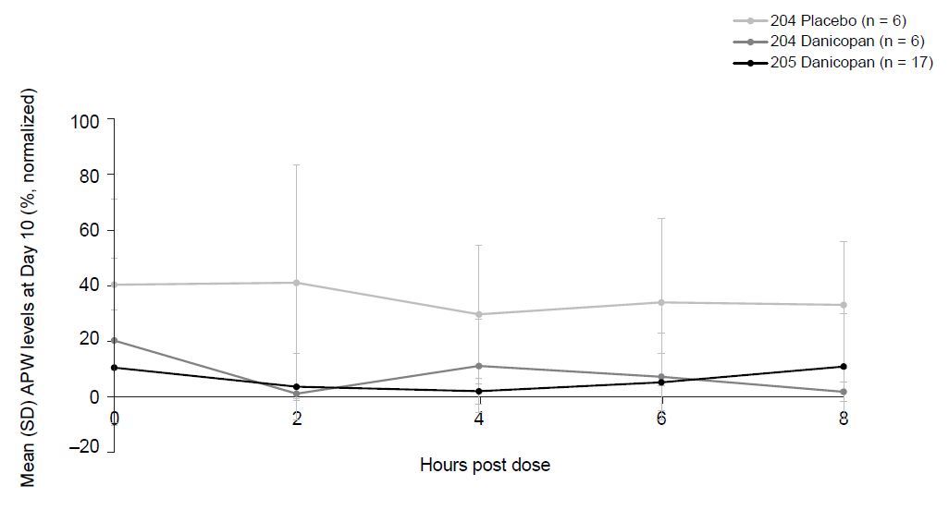
APW values are provided on a scale such that 100% of activity is normal activity as per assay control. Full inhibition of AP corresponds to a value of 0.
APW = alternative pathway Wieslab activity; SD = standard deviation.

Supplementary FIGURE S2: Overall design for study 201ª

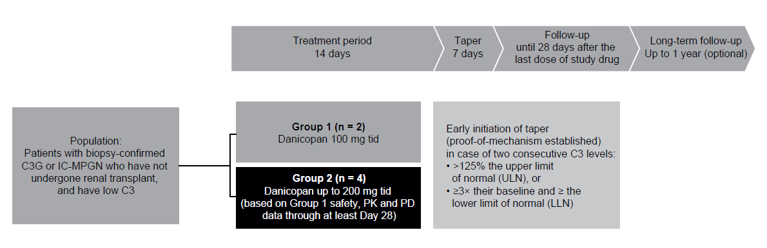
ªStudy 201 was a multicenter, open-label study in which patients with C3G or idiopathic immune complex-mediated membranoproliferative glomerulonephritis (IC-MPGN) received danicopan (previously ACH4471, ALXN2040) for 2 weeks followed by a 1-week taper. The study assessed the ability of danicopan to inhibit alternative complement pathway (AP) activity in the setting of AP over-activation in patients with C3G or IC-MPGN. Doses for this study were selected based on available data from preceding single-ascending (ACH471-001) and multiple-ascending dose studies in healthy volunteers (ACH471-002), and relative bioavailability studies in healthy volunteers [1, 2, 3].

Supplementary References
1. Kulasekararaj, Austin G., et al. (2021), 'Phase 2 Study of Danicopan in Paroxysmal Nocturnal Hemoglobinuria Patients with an Inadequate Response to Eculizumab', Blood.
2. Risitano, A. M., et al. (2020), 'Danicopan: an oral complement factor D inhibitor for paroxysmal nocturnal hemoglobinuria', Haematologica, online ahead of print.
3. Wiles, J. A., et al. (2020), 'Discovery and Development of the Oral Complement Factor D Inhibitor Danicopan (ACH-4471)', Curr Med Chem, 27 (25), 4165-80.

