Online supplementary information

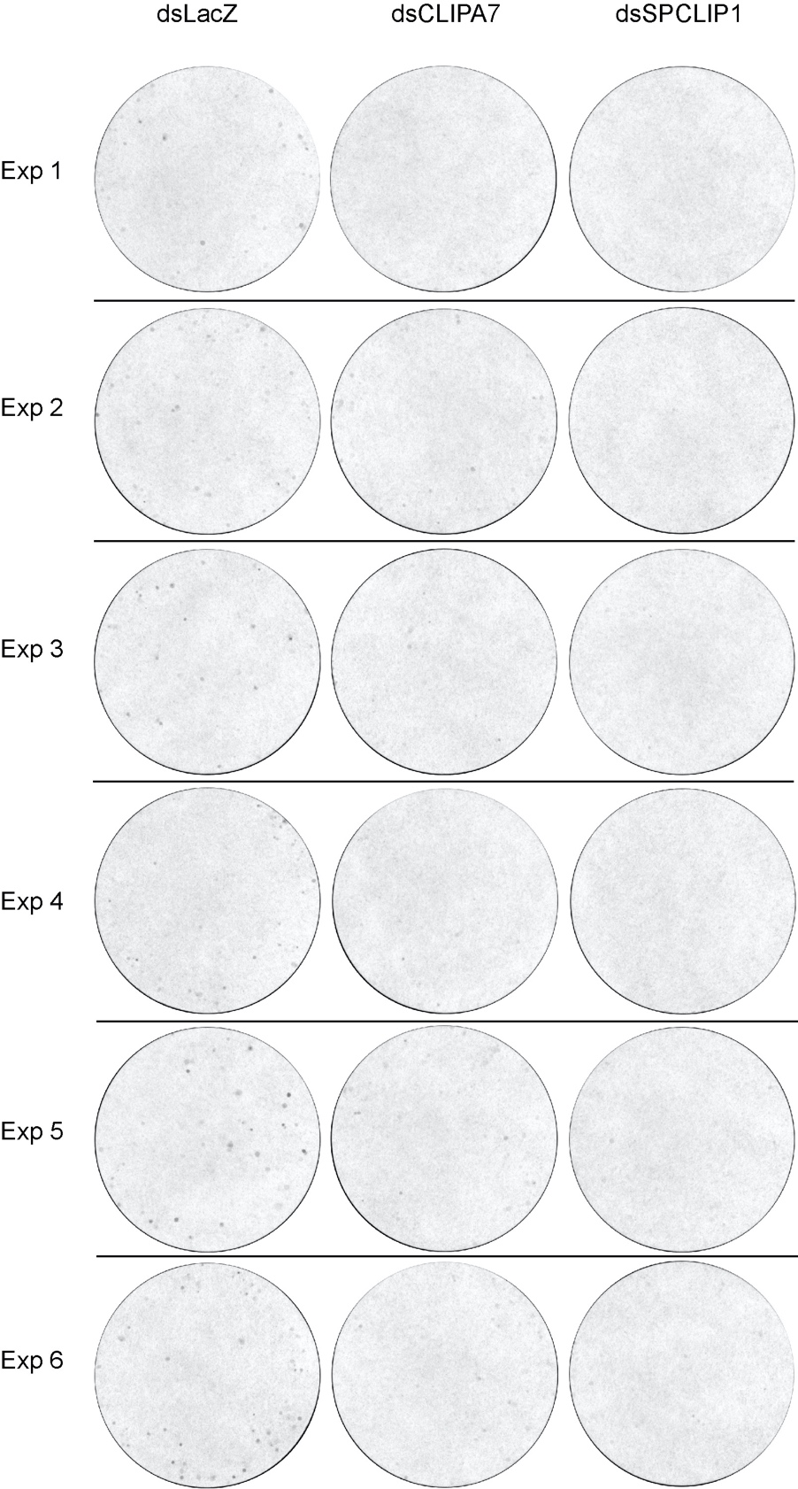

Online suppl. Fig. 1. Filters papers showing melanotic excreta at 12 hrs after mosquito injection with E. coli (OD₆₀₀=0.8). Images were acquired on a Bio-Rad Chemidoc MP system and total melanotic spot area was quantified by MelASA (see methods section). Six different experiments (Exp) are shown.

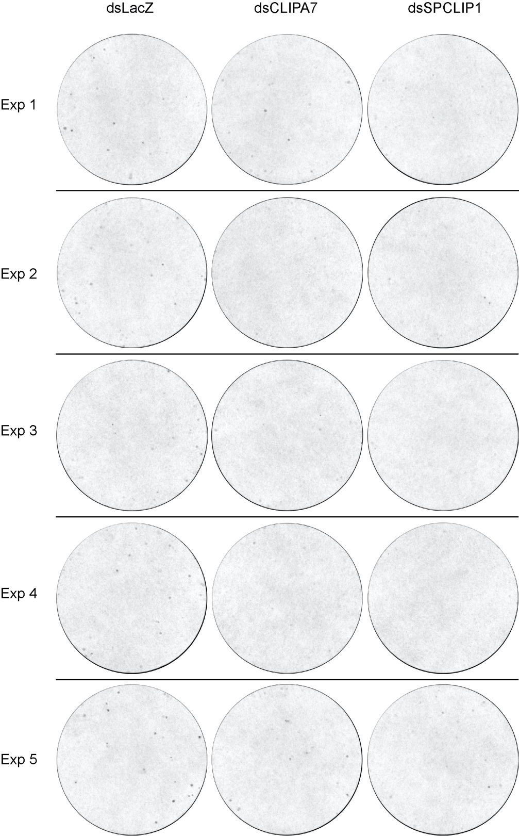

Online suppl. Fig. 2. Filters papers showing melanotic excreta at 12 hrs after mosquito injection with E. coli (OD₆₀₀=3). Images were acquired on a Bio-Rad Chemidoc MP system and total melanotic spot area was quantified by MelASA (see methods section). Five different experiments (Exp) are shown.

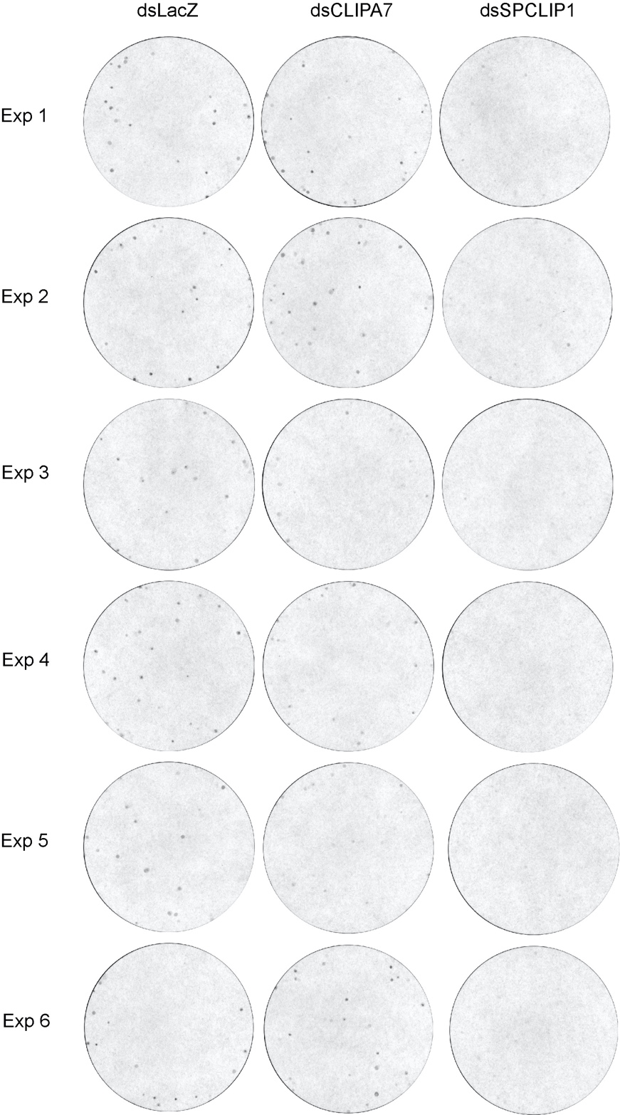

Online suppl. Fig. 3. Filters papers showing melanotic excreta at 12 hrs after mosquito injection with S. aureus (OD₆₀₀=0.8). Images were acquired on a Bio-Rad Chemidoc MP system and total melanotic spot area was quantified by MelASA (see methods section). Six different experiments (Exp) are shown.

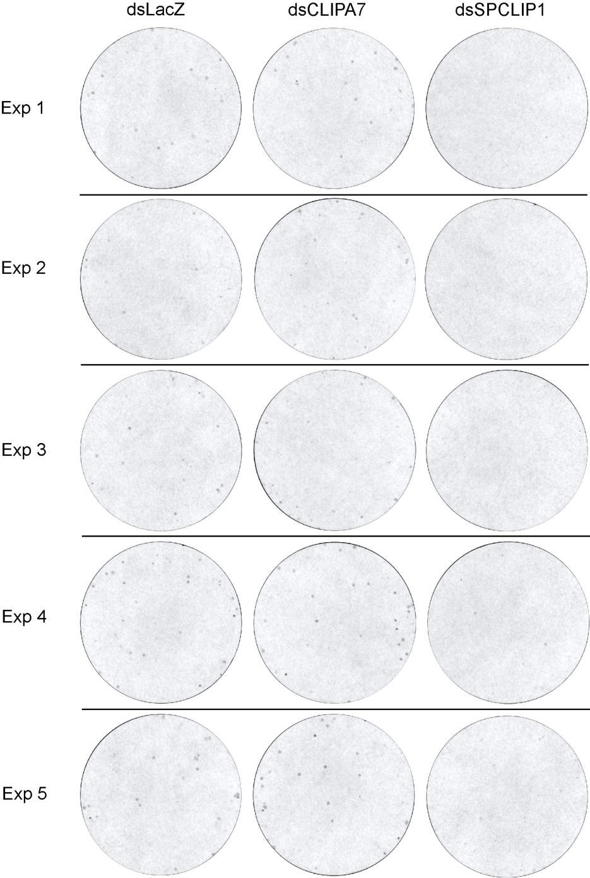

Online suppl. Fig. 4. Filter papers showing melanotic excreta at 12 hrs after mosquito injection with M. luteus (OD₆₀₀=2). Images were acquired on a Bio-Rad Chemidoc MP system and total melanotic spot area was quantified by MelASA (see methods section). Five different experiments (Exp) are shown.

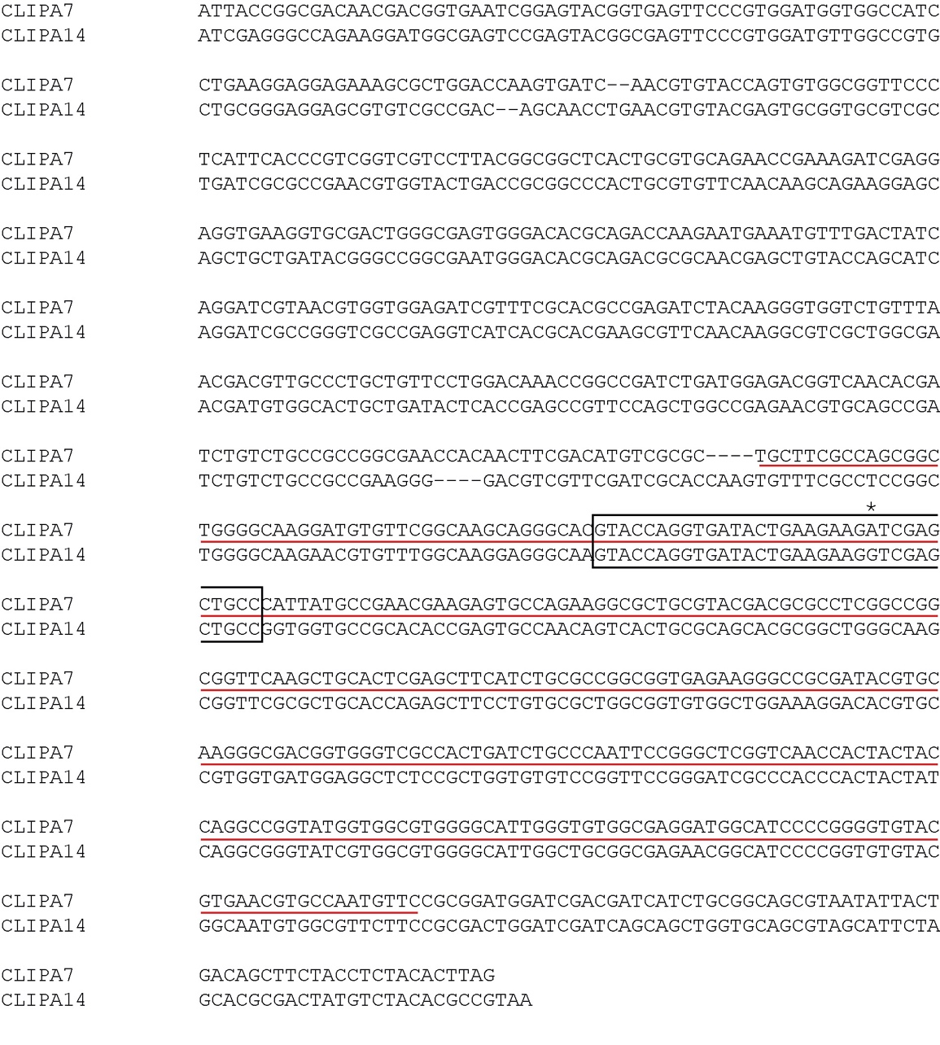

Online suppl. Fig. 5. Alignment of the partial coding sequences of CLIPA7 and CLIPA14 corresponding to the protease-like domains. The partial coding sequences (cds) corresponding to the protease-like domains of CLIPA14 (GenBank KY344791) and CLIPA7 (VectorBase AGAP011792) were aligned using MUSCLE sequence alignment tool. The CLIPA7 sequence complementary to the old dsRNA that was previously used to silence CLIPA7 [1] is underlined in red. Highlighted in an opened rectangular box is a contiguous sequence of 34 nucleotides within the dsCLIPA7 complementary sequence that shares complete sequence identity with a corresponding sequence in CLIPA14 cds except for one base mismatch (indicated by an asterisk).

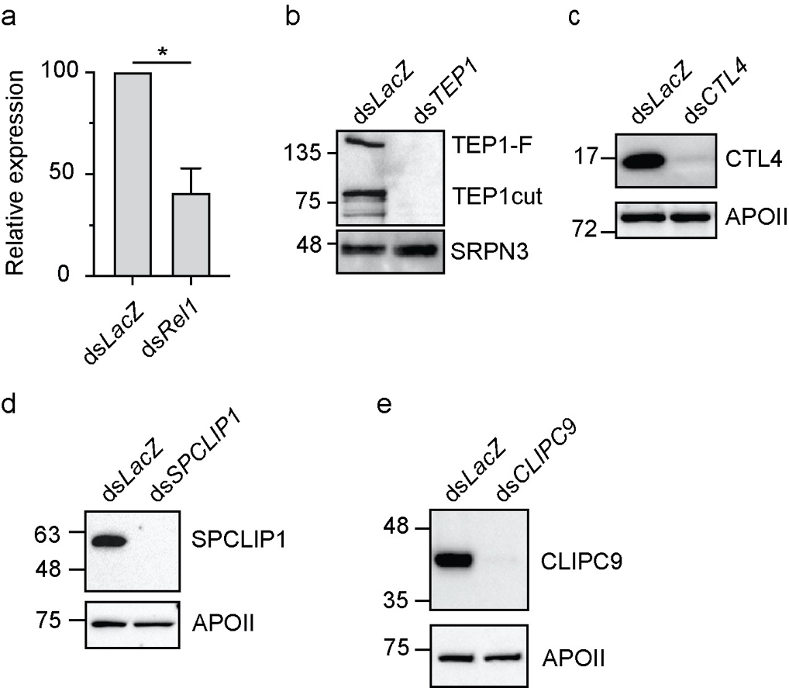

Online suppl. Fig. 6. Efficiency of gene silencing by RNAi. Efficiency of gene silencing for the indicated genes was measures by qRT-PCR for a Rel1 and by western blot for b TEP1, c CTL4, d SPCLIP1 and e CLIPC9. b-e Hemolymph was extracted from 35 mosquitoes per sample. Protein quantification was performed using Bradford assay and equal amounts of hemolymph proteins were loaded per lane. Membranes were also probed with αApo-II (αApolipophorin II) or αSRPN3 as loading controls.

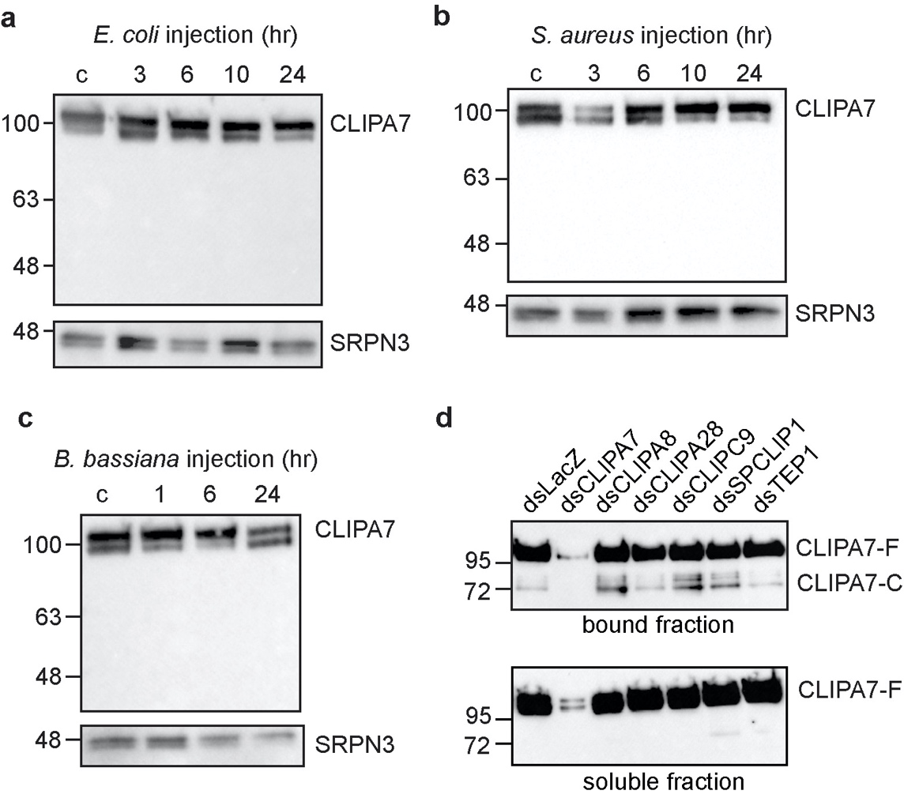

Online suppl. Fig. 7. CLIPA7 cleavage is not detected after infections with live bacteria and fungi. a-c Western blots showing CLIPA7 protein in hemolymph extracts of wildtype mosquitoes at the indicated time points after injection with a E. coli (OD₆₀₀=0.8), b S. aureus (OD₆₀₀=0.8) and c B. bassiana (2000 spores/mosquito). In all blots, each lane contained hemolymph extracts from 35 mosquitoes. Membranes were re-probed with αSRPN3 as loading control. d Hemolymph containing E. coli bioparticles was extracted from the indicated mosquito genotypes at 20 min after bioparticle injection into the hemocoel. Bioparticles were pelleted by centrifugation, and the soluble fractions collected. Bound proteins were extracted from bioparticle pellets with Laemmli protein loading buffer (1x). Shown is a western blot analysis of the soluble and bound fractions.
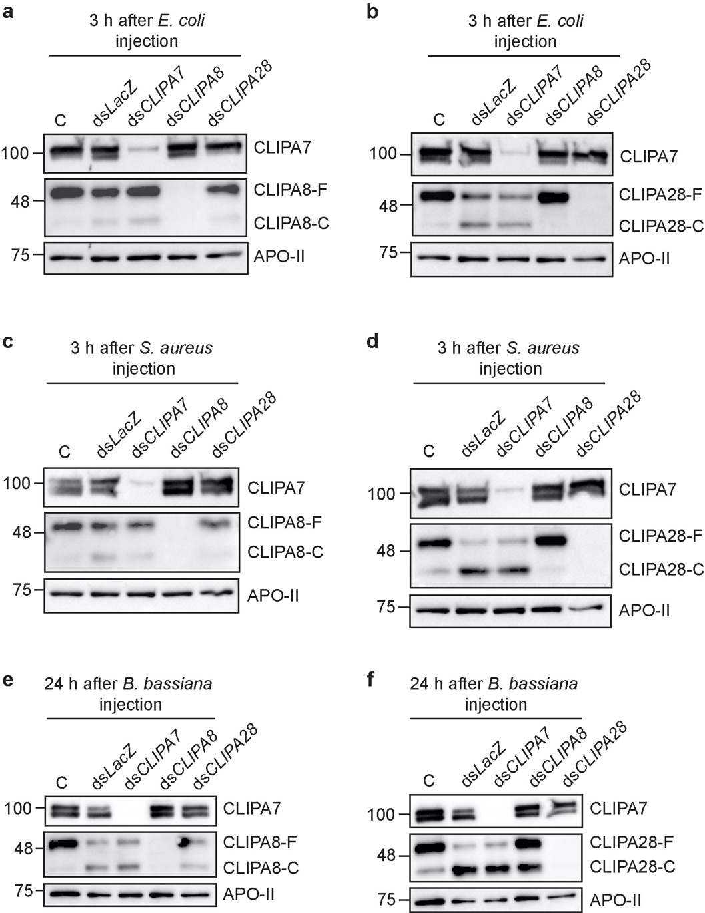

Online suppl. Fig. 8. CLIPA7 is dispensable for the activation cleavage of CLIPA8 and CLIPA28. a-b Western blots showing a CLIPA8 and b CLIPA28 cleavage in hemolymph extracts from the indicated mosquito genotypes at 3 hrs after E. coli (OD₆₀₀=0.8) injection. c-d Western blots showing c CLIPA8 and d CLIPA28 cleavage in hemolymph extracts from the indicated mosquito genotypes at 3 hrs after S. aureus (OD₆₀₀=0.8) injection. e-f Western blots showing e CLIPA8 and f CLIPA28 cleavage in hemolymph extracts from the indicated mosquito genotypes at 24 hrs after injection of B. bassiana (2000 spores/mosquito). In all blots, each lane contained hemolymph extracts from 35 mosquitoes. Membranes were also probed with αCLIPA7, and with αApoII as loading control.

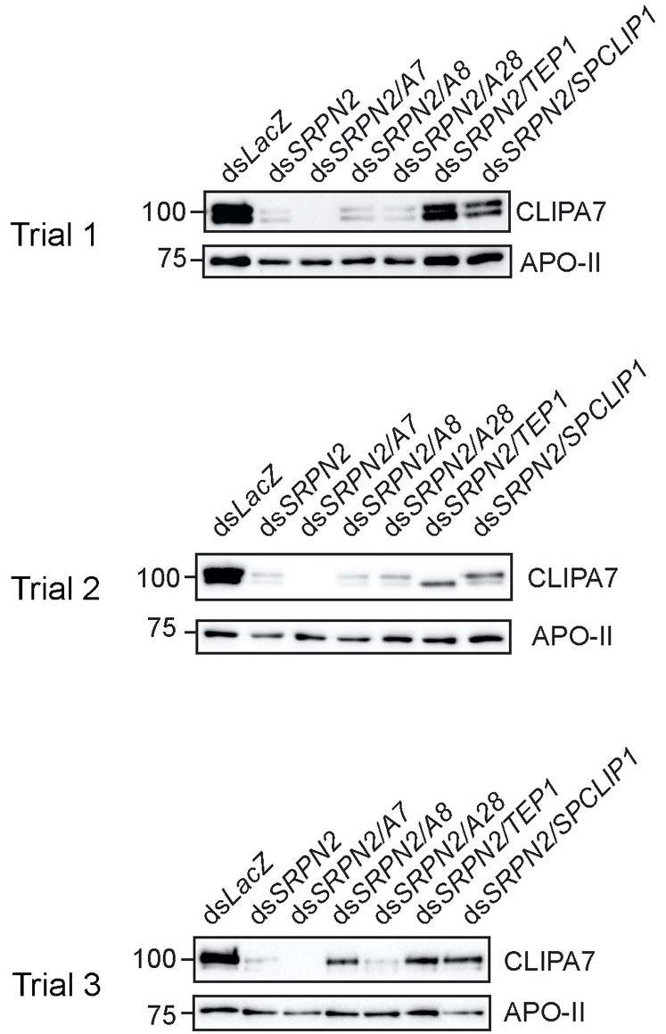

Online suppl. Fig. 9. CLIPA7 consumption in SRPN2 kd naïve mosquitoes is not rescued by the knockdown of positive regulatory cSPHs nor by TEP1. Three independent western blots showing CLIPA7 protein levels in hemolymph extracts from the indicated naïve mosquito genotypes at day 7 after dsRNA injection. Hemolymph was extracted from 35 mosquitoes per sample. Protein quantification was performed using Bradford assay and equal amounts of hemolymph proteins were loaded per gel lane. Membranes were also probed αApo-II as loading control.

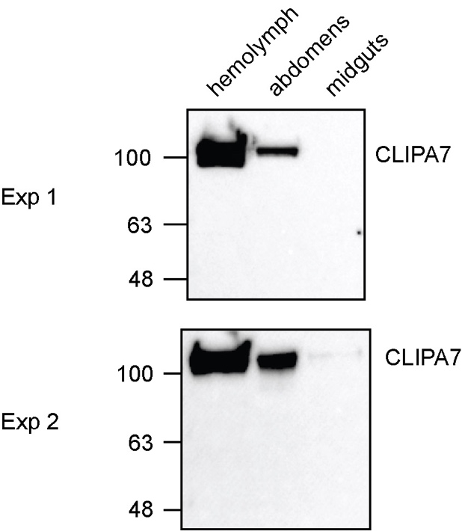

Online suppl. Fig. 10. CLIPA7 protein is detected in hemolymph and abdomen extracts. Hemolymph, abdomen and midgut extracts were prepared from naïve mosquitoes, quantified by Bradford assay to load equal amounts per gel lane. Membranes were probed with αCLIPA7. Two independent experiments are shown.

Online supplementary Table 1: Primers used for dsRNA production
Gene | Primers used for dsRNA synthesis (T7 promoter sequence underlined) | Reference
LacZ | For: 5'-TAATACGACTCACTATAGGGAGAATCCGACGGGTTGTTACT-3'  Rev: 5'-TAATACGACTCACTATAGGGCACCACGCTCATCGATAATTT-3' | [2]
TEP1  (AGAP010815) | For: 5'-TAATACGACTCACTATAGGGTTTGTGGGCCTTAAAGCGCTG-3'  Rev: 5'- TAATACGACTCACTATAGGGACCACGTAACCGCTCGGTAAG-3' | [3]
CTL4  (AGAP005335) | For: 5'- TAATACGACTCACTATAGGGGTTAGCAGCATTGGGATTACCCT-3'  Rev: 5'- TAATACGACTCACTATAGGGGAAGTCGCAACCCAGCTCATTGT-3' | [4]
SPCLIP1  (AGAP028725) | For: 5'- TAATACGACTCACTATAGGGGTCACCGAACACGGCCAAC-3'  Rev: 5'-TAATACGACTCACTATAGGGATCGAAGCTGATCGGATCGGG-3' | [4]
CLIPA7  (AGAP011792) | For: 5'-TAATACGACTCACTATAGGGGTGCTGGCAGTCCTGGAACT-3’  Rev: 5'-TAATACGACTCACTATAGGGCCACCACCTTGGTTATATCCA-3’
CLIPA8  (AGAP010731) | For: 5'- TAATACGACTCACTATAGGGAACAACGAACCCGTAGAATATG-3'  Rev: 5'- TAATACGACTCACTATAGGGGGTTAGCGCCTCGATACC-3' | [5]
CLIPA28  (AGAP010730) | For: 5'-TAATACGACTCACTATAGGGAGACCACCAAGGAACCGTTCCCGCA GCAA-3'  Rev: 5'- TAATACGACTCACTATAGGGAGACCGCAACCGATGCCCCACGAT ACGAT-3' | [6]
SRPN2  (AGAP006911) | For: 5'- TAATACGACTCACTATAGGGCTGGTCAATGTGATCTACTT-3'  Rev: 5'- TAATACGACTCACTATAGGGATTGTTCCGAGGGTTTCAT-3'
CLIPC9  (AGAP004719) | For: 5'-TAATACGACTCACTATAGGGGGTGCAGTAAGAAGGCCCAT -3'  Rev: 5'-TAATACGACTCACTATAGGGACTGCATGTCCAAGCAATCC -3' | [7]
Rel1  (AGAP006747) | For : 5'-TAATACGACTCACTATAGGGAGAATCAACAGCACGACGATGAG-3'  Rev : 5'-TAATACGACTCACTATAGGGAGATCGAAAAAGCGCACCTTAATT-3' | [8]

 | Online supplementary Table 2: Parasite counts in the indicated genotypes (Pooled trials 1, 2 and 3)
Gut # | LacZ |  | CLIPA7 kd |  | TEP1 kd |  | CTL4 kd |  | CLIPA7/TEP1 dkd |  | CLIPA7/CTL4 dkd
 | live oocyts | Melanized ookinetes | live oocysts | Melanized ookinetes | Live oocysts | Melanized ookinetes | Live oocysts | Melanized ookinetes | Live oocysts | Melanized ookinetes | Live oocysts | Melanized ookinetes
1 | 55 | 0 | 0 | 0 | 1037 | 0 | 0 | 0 | 693 | 0 | 0 | 221
2 | 63 | 0 | 91 | 0 | 1365 | 0 | 0 | 239 | 1145 | 0 | 3 | 70
3 | 289 | 0 | 173 | 0 | 1355 | 0 | 0 | 591 | 663 | 0 | 161 | 89
4 | 6 | 0 | 427 | 11 | 69 | 0 | 7 | 94 | 822 | 0 | 0 | 186
5 | 249 | 0 | 133 | 0 | 816 | 1 | 1 | 455 | 668 | 0 | 11 | 0
6 | 230 | 0 | 138 | 0 | 212 | 0 | 6 | 308 | 518 | 0 | 0 | 0
7 | 25 | 0 | 93 | 8 | 593 | 0 | 0 | 457 | 687 | 0 | 4 | 7
8 | 80 | 0 | 0 | 0 | 274 | 0 | 0 | 0 | 507 | 0 | 15 | 56
9 | 253 | 0 | 0 | 0 | 252 | 0 | 6 | 33 | 471 | 0 | 109 | 23
10 | 1 | 0 | 276 | 2 | 563 | 2 | 2 | 491 | 163 | 0 | 0 | 100
11 | 636 | 3 | 27 | 0 | 890 | 0 | 37 | 285 | 541 | 3 | 4 | 179
12 | 24 | 0 | 125 | 0 | 246 | 0 | 0 | 0 | 544 | 0 | 25 | 203
13 | 850 | 0 | 184 | 0 | 297 | 0 | 1 | 425 | 658 | 0 | 6 | 3
14 | 17 | 0 | 358 | 0 | 0 | 0 | 2 | 309 | 712 | 1 | 0 | 53
15 | 26 | 17 | 0 | 0 | 1317 | 0 | 28 | 168 | 1347 | 0 | 6 | 0
16 | 317 | 0 | 14 | 0 | 800 | 0 | 2 | 20 | 1317 | 1 | 16 | 185
17 | 273 | 0 | 364 | 0 | 391 | 0 | 8 | 421 | 667 | 0 | 2 | 406
18 | 20 | 0 | 779 | 0 | 147 | 0 | 0 | 171 | 0 | 0 | 4 | 141
19 | 100 | 0 | 1356 | 0 | 744 | 0 | 0 | 155 | 14 | 0 | 163 | 4
20 | 288 | 0 | 38 | 0 | 4 | 0 | 5 | 16 | 898 | 0 | 2 | 940
21 | 225 | 0 | 119 | 0 | 578 | 0 | 0 | 121 | 759 | 3 | 145 | 241
22 | 138 | 0 | 266 | 0 | 394 | 0 | 0 | 181 | 1260 | 3 | 20 | 62
23 | 391 | 0 | 27 | 0 | 515 | 0 | 0 | 624 | 551 | 0 | 7 | 251
24 | 295 | 0 | 22 | 0 | 724 | 0 | 0 | 0 | 821 | 0 | 28 | 308
25 | 0 | 0 | 14 | 0 | 250 | 0 | 65 | 147 | 1173 | 0 | 30 | 5
26 | 89 | 0 | 50 | 13 | 1053 | 0 | 7 | 669 | 8 | 0 | 264 | 6
27 | 166 | 0 | 325 | 0 | 562 | 0 | 32 | 357 | 1037 | 0 | 0 | 0
28 | 0 | 0 | 106 | 0 | 495 | 0 | 62 | 179 | 206 | 0 | 30 | 18
29 | 281 | 0 | 74 | 0 | 16 | 0 | 5 | 465 | 633 | 0 | 55 | 121
30 | 182 | 0 | 18 | 0 | 609 | 0 | 8 | 12 | 302 | 0 | 147 | 6
31 | 46 | 0 | 267 | 0 | 11 | 0 | 1 | 131 | 713 | 0 | 151 | 123
32 | 206 | 0 | 563 | 0 | 774 | 0 | 2 | 11 | 508 | 0 | 0 | 1073
33 | 236 | 0 | 143 | 0 | 822 | 0 | 2 | 83 | 945 | 0 | 0 | 47
34 | 32 | 0 | 248 | 9 | 1017 | 0 | 4 | 612 | 346 | 0 | 12 | 367
35 | 359 | 0 | 441 | 0 | 124 | 0 | 188 | 16 | 32 | 0 | 2 | 43
36 | 0 | 0 | 47 | 0 | 586 | 0 | 0 | 1105 | 462 | 0 | 0 | 16
37 | 0 | 0 | 288 | 0 | 462 | 0 | 4 | 14 | 266 | 0 | 16 | 91
38 | 485 | 0 | 0 | 0 | 298 | 0 | 0 | 460 | 430 | 0 | 16 | 29
39 | 56 | 0 | 49 | 0 | 102 | 0 | 0 | 1081 | 18 | 0 | 55 | 6
40 | 26 | 0 | 228 | 0 | 762 | 0 | 9 | 42 | 411 | 0 | 13 | 3
41 | 48 | 0 | 319 | 0 | 1297 | 3 | 0 | 184 | 57 | 0 | 6 | 138
42 | 741 | 0 | 64 | 0 | 61 | 0 | 0 | 441 | 0 | 0 | 9 | 33
43 | 47 | 3 | 378 | 3 | 1179 | 4 | 1 | 254 | 0 | 0 | 115 | 291
44 | 44 | 2 | 680 | 0 | 0 | 0 | 0 | 305 | 216 | 0 | 107 | 29
45 | 142 | 0 | 4 | 0 | 623 | 0 | 201 | 19 | 143 | 0 | 12 | 551
46 | 11 | 0 | 259 | 0 | 635 | 0 | 0 | 651 | 255 | 0 | 42 | 45
47 | 2 | 1 | 311 | 1 | 230 | 0 | 0 | 691 | 0 | 0 | 3 | 481
48 | 539 | 0 | 57 | 0 | 221 | 5 | 0 | 34 | 338 | 0 | 3 | 13
49 | 431 | 0 | 0 | 0 | 177 | 0 | 0 | 309 | 0 | 0 | 1 | 111
50 | 26 | 2 | 549 | 0 | 561 | 0 | 0 | 313 | 395 | 0 | 67 | 49
51 | 38 | 0 | 470 | 0 | 623 | 4 | 41 | 0 | 0 | 0 | 77 | 235
52 | 12 | 19 | 217 | 0 | 345 | 1 | 0 | 336 | 337 | 1
53 | 134 | 25 | 325 | 0 | 0 | 0 | 0 | 9 | 282 | 0
54 | 138 | 0 | 141 | 3 | 191 | 0 |  |  | 456 | 0
55 | 16 | 0 | 101 | 0 | 83 | 0 |  |  | 522 | 4
56 | 150 | 0 | 437 | 0 | 120 | 0 |  |  | 441 | 0
57 | 27 | 0 | 113 | 9 |  |  |  |  | 0 | 0
58 |  |  |  |  |  |  |  |  | 0 | 0
59 |  |  |  |  |  |  |  |  | 145 | 0
60 |  |  |  |  |  |  |  |  | 274 | 0
61 |  |  |  |  |  |  |  |  | 313 | 0
62 |  |  |  |  |  |  |  |  | 407 | 1
63 |  |  |  |  |  |  |  |  | 307 | 0
64 |  |  |  |  |  |  |  |  | 401 | 0
65 |  |  |  |  |  |  |  |  | 991 | 0
66 |  |  |  |  |  |  |  |  | 309 | 0
67 |  |  |  |  |  |  |  |  | 331 | 1
68 |  |  |  |  |  |  |  |  | 763 | 0
69 |  |  |  |  |  |  |  |  | 0 | 0
70 |  |  |  |  |  |  |  |  | 679 | 0
71 |  |  |  |  |  |  |  |  | 307 | 0
72 |  |  |  |  |  |  |  |  | 617 | 0
73 |  |  |  |  |  |  |  |  | 154 | 0
74 |  |  |  |  |  |  |  |  | 471 | 0

References

1. Volz J, Muller HM, Zdanowicz A, Kafatos FC, Osta MA. A genetic module regulates the melanization response of Anopheles to Plasmodium. Cellular microbiology. 2006;8(9):1392-405.
2. Habtewold T, Povelones M, Blagborough AM, Christophides GK. Transmission blocking immunity in the malaria non-vector mosquito Anopheles quadriannulatus species A. PLoS pathogens. 2008;4(5):e1000070.
3. Povelones M, Upton LM, Sala KA, Christophides GK. Structure-function analysis of the Anopheles gambiae LRIM1/APL1C complex and its interaction with complement C3-like protein TEP1. PLoS pathogens. 2011;7(4):e1002023.
4. Povelones M, Bhagavatula L, Yassine H, Tan LA, Upton LM, Osta MA, et al. The CLIP-Domain Serine Protease Homolog SPCLIP1 Regulates Complement Recruitment to Microbial Surfaces in the Malaria Mosquito Anopheles gambiae. PLoS pathogens. 2013;9(9):e1003623.
5. Schnitger AK, Kafatos FC, Osta MA. The Melanization Reaction Is not Required for Survival of Anopheles gambiae Mosquitoes after bacterial Infections. J Biol Chem. 2007;282(30):21884-8.
6. El Moussawi L, Nakhleh J, Kamareddine L, Osta MA. The mosquito melanization response requires hierarchical activation of non-catalytic clip domain serine protease homologs. PLoS pathogens. 2019;15(11):e1008194.
7. Sousa GL, Bishnoi R, Baxter RHG, Povelones M. The CLIP-domain serine protease CLIPC9 regulates melanization downstream of SPCLIP1, CLIPA8, and CLIPA28 in the malaria vector Anopheles gambiae. PLoS pathogens. 2020;16(10):e1008985.
8. Kamareddine L, Nakhleh J, Osta MA. Functional Interaction between Apolipophorins and Complement Regulate the Mosquito Immune Response to Systemic Infections. Journal of innate immunity. 2016;8(3):314-26.

