A.

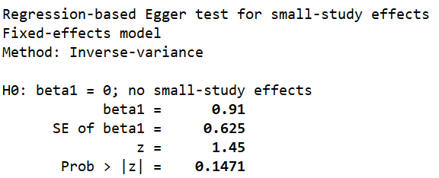

B.

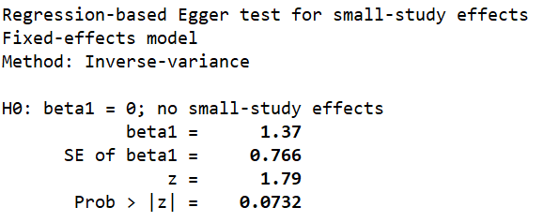

C.

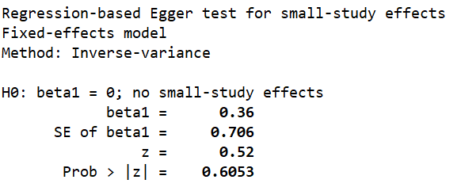

eFigure 1C. Diabetes mellitus funnel plot and Egger’s test results

D.

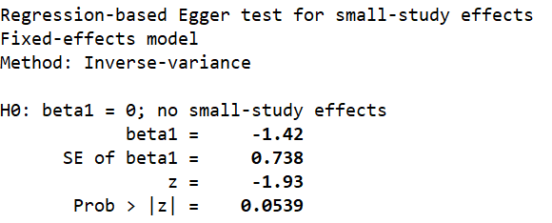

E.

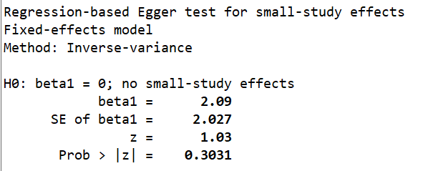

F.

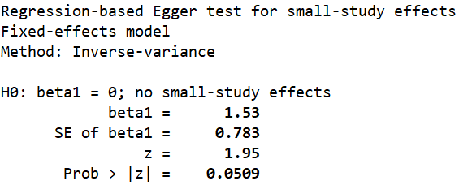

G.

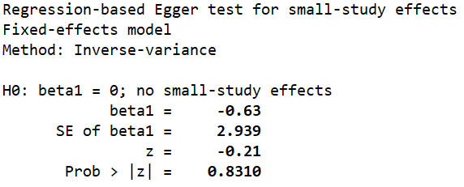

H.

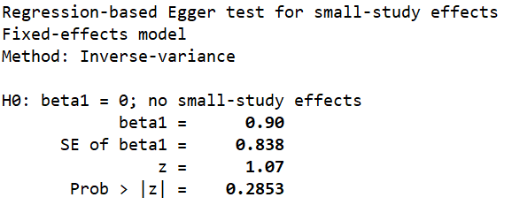

I.

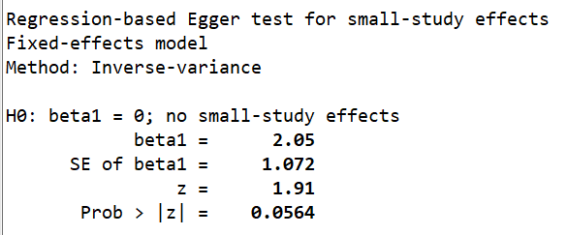

eFigure 1. Funnel plot and Egger’s test of predictors for sICH in patients with AIS. Age (A), Initial NIHSS Score (B), Diabetes mellitus (C), Systolic blood pressure (D), Pool collaterals (E), ICA occlusion (F), Passes of retriever >3 (G), Procedure time (H), mTICI≥2b (I). EVT: Endovascular Thrombectomy; sICH: Symptomatic Intracranial Hemorrhage; AIS: Acute Ischemic Stroke; NIHSS: National Institute of Health Stroke Scale; ICA: Internal Carotid Artery; mTICI: modified Thrombolysis In Cerebral Infarction.

