Supplementary Figure 1. Comparison of patients' overall survival according to the extent of ILD. (a. ILD extent≥20% vs.＜20%: p=0.182; b. ILD extent≥25% vs.＜25%: p=0.090).
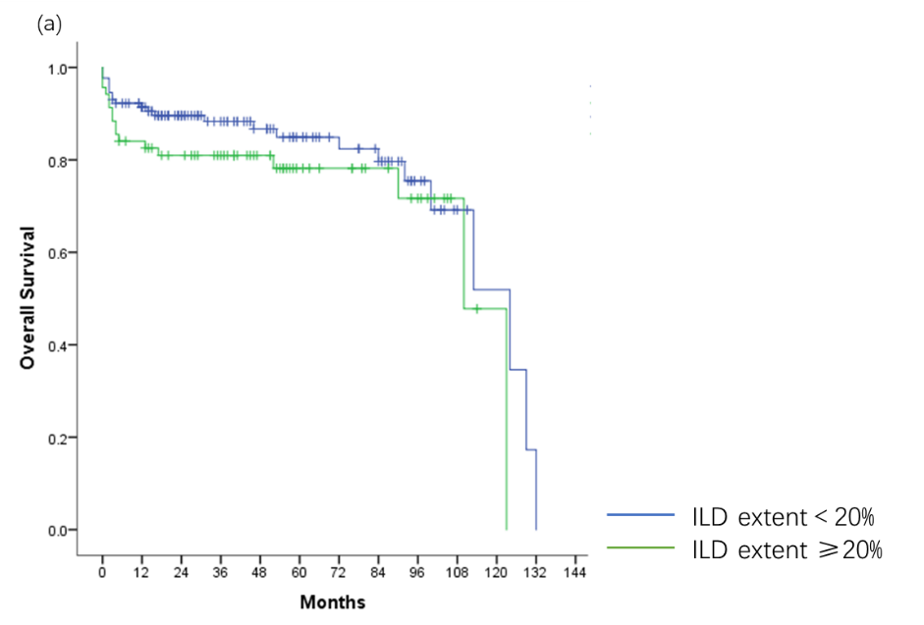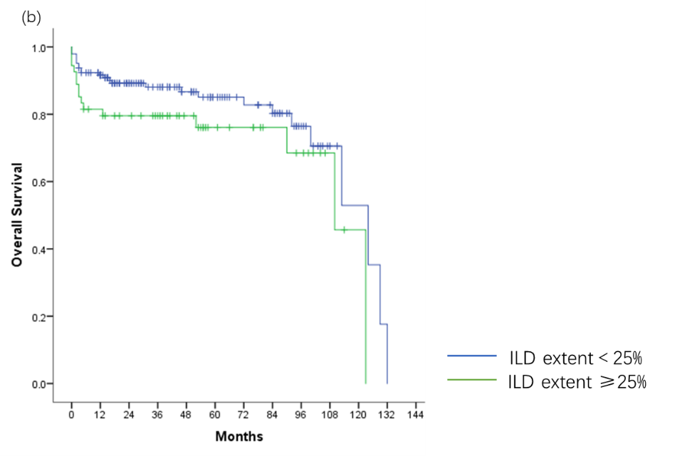

Supplementary Table 1. Details of infections requiring hospitalization during follow-up.
 | AAV-ILD | UIP | NSIP | OP | Unclassified ILD | p-value
Infectious patients, no. (%) | 110(53.9) | 89(58.6) | 14(35.9) | 2(66.7) | 5(50.0) | 0.082
Infectious episodes, no. (%) | 168 | 134 | 24 | 3 | 7 | -
First in-patient infection time, median (IQR)(weeks) | 3(2-17) | 3(2-18) | 4(2-16) | 5.5(4.3-6.8) | 3(2-3) | 0.326
Infection pathogens, no. (%)
Bacteria | 162/168(96.4) | 129/134(96.3) | 23/24(95.8) | 3/3(100.0) | 7/7(100.0) | 0.939
Fungus | 28/168(16.7) | 21/134(15.1) | 4/24(16.7) | 1/3(33.3) | 2/7(28.6) | 0.752
Pneumocystis jirovecii | 7/168(4.2) | 5/134(3.7) | 1/24(4.2) | 1/3(33.3) | 0 | 0.338
Aspergillus | 7/168(4.2) | 5/134(3.7) | 1/24(4.2) | 0 | 1/7(14.3) | 0.695
Candida | 16/168(9.5) | 13/134(9.7) | 2/24(8.3) | 0 | 1/7(14.3) | 0.847
Virus | 12/168(7.1) | 9/134(6.7) | 2/24(8.3) | 1/3(33.3) | 0 | 0.411
CMV | 6/168(3.6) | 4/134(3.0) | 1/24(4.2) | 1/3(33.3) | 0 | 0.300
EBV | 4/168(2.4) | 2/134(1.5) | 1/24(4.2) | 1/3(33.3) | 0 | 0.181
Influenza virus | 2/168(1.2) | 2/134(1.5) | 0 | 0 | 0 | 0.823
Locations of infection, no. (%)
Pulmonary | 157/168(93.5) | 124/134(92.5) | 23/24(95.8) | 3/3(100.0) | 7/7(100.0) | 0.619
Genitourinary | 12/168(7.1) | 12/134(9.0) | 0 | 0 | 0 | 0.130
Gastrointestinal | 2/168(1.2) | 2/134(1.5) | 0 | 0 | 0 | 0.823
Catheter-associated | 4/168(2.4) | 4/134(3.0) | 0 | 0 | 0 | 0.608
Sepsis | 6/168(3.6) | 5/134(3.7) | 1/24(4.2) | 0 | 0 | 0.859
AAV: ANCA-associated vasculitis; CMV: cytomegalovirus; EBV: Epstein-Barr virus; ILD: interstitial lung disease; IQR: interquartile range; NSIP: non-specific interstitial pneumonia; OP: organizing pneumonia; UIP: usual interstitial pneumonia.

Supplementary Table 2. Characteristics of relapses during follow-up.
 | AAV-ILD | UIP | NSIP | OP | Unclassified ILD | p-value
Relapse cases, no. (%) | 54 (26.5) | 42(27.6) | 8(20.5) | 1(33.3) | 3(30.0) | 0.813
Relapse events, no. (%) | 85 | 69 | 11 | 1 | 4 | -
First relapsing time, median (IQR) (months) | 12(7-27) | 12(5.5-32) | 12(9.5-27) | 7 | 18(17-51) | 0.421
Organ involvement at relapse, no. (%)
Pulmonary | 42/85(49.4) | 36/69(52.2) | 4/11(36.4) | 1/1(100.0) | 1/4(25.0) | 0.337
Renal | 47/85(55.3) | 36/69(52.2) | 6/11(54.5) | 1/1(100.0) | 4/4(100.0) | 0.102
General ¹ | 14/85(16.5) | 13/69(18.8) | 1/11(9.1) | 0 | 0 | 0.462
Ear, nose, and throat | 2/85(2.4) | 1/69(1.4) ^{b} | 0 | 1/1(100.0) | 0 | 0.037
Central nervous system | 2/85(2.4) | 2/69(2.9) | 0 | 0 | 0 | 1.000
Peripheral nervous system | 4/85(4.7) | 3/69(4.3) | 1/11(9.1) | 0 | 0 | 0.831
Gastrointestinal | 2/85(2.4) | 1/69(1.4) | 1/11(9.1) | 0 | 0 | 0.616
Eye | 6/85(7.1) | 5/69(7.2) ^{b} | 0 | 1/1(100.0) | 0 | 0.058
AAV: ANCA-associated vasculitis; ILD: interstitial lung disease; IQR: interquartile range; NSIP: non-specific interstitial pneumonia; OP: organizing pneumonia; UIP: usual interstitial pneumonia.
¹ General included fever or weight loss (≥2 kg).
^{b} UIP vs OP.

Supplementary Figure 2. Relapse-free survival of patients with AAV-ILD (a) and compared with the types of ILD (b; log rank p=0.811). UIP (blue line), NSIP (green line), OP and unclassified ILD (yellow line). AAV: ANCA-associated vasculitis; ILD: interstitial lung disease; NSIP: non-specific interstitial pneumonia; OP: organizing pneumonia; UIP: usual interstitial pneumonia.
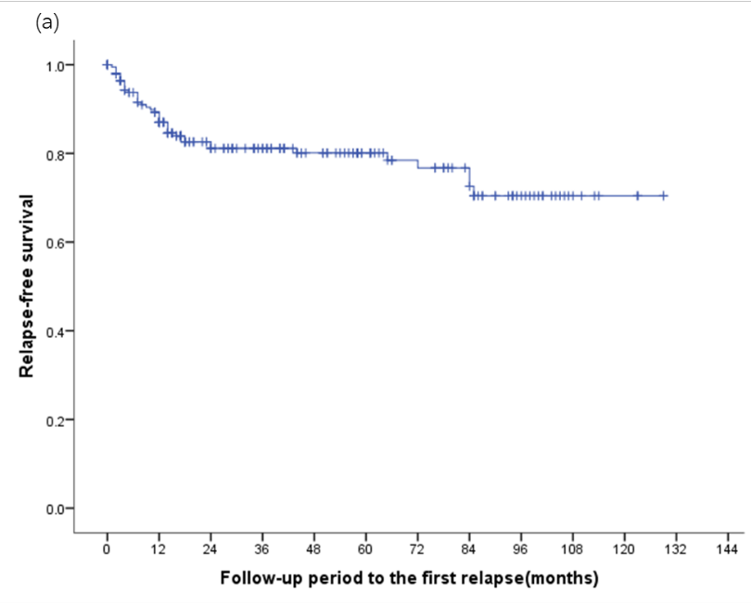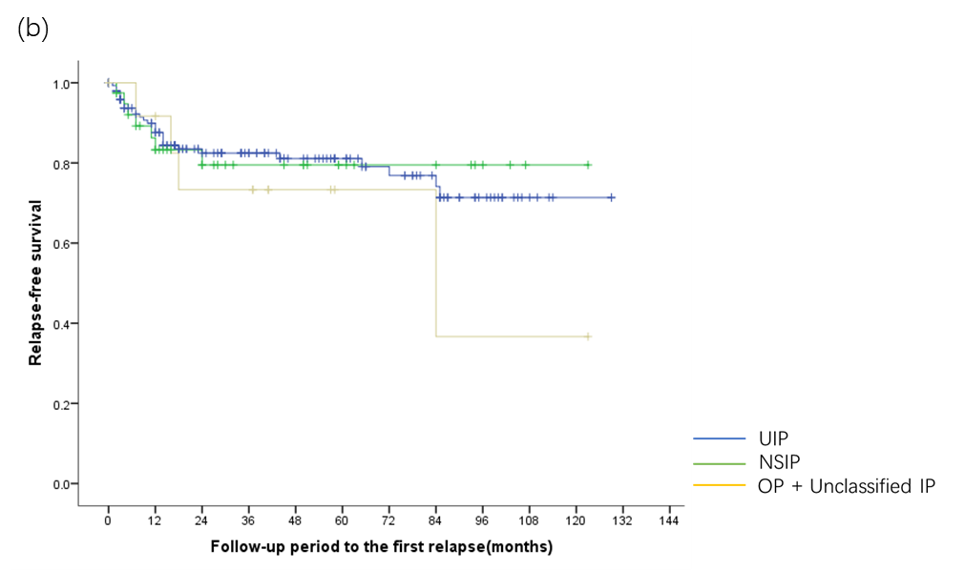

Supplementary Table 3. Univariate analysis for predictors of mortality in AAV-related ILD.
FVC% pred. at baseline
FVC% pred. <50% (vs. ≥50%-<90%) | 1.508(0.166-13.662) | 0.715
FVC% pred. <50% (vs. ≥90%) | 1.065(0.321-3.540) | 0.918
FVC% pred. ≥50%-<90% (vs. ≥90%) | 1.051(0.316-3.491) | 0.936
FVC% pred. <80% (vs. ≥80%) | 1.172(0.393-3.494) | 0.776
FVC% pred. <50% (vs. ≥50%-<80%) | 1.533(0.182-12.926) | 0.694
FVC% pred. <50% (vs. ≥80%) | 1.128(0.363-3.503) | 0.836
FVC% pred. ≥50%-<80% (vs. ≥80%) | 1.118(0.360-3.474) | 0.847
AAV: ANCA-associated vasculitis; FVC: forced vital capacity; ILD: interstitial lung disease; % pred.: % predicted.

Supplementary Table 4. Multivariate analyses for predictors of mortality in AAV-related ILD.
 | Model 5 | Model 6
Age, years ¹ | 1.036(0.994-1.080); p=0.092 | 1.035(0.993-1.079); p=0.106
Male | 0.939(0.491-1.797); p=0.850 | 0.896(0.475-1.693); p=0.736
Ear, nose and throat | 0.648(0.293-1.435); p=0.285 | 0.673(0.305-1.486); p=0.327
Respiratory failure ² | 4.770 (2.205-10.317); p<0.001 | 5.036(2.309-10.985); p<0.001
Infection requiring hospitalization ² | 1.439(0.639-3.240); p=0.379 | 1.368(0.607-3.082); p=0.450
ILD extent≥30% (vs.＜30%) | 1.425(0.679-2.993); p=0.349
Extent of ILD disease |  | 1.596(0.187-13.660); p=0.669
Model 5 and model 6 incorporated age, sex, ENT involvement, respiratory failure, infection, and ILD extent. Data are presented as hazard ratio (95% CI) and p-value. AAV: ANCA-associated vasculitis; ILD: interstitial lung disease.
¹ per 10 years increase.
² both at baseline and during follow-up.

Supplementary Table 5. Univariate and Multivariate analyses for predictors of mortality in AAV-UIP.
 | Univariate analysis |  | Multivariate analysis
 | Hazard ratio (CI 95%) | p-value | Hazard ratio (CI 95%) | p-value
Age, years ¹ | 1.412(0.897-2.221) | 0.136
Male | 0.814(0.414-1.603) | 0.552
Ever-smoker | 1.135(0.559-2.304) | 0.726
MPA | 1.299(0.176-9.606) | 0.798
GPA | 0.931(0.126-6.888) | 0.944
MPO-ANCA | 1.694(0.383-7.489) | 0.487
PR3-ANCA | 0.472(0.111-2.002) | 0.309
Alveolar hemorrhage | 1.793(0.537-5.981) | 0.342
Fever | 1.590(0.802-3.154) | 0.185
Weight loss (≥2 kg) | 0.860(0.435-1.699) | 0.664
Cutaneous | 1.149(0.272-4.860) | 0.850
Ear, nose and throat | 0.594(0.268-1.319) | 0.201
Eye | 1.013(0.137-7.482) | 0.990
Peripheral nervous system | 1.411(0.625-3.183) | 0.407
Renal | 1.212(0.530-2.771) | 0.649
Renal insufficiency | 0.749(0.322-1.740) | 0.501
BVAS | 0.998(0.951-1.046) | 0.921
FFS=1(ref.=0) | 0.920(0.433-1.952) | 0.827
FFS≥2(ref.=0) | 0.704(0.255-1.948) | 0.500
Serum creatinine, μmol/L¹ | 0.999(0.986-1.012) | 0.827
CRP, mg/L¹ | 1.067(1.001-1.138) | 0.047
CT results
Extent of ILD | 5.397(0.745-39.091) | 0.095
ILD extent≥20% (vs.＜20%) | 1.352(0.655-2.787) | 0.414
ILD extent≥25% (vs.＜25%) | 1.413(0.671-2.975) | 0.363
ILD extent≥30% (vs.＜30%) | 1.933(0.900-4.155) | 0.091
BAL results
Lymphocyte percentage ¹ | 0.612(0.246-1.520) | 0.290
Neutrophil percentage ¹ | 1.170(0.991-1.381) | 0.064 | 1.286(1.034-1.600) | 0.024
Hemosiderin-laden macrophage percentage ¹ | 0.989(0.754-1.298) | 0.938
PFT results
Restrictive syndrome | 1.044(0.331-3.297) | 0.941
FVC% pred. at baseline ² | 0.985(0.726-1.337) | 0.924
TLC% pred. at baseline ² | 0.912(0.663-1.256) | 0.574
DLCO % pred. at baseline ² | 1.046(0.660-1.658) | 0.849
Respiratory failure ³ | 4.750(2.343-9.632) | <0.001 | 6.342(1.370-29.368) | 0.018
Relapse | 1.412(0.678-2.940) | 0.357
ILD acute exacerbation | 1.730(0.774-3.868) | 0.182
Infection requiring hospitalization ³ | 2.325(1.080-5.002) | 0.031
AAV: ANCA-associated vasculitis; ANCA: antineutrophil cytoplasm antibodies; BAL: bronchoalveolar lavage; BVAS: Birmingham Vasculitis Activity Scores; CRP: c-reactive protein; DLCO: diffusing capacity for carbon monoxide; FFS: five-factor score; FVC: forced vital capacity; GPA: granulomatosis with polyangiitis; MPA: microscopic polyangiitis; MPO: myeloperoxidase; PR3: proteinase-3; TLC: total lung capacity; % pred.: % predicted; UIP: usual interstitial pneumonia.
¹ Hazard ratio reported per 10 U increase.
² Hazard ratio reported per 10 U decrease.
³ both at baseline and during follow-up.

