Supplemental Table 1. Evaluation of Least Absolute Shrinkage and Selection Operator (LASSO) Regression Mode Performance
 | Model 1 | Model 2
Accuracy | 0.86 | 0.67
Sensitivity | 0.94 | 0.88
Specificity | 0.75 | 0.34
Precision | 0.85 | 0.67
F1 socre | 0.89 | 0.76

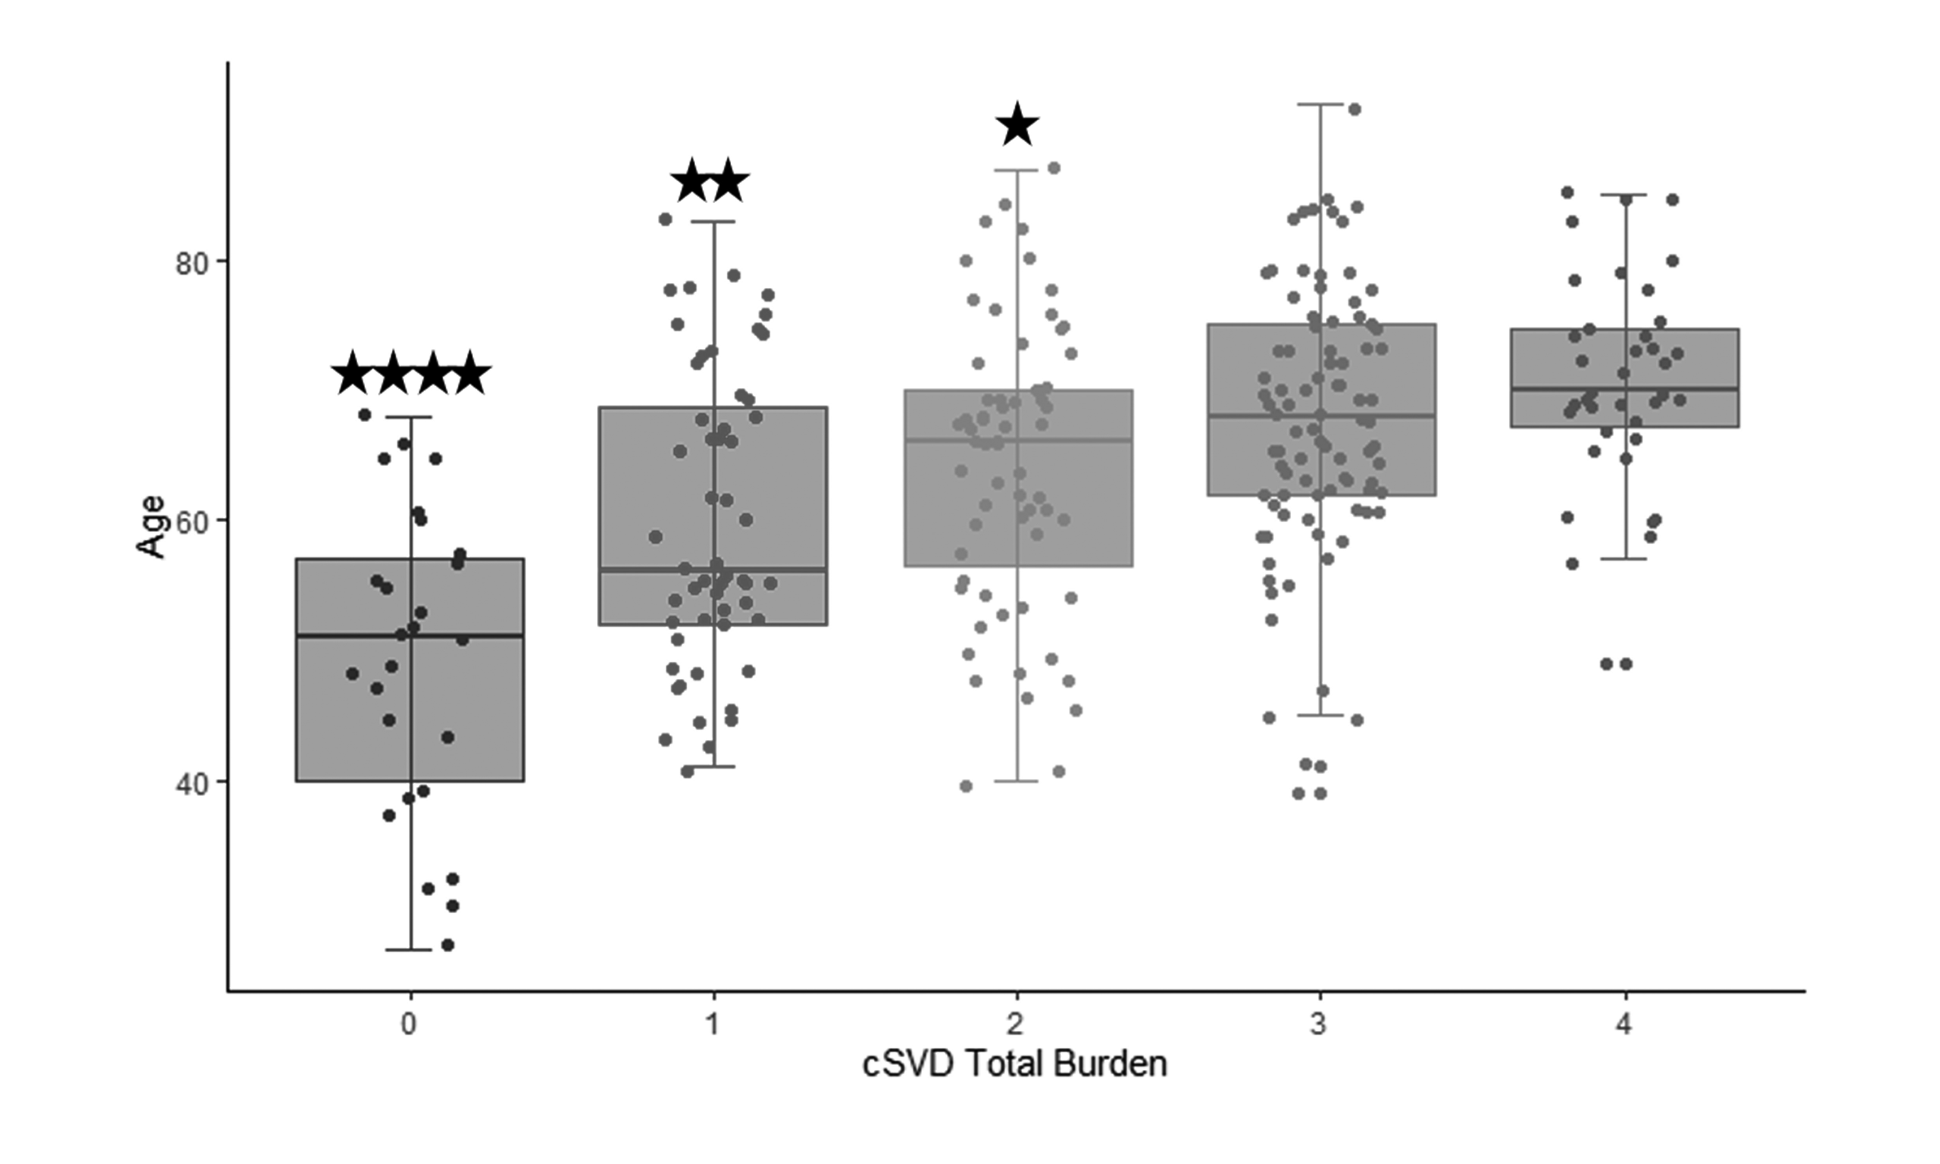
Supplemental Figure 1. Age of each cSVD total burden score group. Four stars on the box of the score 0 group indicated that the score 0 group was younger than the score 1~4 groups. Two stars on the box of the score 1 group indicated that the score 1 group was younger than the score 3 and 4 groups. One star on the box of the score 2 group indicated that the score 2 group was younger than the score 4 group. Abbreviation: cSVD, cerebral small vessel disease.

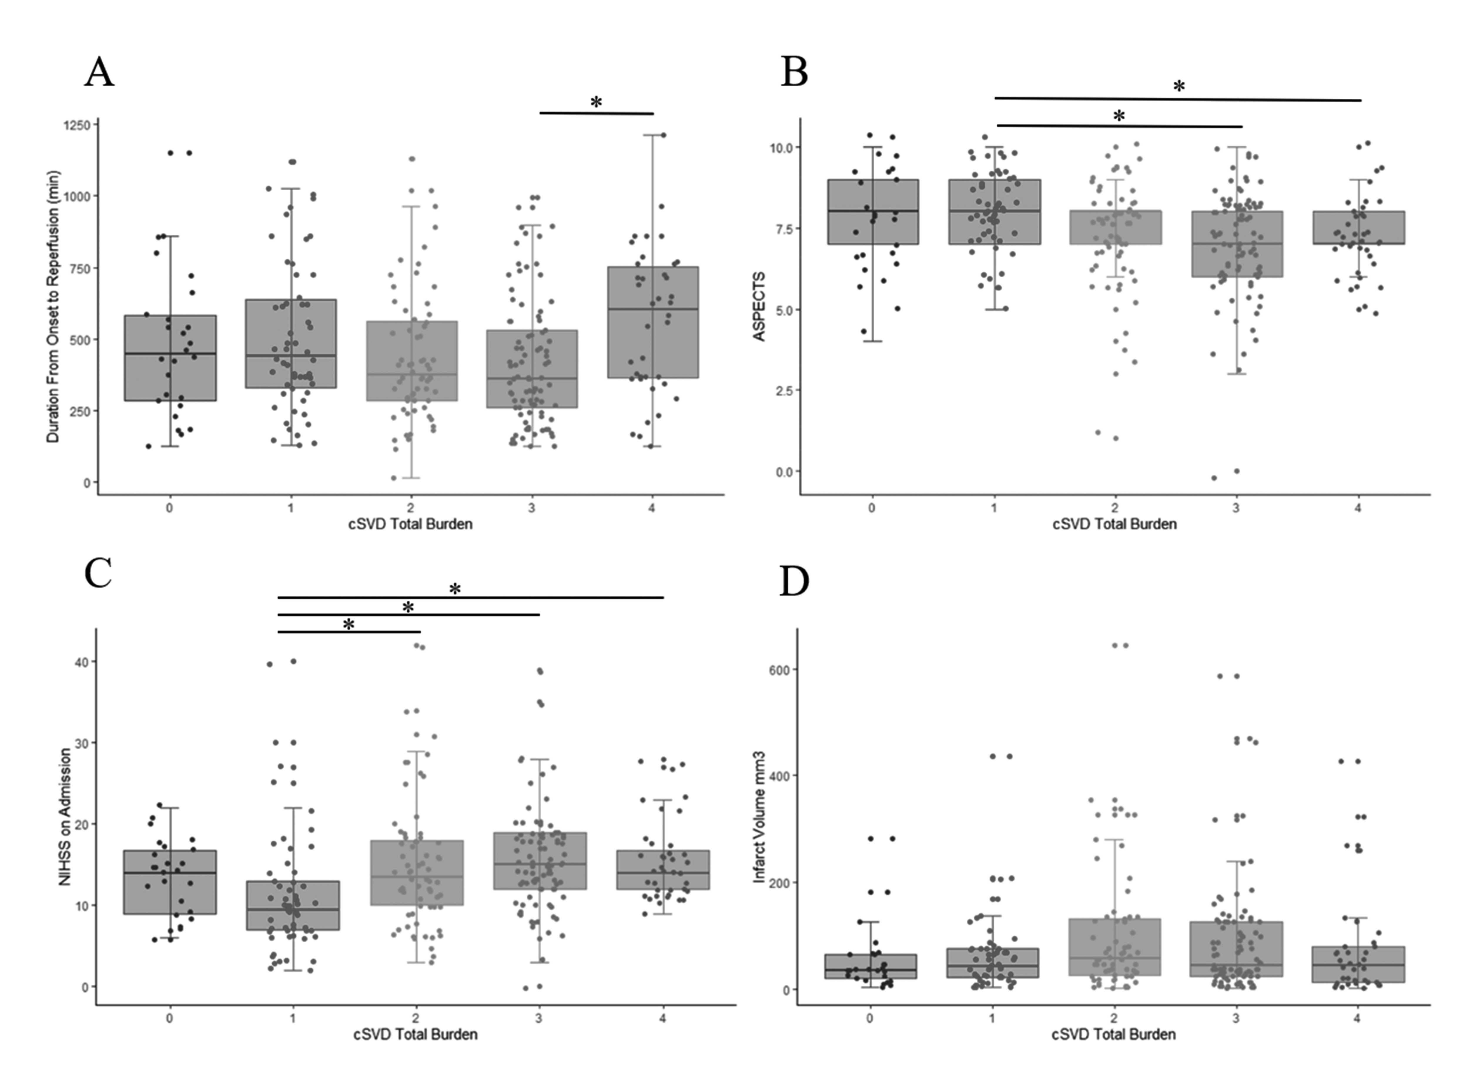
Supplemental Figure 2. Duration from onset to reperfusion (A), ASPECTS (B), NIHSS on admission (C) and infarct volume (D) in each cSVD total burden group. Abbreviation: ASPECTS, Alberta stroke program early CT score; NIHSS, national institute of health stroke scale; cSVD, cerebral small vessel disease.
*, P<0.05.

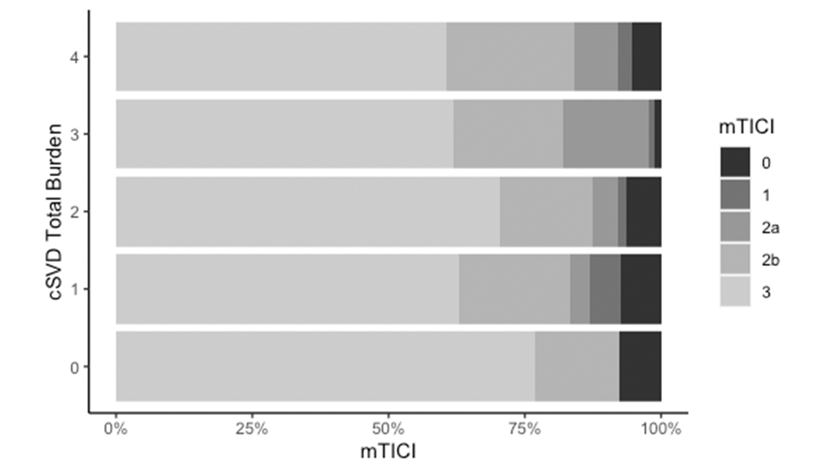Supplemental Figure 3. Modified thrombolysis in cerebral infarction score distribution in each total cSVD burden group after thrombectomy. Abbreviation: cSVD, cerebral small vessel disease; mTICI, modified thrombolysis in cerebral infarction.

