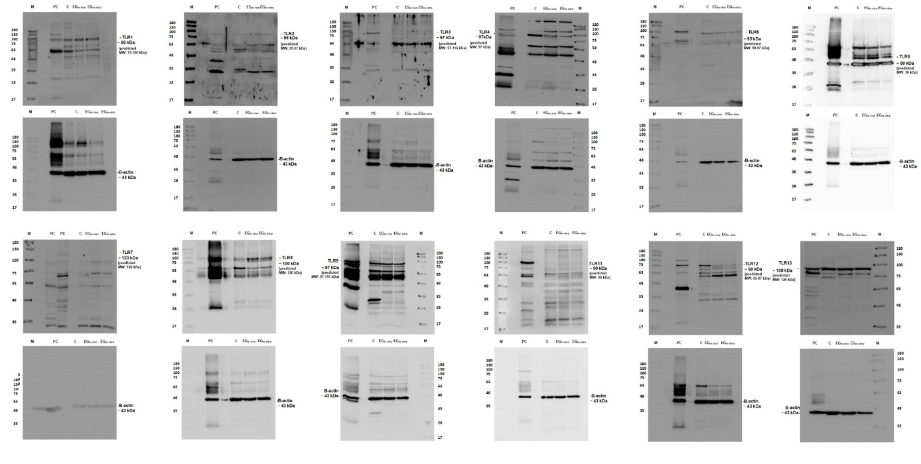
Supplementary Figure 1. Whole western blot images of TLR proteins in the fetal lung tissue of control (CG) and experimental groups (EG_{in vivo} and EG_{in vitro}). Bands were visualized using peroxidase-labeled secondary antibodies. A specific, strong band corresponding to each TLR could readily be detected in all lung tissue samples, except for TLR-2, TLR-3, TLR-7, and TLR-11. β-actin was used as an endogenous control. Pre-stained protein ladder V (Genaid, 10-180 kDa MW) was used as a protein marker. Sizes of bands for each protein are indicated. M: Markers; PC: positive control; testis were used as a positive control for all TLRs, RAW cell lysate was also used as a positive control only for TLR-7 (on the left column close to marker column); C: Control group; EG_{in vivo}, EG_{in vitro}: Experimental groups.

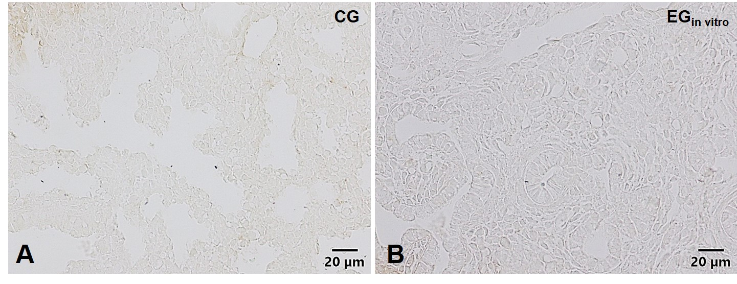
Supplementary Figure 2. The negative control sections were treated in an identical manner except for the use of TBS (pH 7.6) instead of the primary antibody. After a final rinse and wash in TBS, immune positive cells were detected using 3, 3’ diaminobenzidine tetrahydrochloride (DAB) solution (3 mg/ml in Tris-HCl, pH 7,6 with 3 % H2O2). The sections were observed on an Olympus BX51 microscope and images were captured using Olympus DP70 camera with DP controller software (Ver. 3.1.1.267). No immune-positivity were detected in any of the negative control sections used for each antibody in CG (a), EG_{in vitro} (b).

