Supplementary material
Figure S1. Flow chart describing the selection of the study population.
Abbreviations: MIA, malnutrition, inflammation, and atherosclerosis cohort; IAR, interleukin-6 to albumin ratio.
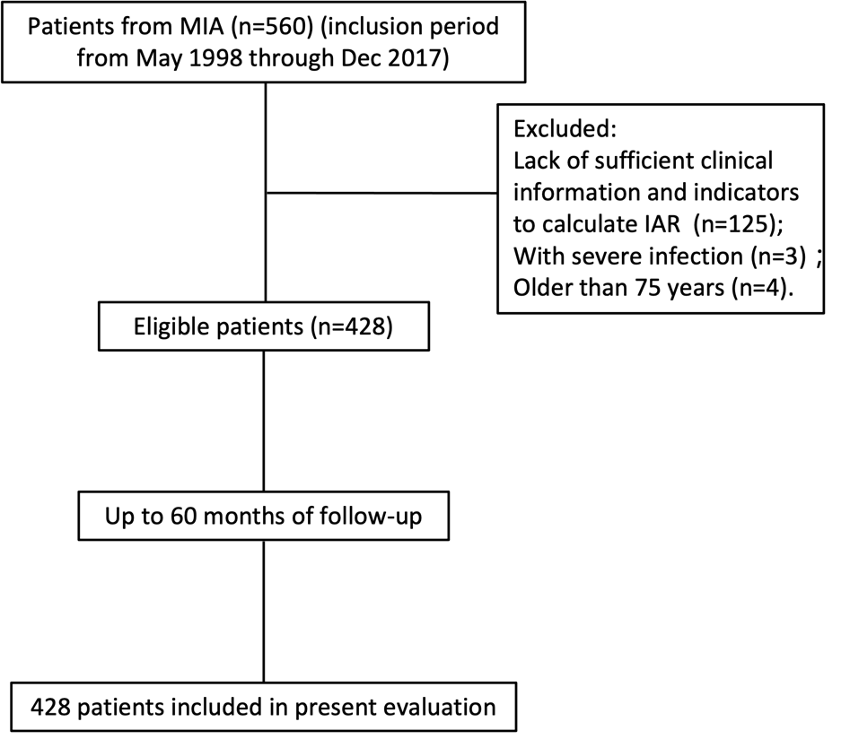
Figure S2. Median (25th to 75th percentile) baseline interleukin-6 to albumin ratio (IAR; crude values) in survivors and non-survivors. * P<0.001
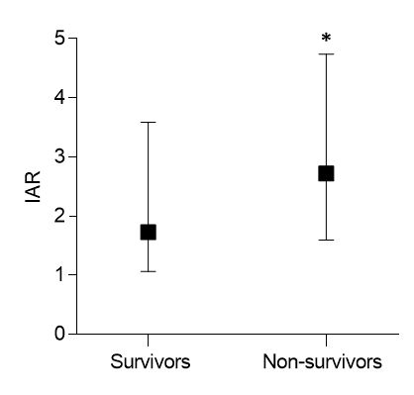

Figure S3. Area under the ROC curve (AUC) with 95% confidence interval (CI) of risk factors to predict all-cause and cardiovascular (CV) mortality at 60 months in 428 incident dialysis patients. Abbreviations: hsCRP, high-sensitivity C-reactive protein; CAR, hsCRP to albumin ratio; IL-6, interleukin-6; IAR, interleukin-6 to albumin ratio.
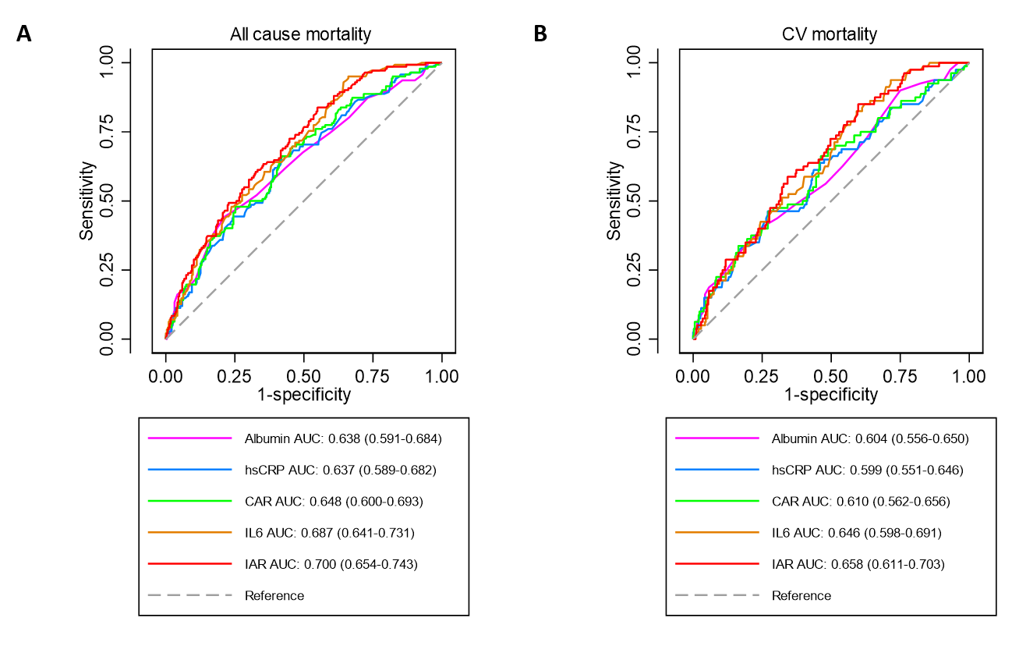

Table S1. Correlations between interleukin-6 to albumin ratio (IAR) and continuous (Spearman rank correlations; rho) and dichotomous (Kruskal-Wallis test; ꭕ2) variables, respectively.
 | rho | P-value
Age (year) | 0.32 | <0.001
HDL-C (mmol/L) | -0.20 | <0.001
Hemoglobin (g/L) | -0.20 | <0.001
WBC (*109/L) | 0.29 | <0.001
hsCRP (mg/L) | 0.56 | <0.001
BMI (kg/m2) | 0.13 | 0.009
 | ꭕ2 | P-value
Sex (male vs. female) | 3.67 | 0.055
Presence of diabetes mellitus | 30.08 | <0.001
Presence of cardiovascular disease | 48.28 | <0.001
Smoking | 11.47 | <0.001

Abbreviations: HDL-C, high-density lipoprotein cholesterol; WBC, white blood cell; hsCRP, high-sensitivity C-reactive protein; BMI, body mass index.

