Research Article
Thyroid Dysfunction After Atezolizumab and Bevacizumab is Associated with Favorable Outcomes in Hepatocellular Carcinoma

Young Shin Song^{a,b*}, Hannah Yang^{c*}, Beodeul Kang^{c}, Jaekyung Cheon^{c}, Ilhwan Kim^{d}, Hyeyeong Kim^{e}, Won Suk Lee^{c}, Yun Beom Sang^{c}, Sanghoon Jung^{f}, Ho Yeong Lim^{g}, Vincent E. Gaillard^{h}, Chan Kim^{c}, Hong Jae Chon^{c}

ªDivision of Endocrinology and Metabolism, Department of Internal Medicine, CHA Bundang Medical Center, CHA University School of Medicine, Seongnam, Korea
^{b}Division of Endocrinology and Metabolism, Department of Internal Medicine, Seoul Metropolitan Government Seoul National University Boramae Medical Center, Seoul National University College of Medicine, Seoul, Korea
^{c}Division of Medical Oncology, Department of Internal Medicine, CHA Bundang Medical Center, CHA University School of Medicine, Seongnam, Korea
^{d}Division of Oncology, Department of Internal Medicine, Inje University College of Medicine, Haeundae Paik Hospital, Busan, Korea
^{e}Department of Internal Medicine, Ulsan University Hospital, University of Ulsan College of Medicine, Ulsan, Korea
^{f}Department of Radiology, CHA Bundang Medical Center, Seongnam, Korea
^{g}Division of Hemato-Oncology, Department of Internal Medicine, Samsung Medical Center, Sungkyunkwan University School of Medicine, Seoul, Korea
^{h}F. Hoffmann-La Roche Ltd., Basel, Switzerland
*These authors equally contributed to this work.

Short Title: Thyroid adverse events after Ate/Bev and outcome in hepatocellular carcinoma

Corresponding authors:
Hong Jae Chon (Lead contact)
Medical Oncology, Department of Internal Medicine
CHA Bundang Medical Center, CHA University
59 Yatap-ro, Bundang-gu, Seongnam 13496 , Republic of Korea
Phone: 82-31-780-7590; Fax: 82-31-780-3929
E-mail: minidoctor@cha.ac.kr

Chan Kim
Medical Oncology, Department of Internal Medicine
CHA Bundang Medical Center, CHA University
59 Yatap-ro, Bundang-gu, Seongnam 13496 , Republic of Korea
Phone: 82-31-780-7590; Fax: 82-31-780-3929
E-mail: chan@cha.ac.kr

Table of contents
Supplementary Table 1. Incidence of Ate/Bev treatment-related adverse events (AEs) according to thyroid AEs
Supplementary Table 2. Hazard ratios for progression-free survival and overall survival according to immune-related adverse events
Supplementary Table 3. Baseline clinical characteristics of a validation cohort (IMbrave150)

Supplementary Figure 1. CONSORT diagram
Supplementary Figure 2. Progression-free survival and overall survival according to thyroid adverse events (AEs).
Supplementary Figure 3. Comparison of baseline cytokine levels and T cell fractions between patients with hypothyroidism and those without thyroid adverse events.
Supplementary Table 1. Incidence of Ate/Bev treatment-related adverse events (AEs) according to thyroid AEs
 | Thyroid AE+  (n = 41) | Thyroid AE−  (n = 167) | P
Dermatological toxicity | 12 (29.3) | 25 (15.0) | 0.032
Gastrointestinal toxicity | 5 (12.2) | 17 (10.2) | 0.777
Hepatotoxicity | 19 (46.3) | 65 (38.9) | 0.386
Pulmonary toxicity | 1 (2.4) | 2 (1.2) | 0.484
Rheumatic toxicity | 2 (4.9) | 5 (3.0) | 0.626
Pituitary toxicity | 2 (4.9) | 3 (1.8) | 0.256
Diabetes mellitus | 1 (2.4) | 8 (4.8) | 0.507
Adrenal insufficiency | 6 (14.6) | 2 (1.2) | <0.001
Fatigue | 12 (29.3) | 42 (25.1) | 0.590
Hypertension | 19 (46.3) | 60 (35.9) | 0.218
Proteinuria | 21 (51.2) | 76 (45.5) | 0.511
Bleeding | 5 (12.2) | 16 (9.6) | 0.573
The incidence is presented as n (%).

Supplementary Table 2. Hazard ratios for progression-free survival and overall survival according to immune-related adverse events
 |  | PFS |  | OS
 | irAE, n (%) | HR | P | HR | P
 |  | (95% CI) |  | (95% CI)
Dermatological toxicity | 37 (17.8) | 0.471 | 0.005 | 0.698 | 0.231
 |  | (0.275, 0.809) |  | (0.388, 1.257)
Gastrointestinal toxicity | 22 (10.6) | 0.509 | 0.052 | 0.97 | 0.931
 |  | (0.258, 1.005) |  | (0.486, 1.933)
Hepatotoxicity | 84 (40.4) | 0.664 | 0.028 | 1.197 | 0.399
 |  | (0.461, 0.956) |  | (0.788, 1.818)
Pulmonary toxicity | 3 (1.4) | 2.295 | 0.246 | 9.461 | < 0.001
 |  | (0.564, 9.348) |  | (2.879, 31.097)
Rheumatic toxicity | 7 (3.4) | 0.495 | 0.495 | 0.227 | 0.141
 |  | (0.157, 1.559) |  | (0.032, 1.633)
Pituitary toxicity | 5 (2.4) | 0.284 | 0.079 | 0.455 | 0.275
 |  | (0.069, 1.158) |  | (0.110, 1.872)
Diabetes mellitus | 9 (4.3) | 0.879 | 0.759 | 0.326 | 0.118
 |  | (0.387, 2.000) |  | (0.080, 1.328)
Adrenal insufficiency | 8 (3.8) | 0.429 | 0.148 | 1.101 | 0.851
 |  | (0.136, 1.350) |  | (0.404, 3.003)
Thyroid AEs | 41 (19.7) | 0.279 | < 0.001 | 0.329 | 0.001
 |  | (0.159, 0.489) |  | (0.165, 0.657)
irAE, immune-related adverse event; PFS, progression-free survival; OS, overall survival; HR, hazard ratio; AEs, adverse events

Supplementary Table 3. Baseline clinical characteristics of a validation cohort (IMbrave150)
 | All patients  (n = 269) | Thyroid AE  (n = 36) | No thyroid AE  (n = 233) | P
Age, year, median (IQR) | 66.0  (59.0–72.0) | 65.0  (61.0–65.0) | 66.0  (58.0–72.0) | 0.829
Male sex, n (%) | 220 (81.8) | 32 (88.9) | 188 (80.7) | 0.235
Geographic region, n (%)
Asia | 122 (45.4) | 13 (36.1) | 109 (46.8) | 0.340
Europe | 84 (31.2) | 15 (41.7) | 69 (29.6)
North America | 56 (20.8) | 8 (22.2) | 48 (20.6)
Rest of the world | 7 (2.6) | 0 (0) | 7 (3.0)
ECOG performance status, n (%) |  |  |  | 0.017
0 | 177 (65.8) | 30 (83.3) | 147 (63.1)
1 | 92 (34.2) | 6 (16.7) | 86 (36.9)
Child–Pugh classification, n (%) |  |  |  | N/A
A | 269 (100.0) | 36 (100.0) | 233 (100.0)
Barcelona clinical liver cancer stage, n (%) |  |  |  | 0.245
A | 7 (2.6) | 1 (2.8) | 6 (2.6)
B | 42 (15.6) | 9 (25.0) | 33 (14.2)
C | 220 (82.8) | 26 (72.2) | 194 (83.3)
Alpha–fetoprotein ≥ 400 ng/ml, n (%) | 92 (34.2) | 9 (25.0) | 83 (35.6) | 0.211
Presence of macrovascular invasion, n (%) | 105 (39.0) | 11 (30.6) | 94 (40.3) | 0.263
Presence of extrahepatic spread, n (%) | 164 (61.0) | 22 (61.1) | 142 (60.9) | 0.985
Etiology of HCC, n (%) |  |  |  | 0.427
Hepatitis B | 106 (39.4) | 11 (30.6) | 95 (40.8)
Hepatitis C | 66 (24.5) | 8 (22.2) | 58 (24.9)
Alcohol | 34 (12.6) | 7 (19.4) | 27 (11.6)
Other or unknown | 63 (23.4) | 10 (27.8) | 53 (22.7)
Prior local therapy for HCC, n (%) | 119 (44.2) | 17 (47.2) | 102 (43.8) | 0.698
Significant P values in bold. AE, adverse event; IQR, interquartile range; ECOG, Eastern Cooperative Oncology Group; HCC, hepatocellular carcinoma; N/A, not applicable

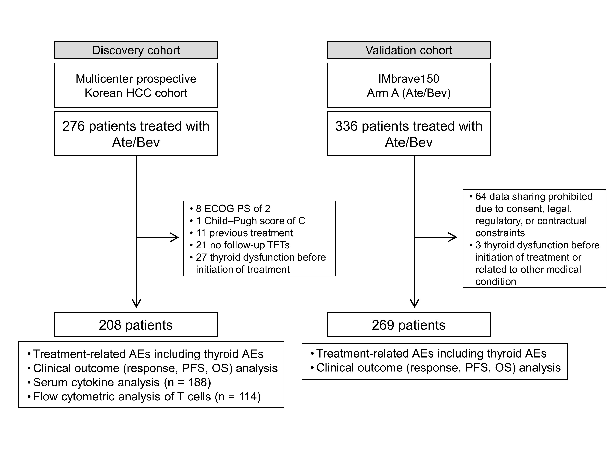
Supplementary Figure 1. CONSORT diagram

Supplementary Figure 2. Progression-free survival and overall survival according to thyroid adverse events (AEs). (a and b) Time-dependent analyses using a time-dependent Cox regression model. (c and d) Patients who do not have a progressive disease response. (e and f) Patients with overt and subclinical thyroid AEs and those without thyroid AEs. (g and h) Patients with early-onset and late-onset thyroid AEs and those without thyroid AEs.

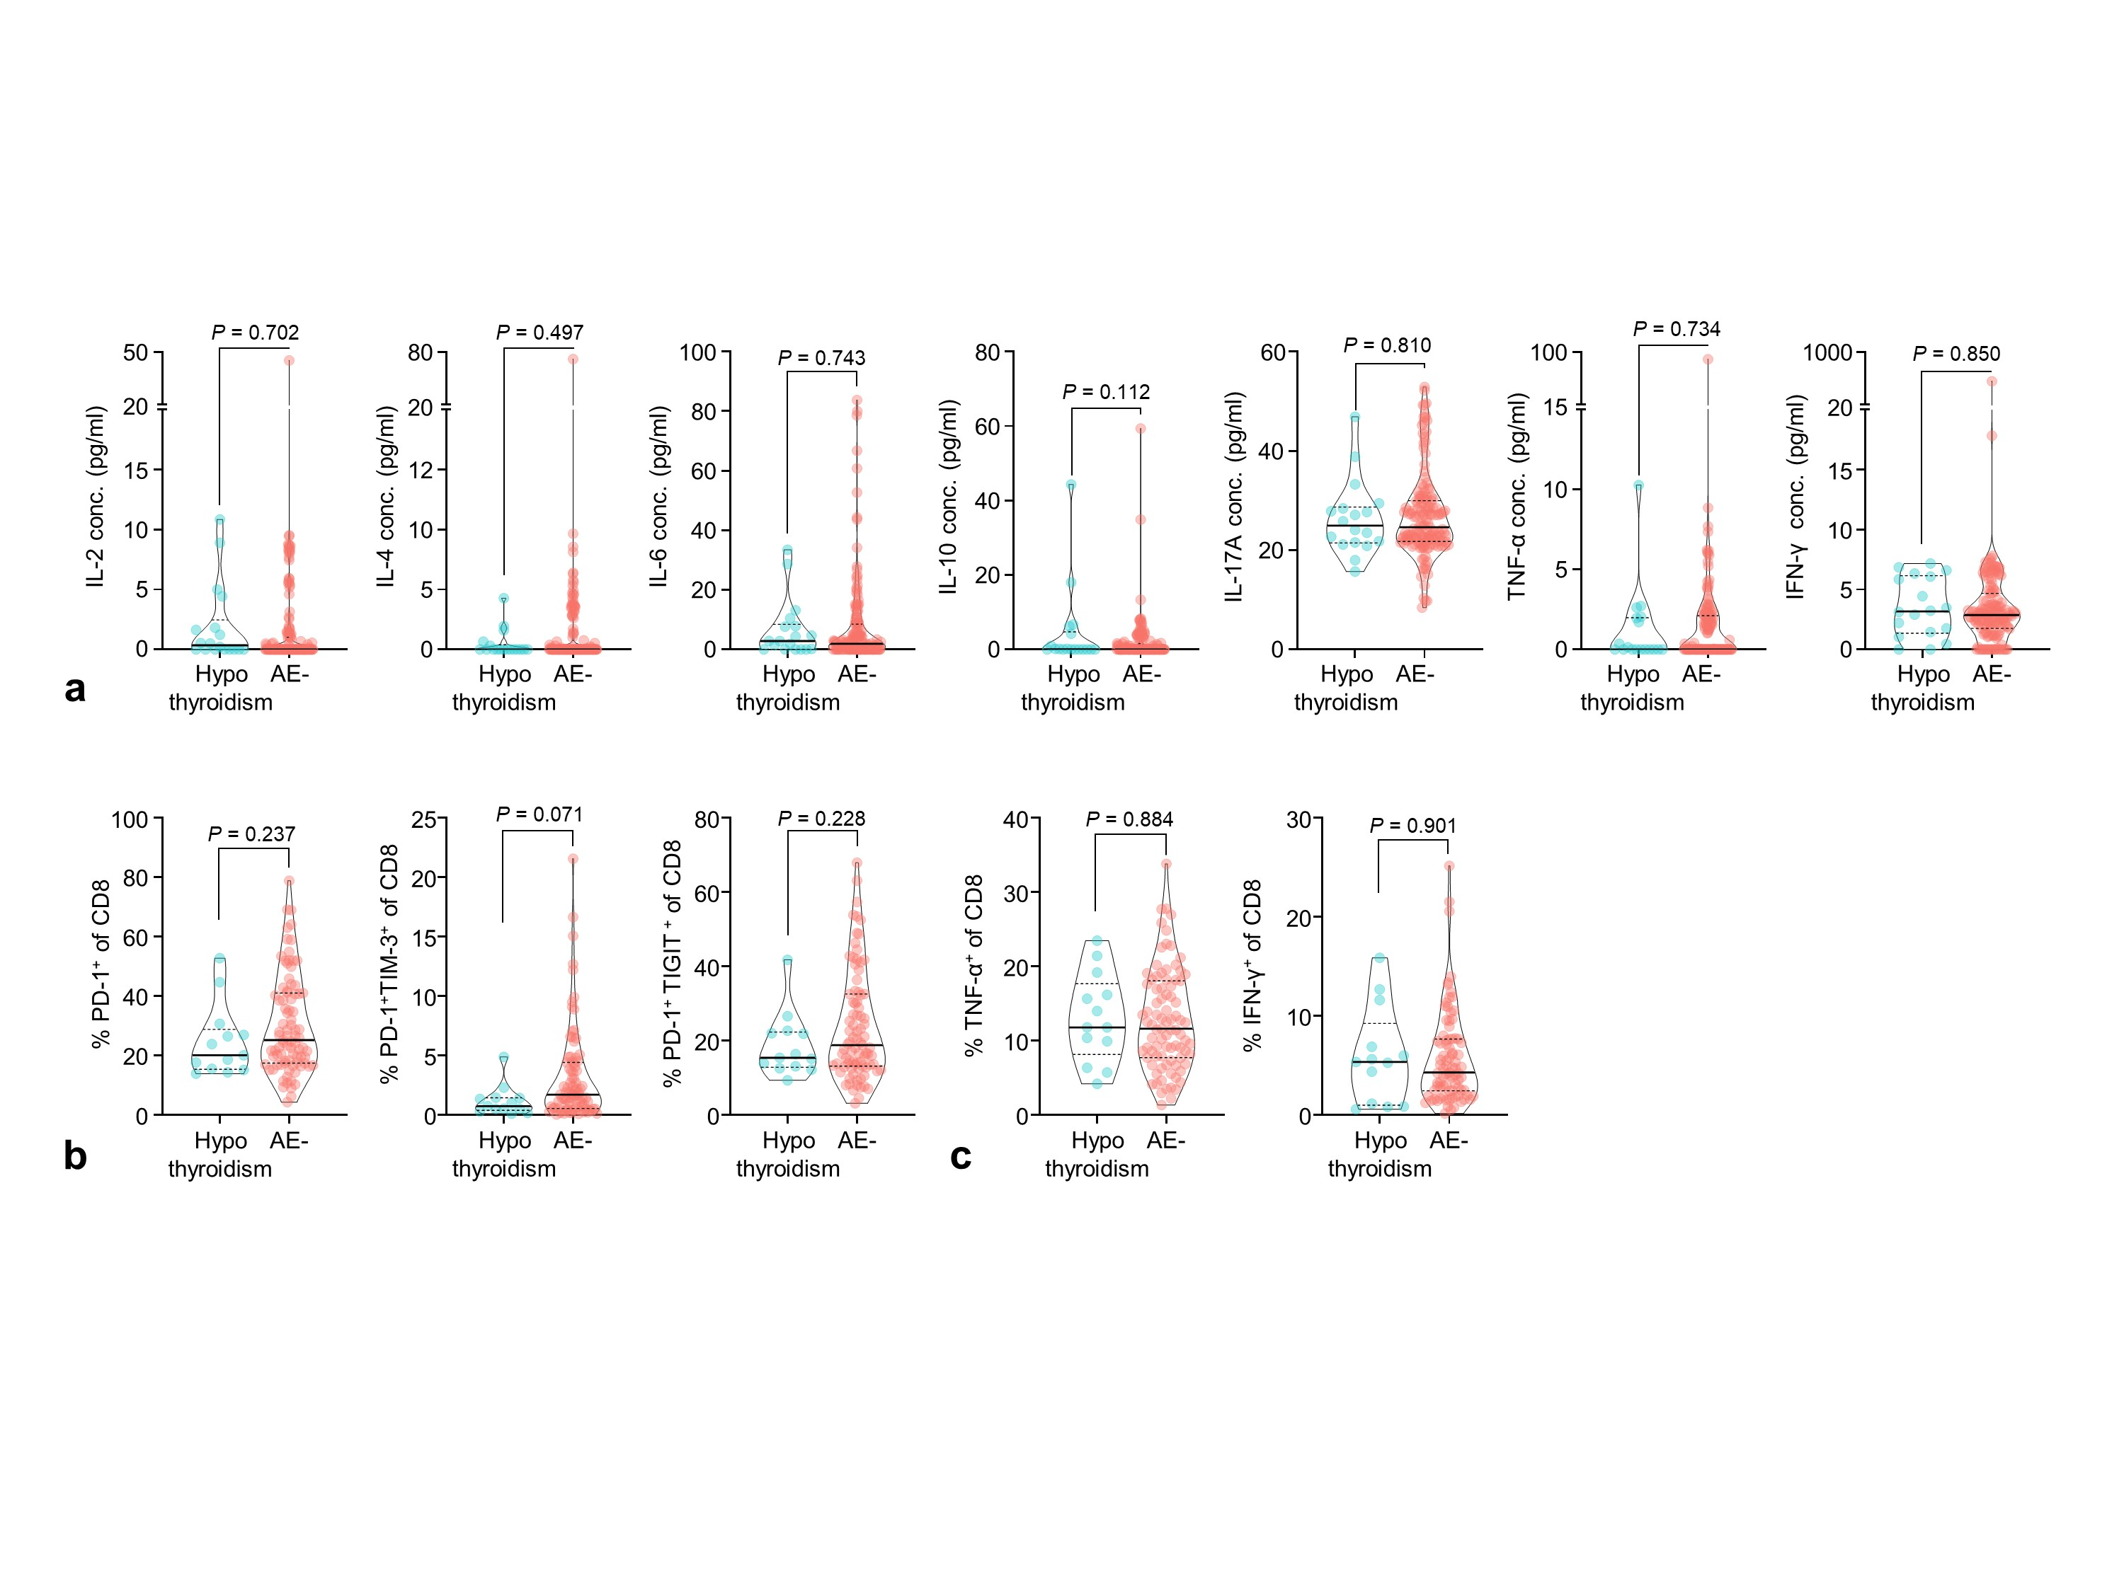
Supplementary Figure 3. Comparison of baseline cytokine levels and T cell fractions between patients with hypothyroidism and those without thyroid adverse events. Baseline cytokine levels (a and b), CD8⁺ cell subset fractions (c), and effector cytokines in CD8⁺ T-cells (d).

