Catecholamine metabolism induces mitochondrial DNA deletions and leads to severe adrenal degeneration during aging

Johannes Friedrich Georg Neuhaus¹, Olivier Richard Baris¹, Anne Kittelmann¹, Katrin Becker², Markus Alexander Rothschild² and Rudolf Josef Wiesner^{1,3,4}

¹Center for Physiology and Pathophysiology, Institute of Vegetative Physiology, Medical Faculty, University of Köln, Robert-Koch-Str. 39, 50931 Köln, Germany
²Institute of Legal Medicine, Medical Faculty, University of Köln, Melatengürtel 60/62, 50823 Köln, Germany
³Center for Molecular Medicine Cologne (CMMC), University of Köln, Robert-Koch-Str. 21, 50931 Köln, Germany
⁴Cologne Excellence Cluster on Cellular Stress Responses in Ageing-associated Diseases (CECAD), University of Köln, Joseph-Stelzmann-Str. 26, 50931 Köln, Germany

Corresponding author: Rudolf J. Wiesner Mail: rudolf.wiesner@uni-koeln.de
Tel: +49-221-4783610
Fax: +49-221-4783538
Inventory of Supplemental Information
Supplementary Figure S1, related to Figure 1
Supplementary Figure S2, related to Figure 5
Supplementary Figure S3, related to Figure 1
Supplementary Figure S4, related to Figure 2
Supplementary Figure S5, related to Figure 2
Supplementary Figure S6, related to Figure 3
Supplementary Figure S7, related to Figure 3
Supplementary Figure S8, related to Figure 4, 5 and 6
Supplementary Figure S9, related to Figure 5
Supplementary Table S1, related to Figure 5, S3 and S9
Supplementary Table S2, related to Figure 4, 5 and 6
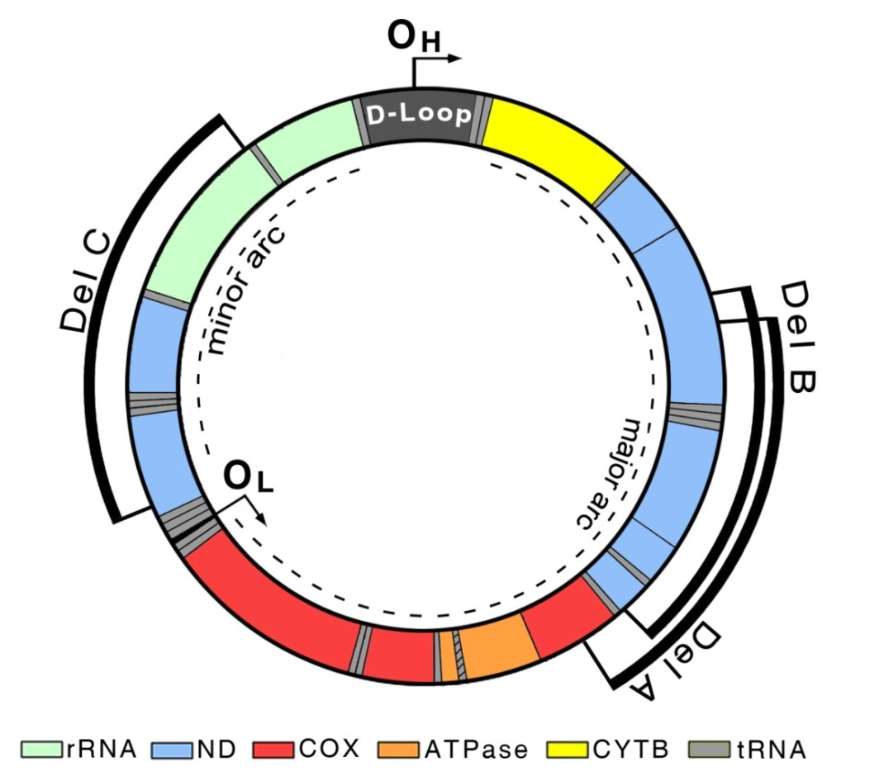
Supplementary Fig. S1. Arrangement of the three mtDNA deletions quantified by PCR. The circle displays a murine mtDNA molecule; rRNAs, tRNAs and protein encoding genes are specified in colours. Black bars indicate the three deletion regions (Del A,B,C) amplified with the corresponding primers. O_{H}: origin of heavy strand replication; O_{L}: origin of light strand replication; D-Loop: non-coding regulatory region; ATPase: ATP synthase; COX: cytochrome c oxidase; CYTB: cytochrome b; ND: NADH dehydrogenase; rRNA: ribosomal RNA.

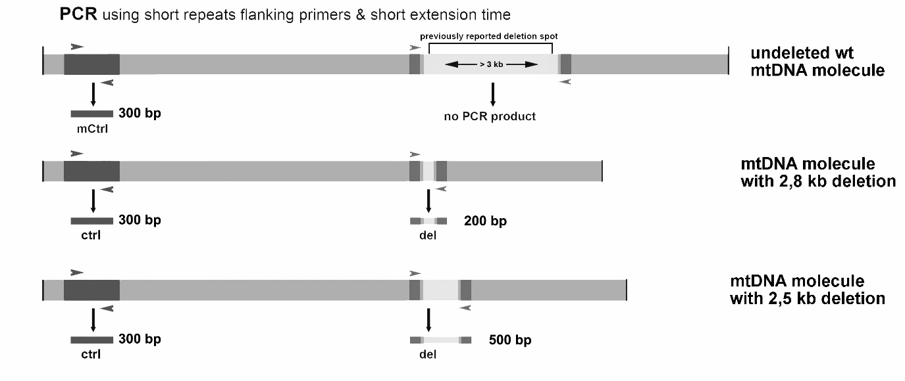
Supplementary Fig. S2. Schematic description of the PCR strategy for mtDNA deletion screening; bp indicate the PCR product size. Choosing short elongation times allows selective amplification of deleted mtDNA molecules only, by avoiding amplification of undeleted wild-type mtDNA molecules, which would require more time to be amplified. This strategy thus allows identification of several distinct, defined deletions in a chosen tissue. Additionally, using nested primers allows increasing specificity and sensitivity of the method. A small region of non-deleted mtDNA in the D-Loop region with a fixed size of 300bp is amplified as positive control for all mtDNA species. wt: wild type mtDNA molecule; del: deleted mtDNA molecule; ctrl: control PCR fragment of the D-Loop; del: deletion containing PCR product.
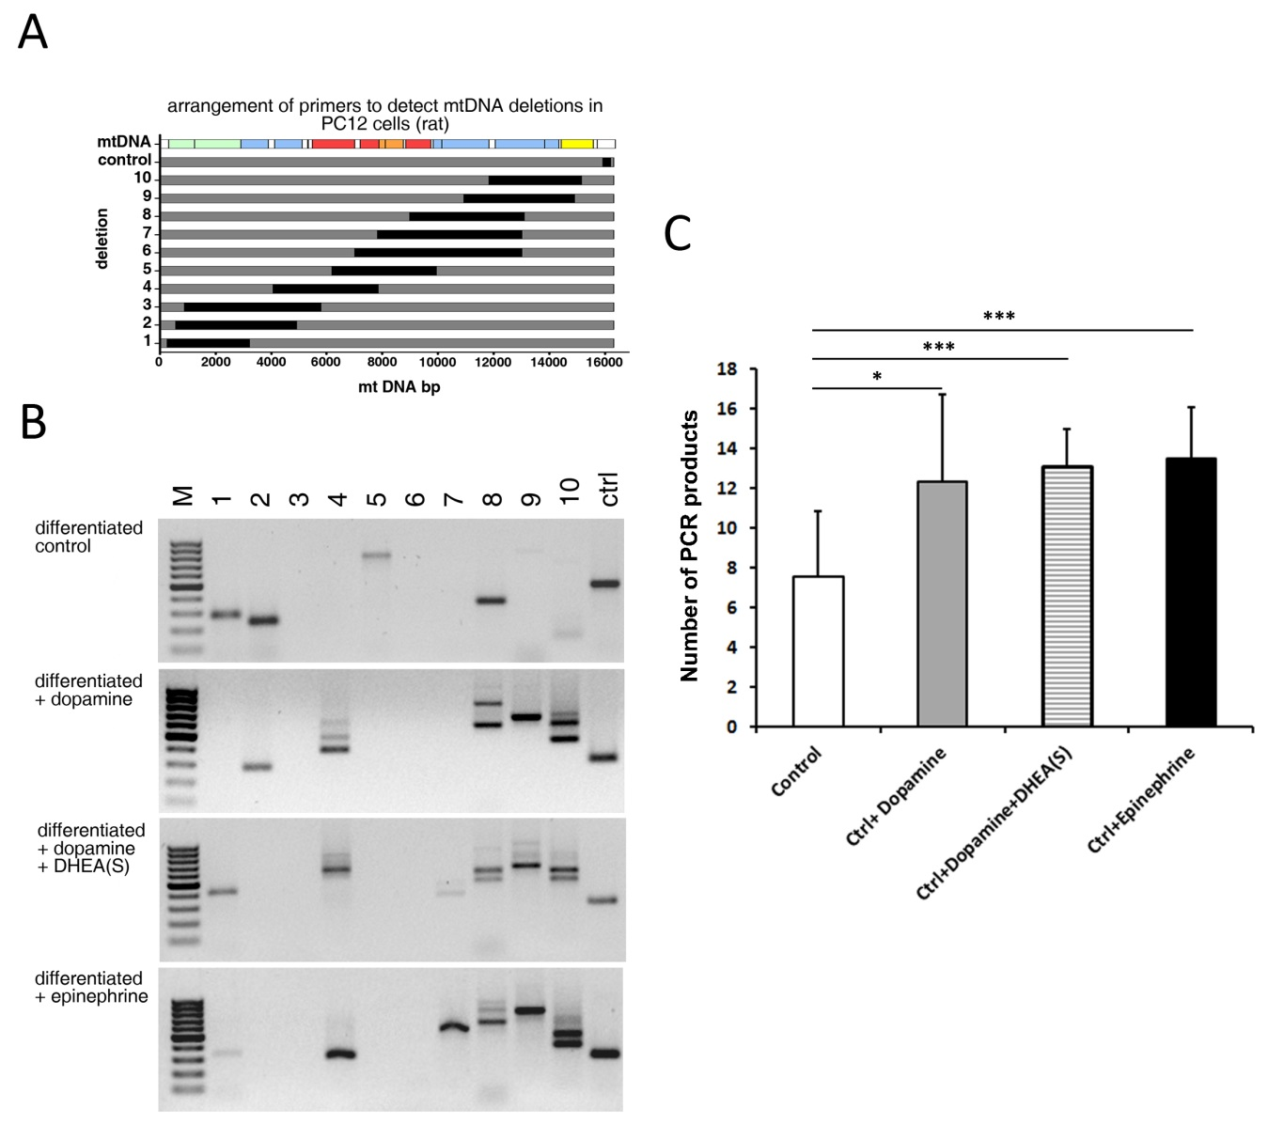
Supplementary Fig. S3. Rat adrenal phaeochromocytoma cells (PC12) also accumulate more mtDNA deletions upon catecholamine treatment. (A) Arrangement of mtDNA deletions detected with nested PCR assay. mtDNA displays an mtDNA molecule; rRNAs, and protein encoding genes are indicated. Black bars show each deletion region and the D-Loop fragment (control) amplified with the corresponding primers. Number 1-10 depict the ten potential deletion spots analysed. rRNA: ribosomal RNA; ND: NADH dehydrogenase; COX: cytochrome c oxidase, ATPase: ATP synthase; CYTB: cytochrome b. (B) Agarose gels of nested PCR products from catecholamine-exposed PC12 cells, showing increased accumulation of mtDNA deletions upon seven days treatment. Every single band represents a specific deletion species. Numbers indicate primer pairs, distributed over the whole mtDNA molecule. The control product (ctrl) is derived from the D Loop region necessary for mtDNA replication. (C) Distinct PCR products were counted, thus allowing comparison between drug-treated cells and controls (n=9 except for PC12 + epinephrine n=6, * = p < 0.05, *** = p < 0.001). Ctrl: control
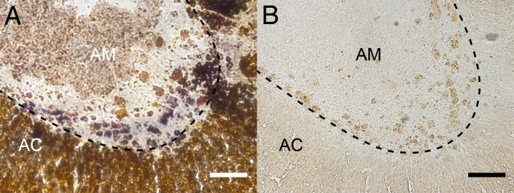
Supplementary Fig. S4. COX-deficient cells and lipofuscin positive deposits in consecutive slides of aged mouse adrenal (130 weeks). (A) Cytochrome c oxidase/succinate dehydrogenase activity staining (COX/SDH) stains for mitochondrial function; blue cells (COX⁻) indicate respiratory dysfunction. (B) Sudan black B staining reveals lipid and lipofuscin deposits. The dashed line indicates the border between adrenal medulla (AM) and cortex (AC), scale bars: 100 µm.

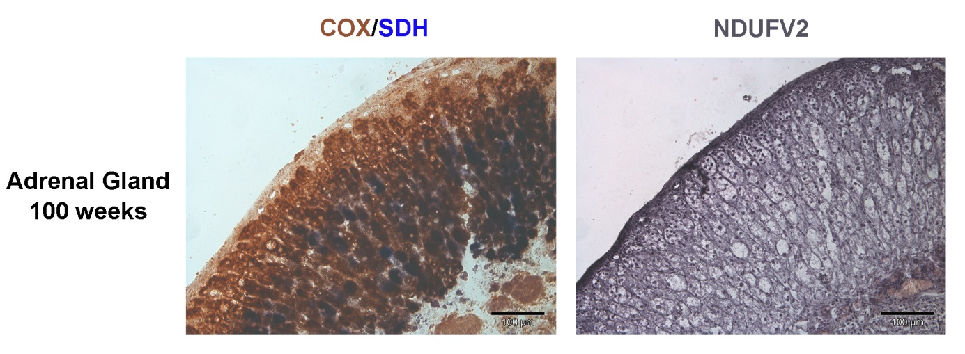
Supplementary Fig. S5. COX-SDH and NDUFV2 staining in consecutive sections of aged mouse adrenal (100 weeks). An antibody against NDUFV2 was used to stain complex I of the mitochondrial respiratory chain in consecutive sections of 100 week-old mouse adrenals after COX-SDH staining (left panel). At this age, cells lacking NDUFV2 could be observed. Scale bars: 100 µm.
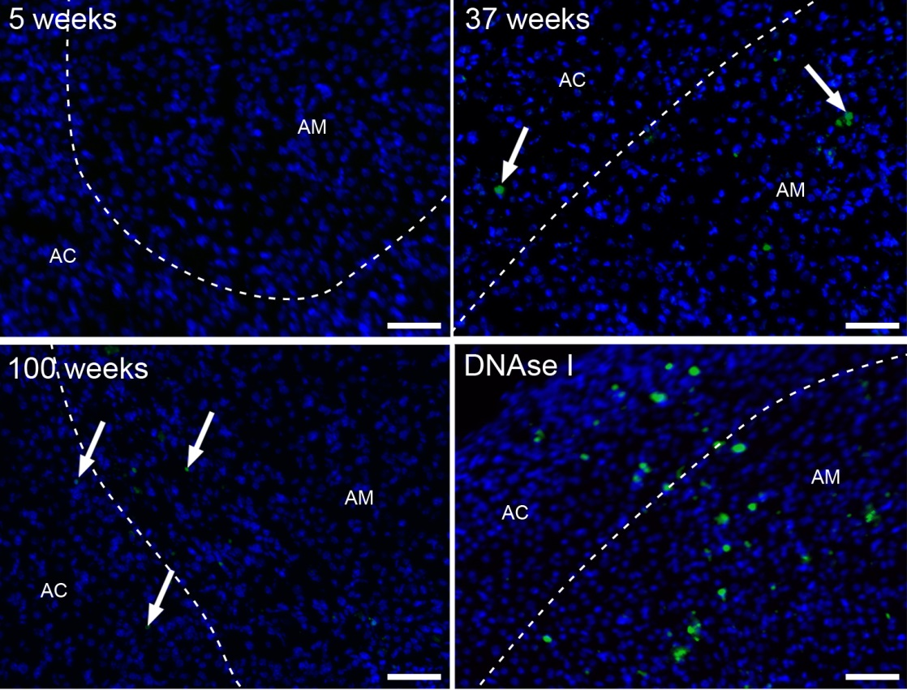
Supplementary Fig S6. TUNEL staining of mouse adrenals shows increasing numbers of apoptotic cells with increasing age. As a positive control, slices were also treated with DNAse I to increase number of TUNEL positive nuclei (lower, right). The dashed line indicates the border between adrenal medulla (AM) and cortex (AC), arrows depict nuclei stained by TUNEL (green) and DAPI (blue), scale bars: 50 µm.

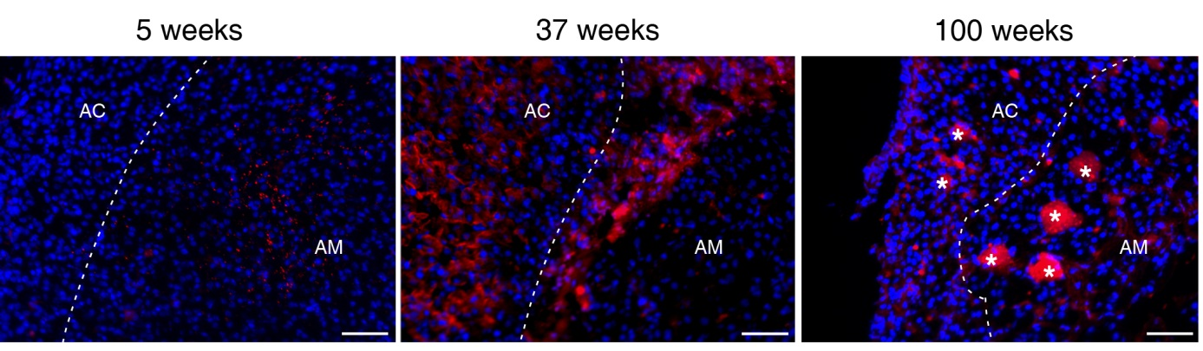
Supplementary Fig S7. F4/80 (red) staining of mouse adrenals shows an increase of macrophages in the aging adrenal (blue: DAPI). The dashed line indicates the border between adrenal medulla (AM) and cortex (AC), asterisks denote auto fluorescent lipid deposits, scale bars: 50 µm.

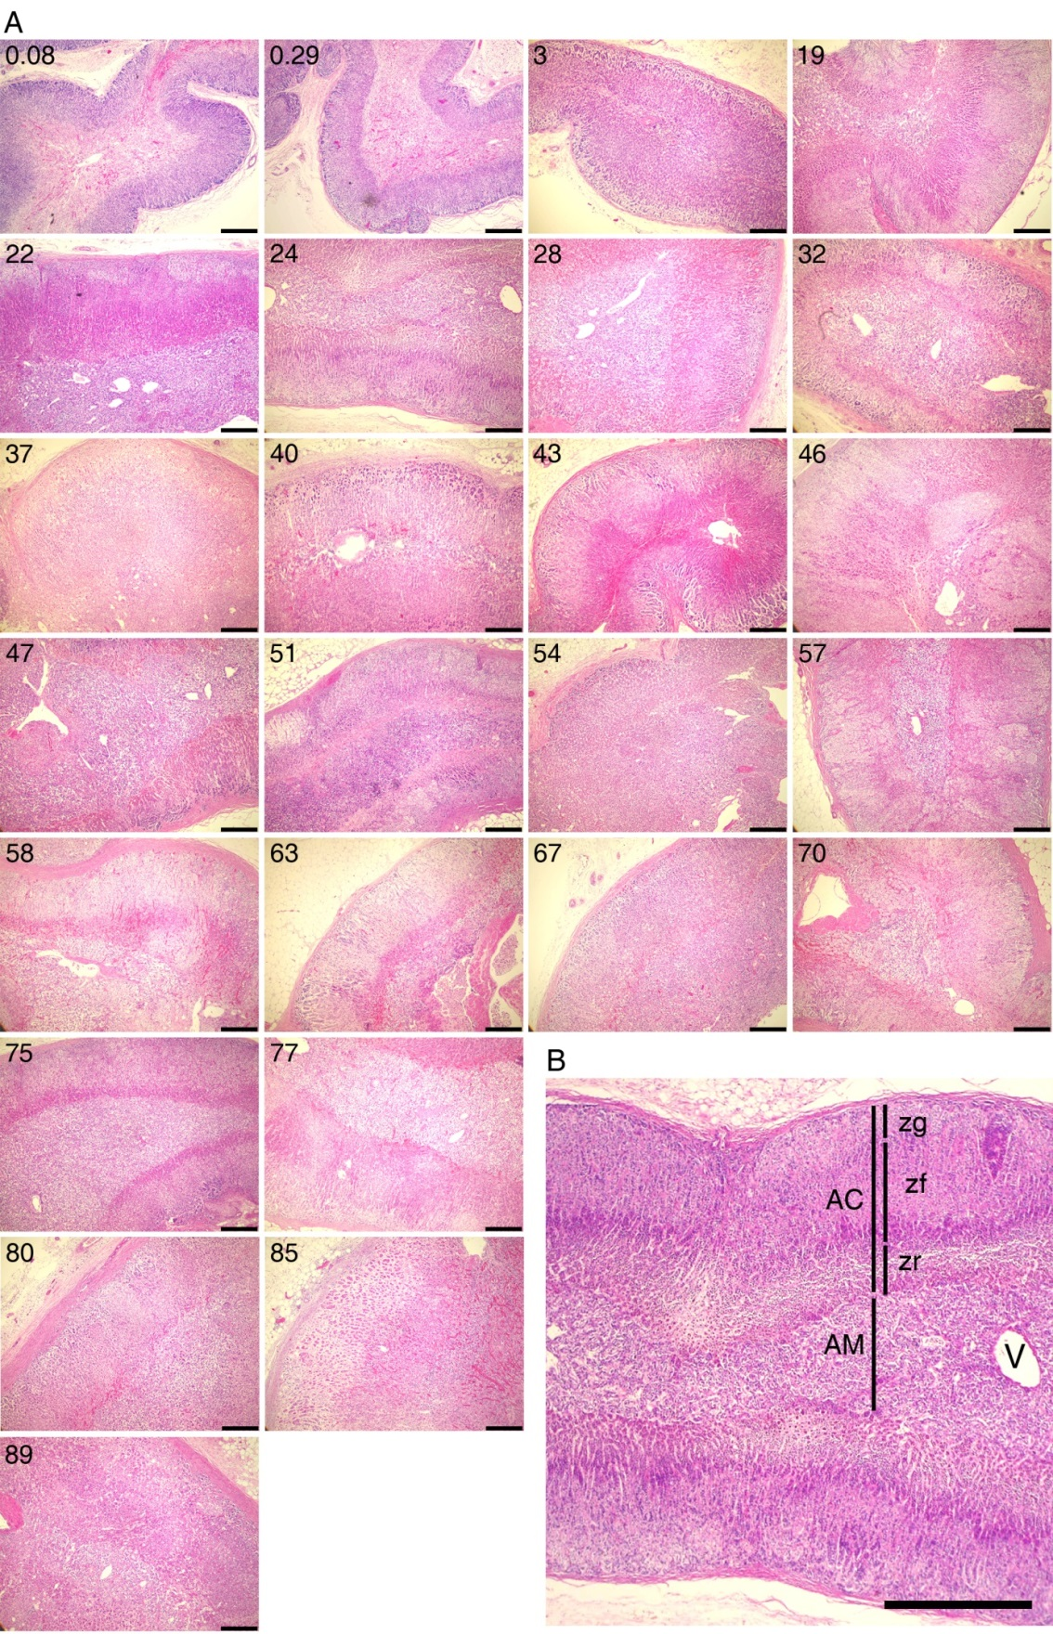
Supplementary Fig. S8. Analyzed human adrenal glands. (A) HE overview of human adrenals assessed in this study. Numbers indicate the age of the individuals, scale bars: 2,5 mm. (B) exemplified adrenal gland structure. AC: adrenal cortex; AM: adrenal medulla; zf: zona fasciculata; zg: zona glomerulosa; zr: zona reticularis; V: blood vessel, scale bar: 500 µm

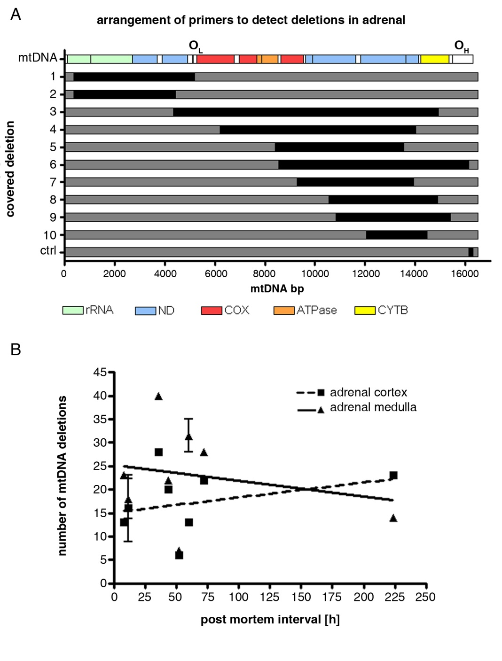
Supplementary Fig S9. Localization of mtDNA deletions detected with the nested PCR assay. (A) mtDNA displays a human mtDNA molecule; rRNAs and protein encoding genes are specified in colours. Black bars show each deletion region and the non-deleted D-Loop fragment (ctrl) amplified with the corresponding primers. (B) No correlation between post mortem interval and increase of number of mtDNA deletion species. Linear regression analysis: adrenal cortex: r2 = 0.08710; slope ≠0: p = 0.4078; adrenal medulla: r2 = 0.04622; slope ≠0: p = 0.5509
Supplementary Table S1 Sequence of primers used for nested PCR mtDNA deletion screening.
Human
nested mtDNA deletion screen (outer primers)
hdel1for | AAC AAA GAA CCC TAA CAC CAG
hdel1rev | AGT CAT GTT AGC TTG TTT CAG G
hdel2for | CCC ACT CCC ATA CTA CTA ATC TC
hdel2rev | AGA TGG TAG AGT AGA TGA CGG
hdel3for | FAC CCA TCC CTG AGA ATC C
hdel3rev | CTG GTG AGT AGT GCA TGG
hdel4for | ACA TAA GCT TCT GAC TCT TAC C
hdel4rev | TTC TAG TCA GGT TAG GTC TAG G
hdel5for | TTA CAC TAT TCC TCA TCA CCC A
hdel5rev | GTA TGAT ATG TTT GCG GTT TCG
hdel6for | TCG CTT CAT TCA TTG CCC
hdel6rev | CGT ACA ATA TTC ATG GTG GCT
hdel7for | CAG CCC TCC TAA TGA CCT
hdel7rev | ATG CTA GGG TAG AAT CCG A
hdel8for | CCC TAC TAT GCC TAG AAG GA
hdel8rev | AAT AGT CCT GTG GTG ATT TGG
hdel9for | CCC ACA GCC TAA TTA TTA GCA
hdel9rev | TGT AGT AAG GGT GGA AGG TG
hdel10for | AAA CCC TCA TTC ACA CGA G
hdel10rev | TGT CTT TGG ATA TAC TAC AGC G
hdelctrlfor | GAG CAC CCT ATG TCG CAG TA
hdelctrlrev | CGG TGT GTG TGT GCT GGG TA
nested mtDNA deletion screen (inner primers)
INhdel1for | TTT ATC TTT AGG CGG TAT GCA C
INhdel1rev | GCT TGT TTC AGG TGC GAG
INhdel2for | CCA TCC TAC CCA GCA CAC
INhdel2rev | GGG ATT AAT TAG TAC GGG AAG G
INhdel3for | AAA TTC TCC GTG CCA CCT
INhdel3rev | AGT CCT GTG GTG ATT TGG
INhdel4for | GCT CGC ATC TGC TAT AGT G
INhdel4rev | AGG TCT AGG AGG AGT AGG G
INhdel5for | AAC ACA AAC TAC CAC CTA CC
INhdel5rev | CGA TGA TGT GGT CTT TGG AG
INhdel6for | CCT CCA AAT ATC TCA TCA ACA ACC
INhdel6rev | CAG TAA TGT ACG AAA TAC ATA GCG G
INhdel7for | CTA GCC ATG TGA TTT CAC TTC CA
INhdel7rev | AGT TTG TTG GTT AGG TAG TTG AGG
INhdel8for | CTA CTC TCA TAA CCC TCA ACA CC
INhdel8rev | GTGG TGA TTT GGA GGA TCA GG
INhdel9for | CAA CAA CCT ATT TAG CTG TTC C
INhdel9rev | TTT ATC GGA ATG GGA GGT G
INhdel10for | CTC ATG TTC ATA CAC CTA TCC C
INhdel10rev | GCG ATG GCT ATT GAG GAG
Rat
nested mtDNA deletion screen (outer primers)
rat1for | GAC TAA GCT AGT ACC TCT CAG GG
rat1rev | AAG TAT TTG TAG GGA GAA GGA GC
rat2for | ATA ATG CAC GAT AGC TAA GAC CC
rat2rev | GCT TTG AAG GCT CTT GAA CTG
rat3for | GCC TAA TCA CGA CAC TTA GCA
rat3rev | GGT CAC AAC AAT TGG TAG ACC T
rat4for | CAA TGA AGC GGA AAG AAA TGG G
rat4rev | AGG TGT CTG ATA TTG GGT TAT AGC
rat5for | ACC TAT TCT GAT TCT TCG GCC A
rat5rev | TCT AGG CAG AGG AGA GTG GA
rat6for | AAT AAG AAA GGA AGG AAT CGA CCC
rat6rev | CAT GGT GAC GAA GTA GAT GAT CC
rat7for | TAC AAT CAT CTC CTC AAT AGC CAC
rat7rev | CAT GGT GAC GAA GTA GAT GAT CC
rat8for | TCT CCG AAG TAT TCT TCT TTG CC
rat8rev | TGA GAA TGA TGA TAG TTT GGT GGG
rat9for | ACG GAG TCC ATC TAT GAT TAC CA
rat9rev | TAA AGG ATT TGG GTG ATT GGG C
rat10for | GCT AAT TCA TGC ACC CAT ACC T
rat10rev | ACT GAT GGA GGC TAG TTG ACC
ratctrlfor | CCT TCC TCA ACA TAG CCG TC
ratctrlrev | GTG GTC TAC TAG AAT GGA GAA GC
nested mtDNA deletion screen (inner primers)
INrat1for | GGT TGG TAA ATT TCG TGC CAG
INrat1rev | TGA CTT CGT AAG AGA TGG TTT GG
INrat2for | AAA CTC AAA GGA CTT GGC GG
INrat2rev | GTG ATT AGT TGG GAG GAA AGC G
INrat3for | TTT CTA ACC CAA GCT ACA GCC
INrat3rev | GAG GTG CAG GAA AGG TTT GG
INrat4for | TGA ATA GAG CAA TGA AGT ACG CAC
INrat4rev | TAG CTC CTA AGA TAG AAG ACA CCC
INrat5for | AGC ACA TCA CAT ATT CAC AGT AGG
INrat5rev | GCA GAG GAG AGT GGA TAT TAG GT
INrat6for | GCT TAC AAG ACG CTA CAT CAC C
INrat6rev | CGA AGT AGA TGA TCC GTA TGC TG
INrat7for | TTC TTC CCA AAC CTT TCC TGC
INrat7rev | CGA AGT AGA TGA TCC GTA TGC TG
INrat8for | TAC ATC AGT CCT CTT AGC ATC AGG
INrat8rev | CTA ATG CTA GGC GTT TGA TTG G
INrat9for | TAG CCT ACC CAT TCA TCA TCC TC
INrat9rev | TTA GCG GGT GTA TAA TTG TCT GG
INrat10for | AAA TTC TCA TTC CTC CTT AGC CTC
INrat10rev | ATA AAT GGG TGT TCT ACT GGT TGG

Supplementary Table S2 Age, gender and post mortem interval of human individuals, which were included in this study.
individual | age [years] | gender | post mortem interval [h]
1 | 0.08 | f | ca. 12
2 | 0.29 | f | ca. 26
3 | 3 | f | >48
4 | 19 | f | <8
5 | 22 | f | >48
6 | 24 | m | ca. 24
7 | 28 | m | ca. 68
8 | 32 | f | ca. 43
9 | 37 | f | 224,5
10 | 40 | f | ca. 72
11 | 43 | m | <24
12 | 46 | m | 80
13 | 47 | m | ca. 12
14 | 51 | f | ca. 48
15 | 54 | m | ca. 60
16 | 57 | m | ca. 100
17 | 58 | f | ca. 75
18 | 63 | m | ca. 75
19 | 67 | m | >72
20 | 70 | m | ca. 17
21 | 75 | f | ca. 20
22 | 77 | m | ca. 38
23 | 80 | m | ca. 61
24 | 85 | f | >72
25 | 89 | f | >100

