Supplement 1: Supplemental Methods

CSF and serum samples
CSF and serum samples were obtained from the local Neuro-Biobank, which uses established procedures for collection and storage of biomaterial (1). CSF and blood samples of each subject were taken within a time interval of max. 20 minutes and analysed without any previous thaw-freeze cycle. CSF was collected by lumbar puncture between 08:00 am and 10:00 am, centrifuged (4000 g) and stored at -80°C within 60 min after collection.

ELISA measurements
To determine CSF and serum progranulin levels, we used a human progranulin ELISA set according to the manufacturer’s protocol (Adipogen AG, Liestal, Switzerland). We analysed all samples in duplicate and used the provided recombinant human progranulin as standard. CSF samples were diluted 1:10 and serum samples were diluted 1:200 in the dilution buffer provided by the manufacturer. Accordingly, we multiplied the primary measurements by the respective dilution factor. The ELISA had the following characteristics: progranulin detection limit 32 pg/ml, assay range 0.063 – 4 ng/ml, intra-assay coefficient of variation < 6.93 %, inter-assay coefficient of variation < 7.32 % (source: manufacturer, Adipogen AG, Liestal, Switzerland). The ELISA antibody was used and validated elsewhere and does not detect granulins (2-5). We measured CSF levels of t-tau, p-tau and amyloid-β using commercially available ELISA sets according to the manufacturer’s protocol (Innotest: Fujirebio, Ghent, Belgium).

Whole exome analysis
In all 37 FTD patients, GRN was screened as part of whole exome sequencing. The SureSelect Human All Exon version 5 (Agilent Technologies) was used for in-solution enrichment and exome sequencing was performed using the HiSeq2000 instrument (Illumina), producing 100-bp length paired-end reads. BWA and GATK software packages (6-8) were used to align sequence reads to the reference (UCSC hg19) and call variant positions, respectively. Mean coverage of GRN was > 100-fold. The called variants were annotated with ANNOVAR (9). Only variants within exons or at splice-sites were considered. Furthermore, GRN variants were only included if non-synonymous and having a minor allele frequency below 0.1 % in public databases (1000G (10), EVS (11), ExAC (12)). We used the algorithms SIFT (13), PhyloP (14), Polyphen-2 (15), Mutationtaster (16) and LRT (17) to predict the pathogenicity of the variants. GRN mutations were confirmed by Sanger sequencing.

SNP genotyping
The single nucleotide polymorphism (SNP) rs5848 was genotyped in patients via whole exome sequencing (SNP coverage: 32 fold [24-38], median [interquartile range]) and in controls by specific SNP genotyping. For this, genomic DNA was extracted from whole blood with standard procedures and used for PCR (Thermocycler T100 Bio Rad). PCR products were purified and digested with Exonuclease I and Fast Alkaline Phosphatase. The rs5848 genotype was identified by the SNaPshot method (by Applied Biosystems, Life Technologies) with a 3500 XL Genetic Analyser sequencer. The SNP was in Hardy-Weinberg equilibrium for both patients and controls (Pearson Chi-Square-test, both p > .05).

Statistical analyses
We analysed the data with SPSS (IBM, Version 22). Throughout the manuscript, the assumption of normality was considered tenable if Kolmogorov-Smirnov’s test was not significant (i.e. p > .05) and QQ-plots were compatible with normality. If normality was violated, log-transformed data were used for the statistical analysis. These log-transformed data fulfilled the above mentioned criteria of normality. Specifically, normality was assumed for the variables age and CSF progranulin, while the variables serum progranulin, t-tau and p-tau required log-transformation.
Group effects on CSF progranulin, serum progranulin and tau levels, respectively, were tested with separate independent two-sided t-tests. Additionally, group effects on CSF progranulin and serum progranulin were tested by two separate analyses of covariance (ANCOVAs), controlling for subjects’ age and gender as covariates as these factors are recognised to influence progranulin levels (18). We tested for differences in gender and age by using Pearson’s Chi-Square test and another independent two-sided t-test, respectively. We analysed the association CSF progranulin (untransformed data) and t-tau (log-transformed data) by calculating the Pearson correlation coefficient.
Our correction of progranulin levels for subjects’ rs5848 genotype was based on the published multiplicative association of SNP rs5848 with both CSF and serum levels in healthy seniors (18). Specifically, Nicholson and colleagues described a multiplicative change of progranulin levels for each additional minor allele by factor 0.92 in CSF and by factor 0.95 in serum. Accordingly, we divided subjects’ progranulin levels by the respective factor for each minor allele to take into consideration subjects’ variable number of minor alleles.

Supplement 2: Pedigree of FTD patient #21895

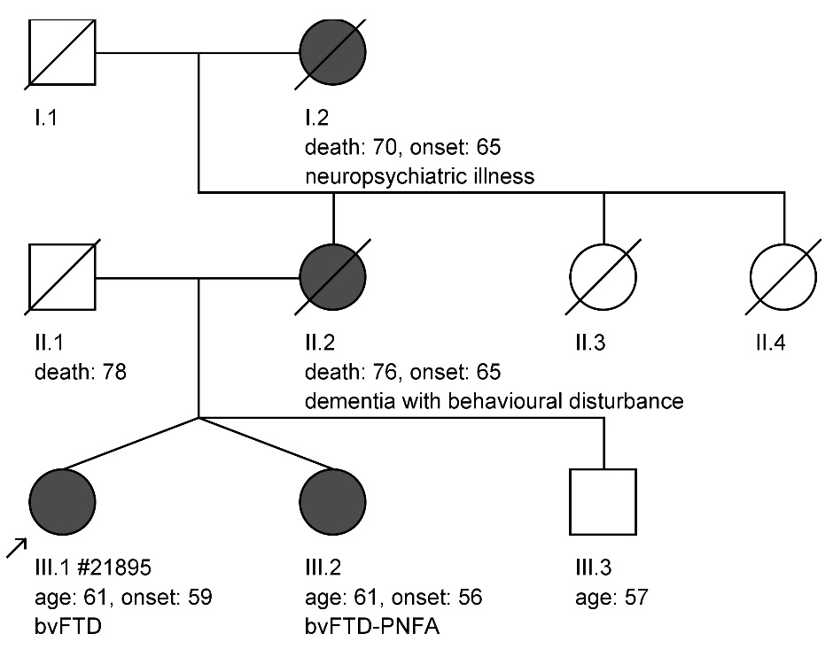

Genetic screening by whole exome sequencing revealed one FTD patient (#21895) carrying a novel missense mutation (c.1117C>T, p.P373S; NM_002087), which the prediction algorithms Mutationtaster (16) and Polyphen-2 (15) both classified as pathogenic. This mutation segregated with disease in the dizygotic twin sister, who likewise suffered from behavioural-variant FTD (bvFTD), combined with progressive non-fluent aphasia (PNFA), indicating that this variant is indeed recurrently associated with FTD. The family history with neuropsychiatric disease/dementia in 3 generations suggested autosomal-dominant FTD.

Supplement 3: CSF progranulin levels in familial versus sporadic FTD patients

Within our final cohort of 34 FTD patients, family history regarding dementia was positive in 20.6 %, negative in 73.5 % and inconclusive in the remaining 5.9 %. CSF progranulin levels did not differ significantly between familial cases (4.41 ng/ml [3.89-4.58], median [interquartile range]) and sporadic cases (3.94 ng/ml [3.26-5.13]) (two-sided Mann-Whitney test, U = -0.21, p = .859). Like in the entire FTD cohort, CSF progranulin levels of sporadic cases (3.94 ng/ml [3.26-5.13]) were significantly lower than those of controls (5.10 ng/ml [4.07-6.60]) (two-sided Mann-Whitney test, U = -2.35, p = .018).

Supplement 4: Influence of SNP rs5848 on progranulin levels

The single nucleotide polymorphism (SNP) rs5848 is a common, well-established regulatory GRN variant in the 3' UTR region, located in a microRNA binding site which has been reported to correlate with progranulin expression in both CSF and serum (18). We compared its allele frequency between groups and retested for differences of group progranulin levels after correcting subjects’ progranulin levels for their rs5848 genotype. The frequency of the minor allele did not differ significantly between patients and controls (χ² (2) = 1.99, p = .423), suggesting that rs5848 unlikely explained the selective reduction of CSF progranulin in patients. Indeed, upon correction of progranulin levels for subjects’ rs5848 genotype, we found that patients’ CSF progranulin levels were still significantly reduced (t (70) = 2.17, p = .033, r = -0.25), while their serum progranulin levels again did not differ significantly from those of controls (t (70) = -1.33, p = .188, r = 0.16), which suggests that rs5848 status does not explain patients’ selective decrease of central nervous progranulin levels.

Supplement 5: Supplemental References

1. Maetzler W, Schmid SP, Wurster I, Liepelt I, Gaenslen A, Gasser T, et al. Reduced but not oxidized cerebrospinal fluid glutathione levels are lowered in Lewy body diseases. Mov Disord. 2011;26(1):176-81.
2. Finch N, Baker M, Crook R, Swanson K, Kuntz K, Surtees R, et al. Plasma progranulin levels predict progranulin mutation status in frontotemporal dementia patients and asymptomatic family members. Brain. 2009;132(Pt 3):583-91.
3. Ghidoni R, Benussi L, Glionna M, Franzoni M, Binetti G. Low plasma progranulin levels predict progranulin mutations in frontotemporal lobar degeneration. Neurology. 2008;71(16):1235-9.
4. Youn BS, Bang SI, Kloting N, Park JW, Lee N, Oh JE, et al. Serum Progranulin Concentrations May Be Associated With Macrophage Infiltration Into Omental Adipose Tissue. Diabetes. 2009;58(3):627-36.
5. Wilke C, Gillardon F, Deuschle C, Hobert M, Hagen JMv, Krüger S, et al. Serum levels of progranulin do not reflect cerebrospinal fluid levels in neurodegenerative disease. Current Alzheimer Research. in press.
6. DePristo MA, Banks E, Poplin R, Garimella KV, Maguire JR, Hartl C, et al. A framework for variation discovery and genotyping using next-generation DNA sequencing data. Nat Genet. 2011;43(5):491-8.
7. Li H, Durbin R. Fast and accurate short read alignment with Burrows-Wheeler transform. Bioinformatics. 2009;25(14):1754-60.
8. McKenna A, Hanna M, Banks E, Sivachenko A, Cibulskis K, Kernytsky A, et al. The Genome Analysis Toolkit: a MapReduce framework for analyzing next-generation DNA sequencing data. Genome Res. 2010;20(9):1297-303.
9. Wang K, Li M, Hakonarson H. ANNOVAR: functional annotation of genetic variants from high-throughput sequencing data. Nucleic Acids Res. 2010;38(16):e164.
10. Genomes Project C, Abecasis GR, Auton A, Brooks LD, DePristo MA, Durbin RM, et al. An integrated map of genetic variation from 1,092 human genomes. Nature. 2012;491(7422):56-65.
11. EVS. Exome Variant Server. http://evsgswashingtonedu/EVS. 2015.
12. ExAC. Exome Aggregation Consortium. http://exacbroadinstituteorg. 2015.
13. Kumar P, Henikoff S, Ng PC. Predicting the effects of coding non-synonymous variants on protein function using the SIFT algorithm. Nature protocols. 2009;4(7):1073-81.
14. Pollard KS, Hubisz MJ, Rosenbloom KR, Siepel A. Detection of nonneutral substitution rates on mammalian phylogenies. Genome Res. 2010;20(1):110-21.
15. Adzhubei IA, Schmidt S, Peshkin L, Ramensky VE, Gerasimova A, Bork P, et al. A method and server for predicting damaging missense mutations. Nature methods. 2010;7(4):248-9.
16. Schwarz JM, Rodelsperger C, Schuelke M, Seelow D. MutationTaster evaluates disease-causing potential of sequence alterations. Nature methods. 2010;7(8):575-6.
17. Chun S, Fay JC. Identification of deleterious mutations within three human genomes. Genome Res. 2009;19(9):1553-61.
18. Nicholson AM, Finch NA, Thomas CS, Wojtas A, Rutherford NJ, Mielke MM, et al. Progranulin protein levels are differently regulated in plasma and CSF. Neurology. 2014;82(21):1871-8.

