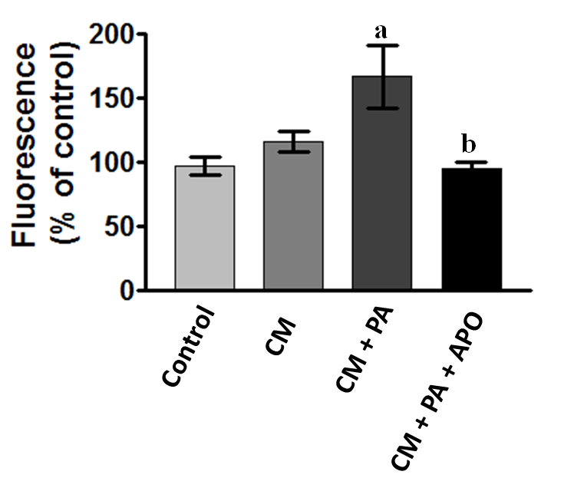

Fig. S3. Quantification of superoxide production in rat aortic segments. Aortic segments treated in CM supplemented with 100 µM palmitic acid in absence or presence of 500 µM apocynin were frozen in OCT. Twelve micron sections were incubated with 5 µM DHE and visualized by fluorescence microscopy. Superoxide production was evaluated by measuring the level of red fluorescence with Image J software. ªStatistically different (P < 0.05) from control. ^{b}Statistically different (P < 0.05) from CM + PA.

