Table S1. Candidates of polymorphism associated with angiogenic pathway
Gene | SNPs | Reference ID | Primer sequences
VEGFA | -2578 A/C | rs699947 | F pyro biotin-GATGGGGCTGACTAGGTA  R pyro AGTGGGACCAGTCAGTCT  S pyro CTGATTATCCACCCAGA
 | -1498 (-460) C/T | rs833061 | F pyro GTGTGGGTGAGTGAGTGT  R pyro biotin-GAGAGGGACACACAGATCTA  S pyro TGCGTGTGGGGTTGA
 | -1154 A/G | rs1570360 | F pyro CGTGTCTCTGGACAGAGTT  R pyro biotin-GCTACCAGCCGACTTTTA  S pyro CGAGCCGCGTGTGGA
 | -634 (+405) C/G | rs2010963 | F pyro TAGCAAGAGCTCCAGAGAG  R pyro biotin-CAAAAGCAGGTCACTCAC  S pyro TGCGAGCAGCGAAAG
 | +936 C/T | rs3025039 | F pyro CGACAGAACAGTCCTTAATC  R pyro biotin-GTGGGTGTGTCTACAGGA  S pyro GGGCGGGTGACCCAG
FLT1 | 27777839* A/G | rs9513070 | F pyro GCCTACTTGATGATGTATTGT  R pyro biotin-GAAATACACGGACACTGAC  S pyro ACTTGTGGCCCACGG
 | 27779335* G/T | rs9554316 | F pyro GGCCATCATAGACACAAA  R pyro biotin-TCTAATTGCTGGAGACCA  S pyro ATCATTCGATTTTTTTTCT
 | 27784927* A/C | rs9554320 | F pyro AAGGTTCCTGTGTGTAGC  R pyro biotin-AATCCCAGGACAAGATTT  S pyro TGTAGCTGATCATTCTCC
 | 319 A/C | rs9582036 | F pyro ACCTCAGTCTCCCAAAGT  R pyro biotin-GGCTTAAGGCATAATAGCA  S pyro CAGCAACAATAGCCTTCT
KDR | IVS25-92 A/G | rs1531289 | F pyro GCAACCAGTTAGTTTTTATTA  R pyro biotin-TTCATTAAATGCCTCTTTC  S pyro TTAGCATCTCACCTCGT
 | +889 C/T | rs2305948 | F pyro biotin-ATGGACCCTGACAAATGT  R pyro GGGAGTGAGATGAAGAAATT  S pyro AGCACCTTAACTATAGATGG
 | +1416 A/T | rs1870377 | F pyro biotin-CATTCTTCACAAGGGTATG  R pyro GCGTTGGAAGTTATTTCTA  S pyro CTGTTATCTCTTTCTTATAG
IL8 | -251 A/T | rs4073 | F pyro TCTGTCACATGGTACTATGATA  R pyro biotin-TCCACAATTTGGTGAATTA  S pyro CTAGAAATAAAAAAGCATAC
IL10 | -1082 A/G | rs1800896 | F pyro GGCTCTCCTTACTTTCTACA  R pyro biotin-CTCTTACCTATCCCTACTTCC  S pyro AAGGCTTCTTTGGGA
CXCR2 | +785 C/T | rs2230054 | F pyro CAGTCCTTTGGCTTCATC  R pyro biotin-AGCAGGACCAGGTTGTAG  S pyro TCGTCCTCATCTTCCT
COL18A1 | +4349 G/A | rs1248337 | F pyro GTTTCTCTTCCAGGACGA  R pyro biotin-TCTCAGAGCTGCTCACAC  S pyro CACGCATCTTCTCCTT

Table S2. The distributions of single nucleotide polymorphism
SNPs | Genotype | N (%) | MAF | HWE
VEGFA rs699947 |  |  | 0.460 | < 0.001
 | C/C | 57 (45.6)
 | C/A | 1 (0.8)
 | A/A | 67 (53.6)
VEGFA rs833061 |  |  | 0.327 | 0.567
 | C/C | 15 (12.0)
 | C/T | 51 (40.8)
 | T/T | 58 (46.2)
VEGFA rs1570360 |  |  | 0.301 | 0.521
 | A/A | 62 (49.6)
 | A/G | 48 (38.4)
 | G/G | 13 (10.4)
VEGFA rs2010963 |  |  | 0.396 | 0.992
 | C/C | 20 (16.0)
 | C/G | 59 (47.2)
 | G/G | 46 (36.8)
VEGFA rs3025039 |  |  | 0.262 | 0.183
 | C/C | 63 (50.4)
 | C/T | 54 (43.2)
 | T/T | 5 (4.0)
FLT1 rs9513070 |  |  | 0.203 | 0.805
 | A/A | 77 (61.6)
 | A/G | 42 (33.6)
 | G/G | 4 (3.2)
FLT1 rs9554316 |  |  | 0.004 | 1.000
 | G/G | 124 (99.2)
 | G/T | 1 (0.8)
 | T/T | -
FLT1 rs9554320 |  |  | 0.232 | 0.650
 | A/A | 8 (6.4)
 | A/C | 42 (33.6)
 | C/C | 75 (60.0)
FLT1 rs9582036 |  |  | 0.209 | 0.337
 | A/A | 74 (59.2)
 | A/C | 45 (36.0)
 | C/C | 3 (2.4)
KDR rs1531289 |  |  | 0.172 | 0.559
 | A/A | 5 (4.0)
 | A/G | 33 (26.4)
 | G/G | 87 (69.6)
KDR rs2305948 |  |  | 0.116 | 0.984
 | C/C | 97 (77.6)
 | C/T | 27 (21.6)
 | T/T | 1 (0.8)
KDR rs1870377 |  |  | 0.424 | 0.672
 | A/A | 43 (34.4)
 | A/T | 58 (46.4)
 | T/T | 24 (19.2)
IL8 rs4073 |  |  | 0.363 | 0.202
 | A/A | 20 (16.0)
 | A/T | 50 (40.0)
 | T/T | 54 (43.2)
IL10 rs1800896 |  |  | 0.085 | 0.794
 | A/A | 103 (82.4)
 | A/G | 21 (16.8)
 | G/G | -
CXCR2 rs2230054 |  |  | 0.459 | < 0.001
 | C/C | 10 (8.0)
 | C/T | 112 (89.6)
 | T/T | -
COL18A1 rs12483377 |  |  | 0.004 | 1.000
 | G/G | 124 (99.2)
 | G/A | 1 (0.8)
 | A/A | -

Figure S1. Linkage disequilibrium plot
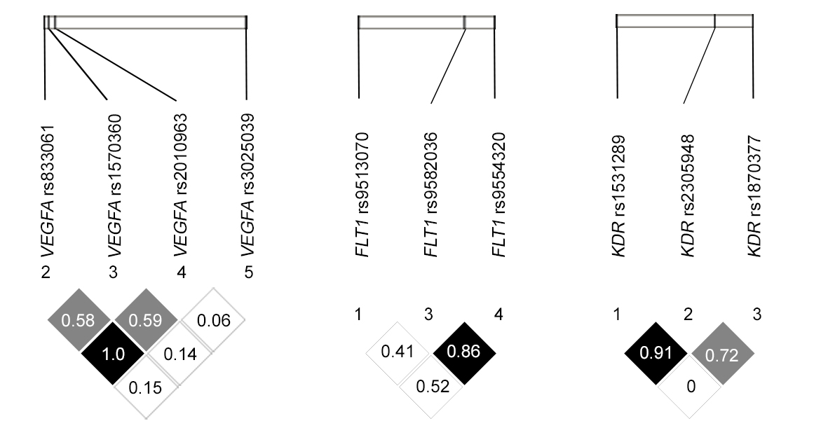
VEGFA |  |  | FLT1 |  |  | KDR
D’ | r² |  | D’ | r² |  | D’ | r²
0.58 | 0.31 |  | 0.41 | 0.012 |  | 0.91 | 0.128
0.59 | 0.099 |  | 0.86 | 0.650 |  | 0.72 | 0.094
0.06 | 0.001 |  | 0.52 | 0.022 |  | 0 | 0
1.0 | 0.322
0.14 | 0.003
0.15 | 0.019

