Supplementary Material
Supplementary Table S1. Primer sequences used in quantitative real-time PCR.
Gene Name | GenBank Accession | Amplicon Size | Sequence (5' -> 3')
IL4 | NM_021283 | 102 | FWRV | GGTCTCAACCCCCAGCTAGT  GCCGATGATCTCTCTCAAGTGT
IL6 | NM_031168 | 76 | FWRV | TAGTCCTTCCTACCCCAATTTCC TTGGTCCTTAGCCACTCCTTC
IL10 | NM_010548 | 105 | FW RV | GCTCTTACTGACTGGCATGAG CGCAGCTCTAGGAGCATGTG
IL13 | NM_008355 | 116 | FWRV | CCTGGCTCTTGCTTGCCTT GGTCTTGTGTGATGTTGCTCA
IL18 | NM_008360 | 169 | FW RV | GACTCTTGCGTCAACTTCAAGG CAGGCTGTCTTTTGTCAACGA
IFN_{ϒ} | NM_008337 | 157 | FW RV | TAGCCAAGACTGTGATTGCGG AGACATCTCCTCCCATCAGCAG
mMCP-1 | NM_008570 | 237 | FWRV | AAACAGTCATAAATGGCAAG GGGAACAAACCATCATCAC
HPRT1 | NM_013556 | 124 | FWRV | TGGATACAGGCCAGACTTTGTT CAGATTCAACTTGCGCTCATC

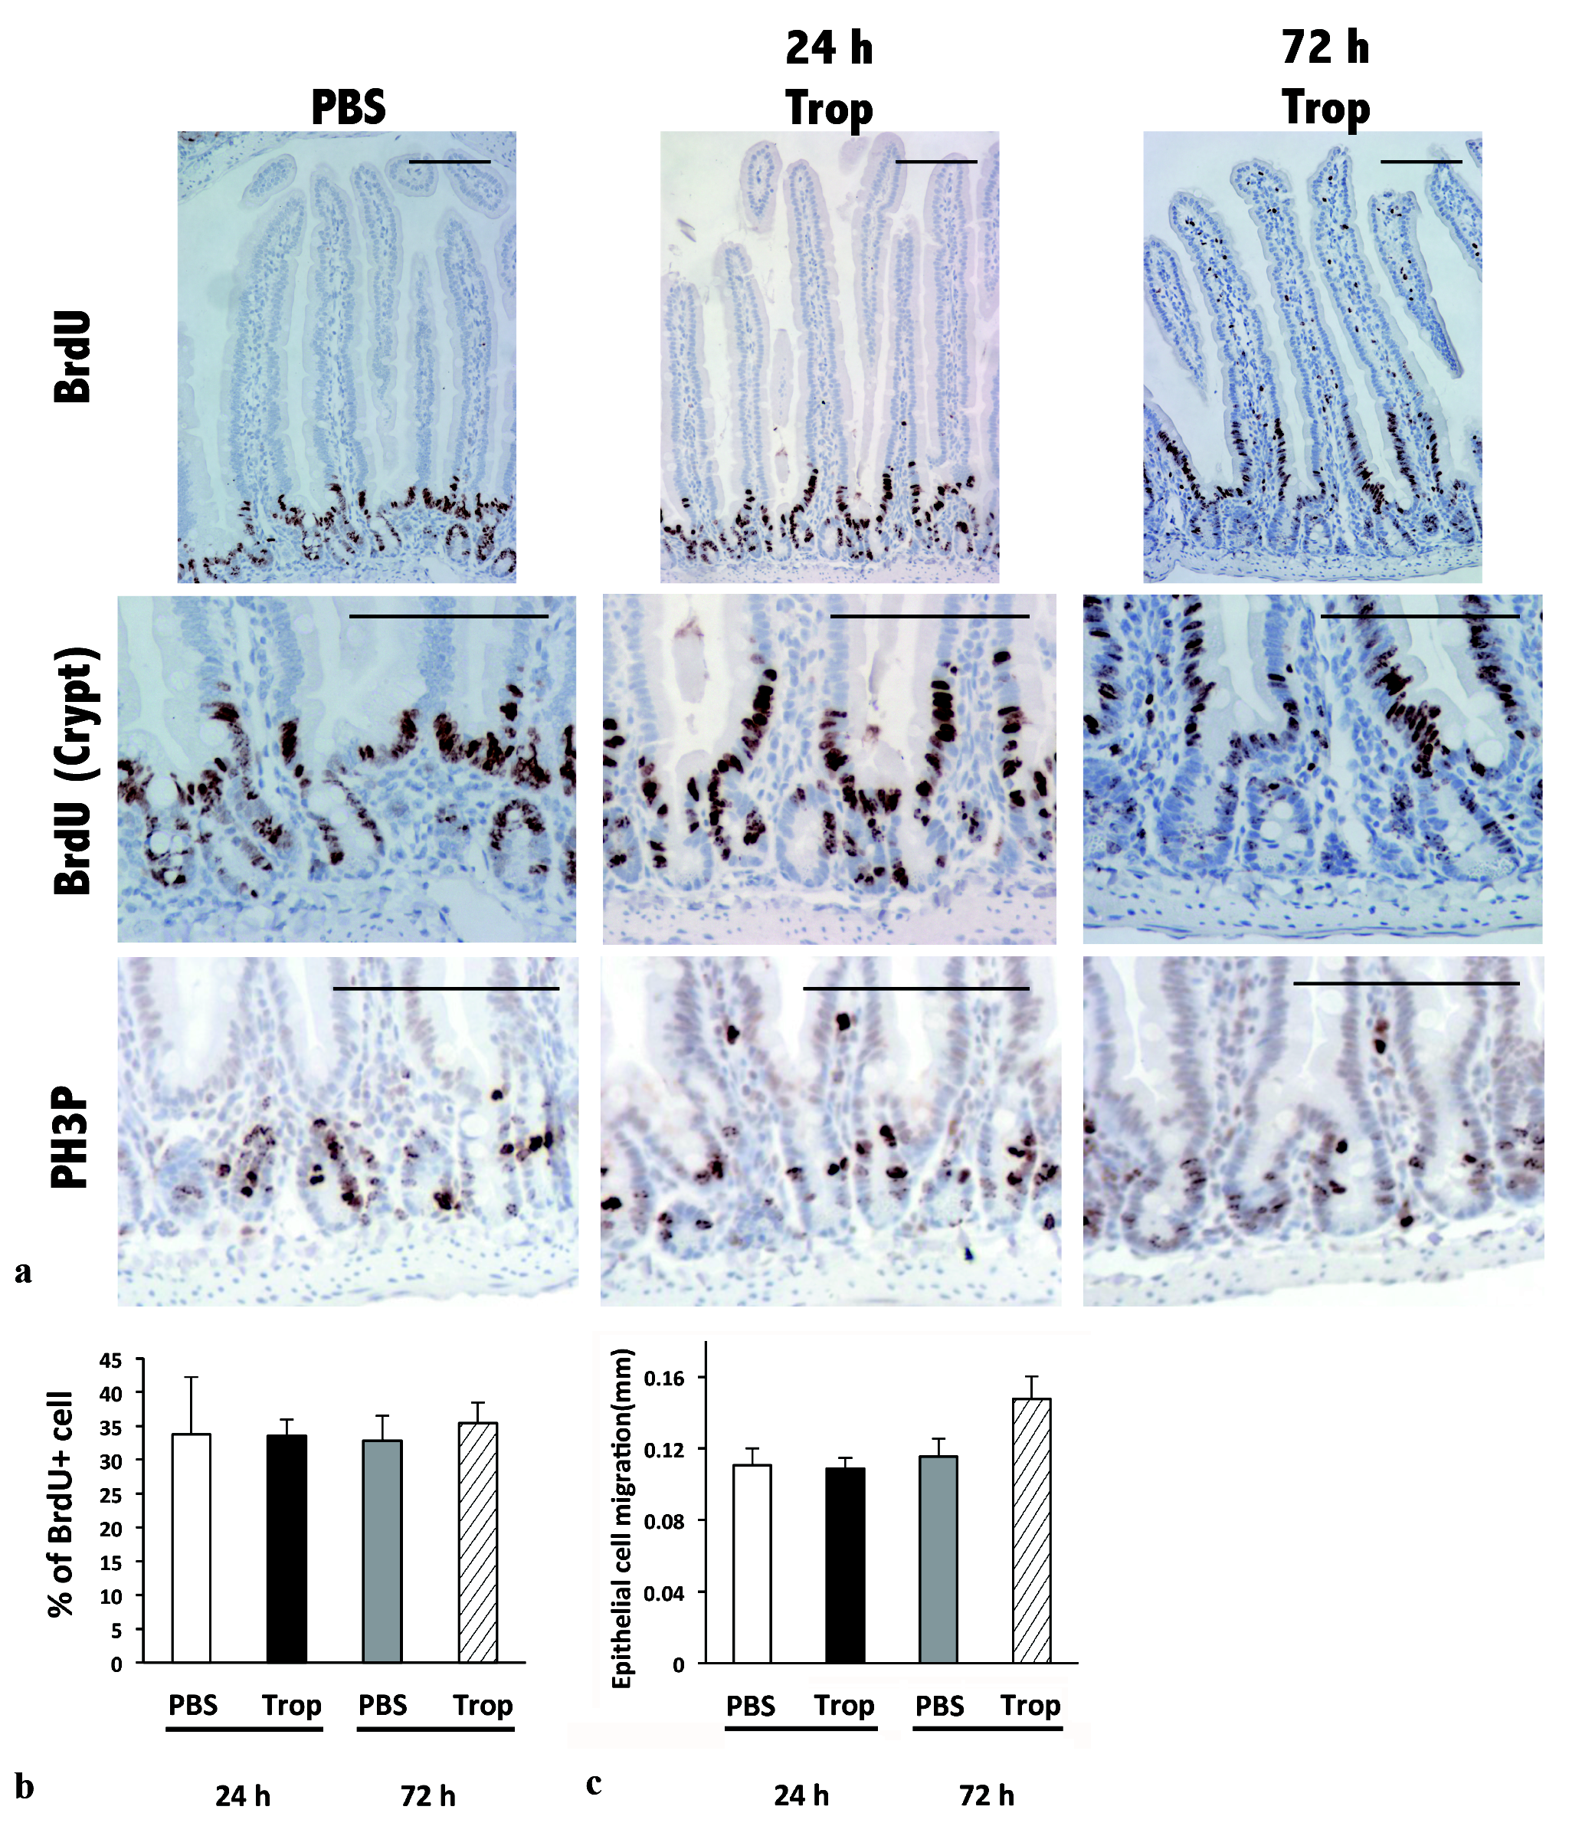
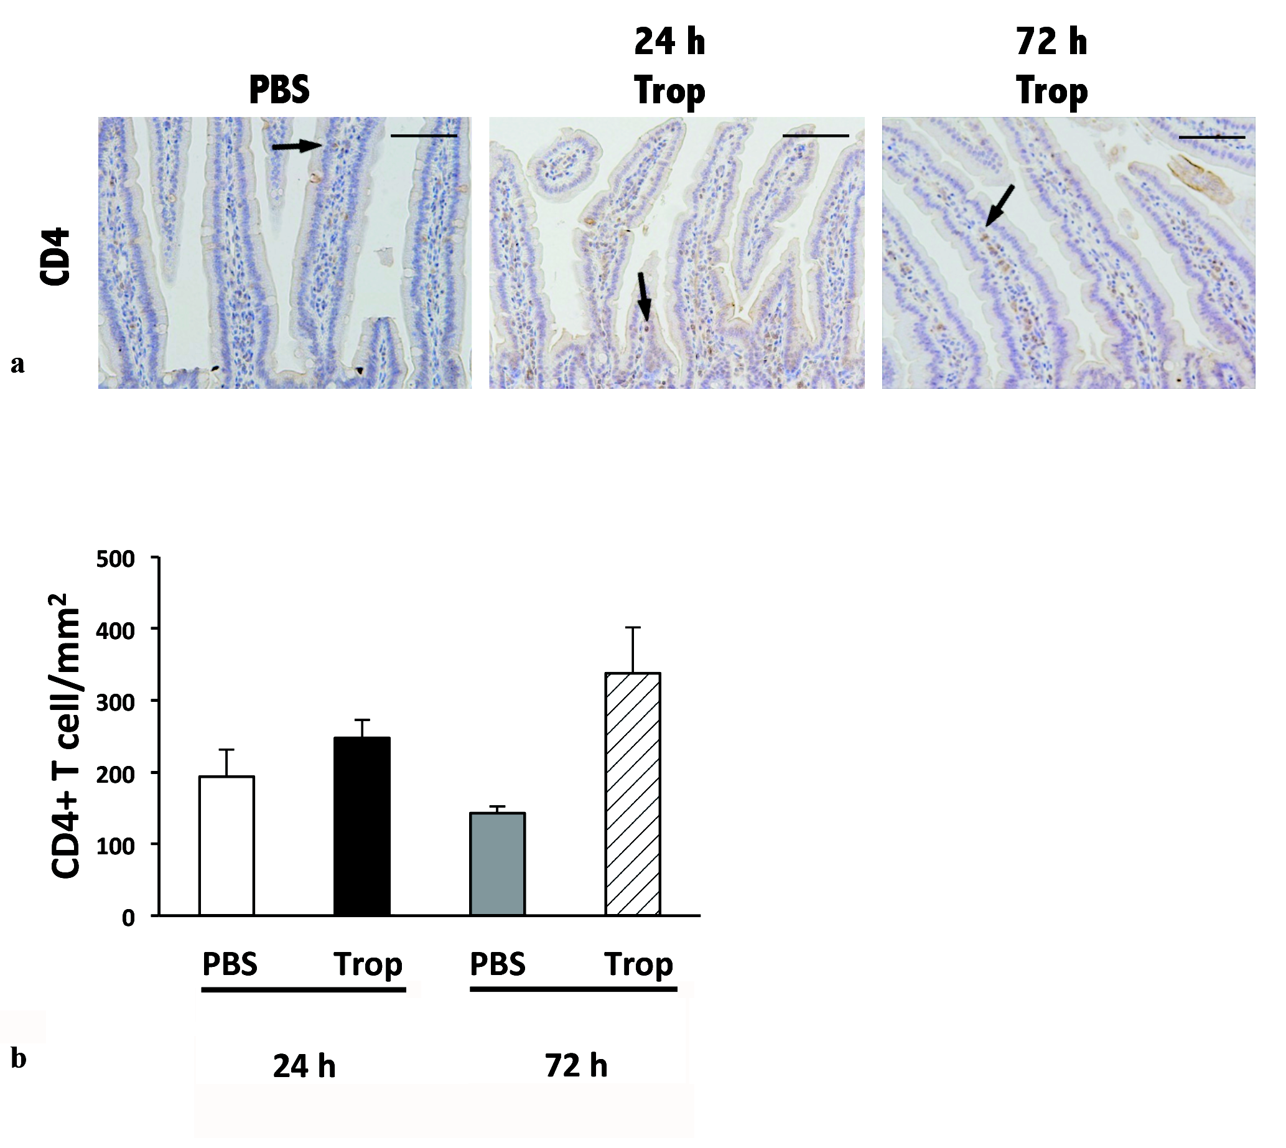
Supplementary Fig. S1. Sensitizing and challenging mouse with tropomyosin resulted in increased but no significant epithelial cell migration from crypt base (proliferative cell was stained brown in immunohistochemistry) in the duodenum. a. Representative sections of duodenum. b. Measurement of distance of proliferative cell migrated from crypt and (c) percentage of BrdU+ cell over total crypt cell of duodenum of control (n=3) and sensitized mice (n=6). Data are expressed as mean ± SEM. Bar = 100 µm. PBS, Mice fed with PBS; Trop, Mice fed with shrimp tropomyosin.

Supplementary Fig. S2. Sensitizing and challenging mouse with tropomyosin did not result in significant changes in the numbers of CD4+ T cells (arrows: CD4+ T cells stained brown in immunohistochemistry) in the duodenum, though a slightly increased infiltration was observed at 72 h after challenge. a. Representative sections of duodenum of PBS control mouse (left) and tropomysoin-sensitized mice, 24 h (middle) and 72 h (right) after challenge. b. Quantification of CD4+ T cell number in the duodenum control (n=3) and sensitized mice (n=6). Data are expressed as mean ± SEM. Bar = 100 µm. PBS, Mice fed with PBS; Trop, Mice fed with shrimp tropomyosin.

